Report on Summer Training
Internship at Hypebrands Pvt. Ltd.

Submitted to Lovely Professional University

In partial fulfillments of the
Requirements for the award of Degree of
Computer Science and Engineering



Submitted by:
Roushan Kumar
Reg. No: 11906794

DEPARTMENT OF ENGINEERING
LOVELY PROFESSIONAL UNIVERSITY
PHAGWARA
2021.

SUMMER INTERNSHIP REPORT

HYPEBRANDS PVT LTD.
(FLUTTER DEVELOPER INTERN)

Roushan Kumar
(Flutter Developer)
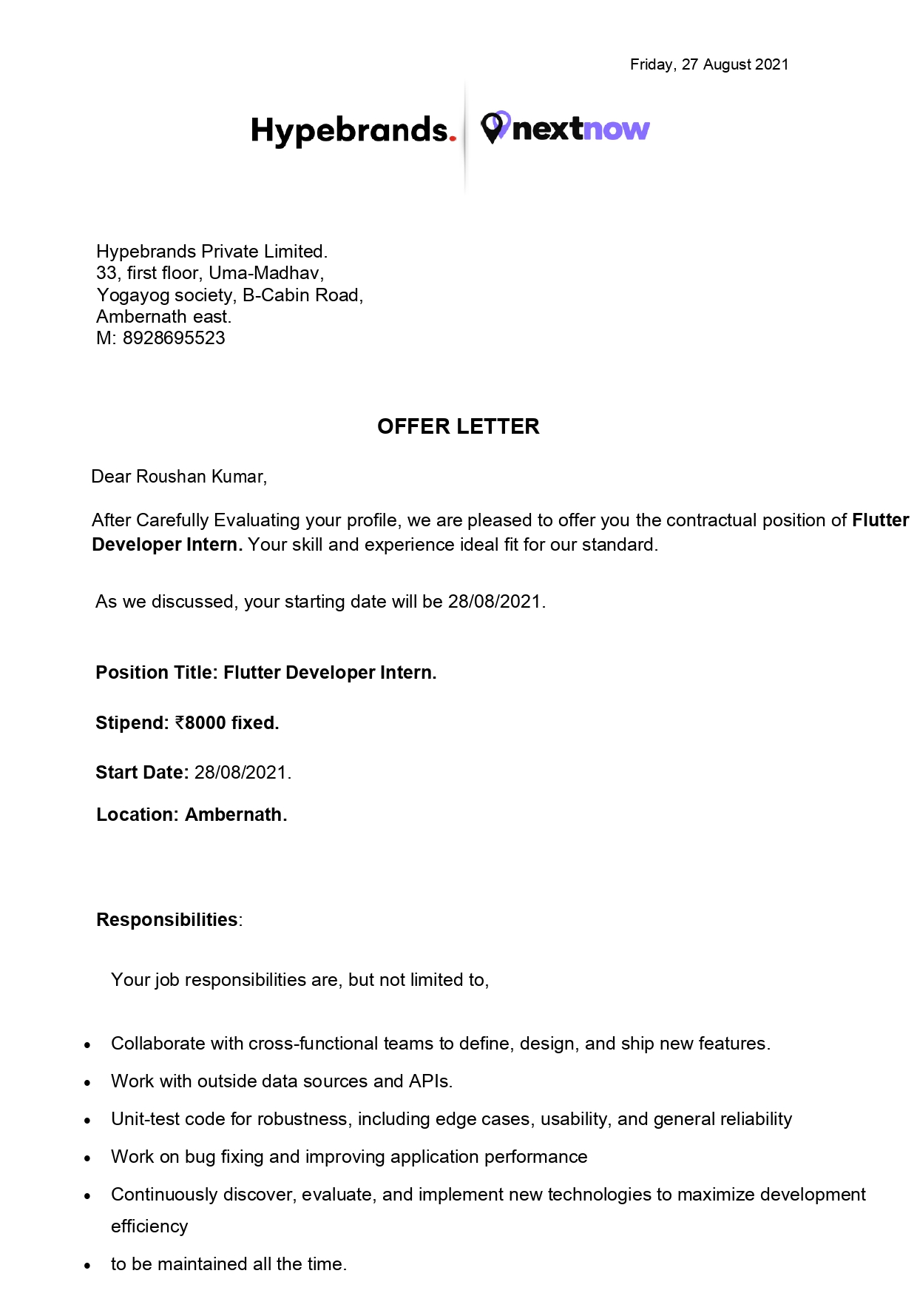
OFFER LETTER SIGNED
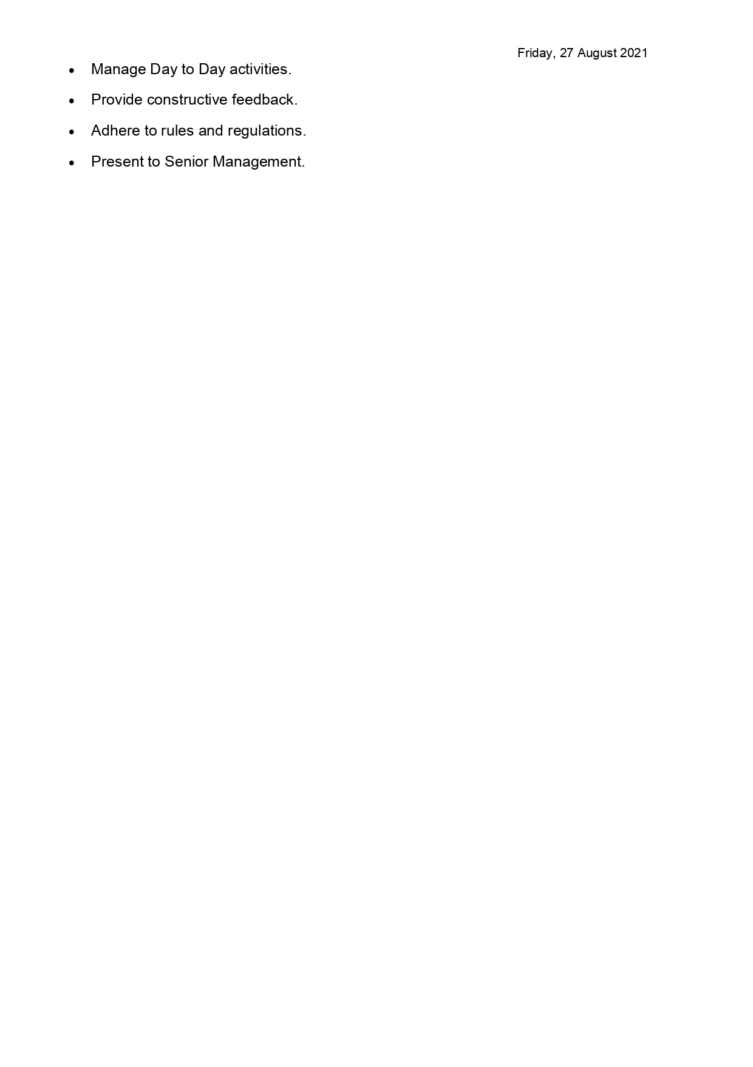
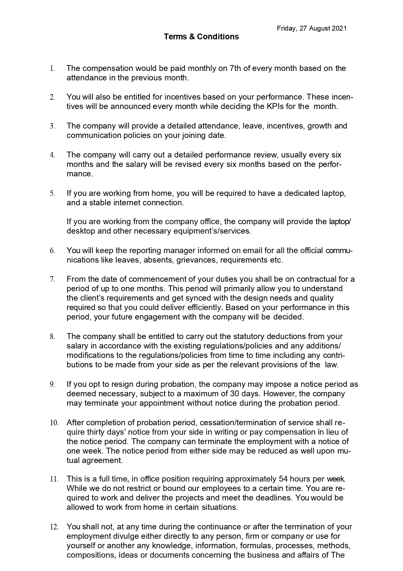
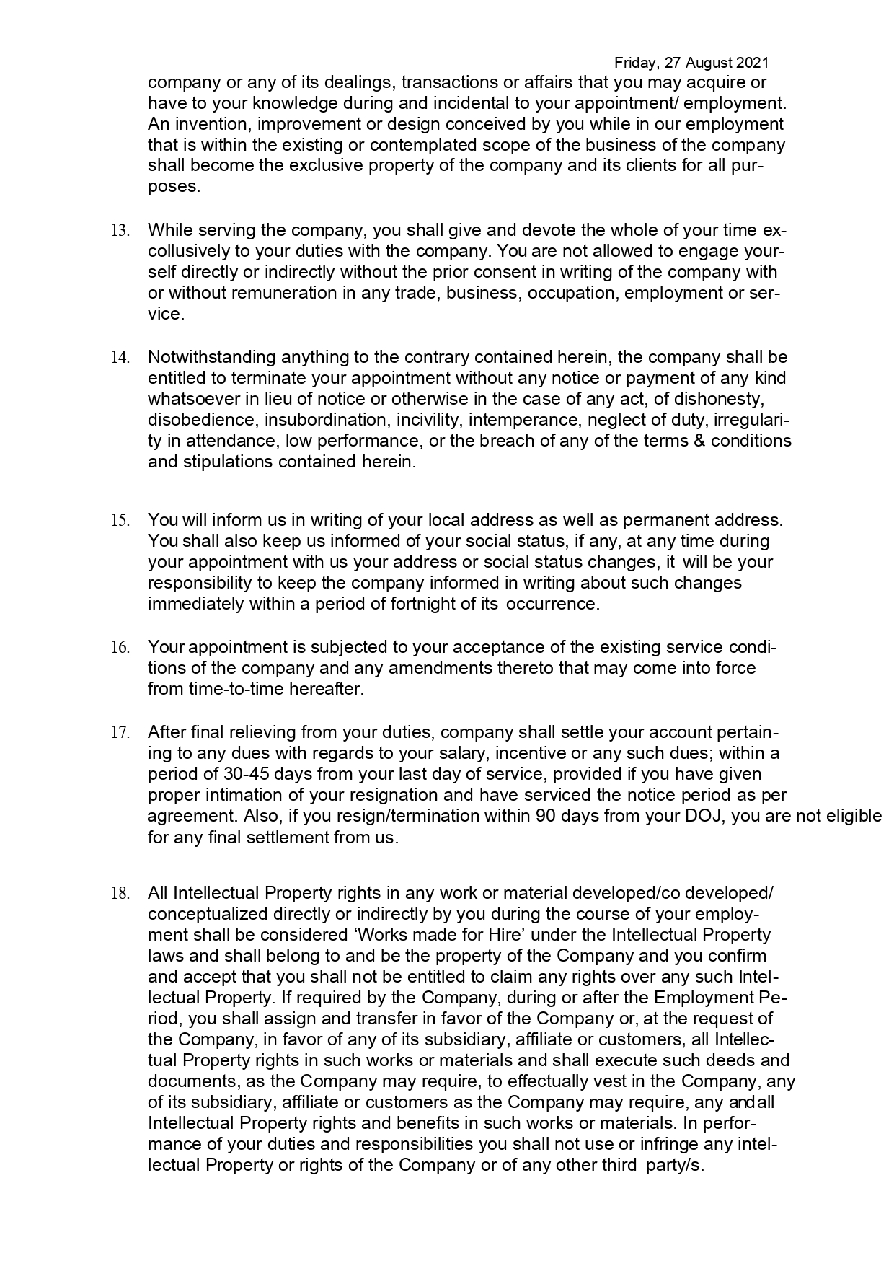
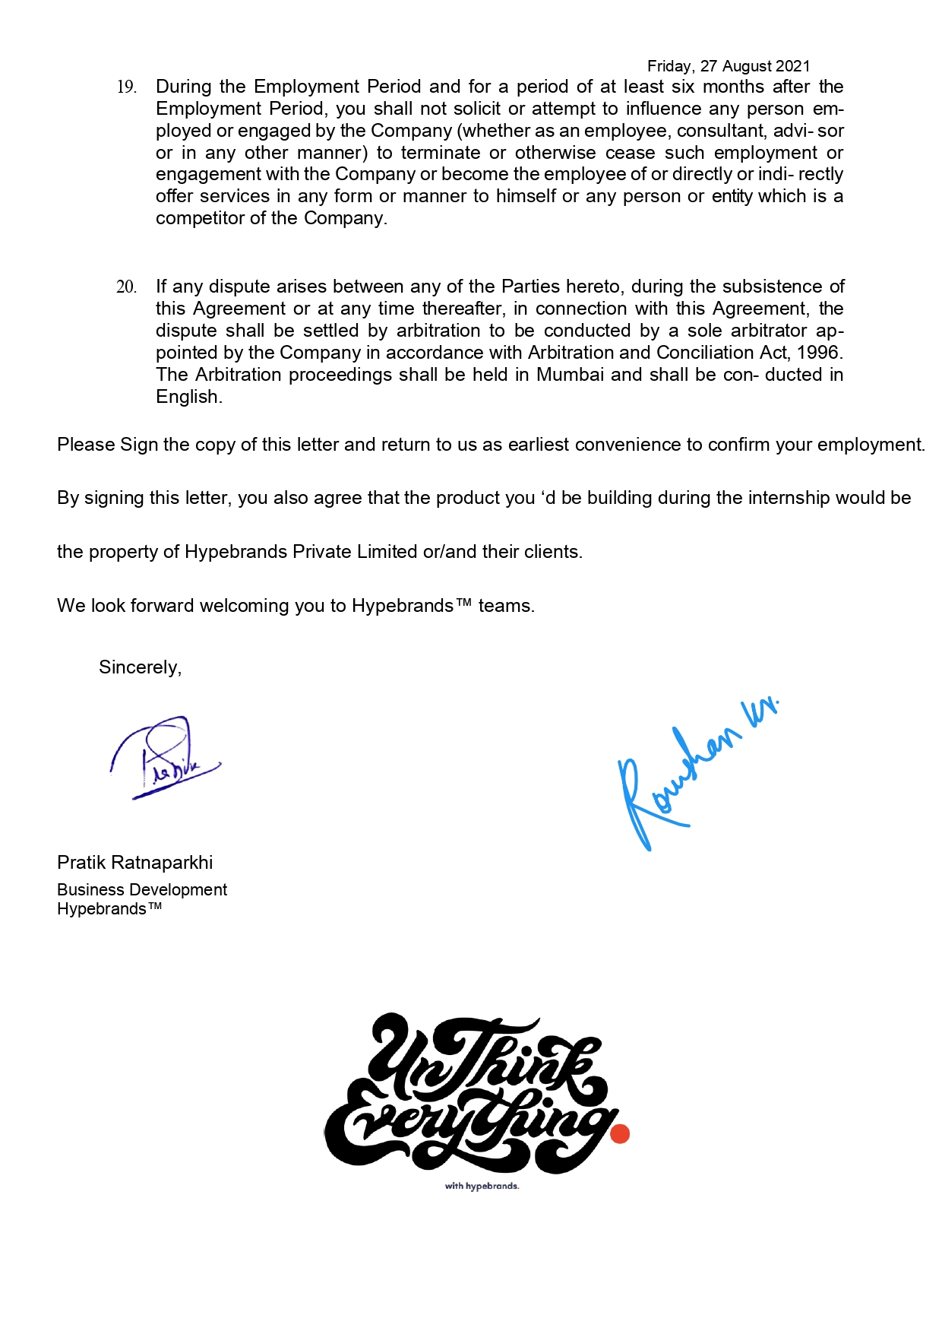

CERTIFICATE OF APPRECIATION
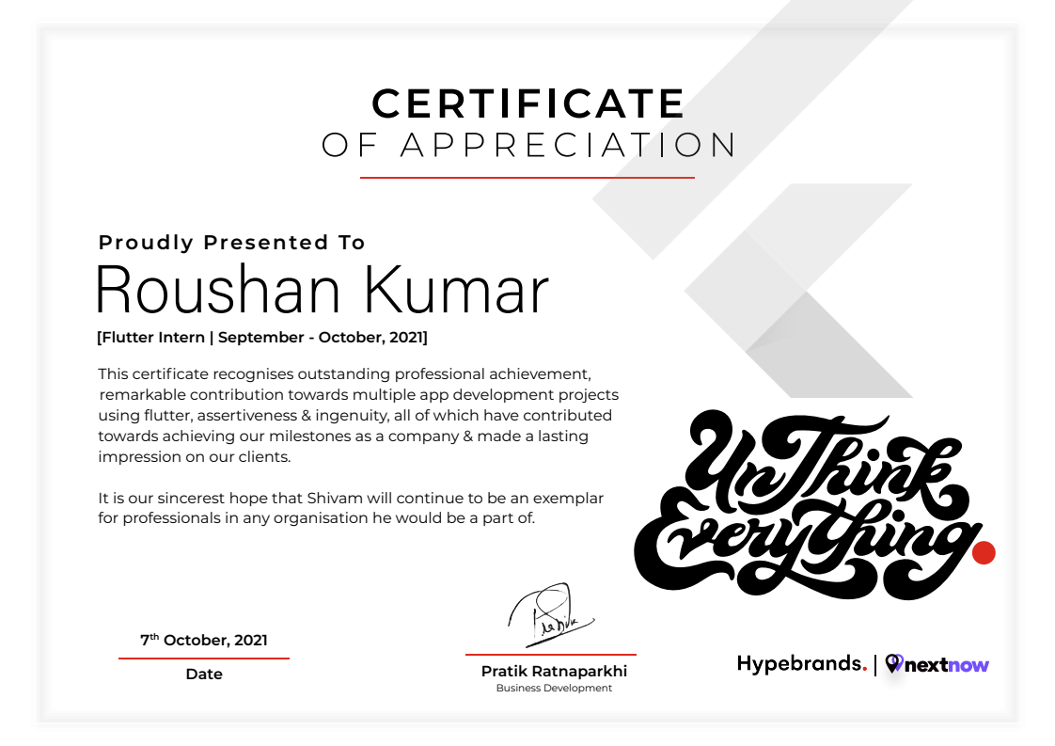
Acknowledgement

I, Roushan Kumar, reg.no 11906794, would like to convey my gratitude to the Management, Faculties, Dean and Placement Cell of Lovely Professional University, Phagwara for emphasizing on the Summer Internship Program and giving me the platform to interact with industry professionals.
I would also like to thank Mr. Pratik Ratnaparkhi, Founder of Hypebrands, Ankita Mishra and Dolly, Project Manager, and all team members for giving me the opportunity to work and develop several digital products for business which can be used by lots of people.
I extend my warm gratitude and regards to everyone who helped me during my internship.

Table of Contents

S.No | Particulars | Page No.
1. | Offer Letter | 3-7
2. | Certificate | 8
3. | Acknowledgement | 9
4. | Executive Summary | 11
5. | About the Organisation | 12
6. | Objective | 13 - 14
7. | Introduction | 15
8. | Project Scope | 16
9. | Related Work | 17
10. | Internship Experience

Executive Summary

The 3-moths Summer Internship Program at Lovely Professional University is a vital part of the 2nd year CSE Course. Since majority of the students come without any prior work experience, the Summer Internship adds worth to their Cvs by giving each student immense learning. At Lovely Professional University, a student can bag an internship through various means since the institure gives us ample oppurtunities to interact with industry experts, I got my internship through Internshala. Hypebrands is a service based company offering various digital solutions like SaaS, Marketing Solutions, Websites, Android applications , Blockchain Technology and various cloud solutions to their client based on American and South-African Clients. Hypebrands has created payment solutions, wallet solutions, Cab-on-demand, Learning Management Systems, and School Managements System for our client. It has also worked with several Govt bodies to solve their problems with a digital solution.

Initially, I was hired for Flutter Developer to develop stunning and blazing fast android applications with a team of great developers and creatives to bring a digital solution to impact people lives and lifestyle.
About the organisation

Hypebrands™ Private Limited is a full service agency. Hypebrands™ offer's it's customers the following services: UI/UX design and Development, Strategic Partner for IT. End-to-end development solutions.
The gap between quality & price is reducing, The choice of choosing products shifts to more symbolic attributes like its Looks, Location, Effective Desirability because of its design, and finally, Who Makes It. That's where it come into play, with our expertise, It build brands that connect. Strategies that over-delivers. consistently. every time. It bring modern, data-driven, innovative disruptive solutions to grow your brand, and it's unlike anyone else out there. That’s because It believe the future of being successful isn't as easy as it used to be, but at the same time, it is much easier than ever before. So that we can work with as many entrepreneurs and hustlers as we can. It's not just the hype, your brand heavily influences the fate of your product.

Objective

Top products, top performance and top service.
Hypebrands Pvt Ltd. Success is our declared goal and utmost concern. Therefore, they make great demands on every detail of our work in all sections of our services.
- They offer our customers
- high-performance, user-friendly software solutions
- first-class, proven hardware products and
- comprehensive individual services

Treat each other with responsibility and respect.
Their everyday wotk both within and outside the company is characterized by mutual respect. The resulting positive attitude is the basis of all issues related to staff management at all classification levels.
They expect and encourage
- a high level of self-motivation
- constructive criticism
- individual responsibility,
- a pleasant working environment as well as
- continuing education

They continue to develop ourselves and our our performances.
The services provided by them have a significant influence on the central business processes of our customers. Therefore, they conduct strict internal control to ensure a high level of transparency and gapless traceabilityy of all work processes.
They continuously control and optimize the effectiveness and efficiency of their actions to be more productive at work and to further improve the quality of their job performace at the same time.

They secure our leading position every day – thereby maintaing our independence
The quality and efficieny of their products and solutions and also their daily personal commitment has made them the market leader conercing ERP solutions for the packaging industry.

To maintain this status and ensure the future success of their company, they pursue clear strategic objectives. Together they want to
- create new jobs
- maintain existing jobs
- foster innovations and
- plan and shape the future
Regular breaks and ongoing maintenance updates simultaneously ensure the effectiveness of our IT solutions while protecting customer’s investments. Only satisfied and successful customers help them to reach their most important strategic goal: to maintain and expand their corporate success and their financial and economic independence.
Introduction

South Africa has a literacy rate of more than 87 percent and population of more than 60 Million Peoples. South Africa is a developing country, ranking 114th on the Human Development Index. It has been classified by the World Bank as a newly industrialised country, with the second-largest economy in Africa, and the 35th-largest in the world.[20][21] South Africa also has the most UNESCO World Heritage Sites in Africa. The country is an upper-middle power in international affairs; it maintains significant regional influence and is a member of both the Commonwealth of Nations and G20. In the last two decades, the country has made significant economic progress by increasing its GDP growth rate to more than 7 percent. It is argued that with the development of the IT sector, the country has a huge potential to jump into an industrialized economy. Because of Africa’s cultural acceptibility, English language, analytical ability and bright trend in software development, a large number of educated and strong youth with good quality and natural skills have a high potential to be a huge source of skilled human resources. Over the past few decades, South Africa’s software and IT services industry has come a long way. It has matured. This industry no longer lives in the surrounding area. It has joined the mainstream. Tech Giants like Google and Microsoft are helping the students in africa to learn about their technologies using various free certification and reward programs.
Not only is the industry making a significant contribution ton national income but it is also playing a vital role in creating high-quality employment for a large portion of the country’s young graduates.
Project Scope
Generally, Everything in schools is on paper, and not informations for over the past years are not managed properly. It becomes very hard for the schools and colleges to maintain these records in school’s personal computers which is unsafe. After this pandemic, we have learnt one thing, to take everything online. Now for managing those things online, It was becoming very hard for schools to manage attendance and classes in a single app. So, Our team in Hypebrands were working on School Management applications to deliver records of each student’s online and on a finger tip. Data on cloud is more secure and faster than on the personal computer and also it is accessible from worldwide. In today's time every school around the world needs one or other kind of School Management Sytem or which is called as School Management Software. Most of the schools have experienced one or other kind of system, however due to limitations of features, product experience or customer support problems they end up looking for better options.

Experience the new age School Management Software:
Having a dynamic system with a bird view of data and reports can give next level of power and quickness in decision-making for principal or management person. School Management App provides extra ordinary Management Dashboard and data reporting functions along with dynamic access rights mechanism which becomes a blessing for management personnel.
Related work
Programming: To build the mobile applications I need to program. In University I learn different programming languages like C, C++, Java, Pythin that helps to understand Dart language. I think every language is similar.

Structuring Data: A project has lots of different categories data which need to be structured properly In this project, Data Strucutes and Database management system course’s knowledge helps me to structure this project data in well manner.

Algorithmic programming: To implement any logic needs to choose right approcah which also called efficient algorithm. The knowledge of algorithms, course is applied here.,

Project Management: To complete any project needs a proper management in workloads. The knowledge of software engineering course is applied here.

System Analysis: Every system needs to be analysis. Hence the knowledge of Sysem analysis is applied here.

Internship Experience

In Hypebrands Pvt Ltd. I have worked as a flutter developer. During my internship program my work performance was an important issue for the organization as well as for me. Performing perfectly was a challenging task for me. The first month of the three-month internship period was my training period. My studies in the first month were perfect for working in the UI/UX part of the flutter application. From the second month I started doing frontend as well as functional/backend work in application. I have managed an average of 6-8hrs per day as a new employee for any IT firm. This is an impressive company. My supervisor is very satisfied with my work and depending on me he hired five new developers in the firm to work on time and efficiently. My work also lacked something.

As already mentioned, the company caters to the needs of clients in three main areas, namely website development services and mobile development services. I was immersed in mobile development services. My role was as an Android Application Developer. Under this role, I will work in a group of two to develop two applciation that can be run on Android Phones and on Iphones as well. The domain selected by my group was Application Development.
For the first two weeks, we were created to learn / master the coding techniques of developing Android applications related to our scheduled work. During this time, we were assisted a lot by our consultants at the firm. Then we were handed the actual application to develop for the next four weeks. The reason for choosing to develop and Andrid apps is that the field provides plenty of scope. Android development tools are open source and so one can fully develop as an android Programmer. Another reason is that the field is relatively new to that industry and the trends show that there is a huge need for Android programmers in the market. Yet, another reason is that programmers can easily market their products in the Andorid App market and earn quite a good support income.

