HTTP vs HTTPS Analysis
Task 16 · Cyber Security Track · Level 1, Day 16
Prepared by: Amruta · Veda Technology · 04 November 2026

1. Objective
To compare HTTP and HTTPS, understand how secure web communication works, and explain the security benefits of TLS using practical evidence collected with the Chrome browser and Developer Tools.

2. Background
HTTP (HyperText Transfer Protocol) sends data between browser and server in plain text. Anyone on the network path, such as public Wi-Fi, a router or an ISP, can read or modify it. HTTPS is HTTP running over TLS (Transport Layer Security). TLS wraps the traffic in encryption, proves the server’s identity with a certificate, and protects the data from tampering.

3. Comparison Table
Feature | HTTP | HTTPS
Full name | HyperText Transfer Protocol | HTTP over TLS (Secure)
Default port | 80 | 443
Encryption | None (plain text) | Yes (TLS)
Authentication | None; server identity not verified | Server certificate verified by a trusted CA
Data integrity | Data can be altered in transit | Tampering is detected (MAC)
Browser indicator | "Not secure" warning | Secure connection indicator
Suitable for logins/payments | No | Yes

4. Practical Observations
Tools used: Google Chrome and Chrome Developer Tools (Network and Security panels). The HTTPS test site was wikipedia.org and the HTTP test site was neverssl.com, which deliberately serves plain HTTP.

4.1 HTTPS: Certificate (Wikipedia)
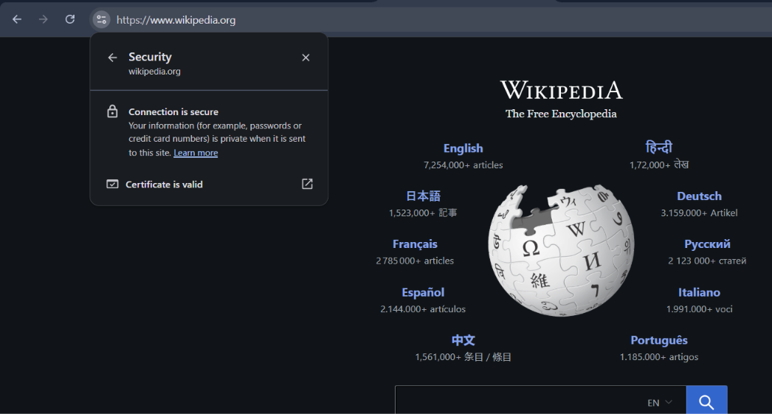
Figure 1: Chrome shows "Connection is secure" and "Certificate is valid" for https://www.wikipedia.org.
The browser confirms that information such as passwords or card numbers stays private when sent to this site. The valid certificate shows the server’s identity was verified by a trusted Certificate Authority.

4.2 HTTPS: Network request
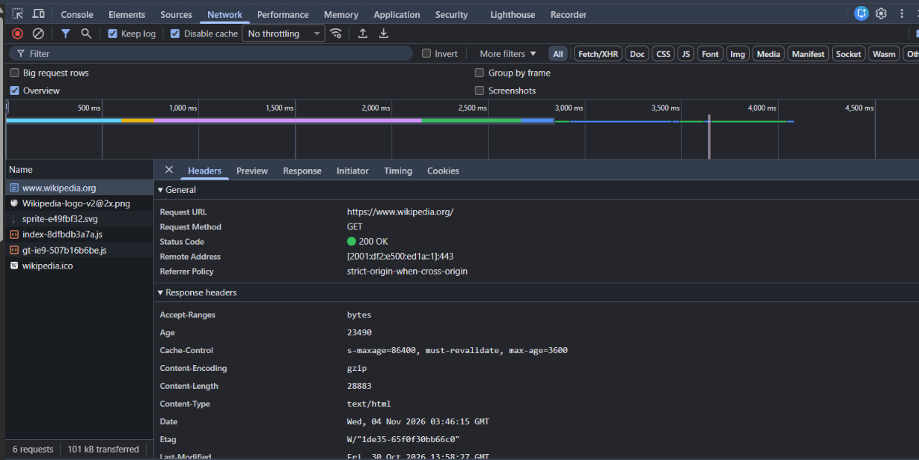
Figure 2: Network tab, request headers for www.wikipedia.org.
- Request URL: https://www.wikipedia.org/ (begins with https://)
- Status Code: 200 OK
- Remote Address: ends with :443, the standard HTTPS port

4.3 HTTPS: TLS details
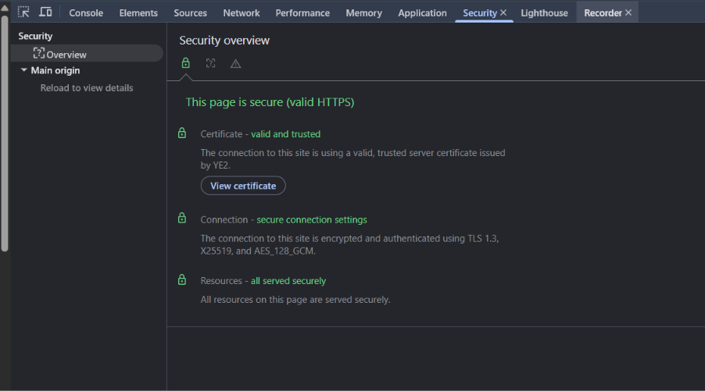
Figure 3: DevTools Security panel for Wikipedia.
The Security panel reports "This page is secure (valid HTTPS)". The certificate is valid and trusted, the connection is encrypted and authenticated using TLS 1.3, X25519 key exchange and AES_128_GCM, and all resources on the page are served securely.

4.4 HTTP: Browser warning

Figure 4: Chrome labels an http:// neverssl.com page as "Not secure".
The address bar shows a "Not secure" label and Chrome warns that "This site doesn’t support a secure connection". This is because the page is delivered without TLS.

4.5 HTTP: Network request

Figure 5: Network tab, request headers for a plain HTTP request to neverssl.com.
- Request URL: http://innerclearlushmelody.neverssl.com/online (begins with http://)
- Status Code: 301 Moved Permanently (a normal redirect to /online/)
- Remote Address: ends with :80, the standard HTTP port
Because this connection uses port 80 with no TLS, the request and response travel unencrypted and can be read by anyone able to observe the traffic.

5. Security Benefits of TLS
- Encryption: data is scrambled in transit, so eavesdroppers see unreadable content instead of passwords or card numbers.
- Authentication: the server proves its identity with a certificate issued by a trusted Certificate Authority, protecting against fake sites and man-in-the-middle attacks.
- Integrity: TLS detects any modification of data in transit, so content cannot be silently altered.

6. Conclusion
The experiment shows a clear difference. Wikipedia over HTTPS used port 443, a valid trusted certificate and TLS 1.3 with AES-128-GCM encryption. The neverssl.com page over HTTP used port 80, no encryption and was flagged "Not secure" by the browser. HTTP is unsafe for sensitive data such as logins and payments, so HTTPS with TLS should be used for any site that handles user information.

7. Interview Questions

What is HTTPS?
HTTPS is HTTP secured with TLS. It provides encrypted, authenticated and tamper-proof communication between a browser and a web server.

What is TLS?
Transport Layer Security is the protocol, and successor to SSL, that performs the handshake, key exchange and encryption between client and server.

Why is HTTP insecure for sensitive data?
Everything travels in plain text, so credentials and personal data can be intercepted or modified, and there is no way to verify that the server is genuine.

