VEDA TECHNOLOGY
TCP vs UDP Report
Task 13: TCP and UDP Comparison | Cyber Security Track | Level 1, Day 13
Field | Details
Name | Amruta
Track | Cyber Security
Task | Task 13: TCP and UDP Comparison
Tools used | Wireshark 4.6.9, Web browser
Date | 01-11-2026

1. Introduction
The transport layer moves data between applications on different hosts. Its two main protocols are the Transmission Control Protocol (TCP) and the User Datagram Protocol (UDP). TCP is connection-oriented and reliable. UDP is connectionless and lightweight.
The objective of this task is to understand transport-layer protocols by capturing real network traffic with Wireshark, comparing how TCP and UDP behave, and identifying where each one is the better choice.

2. Methodology
- Installed Wireshark and started a live capture on the Wi-Fi interface.
- Browsed websites and applications to generate TCP, DNS and QUIC traffic, then stopped the capture (6,311 packets).
- Applied display filters (tcp.flags.syn == 1, tcp.stream eq 3, tcp.flags.fin == 1, dns, udp.port == 443) to isolate each behaviour.
- Expanded the packet details to compare the TCP and UDP headers.

3. TCP Observations

3.1 Connection setup: three-way handshake
Filtering with tcp.flags.syn == 1 shows the packets that start TCP connections. Each SYN from the client (10.191.23.30) is answered by a SYN-ACK from the server (8.219.181.32) on port 443.
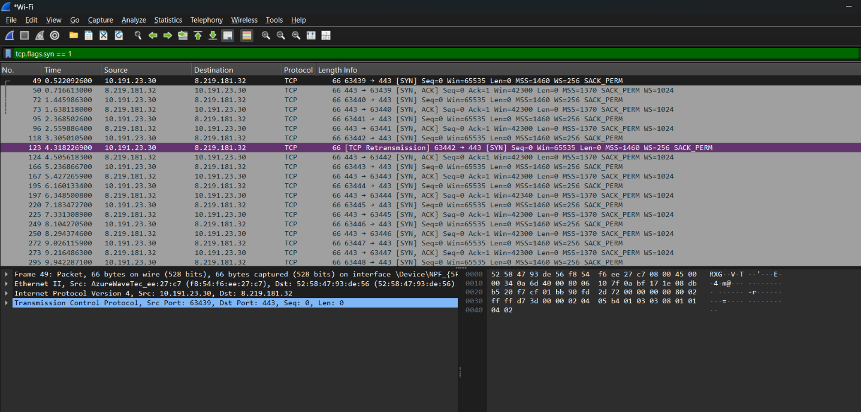
Figure 1: SYN and SYN-ACK packets (filter tcp.flags.syn == 1). Packet 123 is a TCP retransmission of a SYN.
Following one connection (tcp.stream eq 3) shows the complete handshake: SYN (packet 49), SYN-ACK (packet 50) and ACK (packet 53). After this, TLS negotiation and encrypted data transfer begin, and every data segment is confirmed with an ACK.
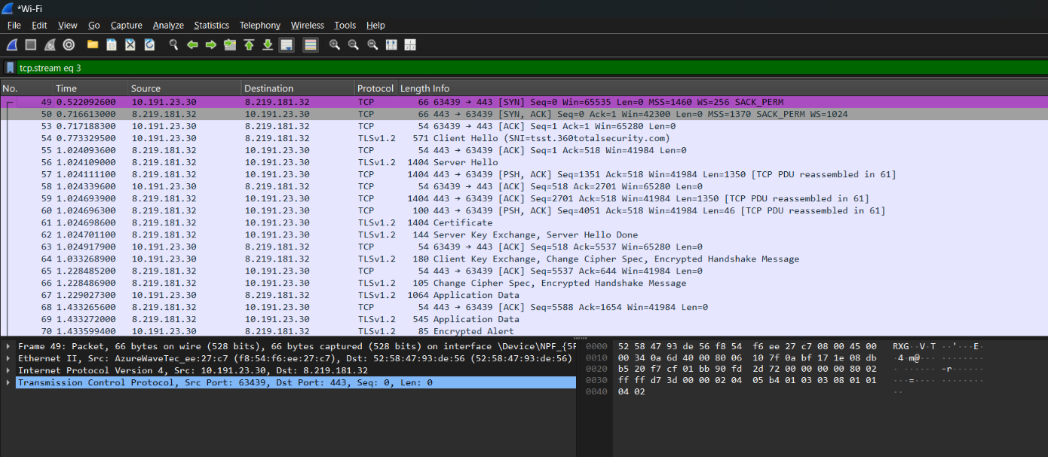
Figure 2: Complete TCP three-way handshake (SYN, SYN-ACK, ACK) followed by TLS and data transfer with ACKs.

3.2 TCP header
The TCP header of the SYN packet contains source and destination ports, sequence number, acknowledgment number, header length (32 bytes with options), flags (SYN), window size (65535), checksum and options. These fields give TCP ordering, error detection and flow control, but add overhead.
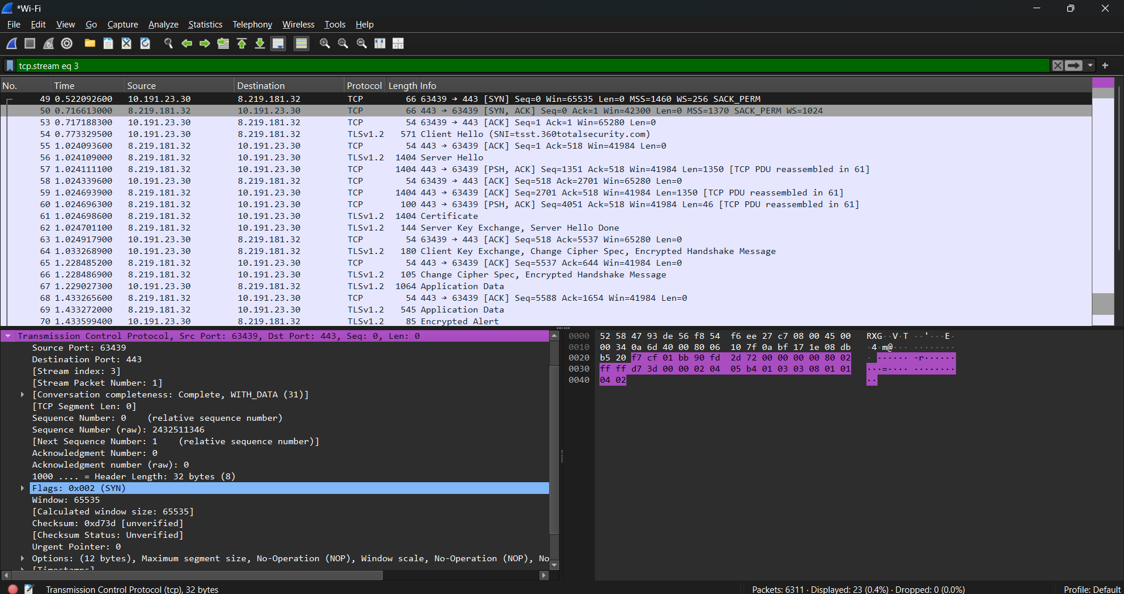
Figure 3: TCP header fields of the SYN packet (header length 32 bytes).

3.3 Connection termination and reliability
TCP closes a connection cleanly using FIN and ACK packets. The capture also shows several [TCP Retransmission] entries (packets 119, 121 and 213), where TCP resent data that was not acknowledged in time. This is TCP's reliability mechanism in action.
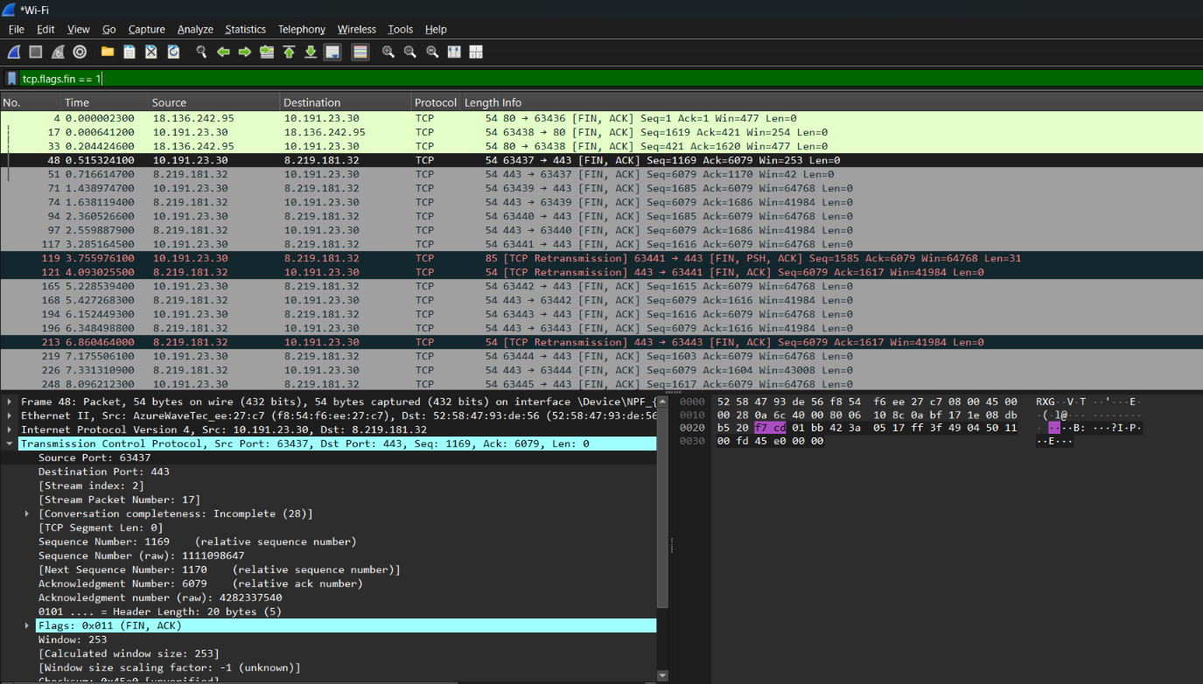
Figure 4: TCP connection termination with FIN, ACK packets and retransmissions (filter tcp.flags.fin == 1).

4. UDP Observations

4.1 DNS over UDP
DNS lookups use UDP port 53. The screenshot shows the laptop sending queries for www.google.com to the DNS server (10.191.23.221) and receiving responses immediately. There is no handshake before the query and no connection close afterwards, which shows UDP is connectionless.
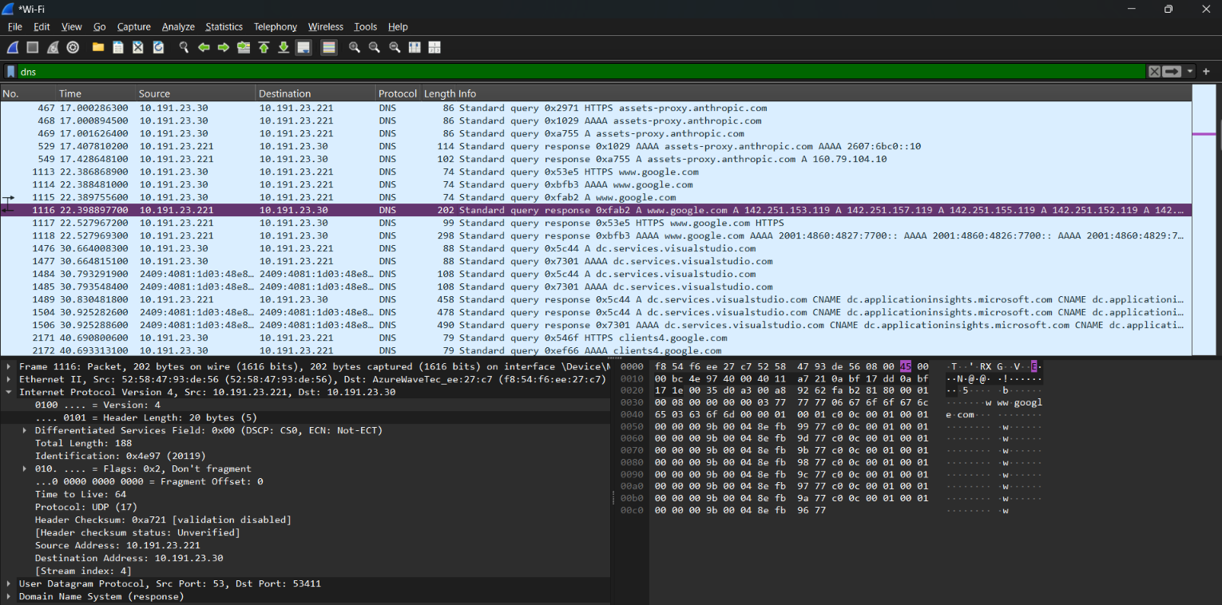
Figure 5: DNS queries and responses over UDP (filter dns). No handshake is needed.

4.2 UDP header
The UDP header has only four fields: source port, destination port, length and checksum. It is a fixed 8 bytes. In the example packet, Length is 145 bytes, which is the 8-byte header plus 137 bytes of data.
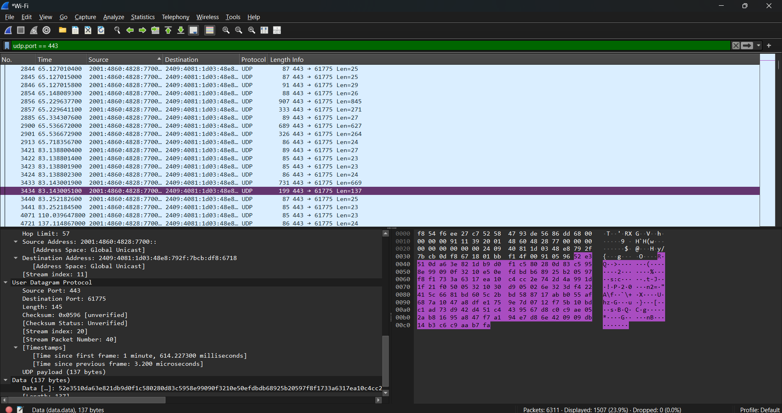
Figure 6: UDP header showing source port (443), destination port (61775), length (145) and checksum.

4.3 QUIC over UDP
Filtering udp.port == 443 shows modern web traffic running over UDP. QUIC, the protocol behind HTTP/3, builds its own reliability and encryption on top of UDP, which reduces connection setup time compared to TCP plus TLS. No SYN or SYN-ACK packets appear.
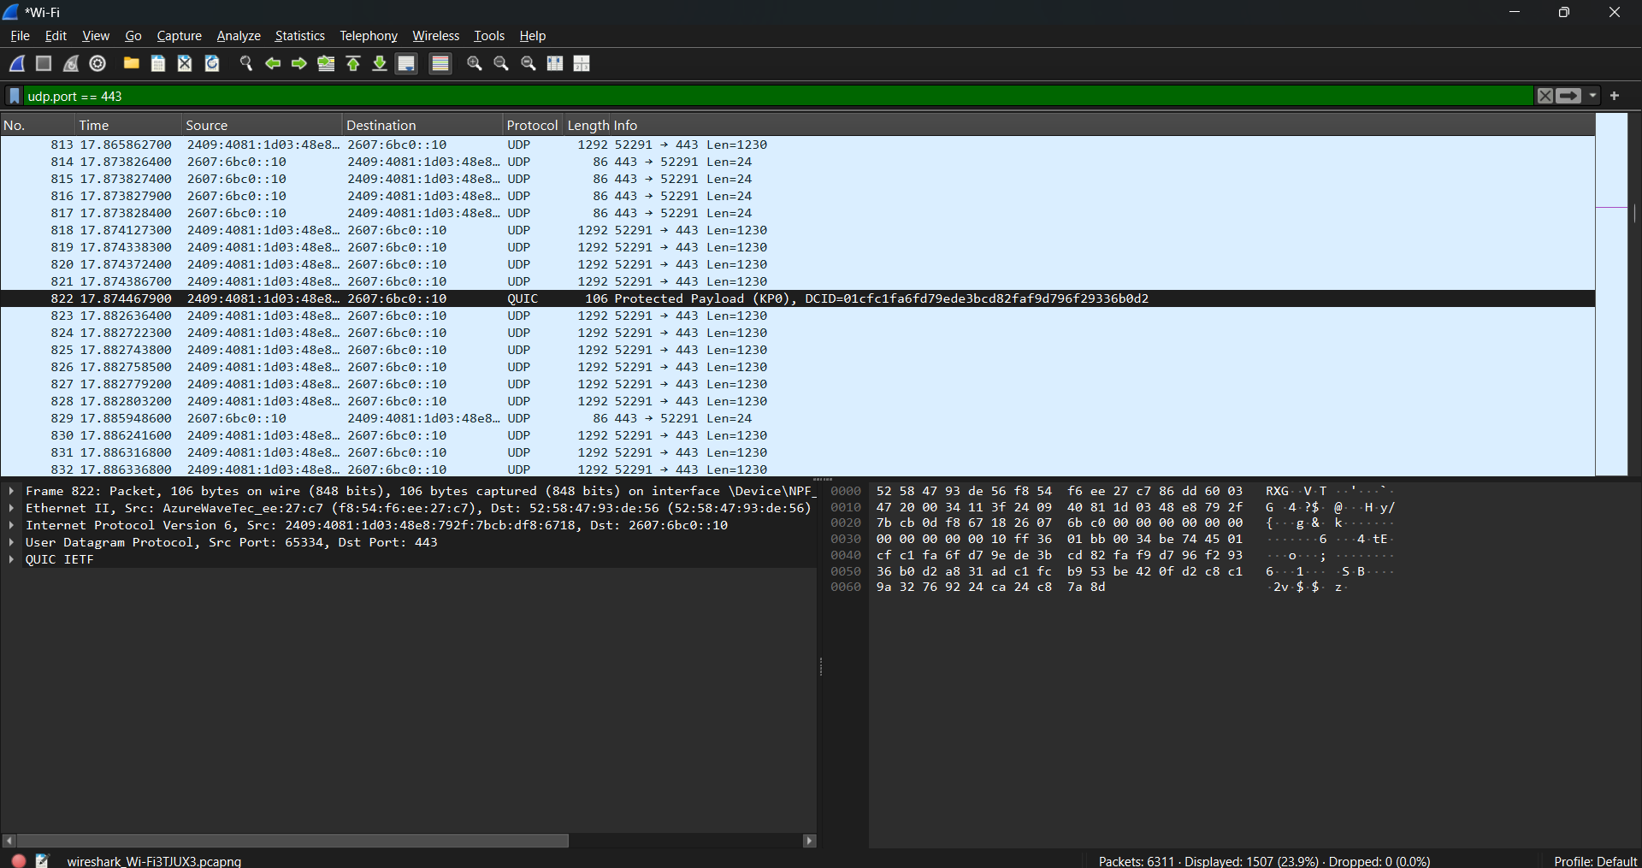
Figure 7: QUIC and UDP traffic on port 443 (filter udp.port == 443), with no handshake packets.

5. TCP vs UDP Comparison
Feature | TCP | UDP
Connection | Connection-oriented (three-way handshake) | Connectionless (no handshake)
Reliability | Guaranteed delivery with retransmission | No guarantee, no retransmission
Ordering | Data arrives in order (sequence numbers) | No ordering
Flow and congestion control | Yes (window size) | No
Header size | 20 to 60 bytes (32 bytes observed) | 8 bytes fixed
Speed and overhead | Slower, higher overhead | Faster, low overhead
Connection close | FIN and ACK exchange | None
Examples | HTTP/HTTPS, SSH, FTP, SMTP | DNS, DHCP, VoIP, streaming, gaming, QUIC

6. Use Cases
- TCP is preferred when accuracy matters more than speed: web browsing, email, file transfer, remote login and online banking.
- UDP is preferred when low latency matters more than perfect delivery: live video streaming, voice and video calls, online gaming and DNS queries. A few lost packets are acceptable or are handled by the application.

7. Security Perspective
- TCP can be abused by SYN flood attacks, where an attacker sends many SYN packets and leaves handshakes incomplete to exhaust server resources.
- UDP is commonly used in amplification and reflection DDoS attacks (for example DNS amplification), because there is no handshake to verify the sender and source addresses can be spoofed.
- Wireshark filters such as tcp.flags.syn == 1 help analysts spot unusual SYN volume, and udp filters help identify abnormal UDP traffic.

8. Conclusion
The captures confirm the theory. TCP establishes a connection with a three-way handshake, acknowledges data, retransmits lost segments and closes with FIN, at the cost of a larger header and more overhead. UDP sends datagrams directly with an 8-byte header and no guarantees, which makes it faster and better suited to real-time traffic. The right choice depends on whether reliability or speed matters more for the application.

9. Interview Questions
- What is TCP? A reliable, connection-oriented transport protocol. It sets up a connection with a three-way handshake, then delivers data in order with error checking, retransmission and flow control.
- What is UDP? A lightweight, connectionless transport protocol that sends datagrams without a handshake, ordering or delivery guarantees. It is fast but less reliable.
- When is UDP preferred? When low latency matters more than reliability and some packet loss is acceptable: live video, VoIP, online gaming and DNS queries.

