**DAILY ONLINE ACTIVITIES SUMMARY**

|  |  |  |  |  |  |  |  |
| --- | --- | --- | --- | --- | --- | --- | --- |
| **Date:** | **05/06/2020** | | | | **Name:** | **Amrutha G** | |
| **Sem & Sec** | **4TH&A** | | | | **USN:** | **4AL18CS006** | |
| **Online Test Summary** | | | | | | | |
| **Subject** | |  | | | | | |
| **Max. Marks** | |  | | **Score** | |  | |
| **Certification Course Summary** | | | | | | | |
| **Course** | **Introduction to cyber security** | | | | | | |
| **Certificate Provider** | | | **GREAT LEARNING** | **Duration** | | | **7.0 HOURS** |
| **Coding Challenges** | | | | | | | |
| **Problem Statement 1:** **Write a Java Program to find the duplicate characters in a string.** | | | | | | | |
| **Status: executed** | | | | | | | |
| **Uploaded the report in Github** | | | | **YES** | | | |
| **If yes Repository name** | | | | **https://github.com/AMRUTHAGANESH/lockdown-java-codings-** | | | |
| **Uploaded the report in slack** | | | | **YES** | | | |

Online Test Summary: Not conducted.

**Online Certification course:**

Name of the course : introduction to cyber security

Duration: 7 hours

Certificate provider: great learning

In today's session I learnt governance and risk and also learnt introduction to cryptography

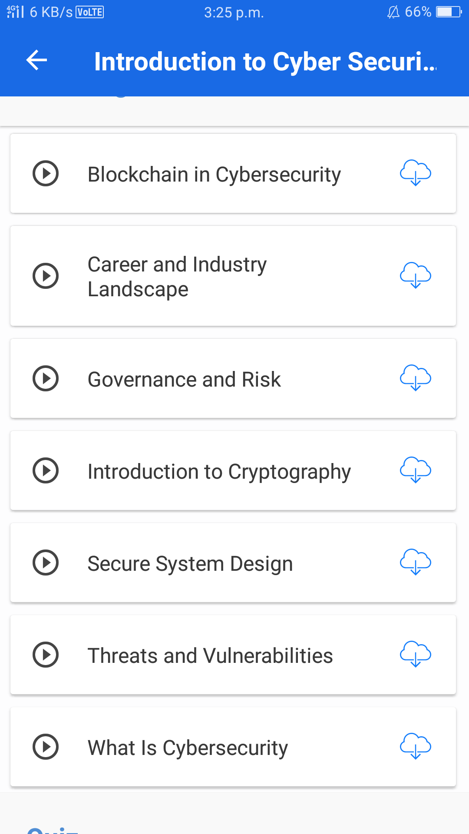

Online Coding summary:

**1. Write a Java Program to find the duplicate characters in a string.**

