**DAILY ONLINE ACTIVITIES SUMMARY**

|  |  |  |  |  |  |  |  |
| --- | --- | --- | --- | --- | --- | --- | --- |
| **Date:** | **06/06/2020** | | | | **Name:** | **Amrutha G** | |
| **Sem & Sec** | **4TH&A** | | | | **USN:** | **4AL18CS006** | |
| **Online Test Summary** | | | | | | | |
| **Subject** | | **DATA COMMUNICATION** | | | | | |
| **Max. Marks** | | **30** | | **Score** | | **26** | |
| **Certification Course Summary** | | | | | | | |
| **Course** | **CYBER SECURITY** | | | | | | |
| **Certificate Provider** | | | **GREAT LEARNING** | **Duration** | | | **7.0 HOURS** |
| **Coding Challenges** | | | | | | | |
| **Problem Statement 1:** **Write a program in C to rotate an array by N positions.**  **Problem Statement 2**: **Write a Java Program to find the second-highest number in an array.** | | | | | | | |
| **Status: executed** | | | | | | | |
| **Uploaded the report in Github** | | | | **YES** | | | |
| **If yes Repository name** | | | | **https://github.com/AMRUTHAGANESH/lockdown-codings https://github.com/AMRUTHAGANESH/lockdown-java-codings-** | | | |
| **Uploaded the report in slack** | | | | **YES** | | | |

Online Test Summary:18CS46 online test was scheduled from 9:15AM to10:00 am. The portion for the IA was module 5 . The question were MCQ type There were 30 question 1 mark respectively duration is 30 minutes .The score I received was 26/30.

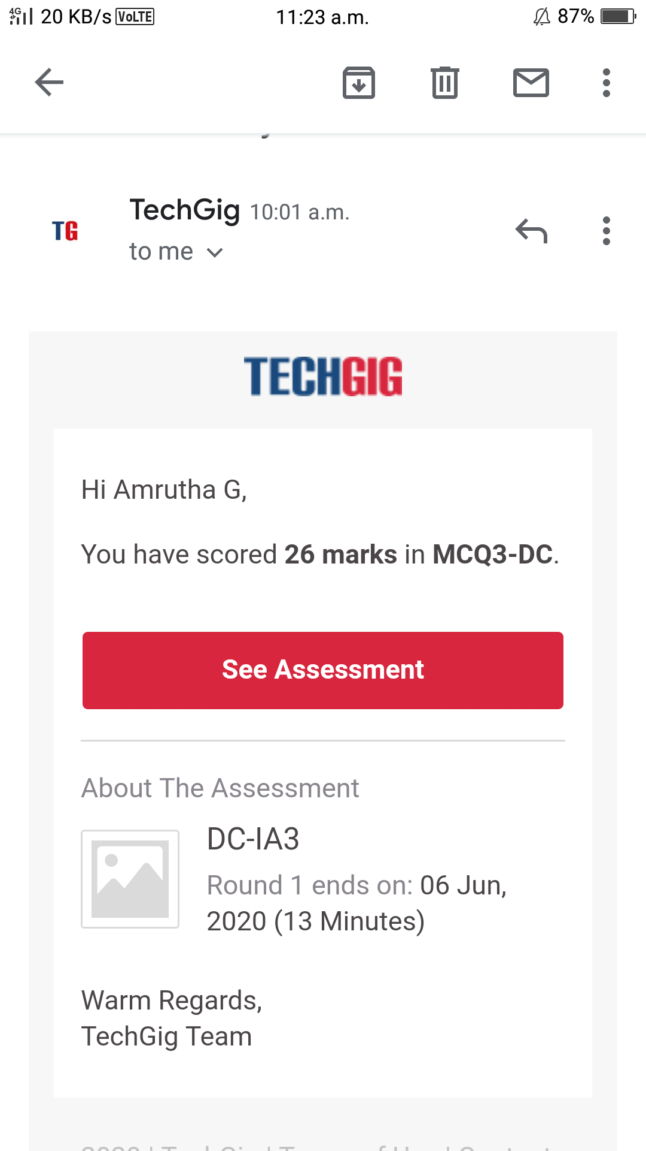

**Online Certification course:**

Name of the course : Cyber security

Duration: 7.0 hours

Certificate provider: great learning

This course contains 6 modules. In this video today I have learnt about secure system design and threats and vulnerabilities

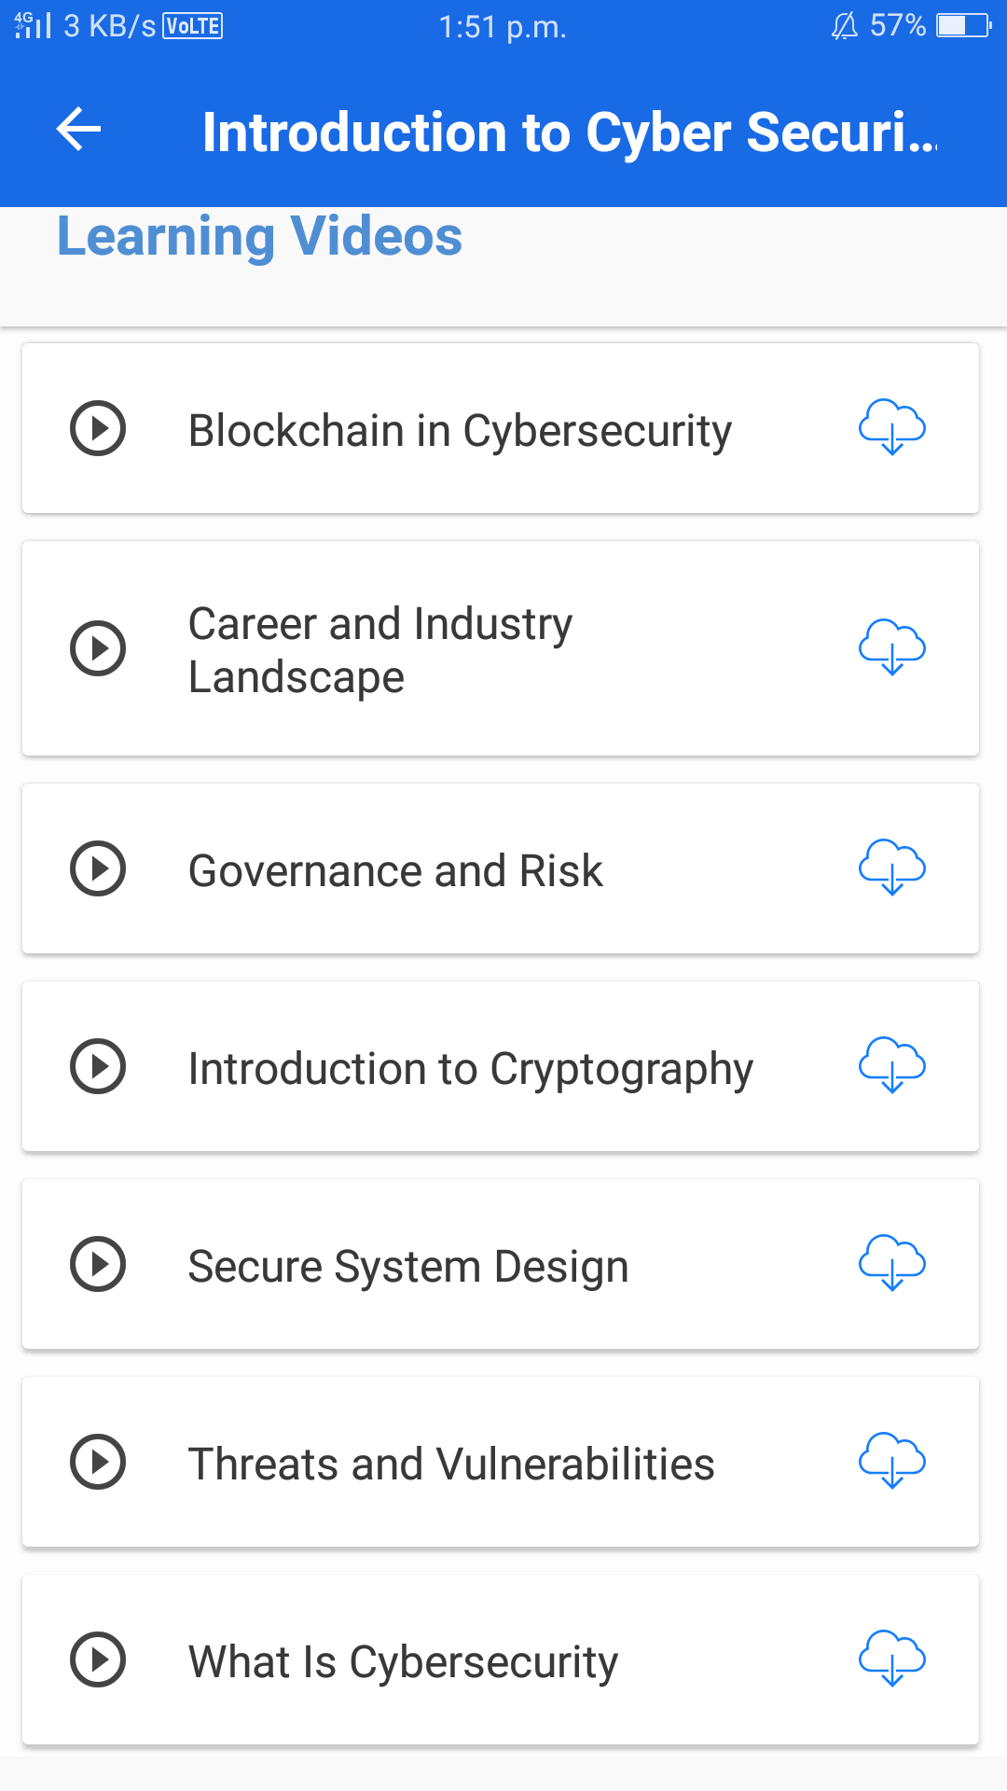

Online Coding summary:

1. **Write a program in C to rotate an array by N positions.**

2. **Write a Java Program to find the second-highest number in an array.**

