**DAILY ONLINE ACTIVITIES SUMMARY**

|  |  |  |  |  |  |  |  |
| --- | --- | --- | --- | --- | --- | --- | --- |
| **Date:** | **07 June 2020** | | | | **Name:** | **Amrutha G** | |
| **Sem & Sec** | **4th sem, 2nd year** | | | | **USN:** | **4al18cs006** | |
| **Online Test Summary** | | | | | | | |
| **Subject** | | **------------------** | | | | | |
| **Max. Marks** | | **----** | | **Score** | | **-----** | |
| **Certification Course Summary** | | | | | | | |
| **Course** | **Introduction to cyber security**  **Fundamental of digital marketing** | | | | | | |
| **Certificate Provider** | | | **Great Learning**  **Google grage** | **Duration** | | | **7hours**  **40 hours** |
| **Coding Challenges** | | | | | | | |
| **Problem Statement:1 program** | | | | | | | |
| **Status: Executed** | | | | | | | |
| **Uploaded the report in Github** | | | | **Yes** | | | |
| **If yes Repository name** | | | | https://github.com/AMRUTHAGANESH/lockdown-codings  <https://github.com/keertanaganiga/lockdown_reports> | | | |
| **Uploaded the report in slack** | | | | **Yes** | | | |

**Certification Course Summary:**

Name of the certification : introduction to cyber security .

Today I successfully completed the cyber security course

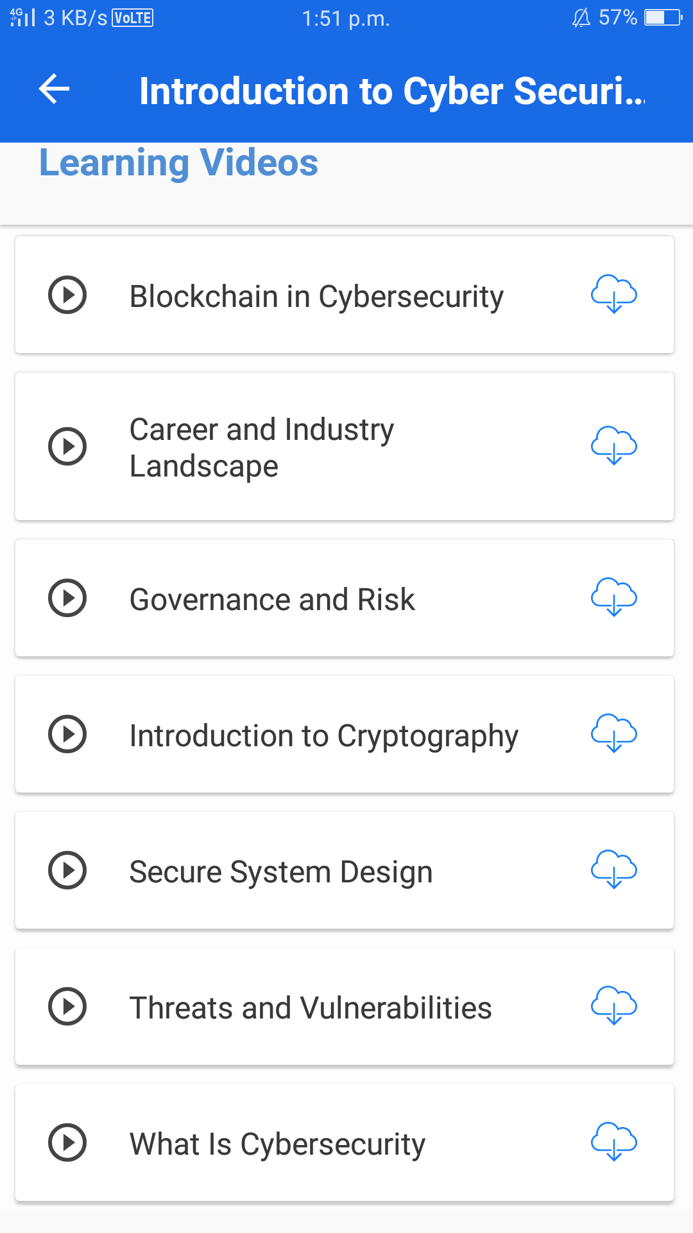

Today I also started new course

Name of the course : fundamental of Digital marketing that course was 40 hours and today I go through 16 modules out of 26 modules

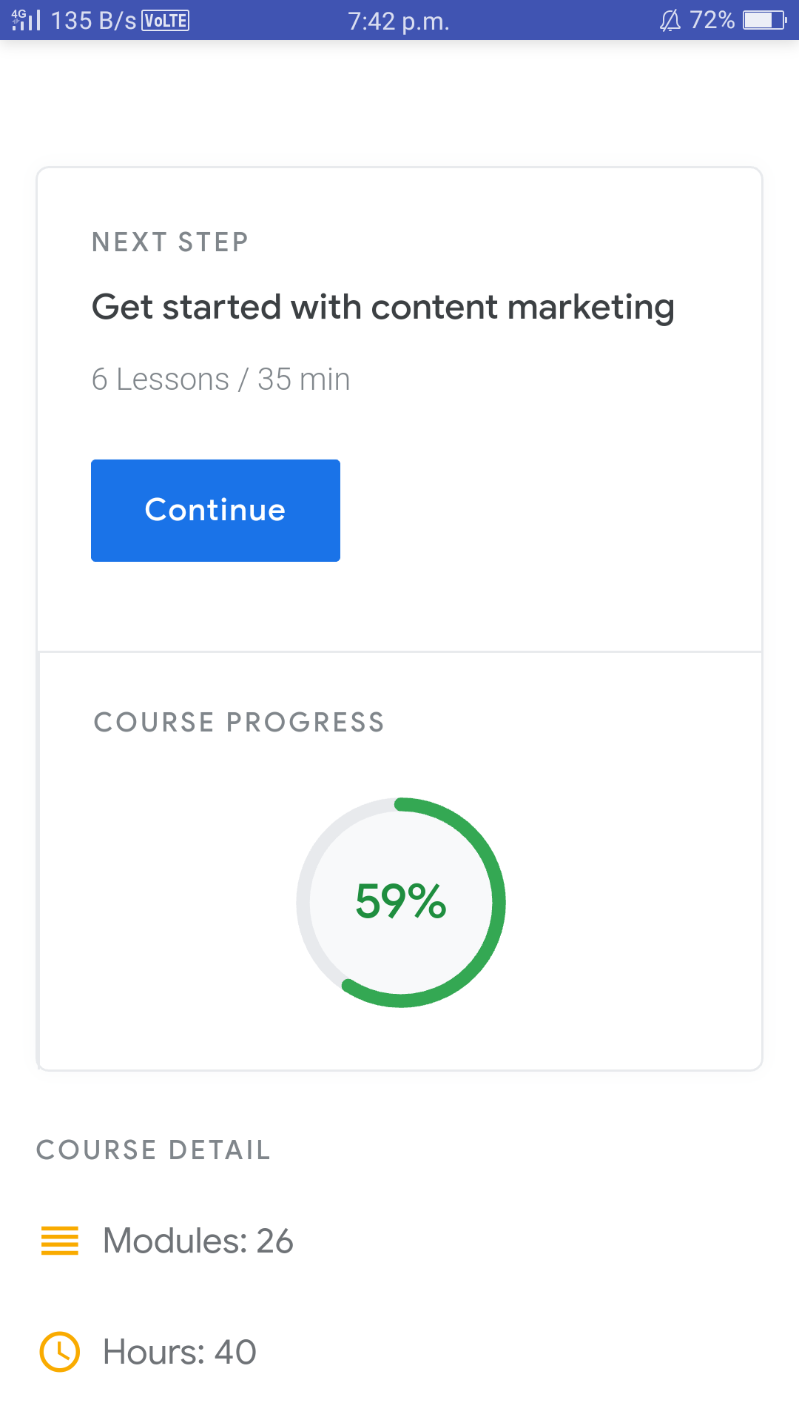

**Coding Challenges:**

Today I solved 1 coding challenge,

1. **Write a C++ Program to swap two numbers using friend as a bridge concept.**

