**DAILY ONLINE ACTIVITIES SUMMARY**

|  |  |  |  |  |  |  |  |
| --- | --- | --- | --- | --- | --- | --- | --- |
| **Date:** | **8/06/2020** | | | | **Name:** | **Amrutha G** | |
| **Sem & Sec** | **4th SEM ‘A’ Section** | | | | **USN:** | **4AL18CS006** | |
| **Online Test Summary** | | | | | | | |
| **Subject** | | **Complex Analysis,Probability and Statistical Methods(18MAT41)** | | | | | |
| **Max. Marks** | | **30** | | **Score** | | **20** | |
| **Certification Course Summary** | | | | | | | |
| **Course** | **FUNDAMENTAL OF DIGITAL MARKETING** | | | | | | |
| **Certificate Provider** | | | **Google garage** | **Duration** | | | **40 Hours** |
| **Coding Challenges** | | | | | | | |
| **Problem Statement:** Given a matrix, check whether it’s Magic Square or not. A Magic Square is a n x n matrix of distinct element from 1 to n2 where sum of any row, column or diagonal is always equal to same number. | | | | | | | |
| **Status: Completed** | | | | | | | |
| **Uploaded the report in Github** | | | | **Yes** | | | |
| **If yes Repository name** | | | | **https://github.com/AMRUTHAGANESH** | | | |
| **Uploaded the report in slack** | | | | **Yes** | | | |

ONLINE TEST DETAILS:

Today mathematics 4 test was conducted on module 2 and the test was for 40 min and 30 marks which contained 15 questions each of 2 marks.

And I have secured 20 marks out of 30.

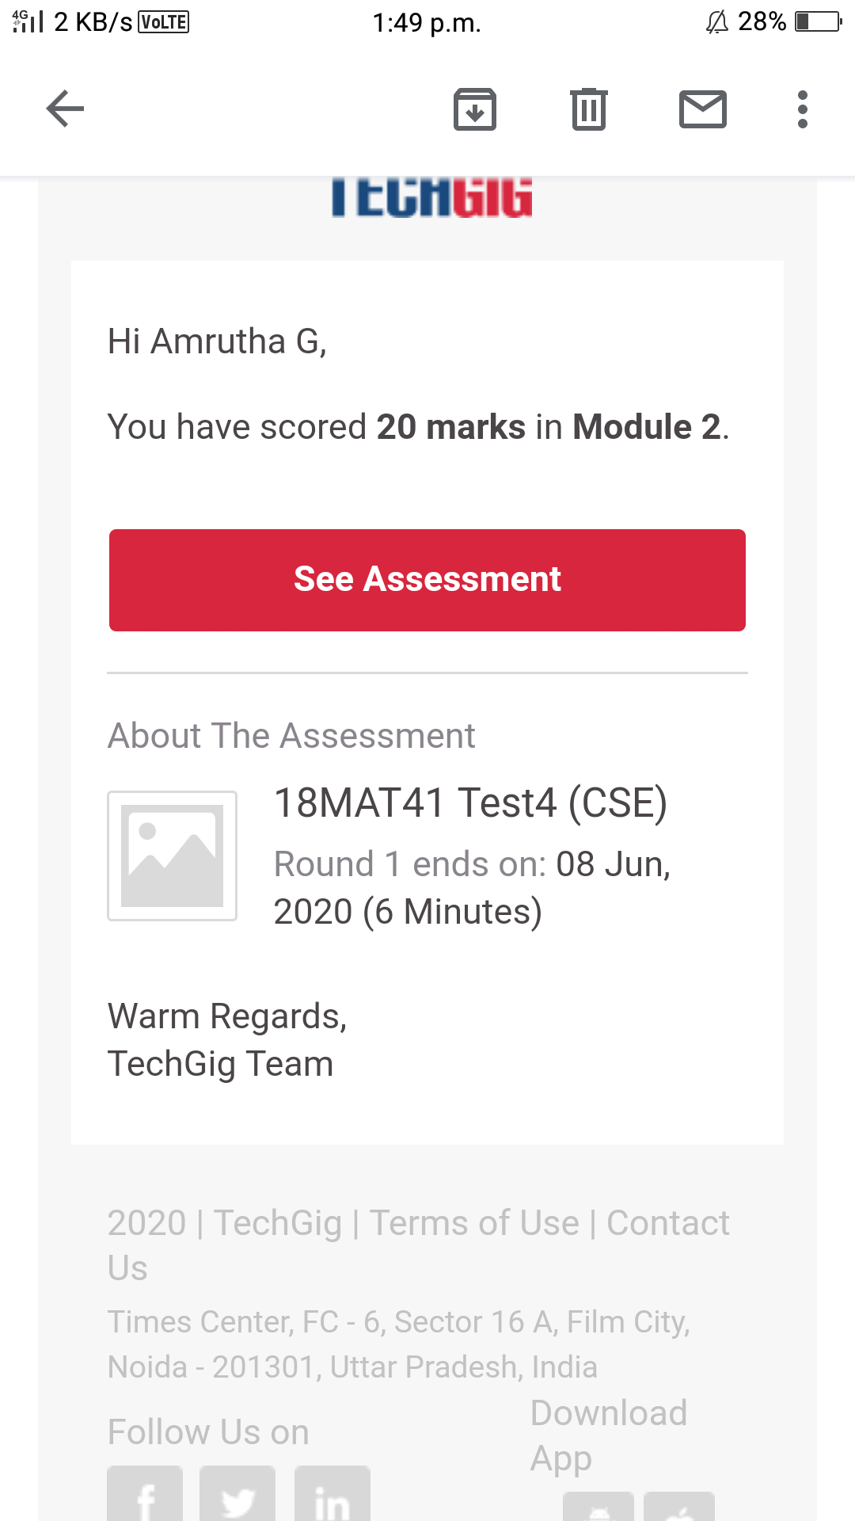

CERTIFICATION COURSE DETAILS:

Name of the course : fundamental of digital marketing

In today's session I go through 4 modules

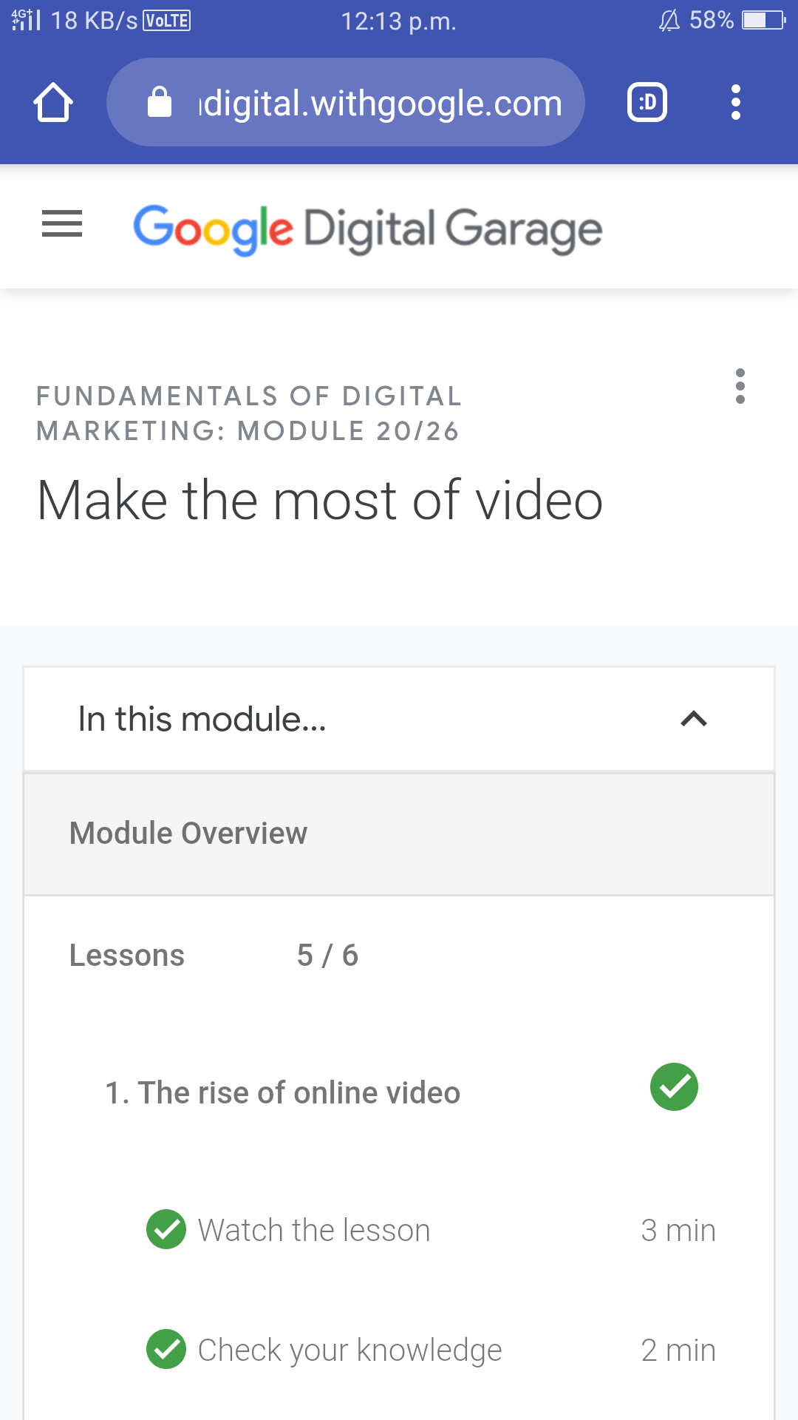

Snap shot

Today I also attended webinar meeting that was about 11 to 1 o clock

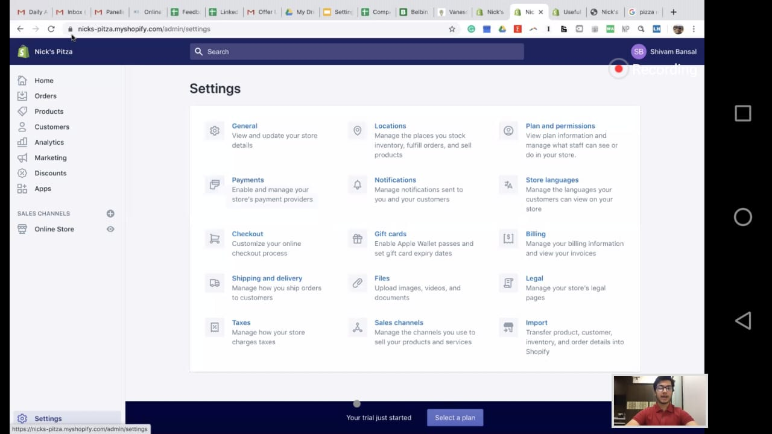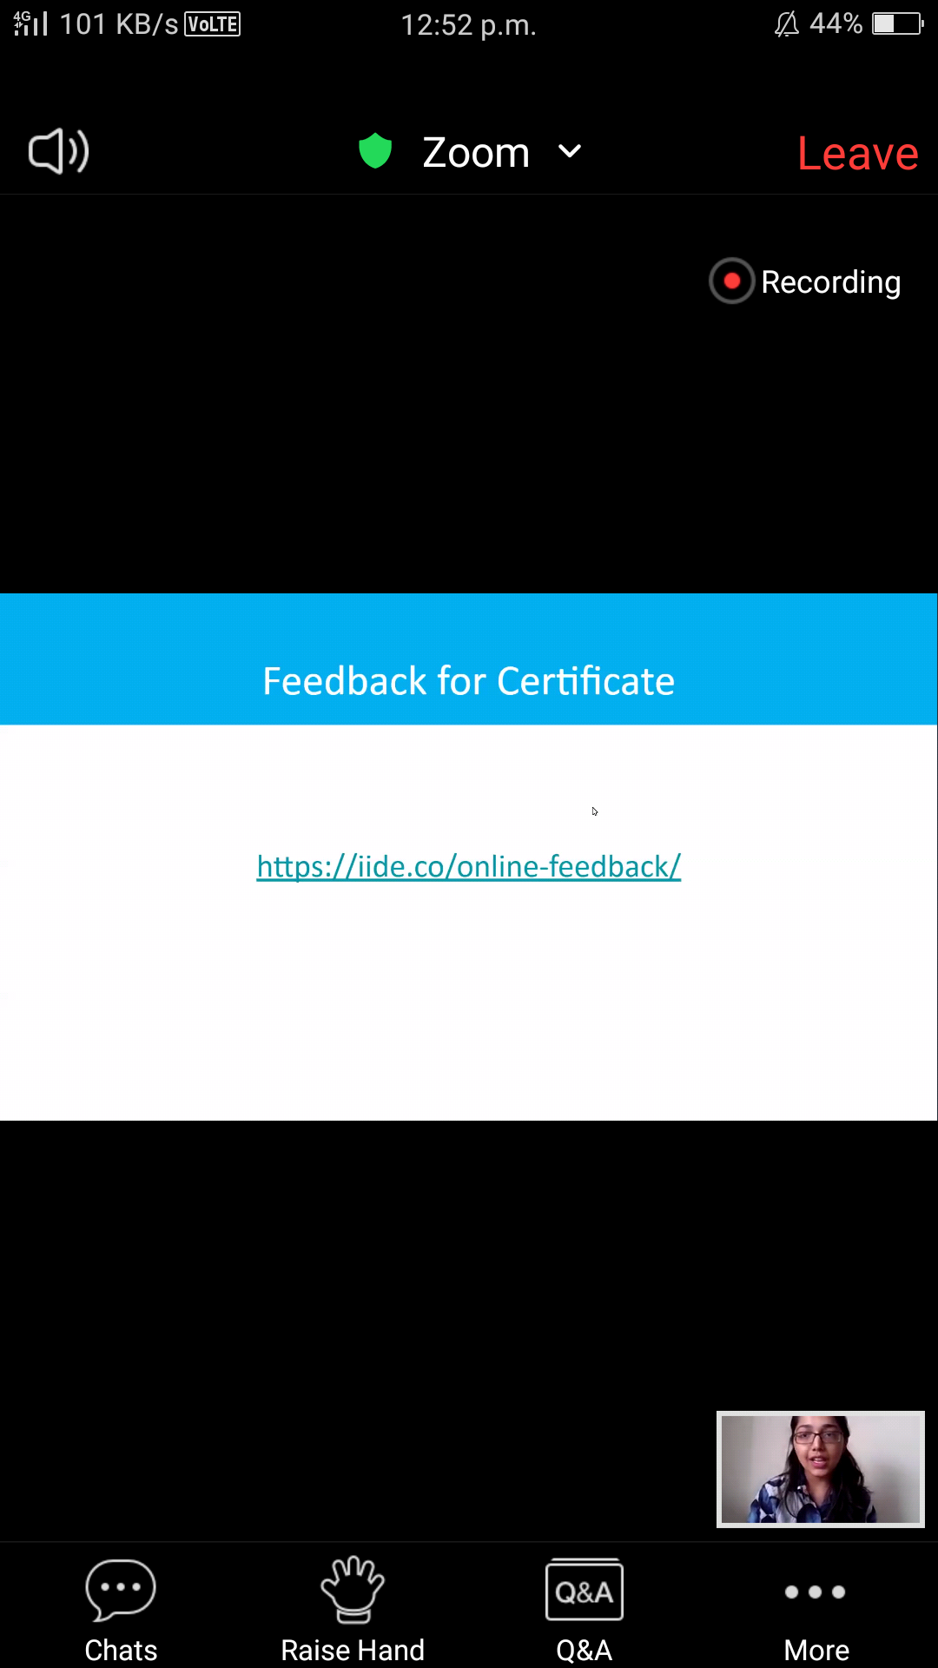

CODING CHALLENGES DETAILS:

Problem statement 1:

Given a matrix, check whether it’s Magic Square or not. A Magic Square is a n x n matrix of distinct element from 1 to n2 where sum of any row, column or diagonal is always equal to same number.

