KIWIHULOGIC
Reverse engineering report
version 1.1
G.J. van Loo, Jan 2009

Introduction.
This document describes the conversion process for the AMSAT schematics (for the QL8x12B-2PL68C) into the HDL language 'Verilog'. It provides a description of the logic. During this conversion decisions, observations, assumptions and optimisations have been made. Each of those is documented in here as well.

History
Date/Version | Comments
29/Dec./2009
Version 1.0 | Initial drop
Version 1.1 | Converted core code to Verilog 1995 format.
 | Removed unused signals.
 | Used Gray code in SPI control counter to be more sure of clean clocks.
 | Added `define to amsat.h which allows include of SPI clock divider.
 | Used different (faster) status bit for SPI busy.

General.
This is a top level description of the design. I had no idea what the logic is supposed to do or drive which is the best basis for a conversion as it prevents prejudice which can easily lead to conversion mistakes.

Files.
The input consist of 6 schematics in PDF format:
- edac8m.pdf
- kiwierr.pdf
- kiwihulogic.pdf
- shift8.pdf
- spi.pdf
- spiclk.pdf
These files have been converted into Verilog files with identical names:
- edac8m.v
- kiwierr.v
- kiwihulogic.v
- shift8.v
- spi.v
- spiclk.v
Three additional Verilog RTL files have been added:
- kiwihulogic_top.v
- spi_control_counter.v
- amsat.h
Besides these files there is on top level file which contains the testbench for the design:
- test_kiwihulogic_top.v
The following files have been used for stand alone development and debug of some blocks:
- test_kiwihulogic.v
- test_spi.v
The spiclk block was not found anywhere. It can now conditionally be included.
Hierarchy:
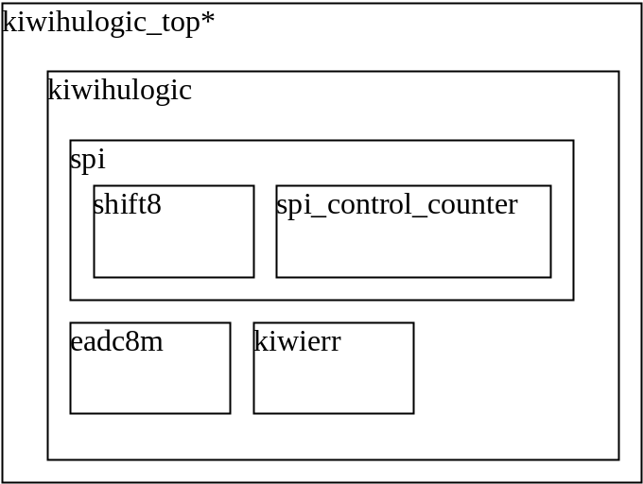

Currently kiwihulogic_top.v has behavioural (simulation) pads for I/O. Later these have to be replaced with real PADS from the Quicklogiv library.

Logic.
After analysis of the schematics I found that the logic consist of two major blocks and two minor blocks:
Major blocks:
- SPI interface
- ED/Error interface
Minor blocks:
- SCC control lines
- MUX output
The block works of an external active LOW reset. However all internal logic uses an active HIGH reset.

Address map.
The address map is based on the incoming address lines A0-A3. If these are externally connected to different address lines the address map should shifted accordingly.
Also the address offset from the nIOCS2 line should be added.

Address map:
Address | Selected Device | Read Data bus holds | Notes
0x0-0x3 | SCC | EDATA*
0x4 | EDATA error counter | EDATA error counter | Read Only.
0x5 | EDATA* | EDATA*
0x6 | MUX | - | Write D0,D1 only
0x7 | EDATA* | EDATA*
0x8 | SPI data | SPI data | See SPI descr.
0x9 | SPI Control 0 | SPI Control 0 | See SPI descr.
0xA | SPI Control 1 | SPI Control 1 | See SPI descr.
0xB | SPI data | SPI data | Read only.
0xC-0xF | EDATA* | EDATA*
*Default the EDATA bus is passed to the output driver pads. Thus every unused address lets the EDATA go to the output pads. But the output drivers are only enabled (data can be read) if ECS0 or ECS1 is low.
Any data arriving at the data pins D0..D7 is passed straight to all three ED busses. The data is driven onto the three external busses for every cycle where nRD is high.

Build defines.
At the moment there are two defines in the amsat.h file. These are:
- `define RTL_SIM
- `define WITH_SPI_CLK_DIV
RTL_SIM
This define is used to enable 'initial' statements in the code. These are required to get a clean simulation but produce synthesis warning messages. For synthesis it is best to remove this define.
WITH_SPI_CLK_DIV
This define pulls in the SPI clock divider module. I think this may be required as a SPI clock of 1.75 MHz (with a duty cycle of 25%) seems rather high to me. With the clock divider enabled the SPI interface is slower (~290 KHz) but the interface needs more careful programming.

SPI interface
Address map:
Address | Read | Write
0x8 | SPI data last received | SPI data. Also starts SPI transfer
0x9 | Bits 0-7 | Bits 5:2
0xA | * | Bits 1:0
0xB | SPI data* | <No action>*
*These accesses are probably not meant be used.

Description
The SPI interface consists of control logic, an 8-bit input shift register and an 8-bit output shift register.
The control logic is build from
- 3-clock start logic
- 6-bit counter
- a few stop registers.
The SPI operation is only started when a write is done to address 0x8 (See 3.3 Address map.)
The 3-clock cycles start registers make sure that the serial shift out register is loaded with the data arriving at the D0 pins.
After three cycles the 6-bit counter is started which controls the rest of the logic. It generates the external SPI clock and the internal spi clock (To the shift register).
After 32 cycles it is stopped.
Reading from address 8 will return the SPI data last received.

If the SPI clock divider is included the whole interface gets slower. One thing to be careful off is that it takes a few cycles for the SPI logic to be able to receive the next data. This means that after bit 6 of the control register is clear you have to wait 6 system clock cycles before a new value can be written to the data register. The SPI clock divider makes the interface run 24 times slower. With a system clock of about 7MHz the SPI interface then runs at about 292 KHz.
There is a define in the amsat.h file which determines if the SPI clock divider is included.

SPI Data register
The SPI block has two data registers at the same address.
Any write to address 0x8 will load the data written into the SPI transmit register and start a SPI sequence. The data written will be shifted out the MOSI pin one bits at a time.
At he same time data at one of the MISO pins (0..3) will be shifted into the data load register. When reading from this address the last eight data bits data shifted into the shift register can be read. No SPI transactions takes place.

SPI Control registers
The SPI block has two control registers. These are organised rather peculiar:
SPI control register 0 (At address 0x9)
The control register at address 9 is readable and writeable. But you can only write bits 2-5 whilst you can read bits 0-7. The bits read on the data lines D0 and D1 are the bits which are written to the SPI control register at address 0xA. Bit 6 is the 'SPI BUSY bit' and bit 7 is always read as 0.
Bit | R/W | Description
7 | R | 0
6 | R | 1 = SPI interface is busy.  0 = SPI interface not busy
5 | R/W | 1 = SPI input clock inverted  0 = SPI input clock normal
4 | R/W | 1 = SPI input clock inverted  0 = SPI input clock normal
3 | R/W | 1 = SPICSn[3] is low  0 = SPICSn[3] is high
2 | R/W | 1 = SPICSn[2] is low  0 = SPICSn[2] is high
1 | R** | 1 = SPICSn[1] is low  0 = SPICSn[1] is high
0 | R** | 1 = SPICSn[0] is low  0 = SPICSn[0] is high
**These bits can be written through SPI control register 1 at address 0xA.
SPI clock.
Normally the SPI clock line is low and is pulsed high for each SPI data bit. If bit 4 or 5 is set the clock is immediately inverted. Thus setting bit 4 or 5 will cause a rising clock edge. The same holds if bit 4 or 5 is cleared: It will cause an immediate falling clock edge. It is best practice to change these bits only when all SPICSn lines are high (All SPICSn control bits are cleared).
SPI control register 1 (At address 0xA)
The control register at address 0xA is only writeable and then only the data bits D0 and D1 are stored. These bits control the SPICSn[1:0] outputs.
Bit | R/W | Description
7 | - | <Unused>
6 | - | <Unused>
5 | - | <Unused>
4 | - | <Unused>
3 | - | <Unused>
2 | - | <Unused>
1 | W** | 1 = SPICSn[1] is low  0 = SPICSn[1] is high
0 | W** | 1 = SPICSn[0] is low  0 = SPICSn[0] is high
**These bits can be read through SPI control register 0 at address 0x9.

Control registers remark.
The control register setup in the SPI block does not make sense. We can write 6 bits but there are separate addresses for control reg bits 1:0 versus control bits 5:2. This would make sense if bits 1:0 have a different control function from the other bits.
However control registers bits 0,1,2 and 3 are the chip selects.
It would make more sense to have all the CS bits in register 0 and the clock control bits in register 1.

SPI Optimisation
The control register in the original diagram was marked as 'UCNTE8' and had 8 outputs. However outputs 6 and 7 where never used. Also the counter had an EN_n and CLR pin which where driven at the same time. This means that the enable function was not used. For these reasons the counter has been replaced with a 6-bit counter with no enable but only with a a-synchronous reset. This should free up 2 registers which can be used for other means.

SPI CLK Discrepancy
In the schematics there exists a page called 'SPICLK'. This page contains a clock divider with an input signal called CLK7 and an output clock named CLK409. However in none of the other pages is this block used.
In the top level digram the external pad providing CLK7 goes directly to the SPI block.

ED/Error interface
The ED interface consists of three parallel busses: ED0, ED1, ED2. Data arriving on the D bus is driven out on all three busses as long as nRD is high.
Any incoming data (nRD is low) is passed through error detection logic. This logic has two functions:
- It makes a majority decision for the three busses and passes the majority value on to the output bus. The majority decision is done on a per-bit basis.
- If any of a bus bits is different from the two other busses an 8-bit error counter is incremented. This error counter is only cleared on a system reset.

Miscellaneous logic
There are few small logic circuits.

MUX
There is a 2-bit register which can be written only. The two bits come out of the design as mux[0] and mux[1].
The register is written when a write to address 6 takes place. Only the LS two data bits (1 and 0) are used.
Bit | R/W | Description
7 | - | <Unused>
6 | - | <Unused>
5 | - | <Unused>
4 | - | <Unused>
3 | - | <Unused>
2 | - | <Unused>
1 | W** | MUX[1]
0 | W** | MUX[0]
**These bits can NOT be read.

SCC
There are three SCC outputs:
- nSCCCS
- nSCCRD
- NSCCWR

I have assumed the following functionality:
nSCCCS: Chip select SCC device (Active low) when IOCS2 is low and Ax<=3
nSCCRD: Read SCC device (Active low).
nSCCRD: Write SCC device (Active low).

The extra functionality is that both nSCCRD and nSCCRD are low when the nRESET signal is low.

Conversion process
This section descries the conversion process and assumptions which have been made during the schematic conversion. Some of these are based on general standards used for schematics. Others have been made after analysis of the logic.
Logic
Most logic has been converted one-to-one. So an OR gate with inverted input followed by an AND gate has been directly translated as : X = (A | ~B) & C.

Tri-state control of the pads.
During all my years of electronic engineering I have not found a consist way in which the tri-state control of pads has been clearly indicated in schematics.
Therefore the following logic reasoning has been used to determine the tri-state control pin of the output pads:
- The nRD signal is directly connected to the Tri-state control of the xE0D/xE1D/xE2D busses.
- nRD is LOW on a CPU read when data flows from ED to D.
- On a read the ED output pads must be tri-stated.
- Thus the pads are TRI-stated if nRD is LOW.
- Hence the Tri-state control of the pads is active LOW.

Registers
Most registers have 5 inputs:
- Clock
- D
- EN
- CLR
- PRE.
The following behaviour has been assumed during the schematics conversion.
- D is clocked in on the rising edge of the CLK pin.
- The Enable is active high.
- The CLR and PRE are active high and work a-synchronous.

Some register have no reset. This causes problems during HDL simulation as default the register is assume to contain the value 'X'. I assume a power-up state of 0. To get this behaviour those register have an 'initial' statement. This code should be removed during synthesis so it is placed inside `ifdef RTL-SIM...`endif text. This RTL_SIM variable is define in a header file called "amsat.h".

Observations
During simulations some external stimulation conditions had to be created to extract the expected behaviour

The nWr signal must go low after SPICS (derived from nIOCS2) has gone high.
Otherwise the control registers in the SPI block don't work!

The nRd signal must go high before the nECS0/1 signals go high.
Otherwise the error counter will not increment!

Error(s)
Whilst converting the design several discrepancies and errors or potential errors have been found. In this chapter I highlight each issue. Some errors where obvious whilst other came to light when I tried to stimulate the design and did not get the expected behaviour. It may well be that some of the errors do not exists but are caused by me using the wrong assumptions. e.g. I assume a signal called nXXX to be active low. Where the code did not behave as expected I have checked if different assumptions would make it work but have not found any situation where that was the case.

ExD error counter.
I am pretty sure that there is an error in the logic controlling the ED error counter.
(Schematic of KIWHULOGIC.PDF).
I have not been able to find any combination of signals to the ECS0, ECS1, nRD and ExD which produced a satisfactory, working error counter.
The following is the existing control for the error counter:
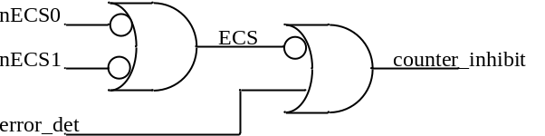

The logic above results it the following truth table:
error_det | nECS0 | nECS1 | counter_inhibit
0 | 0 | 0 | 0
0 | 0 | 1 | 0
0 | 1 | 0 | 0
0 | 1 | 1 | 1
1 | 0 | 0 | 1
1 | 0 | 1 | 1
1 | 1 | 0 | 1
1 | 1 | 1 | 1
I assume
- The ECS0/1 are active low.
These then generate ECS (Active high if either nECS0 or nECS1 is low).
- The counter is supposed to increment on each error.
(Thus the counter_inhibit should be LOW on an error)
To me the truth table above and the expected/required functionality do not match. Also if I assume that the names of the ECS pins are wrong and that the nECS pins should both be HIGH to enable the logic I still do not get the correct functionality. I can NOT change the polarity of the 'error_det' signal as that is generated by existing code. (Which seem to work correct).
New logic
I assume that we want the counter to increment if either nECS0 or nECS1 is low and at the same time an error has been detected. So for now I have implemented the following truth table:
error_det | nECS0 | nECS1 | counter_inhibit
0 | 0 | 0 | 1
0 | 0 | 1 | 1
0 | 1 | 0 | 1
0 | 1 | 1 | 1
1 | 0 | 0 | 0
1 | 0 | 1 | 0
1 | 1 | 0 | 0
1 | 1 | 1 | 1

Error counter increment
I could not get the error counter to function without using a simulation 'trick'. This is more a simulation error then a real design error. In general this points to a weak pat of the design.

D Tri-state control
The following is the tri-state control logic as found in KIWIHULOGIC:

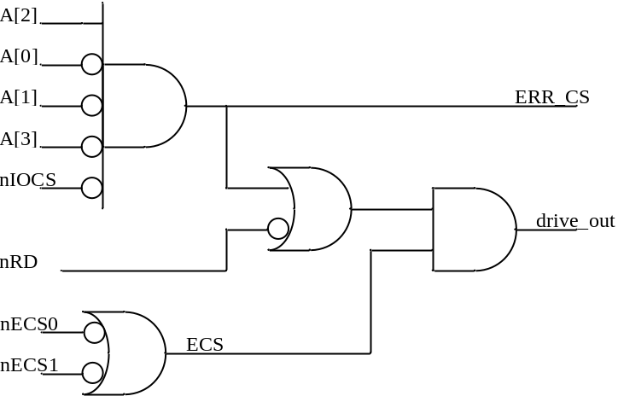
Again I have generated a truth table from that logic. In order to keep the table size limited I use three inputs: ERR_CS, ECS and nRD. The ERR_CS signal is high if the address is 0x4 (0100) and nIOCS is active low. The ECS is high if either ECS0 or ECS1 is low. The tri-state control make that the pads drive out if it is high. So I have named that signal drive_out.
# | nRD | ERR_CS | ECS | drive_out
0 | 0 | 0 | 0 | 0
1 | 0 | 0 | 1 | 1
2 | 0 | 1 | 0 | 0
3 | 0 | 1 | 1 | 1
4 | 1 | 0 | 0 | 0
5 | 1 | 0 | 1 | 0
6 | 1 | 1 | 0 | 0
7 | 1 | 1 | 1 | 1

Note that the D port is used to output data if we read any internal register or if data is read from the three ExD ports.
It is a fact that the pads should be driving only on a READ (nRD=0).
From the diagram we see already that this is NOT the case: # 7 has drive_out=1, despite that the nRD is high!
Also there is no logic which takes into account if we read any of the other registers (e.g. the SPI registers). As such I have to come to the conclusion that the logic is wrong.

New logic
I assume that we want to drive the bus if we read from either an internal register in the FPGA (nIOCS is low) or if we read from the ExD bus. In all other cases we should NOT drive the bus.
I have therefore implemented the following code:
assign Drive_D = ~nRD & (~nIOCS|ERR_ECS);
With this code the simulation passed all tests.

MISO potential error.
I found a potential error in the top level digram: KIWIHULOGIC.
The error is in the input mux of the MSIO data. This is the diagram:
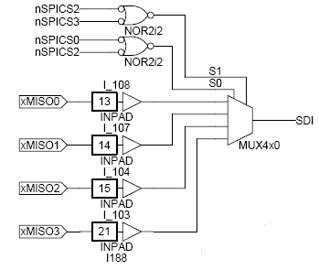
We can not see from this diagram how the four MISO signals are connected to the 4-input multiplexor. The diagram suggest that they are connected as MISO0..MISO3 to resp. mux input 0..3. This does not correspond to the nSPICS[0..3] decoding.

The two select inputs of the MUX are build from the nSPICS signals. I assume only one of those is low at any time. The selects are generated using NOR gates with inverted inputs (Which is effectively an AND gate). Below you can find the truth table of the logic gate and of the resulting select lines.
A | B | O |  | CS20 | S0 | CS23 | S1
0 | 0 | 0 |  | 00 | - | 00 | -
0 | 1 | 0 |  | 01 | 0 | 01 | 0
1 | 0 | 0 |  | 10 | 0 | 10 | 0
1 | 1 | 1 |  | 11 | 1 | 11 | 1
The definitive truth table for the Select lines is then:
CS[3:0] | S[1:0]
1111 | 11
1110 | 10
1101 | 11
1011 | 00
0111 | 01
Which as you can see does not select the inputs 0-3 in the correct order.
In the Verilog code (kiwihulogic.v) the MISO input corresponding with the nSPICS is selected using the following code:
always @(MISO or spi_sel)
begin
case (spi_sel)
2'b10 : sdi = MISO[0];
2'b11 : sdi = MISO[1];
2'b00 : sdi = MISO[2];
2'b01 : sdi = MISO[3];
endcase
end
There is a small chance that the code was indeed implemented wrongly and that the error was compensated by swapping the MISO inputs (e.g. on the Printed Circuit Board) . If so the code above has to be replaced using the following code:
always @(MISO or spi_sel)
begin
case (spi_sel)
2'b00 : sdi = MISO[0];
2'b01 : sdi = MISO[1];
2'b10 : sdi = MISO[2];
2'b11 : sdi = MISO[3];
endcase
end

Clock potential errors.
In several places in the design is a part of the logic clocked from a 'generated' clock. That is a clock which is generated from other logic. If a clock is driven directly from the Q of a Flip-Flop this is safe. But if more logic is involved is there a serious hazard of generating clock spikes. For details about this see appendix 1: Generated clocks.
For now I assume that the clocks will work as I am told the design has already been used and was supposed to work. I have some doubts about the correctness of this statements as I have found some obvious errors in the design.

'Spiking' logic.
In the SPI design there is some dubious logic: The control counter is indirectly resetting itself. As soon as the counter value 32 is reached (CNT[5] goes high) an external FF is triggered which then resets the counter. The CNT[5] signal is delayed by:
- A clock to Q delay of a FF (I7).
- An Or-gate
- The CLR to Q delay of a FF (I8)
- A second OR-gate.
- The CLR to Q delay of the counters
All of this determines the width of the clock pulse going into I7. This is probably sufficient to make the circuit safe, but it is not the normal way to design logic circuits. Gate level annotated simulations should show if this works.

Next steps.
The following is a list of steps which have to be taken to get to final working electronics:

Environment modelling
I have written Verilog code which drives the design. I have guessed what the driving signals will look like. Before we can go any further I need to have a much better idea what the external environment is of the design.
I will need to generate as accurate as possible the real signals coming into the device. I have to make sure we can work with the set-up and hold times we are presented with.
I also need to write model for external logic receiving our signals. I have to make sure our signals meet the external requirements with respect to set-up and hold times.

Synthesis.
The Verilog code has to be synthesized. For this a synthesis tools is required. I have extensive experience with the Synplicity tool and I have access to such a tool but we need to have a Quicklogic synthesis library for Synplify for the QL8x12B-2PL68C part in order to use it.

Place & Route.
After synthesis we need to place the logic and connect it up. This is done by a Place & Route tools. Such a tool has to come from Quicklogic. Part of P&R is that we have to specify the external timing constraints. I have no idea what we are connecting to, let alone what the timing requirements are of the surrounding logic.

Timing check.
The next step is to re-simulate the design but then with exact timing information. This requires to following steps:
- Timing extraction
- Logic extraction
- Timing back annotation generation (SDF)

Normally all these steps are done by tools provided by the logic manufacturer, in our case Quicklogic. The design is the simulated again but now we get the exact behaviour as the real electronics will have. This we can use to detect timing issues in the design (e.g. do the generated clock show up spikes or not).

Timing check is important as we can not re-program the devices. As we also have a limited number of them we must be sure that we have the expected behaviour.

Programming.
In order to program the devices we need an FPGA programmer and a programming file. The programming file again has to be generated by a Quicklogic tool. For the programmer we also will need the drivers to communicate with it.

Verification.
The last step will be the verification of the electronics. I assume there is a plan for that already.

Appendix A: Generated clocks.
I know not everybody working on this project has electronics experience so here I explain what the risks are with the clock generating logic found in the design.

In two places the output of a 2-bit counter is used to generate a clock. The logic involved looks like this:

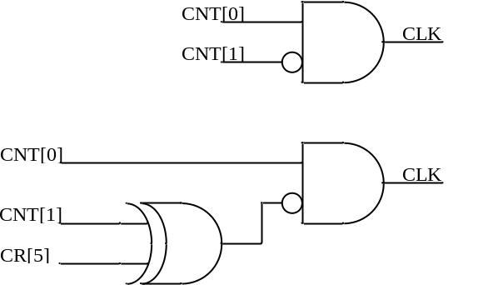

The top circuit is already suspicious but the bottom one even more.
The error lays in the fact that most people think of a 2-bit counter as going through the standard binary sequence: 00, 01, 10, 11, 00, 01, etc.
Looking at macro scale this is correct. However at micro scale this is not the case. Each of the two bits is generated independent and there will be tiny differences when the two bits change. These differences are often very small (a few pico seconds apart) but the are present.

If we take the top circuit the logic diagram is this:
CNT[1:0] | CLK
00 | 0
01 | 1
10 | 0
11 | 0
The problem is where the counters goes from 11 back to 00. Each bit can go independent of the other so it is possible that bit 1 goes to zero just a bit faster the bit zero. We then get the following sequence: 11 => 10 => 00. The intermediate state is 01 so it could produce a CLK which is high. The following diagram show this behaviour, where the delay has been exaggerated:
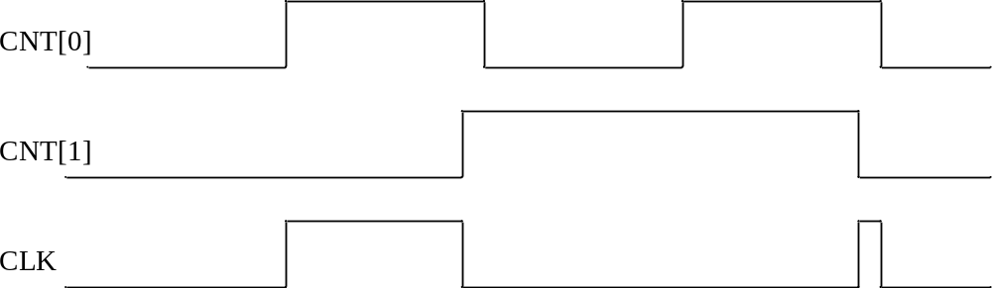
In this case the pulse is likely to be so short that it does trigger a FF. It is also for this reason that the bottom two bits of the control counter in the SPI block are generated using a synchronous counter whilst the other bits are a-synchronous.
In the second digram the two bits take a different path. Bit CNT[0] has an extra delay of 1 gate whilst CNT[1] has a delay of two gates. Thus will widen an existing clock spike or may generate one. I don't know how these two gates will be implemented inside the Quicklogic device. It is possible that (Like with Xilinx devices) both gates will be amalgamate into one piece of logic. In which case it will not amplify or generate spikes.

Preventing spikes:
There is a better solution. This has NOT been implemented but can be done if we find that we have enough spare logic: Make the bottom two bits Gray coded:
00, 01, 11, 10. This is the Verilog code:

// LS 2 synchronous bits Gray coded
always @(posedge clk or posedge clr)
if (clr)
q <= 2'b00;
else
case (q)
2'b00 : q <= 2'b01;
2'b01 : q <= 2'b11;
2'b11 : q <= 2'b10;
2'b10 : q <= 2'b00;
endcase
Only one bit is changing at any time so spikes can NOT occur.

