Particle swarm method for optimization

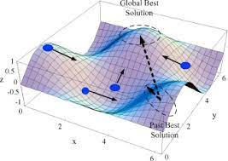


From Wikipedia: particle swarm optimization (PSO)[1] is a computational method that optimizes a problem by iteratively trying to improve a candidate solution with regard to a given measure of quality. It solves a problem by having a population of candidate solutions, here dubbed particles, and moving these particles around in the search-space according to simple mathematical formula over the particle's position and velocity. Each particle's movement is influenced by its local best known position, but is also guided toward the best known positions in the search-space, which are updated as better positions are found by other particles. This is expected to move the swarm toward the best solutions.

In practice, the search of a global solution of the optimization problem

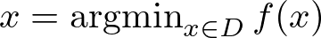
where D is a subset of , is carried out by letting a set of particle explore the state space in a way that mimics a flock of birds or a swarm of flies. From this analogy you have the origin of the name.

It is one of a class of global, derivative free optimization algorithm akin to be parallelised. It is used in several engineering and machine learning applications.

What you have to do

- Read the bibliography and start by writing a simple scalar code that implements one of the variants of the methods.
- Test it on a set of hard minimization problems that you may find on the web (we wil give some indication)
- Make a parallel version using openMP or MPI.

Bibliography

- A survey on particle swarm optimization with emphasis on engineering and network applications, Mohammed Elbes, Shadi Alzubi, Tarek Kanan, Ala Al-Fuqaha, Bilal Hawashin
- A Survey on Parallel Particle Swarm Optimization Algorithms Soniya Lalwani, Harish Sharma, Suresh Chandra Satapathy, Kusum Deep, Jagdish Chand Bansal
- Particle Swarm Optimization Algorithm and Its Applications:A Systematic Review,Ahmed G. Gad

