*April 10, 2018*

**Project Methodology**

Course Assignment: Project planning, process documenting and collaboration

Contents

INTRODUCTION 3

INTERPRETATION OF THE TASK 3

RESEARCH AND ANALYSIS 4

INSPIRATION 4

ANALYSIS 5

SKETCHES – SCANNED IDEA DEVELOPMENT AND DIGITAL SKETCHES 5

WORK PROCESS 6

STYLE/GENRE 6

TYPOGRAPHY 6

COLOURS 6

COMPOSITION, LAYOUT, GRID AND OTHER ELEMENTS 6

SUMMARY AND EVALUATION 7

SOURCES AND REFERENCES 8

# INTRODUCTION

This document describes my work process for the course assignment in Project Methodolgy course in Front-end development at Noroff. The report goes into detail about my work process and design choices for creating a Gantt Chart.

## INTERPRETATION OF THE TASK

In this week’s assignment we are planning a project for a product company named ‘Lofthus Frukt og Saft’ selling natural juices. They have a logo and simple brand identity. The company does not have an online presence from before, and we are building brand and product identity.

Our main task:

* Defining the project, setting up tasks and activities
* Defining scope of the project
* Defining magnitude of each task, and delegate responsibility
* Setting up meetings and presentations
* Structure this information in a Gantt chart for visual representation

The team project manager must design and implement and online project environment where each of the projects participants have easy access to files and project materials. Using GIT and GitHub for file and Project task delegation. A project report including a Gantt Chart must be made before presenting the project to the client. Slack is a great tool for team communication, and Google Disk can be integrated with the solution so that the team can share files and documents.

The Gantt Chart should be made so that the team can complete the project on schedule. After the initial meeting with the client presenting the information we have made this week, we can start with the actual project.

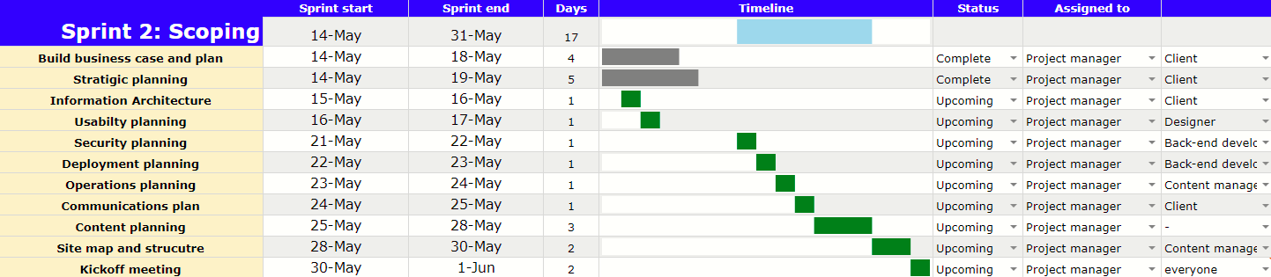

*Image 1: Image showing my Gantt Chart*

# RESEARCH AND ANALYSIS

## INSPIRATION

For this week’s assignment I have researched about project management and watched videos about how to create Gantt Charts. Here some examples of Gantt charts I found inspiration from:

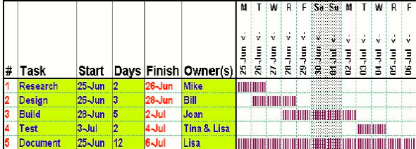

(Indigenous leadership Development Institiute, 2018)

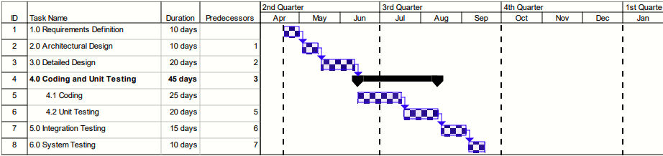

(oe.ocdavis.edu, 2018)

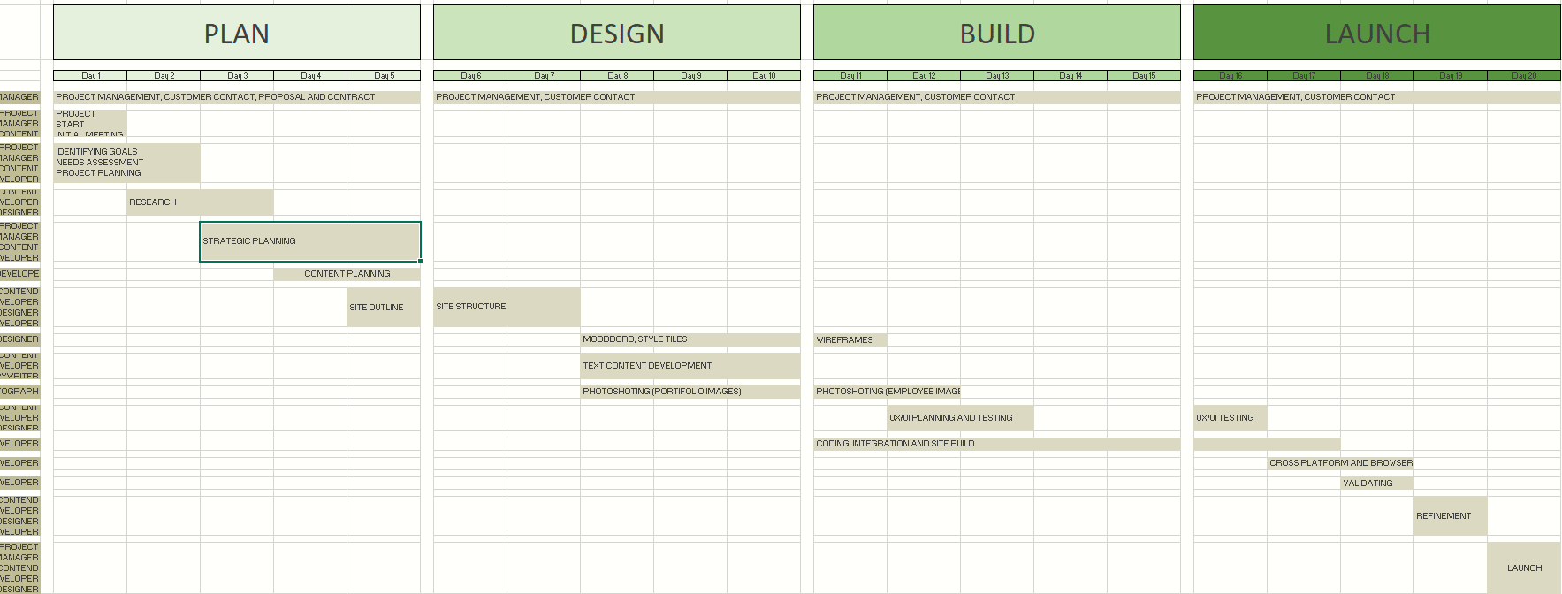

(Noroff, 2018)

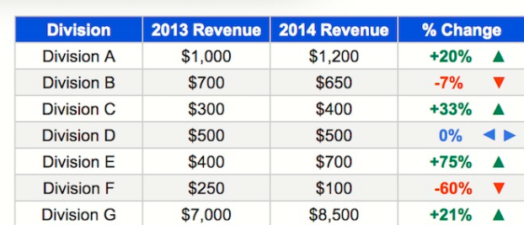

(benlcollins.com, 2018)

## ANALYSIS

I choice to implement a Gantt Chart that with Task Delegation, to make it easier to use during the project. I also choice to use Google Charts to make the chart for easy online sharing with my team. I found a blog post by Trevor Fox showing how to implement timelines using the Sparkline function in Google Docs. (Fox, 2017)

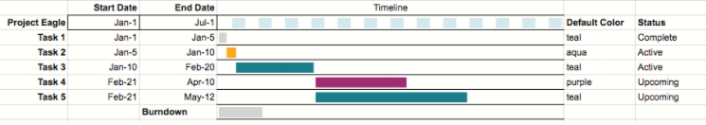

*Image 2: Fox, 2017*

I liked the implementation and choose to use it in my chart. Making it easy for my teammates to use the chart and delegate and edit the tasks

## SKETCHES – SCANNED IDEA DEVELOPMENT AND DIGITAL SKETCHES

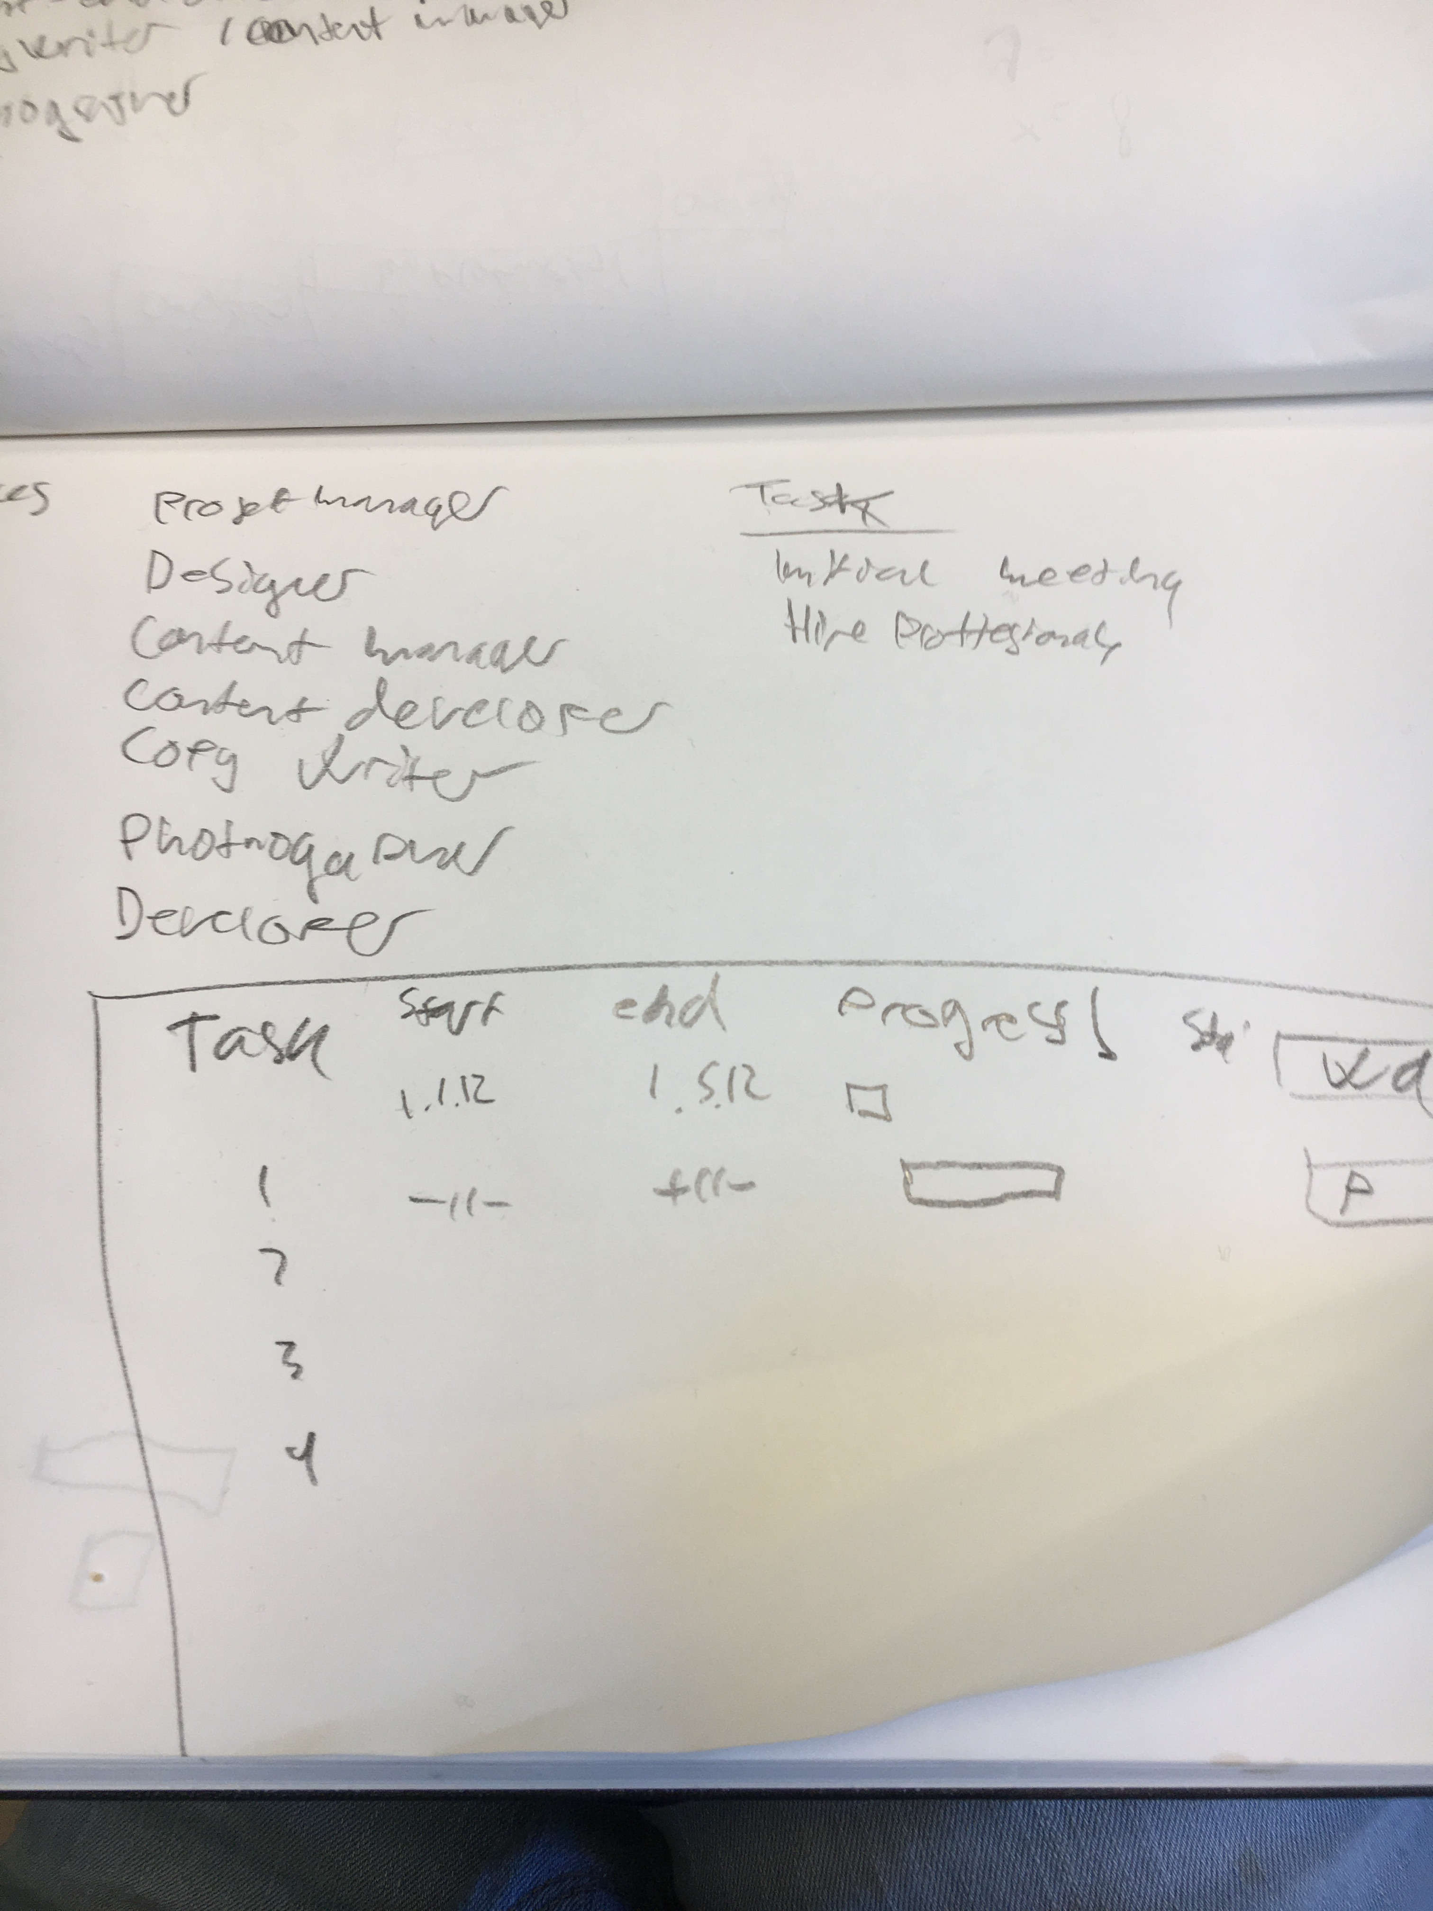For this project I did more notes than sketching, but a simple sketch showing layout of the Gantt Chart.

*Image 3: Gantt chart layout*

# WORK PROCESS

In this week’s assignment I first watched and read the course material. The videos on Lynda did give a good idea on project management in general, but not for web-development projects. I had to read and watch to learn more about how to manage web-development projects.

## STYLE/GENRE

I searched for guides on styling excel sheets and found this guide by Ben Colins. (benlcollins.com, 2018) I found a lot of inspiration from this post on how to make google sheets more readable. Like how to format data, alternating colors on rows, table boarders, and removing grid lines.

## TYPOGRAPHY

Veranda was used for both body and headers in the google sheet. Veranda is a default font in google sheets.

## COLOURS

Blue was used as a main color for this sheet. There is alternating grey shades between the columns to make it more readable. I used different colors on the timeline to change between the different status of tasks.

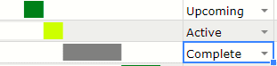

Image 4: Different color states for status of task

For later development of the chart, I could implement a formel to show overlapping better than its showing right now. A color overlay could be used for to show this

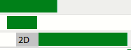

*Image 5: Showing possible implementation to show overlap better*

## COMPOSITION, LAYOUT, GRID AND OTHER ELEMENTS

The spreadsheet was separated in 5 separate sheets for each of the sprints, including two additional extra sheets to present other data from the project.

## Project planning

The project was planned as a 4-month project with 3 development sprints. Agile and scrum will be using during development. Communication is one of the most important parts during a project. Therefore, a daily standup using scrum will be held each day for the development team. Internal weekly meetings are held as quick check-in meetings for updates and next work-steps. Client status meetings are held when the project groups are near deadlines, project manager has regular contact with the client.

## Open-source

The project will only use open source software and code during the project and develop code and take photos and images their self. Open source project management software like GitHub, Google Docs, Trello will be used for project and file management.   
During development the project will use open source frameworks and content management systems. We must have creative control over the design and technology used on the site, for practical and security reasons.

## Intellectual property

The website, files, and content will be handed over to the client when the project is complete. The client will have all rights to the site source code

## Licensing

The project team must write work-for-hire contracts, which means the person who are paying work the work (The client) is the owner for all work created during the project and not the creators. (contenly.net, 2018)

# SUMMARY AND EVALUATION

Defining the scope of the project was the hardest part. This is a complex project that needs a back-end system to handle product sales, user registration, data, content management, ticket-system, newsletters etc. I had to make some assumptions on budget and time scale, quality and resources.

This project-plan is assuming we are building a full-scale ecommerce system from scratch, without using pre-built systems like shoppify etc. The project can be reduced in time by hiring more developers. Another Back-end developer or CMS Developer might be needed for a project of this scale.

Stage-gate was used for project planning. Stage-gate is a project management system most often used for product development scenarios but could be used in web-development projects as well. It is also an ideal choice for an e-commerce business like this. By including Agile with stage-gate you get an Agile/Stage-Gate hybrid process. (Sommer, Hedegaard, Dukovska-Popovska, & Steger-Jensen, 2015)

Using sprints in development is also a consideration. We could argue that we only have 3 sprints during the test and development parts of the project. The stage-gate process is consisting of these phases:

1. Idea and discovery
2. Scoping
3. Build business case
4. Development
5. Testing and validation
6. Launch

A budget plan was also made to get a larger picture of what a project of this size might cost. Payscale.com to calculate the wages. (Payscale.com, 2018)

Keep in mind I only have calculated salary costs, and the project could cost upwards to 350.000$ (Jordan, 2018).

# SOURCES AND REFERENCES

*benlcollins.com.* (2018). Retrieved from Format your Google Sheets so they look good GREAT: https://www.benlcollins.com/spreadsheets/formatting/

*contenly.net*. (2018). Retrieved from https://contently.net/2013/07/09/find-work/work-made-for-hire-what-it-really-means/

Fox, T. (2017, January 24). *https://trevorfox.com/.* Retrieved from https://trevorfox.com/2017/01/google-spreadsheets-gantt-charts/

*Indigenous leadership Development Institiute.* (2018). Retrieved from edo.ca: http://www.edo.ca/downloads/project-management.pdf

Jordan, J. (2018, April 9). *atlanticbt.com*. Retrieved from https://www.atlanticbt.com: https://www.atlanticbt.com/blog/how-much-does-ecommerce-website-cost/

Noroff, C. S. (2018). Gantt_Chart_Workflow_Case.xlsx.

*oe.ocdavis.edu.* (2018). Retrieved from http://oe.ucdavis.edu/local_resources/docs/projectmanagementtraining.pdf

*Payscale.com.* (2018). Retrieved from https://www.payscale.com/

Sommer, A. F., Hedegaard, C., Dukovska-Popovska, I., & Steger-Jensen, K. (2015). Improved Product Development Performance through Agile/Stage-Gate Hybrids: The Next-Generation Stage-Gate Process? *Research-technology Management, 58*(1), 34-45. Retrieved 4 10, 2018, from http://tandfonline.com/doi/abs/10.5437/08956308x5801236