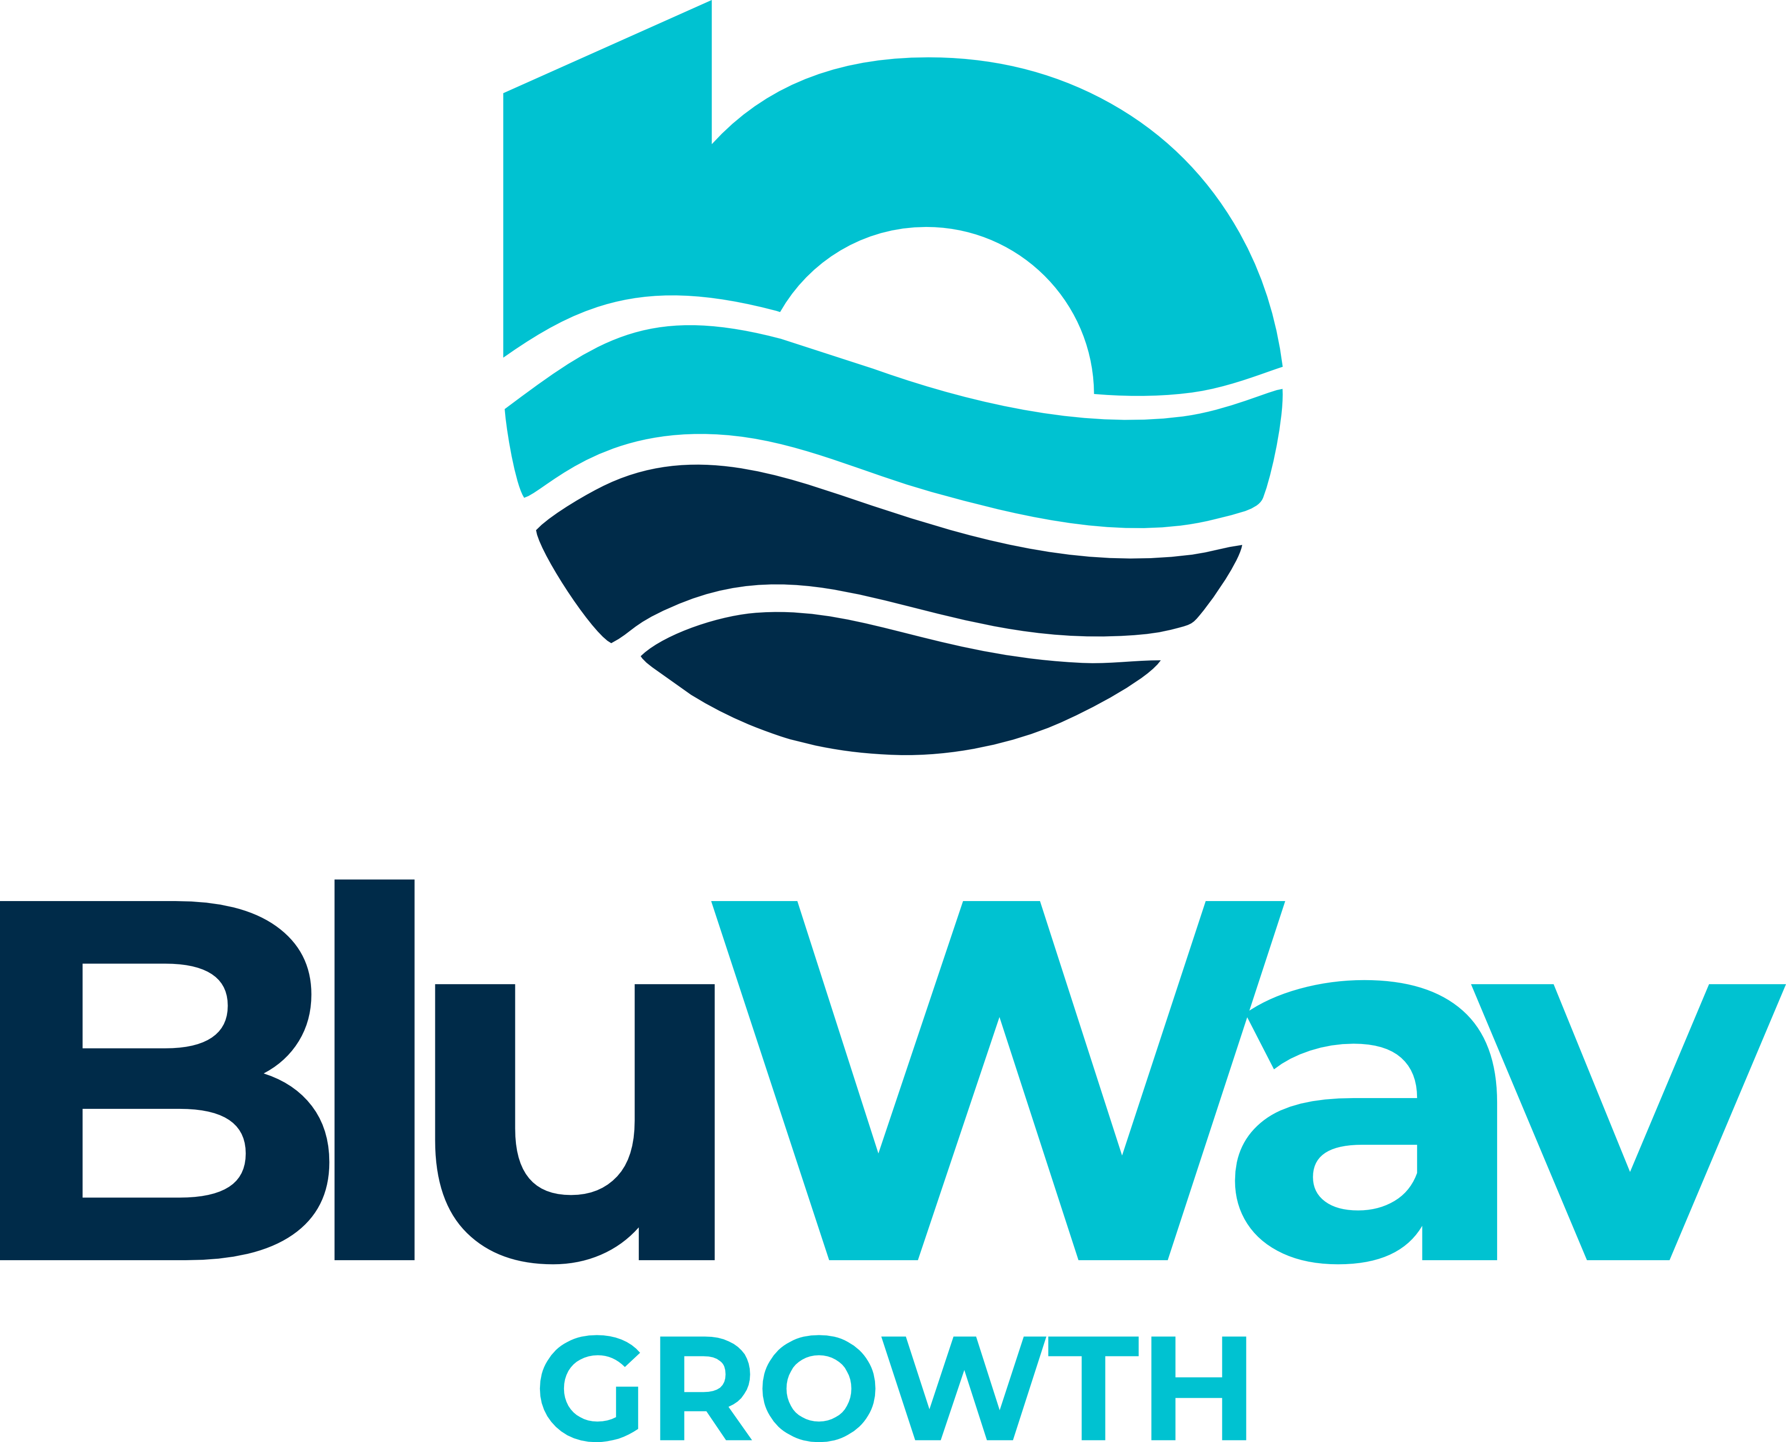

BluWav Growth
S A L E S S C R I P T

Free Health Check Lead · Updated July 2026
Confidential — Agent Use Only
Get Found. Get Chosen. Grow.

What's New in This Version
Updated to reflect BluWav Growth's current global positioning: tagline “Get Found. Get Chosen. Grow.”, three Growth Systems (Ripple / Current / Surge), five CRM tiers (Starter / Lite / Premium / Enterprise / White-Label), 14-day free CRM trial included in every plan, Health Check results delivered within 24 hours, global audience focus (no Caribbean-specific language), and updated objection responses throughout.

How to Use This Script
This is a guide, not a word-for-word read. Internalise the flow, adapt the language to your natural voice, and let the conversation breathe.
- Bold navy = Agent speaking
- Italics = prospect response
- Coaching notes appear indented in teal
- The Free Health Check is a short online form — no meeting or scheduling required
- You can fill it out on the prospect’s behalf during the call, or send them the link to complete themselves

Table of Contents
1. Pre-Call Preparation
2. Opening — The Free Health Check Hook
3. Discovery Questions
4. Presenting BluWav Growth Systems
5. Objection Handling
6. Closing Techniques
7. Follow-Up Language
8. Voicemail Script
9. Quick Reference — At-a-Glance Call Flow

1. Pre-Call Preparation
Before dialling, spend 2–3 minutes on the following so the conversation feels personal and informed.

Know Your Prospect
- Business name, industry, and approximate size
- Are they showing up on Google Search and Google Maps? (Quick search to check)
- Do they have a website? Is it mobile-friendly and professional?
- Are they on WhatsApp Business? Do they have a Google Business Profile?
- Pain points common to their sector — who are their likely competitors?

Set Your Mindset
- You are calling to give something away — a Free Digital Health Check. Lead with generosity.
- Your goal for this call: secure the Health Check, not close a sale.
- The Health Check shows them exactly why customers are choosing their competitor right now — that is the hook.
- Smile before you dial — it carries through in your voice.

Free Health Check — What It Is
A no-cost, no-obligation form that gives BluWav a snapshot of the prospect’s online presence. The client can fill it out themselves online, or you can fill it out on their behalf during the call. No meeting, no scheduling, no commitment. Once submitted, BluWav analyses the results and shows them exactly what’s missing and what it’s costing them. Results delivered within 24 hours. Zero pressure. Pure value.

BluWav Growth Systems — Know These
- RIPPLE ($1,800+): Website + Google Business Profile + CRM trial + smart automation. Gets them found and looking professional. Delivered in 48–72 hours.
- CURRENT ($3,000+): Everything in Ripple + WhatsApp Business setup, advanced lead sequences, local SEO + competitor analysis, reputation builder, automated lead pipeline, conversion landing page, monthly check-in call.
- SURGE ($5,000+): Full system with Google Ads, multi-search engine listing, full WhatsApp sales funnel, monthly visibility reports, quarterly strategy reviews, dedicated account manager.

Every plan includes a 14-day free CRM trial — so even Ripple clients experience the full automation from day one.

CRM Plans — Know the Tiers
- CRM Starter: $59/mo + $99 onboarding. 25 contacts, lead tracking, 1 user.
- CRM Lite: $99/mo + $199 onboarding. 250 contacts, pipeline, basic automation, 2 team members.
- CRM Premium: $179/mo + $299 onboarding. Unlimited contacts, full pipeline, WhatsApp integration, 5 team members. Introductory rate — locks in for life.
- CRM Enterprise: $499/mo + $599 onboarding. Unlimited team, custom workflows, API access, dedicated account manager.
- White-Label: $697/mo + $699 onboarding. For agencies — your brand, unlimited client accounts.

2. Opening — The Free Health Check Hook
The opening has one job: earn 60 more seconds. Lead with the free offer and the competitor angle immediately — do not bury it.

Gatekeeper / Receptionist
AGENT: Hi there! This is [your name] calling from BluWav Growth. Could I speak with [Owner’s Name] please? I’m reaching out about a free online Health Check we’re offering businesses — it’s a short form, and it shows them exactly why customers might be choosing a competitor right now. Completely free, no strings attached.
💡 If asked what it’s about: “It’s a free check of their online presence — Google, website, lead capture. We show them what’s missing and what it’s costing them. No sales pitch, just the facts.”

Decision-Maker Answers — Cold Open
AGENT: Hi [Name], this is [your name] from BluWav Growth — hope I’ve caught you at an okay moment? [Pause] Great. The reason I’m calling is we’re offering businesses a completely free Digital Health Check — no cost, no obligation. It’s a short form about your business, and we use the answers to show you exactly why customers might be choosing a competitor right now instead of you. I can walk you through it right now in two minutes, or send you the link to do it yourself. Most business owners are genuinely surprised by what we find. Would you be open to that?
💡 Pause after “open to?” — silence is your friend. If they say yes, offer to fill it out together on the call right now — it takes 2 minutes and locks in the engagement immediately.

Warm / Referred Lead Open
AGENT: Hi [Name], this is [your name] from BluWav Growth. [Referrer’s Name] suggested I give you a call — they thought you’d find our free Digital Health Check really valuable. It’s a short form about your business — no cost, no commitment. I can walk you through it right now, or send you the link. [Referrer] found the results really eye-opening. Would you be open to that?

Power Phrases
- “Our free Health Check shows you exactly why customers are choosing your competitor right now — not you.”
- “The businesses that get online first — and get it right — win. We want to make sure that’s you.”
- “It’s completely free — we’re not here to sell you anything today. We just want to show you what’s possible.”
- “Results come back within 24 hours — no meeting, no commitment.”

3. Discovery Questions
Once the prospect is engaged, ask open questions to understand their world. Listen more than you talk. These questions also prime them to feel the pain points BluWav solves.

Online Presence & Visibility
- If someone searched for [their type of business] in [their area] right now, do you think they’d find you easily?
- Do you have a Google Business Profile set up — the listing that shows up on Google Maps?
- How are customers finding you at the moment — mostly word of mouth, referrals, or online?
- When did you last update your website? Is it mobile-friendly?

Lead Capture & Follow-Up
- When someone contacts you — by WhatsApp, phone, or your website — what happens next? Is there a system, or does it depend on who picks it up?
- How are you managing enquiries and following up with potential customers right now?
- Do you feel like you’re missing leads or enquiries that never convert into customers?

Growth & Challenges
- What’s the biggest challenge you’re facing in the business right now?
- If you could fix one thing that’s slowing you down or costing you customers, what would it be?
- Where do you want the business to be in the next 12 months?

💡 Reflect back what you hear: “So it sounds like most of your customers come through word of mouth, but you’re not sure how many you’re missing online — is that right?” This builds trust and shows you’re genuinely listening, not just running through a checklist.

4. Presenting BluWav Growth Systems
Only present solutions after you’ve listened. Tie every BluWav capability directly to something the prospect just told you. Avoid feature-dumping — lead with outcomes. The Health Check is always the next step, not a full pitch.

The One System, Every Channel Message
Use this framing when they ask what BluWav does:
AGENT: What BluWav does is bring everything together into one system — your website, your Google listing, WhatsApp, your CRM, and automation — so they all work together to bring you more customers. Right now, most businesses have bits and pieces that don’t talk to each other. We fix that. And every plan includes a 14-day free CRM trial so you can see the automation working from day one.

Bridge Formula — Pain to Solution
Use this structure for every solution you introduce:

Step | What to Say
1. Echo the pain | “You mentioned that [pain point]…”
2. Introduce the solution | “One of the things BluWav does really well is [capability]…”
3. Paint the outcome | “What that means for you is [specific benefit] — so you get [time/money/customers] back.”
4. Tie to the Health Check | “That’s exactly the kind of thing we’d map out in your free Health Check.”

Example Bridges by Pain Point

Pain: “People can’t find us online”
AGENT: You mentioned people mostly find you through word of mouth. The problem is, right now someone is searching for exactly what you offer on Google — and they’re finding your competitor instead of you. BluWav sets up and optimises your Google Business Profile so you show up on Google Search, Google Maps, and Bing. What that means is customers who are ready to buy can actually find you. That’s exactly what the free Health Check looks at — we show you where you’re invisible right now and how to fix it.

Pain: “We’re missing leads / no follow-up system”
AGENT: You mentioned enquiries come in but sometimes fall through the cracks. That’s actually one of the most common things we see. BluWav includes a CRM and automated follow-ups in every plan — so when someone contacts you through your website or WhatsApp, the system captures them and follows up automatically. What that means is you stop losing leads to slow response times. And every plan includes a 14-day free CRM trial so you can see it working from day one.
💡 If they ask what a CRM is: “A CRM — Customer Relationship Manager — is basically a smart contact book that tracks every lead and customer automatically. Instead of relying on memory or a notebook, it reminds you who to follow up with, when, and how. Think of it as your business’s memory. BluWav’s CRM is included free for 14 days so you can see exactly how it works for your business before committing to anything.”

Pain: “Our website is outdated / we don’t have one”
AGENT: You mentioned your website hasn’t been updated in a while — and honestly, customers judge a business in about three seconds online. BluWav builds modern, mobile-first websites that are designed to convert visitors into real enquiries, and we deliver them in 48 to 72 hours. What that means is you could have a professional online presence working for you by the end of this week. The Health Check would show you exactly what your current site is costing you in lost customers.

Pain: “We tried digital marketing before and it didn’t work”
AGENT: I’m sorry to hear that — that’s really frustrating. Can I ask what happened? [Listen] That’s helpful context. What BluWav does differently is bring everything into one connected system — website, Google, WhatsApp, CRM — so nothing falls through the cracks. The Health Check is a great way to see exactly where the gaps are, with no commitment.

5. Objection Handling
Objections are not rejections — they are requests for more information or reassurance. Acknowledge, empathise, and redirect.

Objection | Response
“I’m too busy right now.” | “I completely understand — that’s actually exactly why I’m calling. The Health Check is a short form — no meeting, no scheduling. I can walk you through it right now in two minutes, or send you the link and you do it whenever suits you. We do all the analysis, you get the results in 24 hours.”
“We’re not interested in buying anything.” | “That’s totally fine — this isn’t a sales call. The Health Check is genuinely free with no obligation. It’s a short form and we show you what we find — where you’re invisible online, what’s costing you customers — and you decide what, if anything, you want to do with it. Would you be open to that?”
“We already have a website / we’re already online.” | “That’s great — and honestly, that makes the Health Check even more useful. A lot of businesses have a website but it’s not showing up on Google, or it’s not capturing leads properly. We look at the full picture — Google, Maps, Bing, WhatsApp — and flag anything that could be working harder for you. It’s free, so there’s nothing to lose.”
“How much does it cost?” | “The Health Check itself is completely free — no catch. If you decide you’d like to explore BluWav’s Growth Systems after, we have three plans — Ripple from $1,800, Current from $3,000, and Surge from $5,000 — and every single one includes a 14-day free CRM trial. But there’s zero pressure and zero cost for the Health Check.”
“Send me some information first.” | “Absolutely, I can do that. I’ll send something over right now. The Health Check link is in there too — it’s a short form and takes two minutes. Have a look and if you have any questions, just reach out.”
“We tried digital marketing before and it didn’t work.” | “I’m sorry to hear that — that’s really frustrating. Can I ask what happened? [Listen] What BluWav does differently is bring everything into one connected system — website, Google, WhatsApp, CRM — so nothing falls through the cracks. The Health Check is a great way to see exactly where the gaps are, with no commitment.”
“I don’t think our customers use Google.” | “That’s a really common assumption — and it’s almost always wrong. Modern customers search Google before they call, visit, or buy. If your business isn’t showing up, they’re choosing someone who is. The Health Check would actually show you exactly how many people are searching for what you offer right now. Would you be open to seeing that?”
“We’re a small business, we don’t need all this.” | “That’s exactly who BluWav is built for. Our Ripple plan starts at $1,800 — it’s a one-time investment, you own everything forever, and it includes a 14-day free CRM trial. The Health Check just shows you where the biggest opportunity is for your specific business. No commitment.”

6. Closing Techniques
The close for this call is simple: get the Health Check form completed — either together on the call right now, or by sending them the link. No scheduling, no meeting.

Assumptive Close — Do It Now Together
AGENT: Brilliant — let’s do it right now, it only takes two minutes. I’ll ask you the questions and fill it in as we go. First one: what’s your business name and what do you do?
💡 This is the strongest close — completing the form together on the call locks in engagement immediately and means you control the quality of the answers. Move straight into the questions without waiting.

Send the Link Close — If They Prefer to Do It Themselves
AGENT: No problem at all — I’ll send you the link right now. It’s a short form, takes about two minutes. Once you submit it, we’ll analyse your online presence and come back to you with the results within 24 hours. What’s the best email or number to send it to?
💡 Send the link immediately while they’re on the call. Follow up within 24 hours if the form hasn’t been submitted.

Urgency / Competitor Close
AGENT: Here’s the thing — every day your business isn’t showing up on Google, a competitor is getting that customer instead of you. The Health Check is a short form and it’s completely free. Let’s do it right now — it takes two minutes and I’ll have results back to you within 24 hours.

Soft Close — If They’re Hesitant
AGENT: Look, I don’t want to push you into anything. How about this — I’ll send you the link and you can fill it in whenever suits you. It’s a short form. If you have any questions after, just reach out. Does that work?

Health Check Link
bluwavgrowth.com/free-health-check

7. Follow-Up Language
Most conversions happen on the follow-up. Be persistent without being pushy. Always give a reason for calling back.

Same-Day Follow-Up (After Sending Info)
AGENT: Hi [Name], [your name] from BluWav Growth here. I sent over the info and the Health Check link earlier today — just wanted to make sure it landed okay. It’s a short form, takes two minutes. Did you get a chance to have a look?
💡 If they haven’t filled it in yet, offer to do it together right now on the call. “I can walk you through it now if you like — takes two minutes.”

24-Hour Follow-Up (Form Not Submitted)
AGENT: Hi [Name], [your name] from BluWav Growth again. I know you’re busy so I’ll keep this quick — I just wanted to follow up on the free Health Check link I sent. It’s a short form and we do all the analysis for you — results back within 24 hours. Want me to walk you through it now? Takes two minutes.

One-Week Follow-Up — Competitor Angle
AGENT: Hi [Name], it’s [your name] from BluWav Growth. I’ve been thinking about what you mentioned regarding [specific pain point] — and I actually did a quick check on your online presence. I found a couple of things I think you’d want to know about. The Health Check is a short form — can I send you the link right now, or shall we do it together quickly?
💡 If you actually did a quick Google search on their business before calling back, this is even more powerful — you can reference something specific you noticed.

Follow-Up Cadence
- Day 0: Call + send link with info and Health Check URL
- Day 1: Follow-up call — offer to complete form together
- Day 5: Message nudge with competitor angle
- Day 10: Final call
- After 3 no-responses: move to nurture sequence, revisit in 30 days

8. Voicemail Script
Keep voicemails under 30 seconds. Create curiosity, not information overload. Always end with a clear call to action.

Voicemail — First Attempt
AGENT: Hi [Name], this is [your name] calling from BluWav Growth. I’m reaching out because we’re offering businesses a completely free Digital Health Check — it’s a short form, and it shows you exactly why customers might be choosing a competitor right now instead of you. No meeting, no commitment, results in 24 hours. I’ll send you the link as well. Feel free to call me back on [your number]. Have a great day!

Voicemail — Second Attempt
AGENT: Hi [Name], [your name] from BluWav Growth again. I don’t want to keep bothering you, so this will be my last message for now. I sent the free Health Check link — it’s a short form and takes two minutes. A lot of businesses have been really surprised by what we find. If you have any questions, just reach out. Hope to speak soon!

💡 Smile while you record — it genuinely changes your tone. Speak at 80% of your normal pace. Say your phone number slowly and repeat it once.

9. Quick Reference — At-a-Glance Call Flow

Stage | Time | Goal
Open | 0–1 min | Earn attention. Lead with the free Health Check and the competitor angle immediately.
Engage | 1–2 min | Get a “yes, I’m open to that.” Confirm they’re the decision-maker.
Discover | 2–5 min | Ask 2–3 open questions about their online presence and lead capture. Listen actively.
Present | 5–7 min | Bridge 1–2 BluWav solutions to their specific pain. Reference Ripple / Current / Surge briefly.
Close | 7–9 min | Complete the Health Check form together now, OR send the link immediately.
Wrap | 9–10 min | Confirm form submitted or link sent. Remind them: results in 24 hours. No meeting needed.

Four questions. 24 hours. No meeting. Just results. Make sure your prospect gets theirs.

BluWav Growth · Sales Script · July 2026
Confidential — Agent Use Only · bluwavgrowth.com
Ride the wave. 🌊

