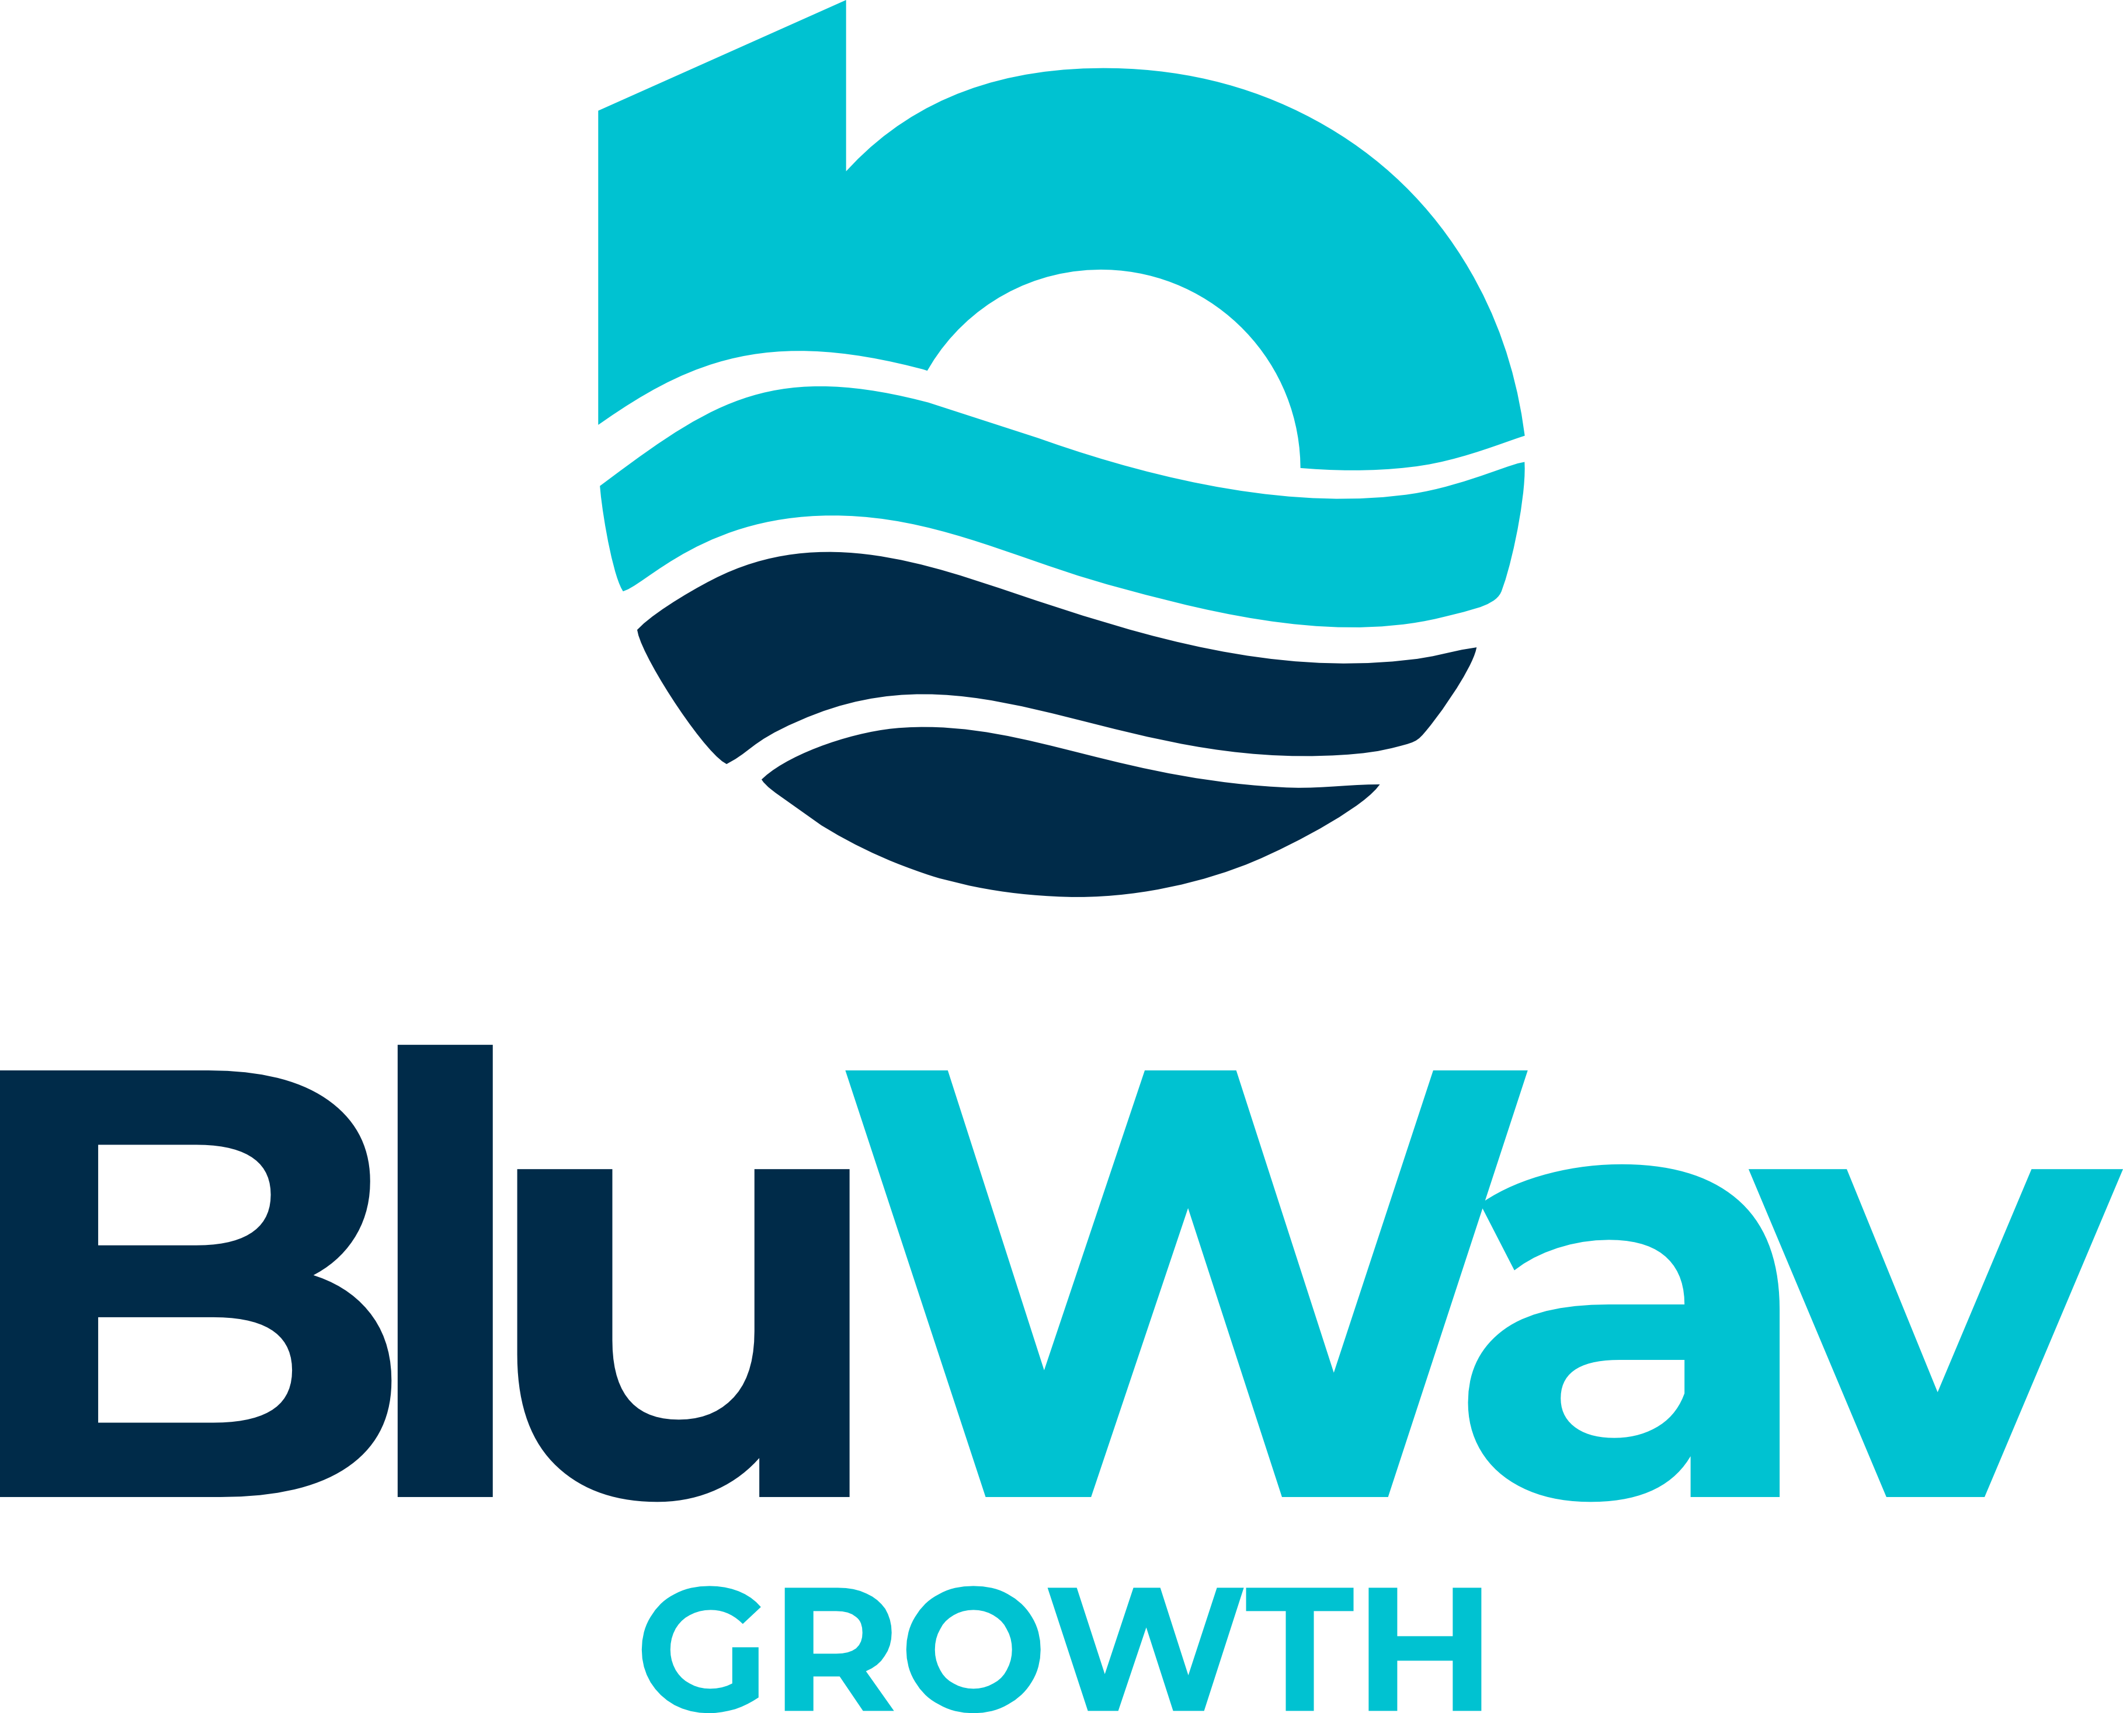

Products & Services Overview
Digital Growth Systems for Modern Businesses
Get Found. Get Chosen. Grow.
A Stratiix Group Company · bluwavgrowth.com · hello@bluwavgrowth.com

About BluWav Growth
BluWav Growth is a digital growth systems firm. We help modern service businesses get found online, get chosen by customers, and grow automatically — through four integrated pillars delivered in 48 hours or less.

We are not a website agency. We are not a marketing shop. We are not a CRM company. We build complete digital growth systems that connect every channel into one working engine.

Pillar | What It Delivers
Digital Presence | Professional website — fast, mobile-ready, built to convert visitors into customers.
Google Visibility | Google Business Profile, local search, Maps presence, Bing listing.
Search Performance | Impressions, clicks, keyword trends, competitor gap analysis, GA4 + Search Console.
Digital Systems | CRM, automation, lead capture, WhatsApp integration, follow-up flows.

Every plan includes a signed agreement. You own your website, CRM, and data forever. No lock-in. Ever.

Growth Systems — Choose Your Level
Every Growth System includes a 14-day free CRM trial. Delivered in 48–72 hours. You own everything we build.

🌊 BluWav Ripple — Starter | From $1,800 | One-time investment
Your digital foundation. Website, Google visibility, and smart automation working together from day one.
- Modern website (you own it forever)
- Google Business Profile setup
- 14-day CRM trial included
- Smart lead automation
- Performance dashboard
- On-page SEO essentials
- Google Search Console + Analytics 4 setup
- WhatsApp chat button
- Mobile-optimized design
- Fast, secure hosting (6 months included)
- Standard support

⚡ BluWav Current — Growth | From $3,000 | One-time investment
The complete growth system. All four pillars activated. Everything in Ripple, plus:
- WhatsApp Business profile setup
- WhatsApp product catalog setup
- Quick replies & automated messages
- Advanced WhatsApp lead sequences
- Local SEO + competitor gap analysis
- 5-star reputation builder
- Automated lead pipeline
- Conversion-optimized landing page
- Monthly performance check-in call
- Priority support

🚀 BluWav Surge — Full Transformation | From $5,000+ | Setup + Monthly Plan
Full-scale growth system deployment. Every pillar maximised. Everything in Current, plus:
- Full WhatsApp sales funnel
- Google Ads campaign setup & launch
- Bing Places + multi-search engine listing
- Bing Webmaster Tools setup
- Ad-ready setup (Google + Bing Ads)
- Monthly visibility & performance report
- Quarterly strategy review call
- Dedicated account manager

Every Growth System Includes: Website · Google · WhatsApp · 14-Day CRM Trial · Automation · Delivered in 48–72 hours

BluWav CRM — Plans & Pricing
Every BluWav Growth plan includes a 14-day free CRM trial — experience the full CRM before you choose your plan. No credit card required.

Plan | Monthly | Onboarding | Annual Option | Key Features
CRM Starter | $59/mo | $99 | — | 25 contacts, lead tracking, 1 user, email support
CRM Lite | $99/mo | $199 | $990/yr | 250 contacts, pipeline, basic automation, 2 team members
CRM Premium ⭐ | $179/mo | $299 | $1,990/yr | Unlimited contacts, full pipeline, WhatsApp, 5 team members, all future features
CRM Enterprise | $499/mo | $599 | — | Unlimited team, custom workflows, API access, dedicated account manager, SLA
White-Label | $697/mo | $699 | Annual contract | Your brand, unlimited client accounts, Super Admin dashboard, agency revenue model

CRM Premium Introductory Rate: $179/month. Price rises to $199/month when the BluWav Growth Dashboard launches. Sign up now and your rate is locked in for life. No exceptions.

Nonprofit Community Rate: Registered nonprofits qualify for CRM Premium at $99/month (no setup fee). Email hello@bluwavgrowth.com with your registration number.

🌊 CRM Starter — $59/month + $99 onboarding
- 25 contacts
- Lead tracking
- Basic contact management
- Basic reporting
- 1 user only
- Email support (72hr response)
- Automation
- Pipeline tracking
- WhatsApp integration
- Team members

💼 CRM Lite — $99/month + $199 onboarding
or $990/year · 2 months free · Cancel anytime
- Everything in CRM Starter
- Up to 250 contacts
- Pipeline tracking
- Basic automation
- 2 team members
- Standard reporting
- Priority email support (48hr)

🖤 CRM Premium — $179/month + $299 onboarding ⭐ Most Popular
or $1,990/year · 2 months free · Introductory rate — locks in for life
- Everything in CRM Lite
- Unlimited contacts
- Full pipeline (Lead → Quote → Won)
- Automated follow-ups (30/60/90 days)
- WhatsApp integration
- Revenue & aging reports
- 5 team members
- Document storage & data export
- All future features included
- Priority support (24hr · email & SMS)
- Growth Dashboard Pro (when launched)

🏛️ CRM Enterprise — $499/month + $599 white-glove onboarding
Full team setup, data migration & training included
- Everything in CRM Premium
- Unlimited team members
- Custom workflows
- Advanced analytics
- API access
- Data migration support
- Custom integrations
- Dedicated account manager
- SLA guarantee
- Quarterly strategy calls
- Priority 12hr support

🏢 White-Label CRM — $697/month + $699 onboarding
Annual contract · White-glove setup included · For agencies and consultants
- Your logo & domain — clients never see BluWav
- Unlimited client accounts
- Charge $297–$997/mo per client
- Super Admin dashboard
- 85–95% client retention
- White-glove onboarding
- Dedicated account manager

Revenue Example: 20 clients × $697/mo = $13,940 MRR for your agency

What's Included in Every Growth System

Component | What You Get
Professional Website | Modern, mobile-optimized website you own forever. Built for speed, SEO, and conversions. Delivered in 48–72 hours.
Google Business Profile | Full Google Maps & Search setup so customers find you first when searching for what you offer.
WhatsApp Business | Professional WhatsApp setup with catalog, quick replies, and automated lead sequences.
Analytics & SEO | Google Analytics 4, Search Console, and on-page SEO so you track and grow your visibility.
CRM Trial | 14-day free trial of CRM Premium — full access, no credit card required.
Smart Automation | Lead capture, automated follow-ups, and pipeline management from day one.
Signed Agreement | Every project starts with a signed agreement. You own everything we build. No exceptions.
Hosting | 6 months hosting included. After 6 months: $200 per 6 months (SSL, security, support).

By the Numbers
Metric | Value
Businesses served globally | 50+
Average delivery time | 48 hours
Years of global expertise | 5+
Client data ownership | 100% — always
Countries served | 5+

Payment & Contact

Accepted Payment Methods
- WiPay (Caribbean cards)
- PayPal
- Bank transfer
- Linx
- Other methods confirmed at time of invoice

Split Payment Options
- 50/50: 50% upfront, 50% on delivery
- 40/30/30: 40% upfront, 30% mid-project, 30% on delivery

Get in Touch
Channel | Details
Website | bluwavgrowth.com
Email | hello@bluwavgrowth.com
Facebook | facebook.com/bluwavgrowth
Instagram | instagram.com/bluwavgrowth
Free Health Check | bluwavgrowth.com/free-health-check
Apply | bluwavgrowth.com/apply.html
Pricing | bluwavgrowth.com/pricing.html

Prices in USD. All plans include a signed agreement. Onboarding fees apply to CRM plans. Subject to change without notice.
BluWav Growth · A Stratiix Group Company · bluwavgrowth.com

