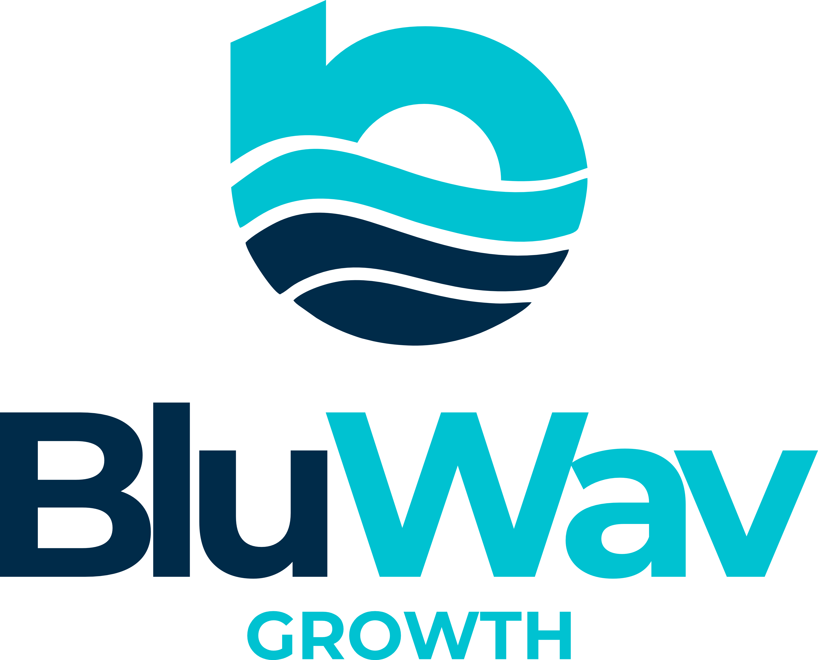

BluWav Growth
SALES AGENT ONBOARDING PACKAGE

Tier 2 · Sales Agent · Confidential · July 2026

Get Found. Get Chosen. Grow.
bluwavgrowth.com · hello@bluwavgrowth.com

Section 1 — About BluWav Growth
BluWav Growth is a digital growth systems firm. We help modern businesses get found online, get chosen by customers, and grow with clarity and confidence.

We are not a website agency. We are not a marketing shop. We are not a CRM company. We build integrated digital growth systems across four pillars:

Pillar | What It Delivers
Digital Presence | Professional website — fast, mobile-ready, built to convert.
Google Visibility | Google Business Profile, local search, maps presence, Bing listing.
Search Performance | Impressions, clicks, keyword trends, competitor gap analysis.
Digital Systems | CRM, automation, lead capture, follow-up flows.

The BluWav CRM connects all four pillars into one working growth engine. It is not the product — the growth system is the product. The CRM is how we make that system real.

Position BluWav Growth as a digital growth systems firm, not a website agency or CRM company. This distinction is what separates us from every competitor.

A Stratiix Group Company · bluwavgrowth.com · hello@bluwavgrowth.com

Section 2 — Your Role as a Sales Agent
As a Tier 2 Sales Agent, your job is to identify business owners who need a stronger digital presence, introduce them to the BluWav Growth system, and close the deal. You do not build websites. You do not set up CRMs. You sell the system and hand the client to the BluWav team.

What You Do
- Identify prospects: small and medium business owners who are invisible online or losing leads.
- Pitch the BluWav Growth system using the scripts and materials in this package.
- Close the deal and submit the lead through the BluWav team contact.
- Follow up with prospects who did not close on the first conversation.
- Refer CRM clients for recurring commission.

What You Do Not Do
- You do not onboard clients or set up any technical systems.
- You do not make promises beyond what is in the approved materials.
- You do not negotiate pricing without prior approval from the VP, Sales & Marketing.
- You do not represent BluWav Growth on social media without approval.

Section 3 — Products and Pricing
Always present BluWav as a system, not a menu of services. Clients who understand the system stop asking “can I just get the website?” and start asking “how do I get the full system?”

Growth Systems
Package | Price | What It Includes | Your Commission
Ripple | $1,800+ | Website, Google Business Profile, CRM 14-day trial, on-page SEO, WhatsApp chat button, smart lead automation, performance dashboard. | $360+
Current | $3,000+ | Everything in Ripple, plus WhatsApp Business setup, product catalog, advanced lead sequences, local SEO + competitor analysis, 5-star reputation builder, automated lead pipeline, conversion landing page, monthly check-in call. | $600+
Surge | $5,000+ | Everything in Current, plus Google Ads campaign setup, Bing Places + multi-search engine listing, full WhatsApp sales funnel, monthly visibility & performance report, quarterly strategy review, dedicated account manager. | $1,000+

BluWav CRM Plans
The CRM is Pillar 4 of the growth system. Every Growth System client receives a 14-day free trial. After the trial, they choose their CRM plan.

CRM Plan | Onboarding | Monthly | Annual Option | Your Commission
CRM Starter | $99 | $59/mo | — | $12/mo for 3 months
CRM Lite | $199 | $99/mo | $990/yr | $20/mo for 3 months
CRM Premium | $299 | $179/mo | $1,990/yr | $36/mo for 3 months
CRM Enterprise | $599 | $499/mo | — | $100/mo for 3 months
White-Label | $699 | $697/mo | Annual contract | $139/mo for 3 months

CRM Premium Introductory Rate: $179/month. When the BluWav Growth Dashboard launches, the price moves to $199/month. Clients who sign now lock in $179 for life. Use this in every CRM conversation.

CRM Performance Reward
Bring 3 or more CRM clients within 60 days and your commission rate upgrades from 20% to 25% for 3 months on all CRM clients in that cohort.

Section 4 — Commission and Bonuses

Performance Bonuses
Deals Closed Per Month | Flat Bonus
3 to 4 deals | +$150
5 to 6 deals | +$400
7 to 9 deals | +$750
10 or more deals | +$1,000

Additional Bonuses
- Package upsell (Ripple to Current, or Current to Surge): +$50 per upsell.
- Second-generation referral (your client refers another client): +$75.

Payment Rules
- Commission is earned when the client payment clears, not when the deal is signed.
- Payouts are processed within 7 business days of payment clearance.
- Minimum payout threshold: $50 USD.
- If a client cancels or requests a full refund within 14 days, the commission is reversed.
- No commission is payable on setup or onboarding fees for any CRM package.
- Payment methods: WiPay, PayPal, bank transfer, Linx, or other methods confirmed at time of payout.

Payout Requests
Submit all payout requests through the BluWav Agent Portal:

Agent Portal | bluwavgrowth.com/commission-calculator.html
Access Code | BLUWAV2026
Response Time | Confirmation within 24 hours of submission

Use the Commission Calculator to calculate your earnings, then submit a Payout Request. You will receive a confirmation email within 24 hours.

Section 5 — Sales Scripts
These scripts are starting points. Adapt the language to your natural style, but keep the core positioning consistent: BluWav Growth is a digital growth systems firm.

Opening Script (Cold Outreach)
“Hi [Name], I work with BluWav Growth. We help businesses like yours get found on Google, build a professional online presence, and automate customer follow-ups — all in one system. We deliver in 48 to 72 hours and you own everything we build. Would you be open to a quick conversation this week?”

Discovery Call Script
Open with a question, not a pitch:
“Before I tell you about what we do, can I ask: when someone searches for [their business type] in [their area] on Google, do you show up? And if they find you, is your website doing anything to turn them into a customer?”

Listen to their answer. Then:
“That is exactly what we fix. BluWav builds the full system: your website, your Google visibility, your WhatsApp setup, and a CRM to track every lead. Most clients go live in 48 to 72 hours. You own everything we build — no lock-in, ever.”

CRM Introductory Rate Script
“CRM Premium is $179 per month right now. That is our introductory rate for early adopters. When we launch the BluWav Growth Dashboard, the price moves to $199. Sign up today and your rate is locked in for life. No exceptions.”

Closing Script
“Based on what you have told me, I think [Ripple / Current / Surge] is the right fit. The investment is [price]. We start as soon as your invoice is paid, and you are live within 48 to 72 hours. Shall I send you the details?”

Free Health Check Script
“Before we go any further, let me offer you something completely free. It’s a short online form — takes two minutes — and it shows you exactly where your business stands online right now. No commitment, no sales pitch. Results come back within 24 hours. Want me to send you the link?”
Health Check link: bluwavgrowth.com/free-health-check

Section 6 — Objection Handler
Objection | Your Response
“It is too expensive.” | “I understand. Let me put it in perspective. A professional website alone costs $3,000 to $8,000 at most agencies and takes 6 to 12 weeks. With BluWav, you get the website, Google setup, WhatsApp integration, and a CRM trial — all in 48 hours, starting at $1,800. You are not paying more; you are getting more, faster.”
“I can get a website cheaper elsewhere.” | “You can. But a website on its own does not grow your business. BluWav builds the full system: the website, the Google visibility, the WhatsApp setup, and the CRM. A cheaper website is just a page on the internet. Our system is what turns visitors into customers.”
“I need to think about it.” | “Of course. What specifically would help you make the decision? Is it the investment, the timeline, or understanding exactly what you get? I want to make sure you have everything you need.”
“I already have a website.” | “Great. Is it showing up on Google when customers search for you? Is it capturing leads automatically? Is it connected to a CRM? Most websites we see are not doing any of those things. That is what we fix.”
“I am not ready yet.” | “I hear that a lot. Can I ask: what would need to change for you to be ready? Because every day you are not online, a competitor is winning the customer that should have been yours. Our free Digital Health Check takes 2 minutes and shows you exactly where you stand — no commitment.”
“I do not need a CRM.” | “Most business owners say that until they see how many leads they are losing. The CRM is not a complicated system; it is the engine that connects everything. Every lead from your website, every WhatsApp message, every referral — tracked in one place. And the 14-day trial is free.”
“We tried digital marketing before and it didn’t work.” | “I’m sorry to hear that. Can I ask what happened? [Listen] What BluWav does differently is bring everything into one connected system — website, Google, WhatsApp, CRM — so nothing falls through the cracks. The free Health Check is a great way to see exactly where the gaps are, with no commitment.”
“We’re a small business, we don’t need all this.” | “That’s exactly who BluWav is built for. Our Ripple plan starts at $1,800 — it’s a one-time investment, you own everything forever, and it includes a 14-day free CRM trial. The Health Check just shows you where the biggest opportunity is for your specific business. No commitment.”

Section 7 — Your 30-Day Action Plan
Your first 30 days set the foundation. Follow this plan and you will have your first deals closed before the month is out.

Week 1: Learn and Prepare
- Read this package in full. Know the products, prices, and scripts.
- Complete your onboarding call with the VP, Sales & Marketing.
- Access the Agent Portal and run through the Commission Calculator.
- Identify your first 10 prospects: business owners you know personally or in your network.
- Practice the opening script out loud until it feels natural.

Week 2: First Conversations
- Contact your first 10 prospects via email, phone, or in person.
- Aim for 3 discovery conversations this week.
- Send the free Digital Health Check link to every prospect: bluwavgrowth.com/free-health-check
- Submit any warm leads to the VP, Sales & Marketing immediately.

Week 3: Follow Up and Close
- Follow up with every prospect from Week 2 who did not respond.
- Aim to close your first deal this week.
- Identify 10 more prospects and begin outreach.
- Ask every conversation: “Do you know any other business owners who might need this?”

Week 4: Build Momentum
- Review your pipeline. Who is close to closing? Follow up.
- Aim for 3 closed deals by end of Month 1.
- Submit your first payout request if you have cleared commissions.
- Book your Month 2 check-in with the VP, Sales & Marketing.

3 deals in Month 1 = $1,080 to $1,800 in commission, plus your performance bonus of $150. That is a strong start.

Section 8 — Key Contacts and Resources

Your Primary Contact
Title | VP, Sales & Marketing — BluWav Growth
Email | hello@bluwavgrowth.com
Response Time | Within 24 hours on business days

Key Links
Main website | bluwavgrowth.com
Free Digital Health Check | bluwavgrowth.com/free-health-check
Agent Portal | bluwavgrowth.com/commission-calculator.html
Agent Portal Code | BLUWAV2026
Sales Agent Agreement | bluwavgrowth.com/sales-agent-agreement.html
Apply page (clients) | bluwavgrowth.com/apply.html
Pricing page | bluwavgrowth.com/pricing.html
BluWav CRM page | bluwavgrowth.com/crm.html
Contract page | bluwavgrowth.com/contract.html

Submitting a Lead
When you have a warm or closed lead, contact the VP, Sales & Marketing immediately with:
- Client name and business name.
- Country or region.
- Package they are interested in.
- Their email and preferred contact method.
- Any notes on their situation or timeline.

The BluWav team will take it from there. You will be notified when the invoice is sent and when payment clears.

What Happens After You Close a Deal
- You submit the lead to the VP, Sales & Marketing.
- BluWav sends the client a scope and invoice within 48 hours.
- Client pays. BluWav builds and delivers within 48 to 72 hours.
- Your commission is processed within 7 business days of payment clearance.
- You receive a confirmation when your payout is sent.

BluWav Growth · Sales Agent Onboarding Package · Confidential · July 2026
This document is the property of BluWav Growth. Not to be distributed without permission.
Ride the wave. 🌊

