# Bayer – Configuration

* Enabled feature WTPA  
  
* Added Level 3 in Corp Structure  
  
* Added three states to Corp Structure (PA, CA, NY) plus a value “Not applicable”



* Updated Form I9 Company Level; set Ewage and PA-R to Level 3



## Steps To Reproduce

There is only one (informational) panel showing up during PHV: see steps below

Keys for Form LS59 (Only form that is enabled in SuperAdmin are on this TEST Panel:

EWAge State= NY

EmployeePayTYpe = Salary

FLSA = EXEMPT

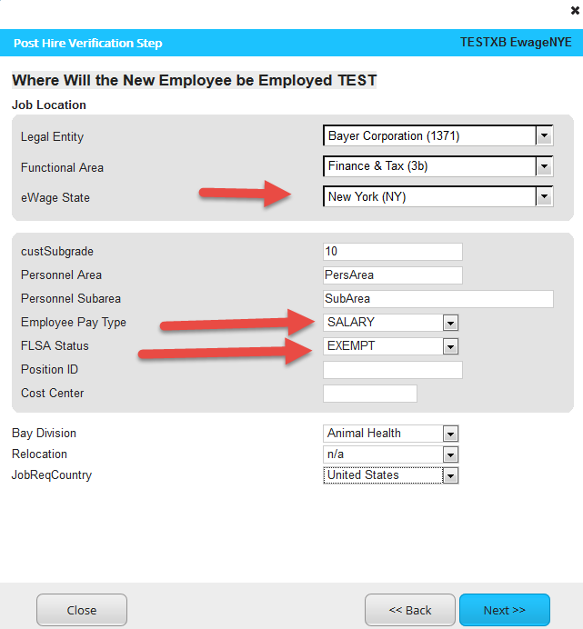

Salary = 4000

Per = Month

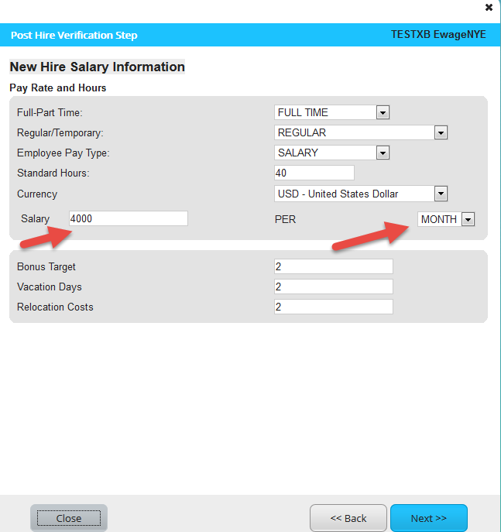





In the Review Panel: I do see this: But when I click on the Pay rate; It tries to open up a window and then it’s going back to this page again.



## During NES:

