In DEV instance (company id BCLCDev), in the manage pending hire, under the Recruiting tab

There is the following error message : “There was an error processing your request. Please contact support”.

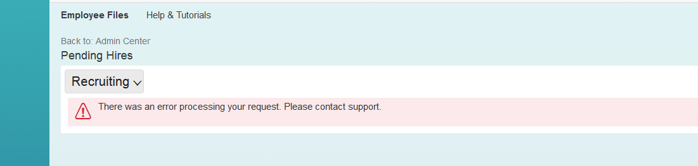

We have Onboarding Module enabled, therefore we don’t expect to have a list of candidate under Recruiting, but we should not have an error message.

Normally, it there should not be any error and the screen should be like this:

