DC 8 Preview

URL: <https://hcm8preview.sapsf.com/provisioning_login>?

Company: Chesapeake Operating Inc.

COMPANY ID (BizX): CHKDEV

DC8 Stage

Onboarding ID: **Chesapeake**

**Settings in Super Admin**

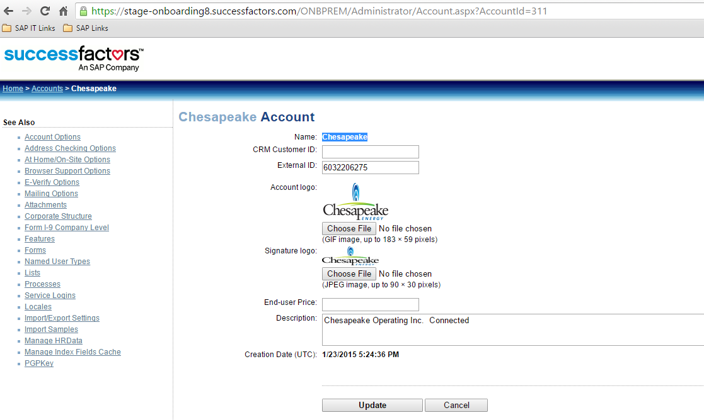

**SCREENSHOT OF ERROR**

