**Ticket #:** 196848

**Datacenter: DC 4**

**Customer:** Sysco Corporation

**Credentials:**

**URL: https://performancemanager4.successfactors.com/flex/partnerprovisioning/index.jsp?**

**Account:** C0000167686P

**Secondary Username :** SFADMIN

**Proxy as:** Chuck Wright

**Problem:** No list "B" drop down for receipt re-verification

**Steps to replicate the issue, click-by-click if necessary.**  
1.  Proxy as Chuck Wright  
2.  Open Onboarding  
3.  Search for candidate “Test Receipt” under I-9 Re-Verification

4. Open Activity

5. Check Form I-9 Re-verification Section 3

**Actual Behavior:** List B did not appear for receipt re-verification

**Expected Behavior:** List B should appear for receipt re-verification

**Steps taken in debugging, reconfiguring, or attempting to work-around the issue:**  
1. Able to replicate the issue

**Screenshots, attachments, etc:**

**Choose List B as a Receipt in Section 2 of Orientation Step (this will trigger I-9 Reverification)**

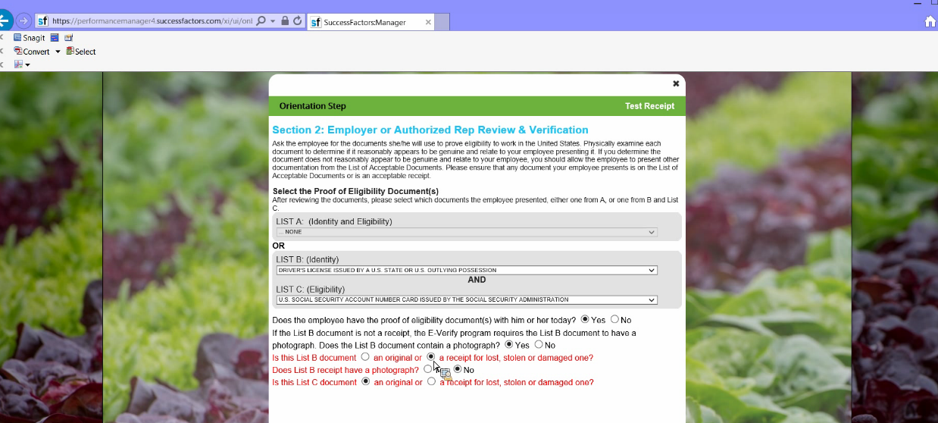

I-9 Re-verification Triggered

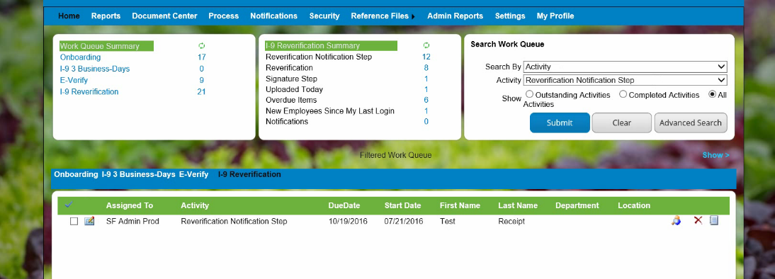

Open Activity

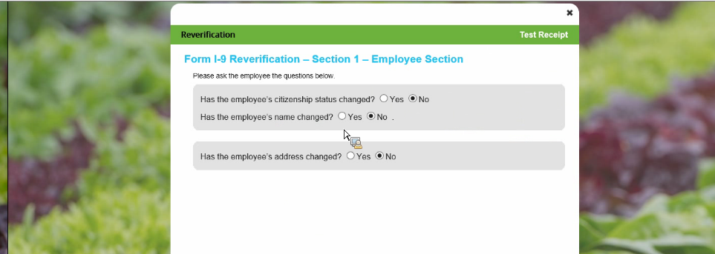

You will see here that **No LIST B** appears

