**Model Specification**

The EMOD model is an individual-based stochastic model of disease transmission, with support for campaign implementation, heterogeneous transmission, and spatially segregated populations coupled by individual-level migration; the software also includes sub-packages implementing “generic”, vector-borne, water-borne, airborne, and sexual disease transmission. The EMOD software is available for download at <http://idmod.org/idmdoc/#EMOD/EMODBuildAndRegression/BuildingEMODTOC.htm>. The model presented in this manuscript was developed within the EMOD “generic” simulation framework, implementing a discrete-time, individual-based form of a susceptible-exposed-infectious-susceptible model. Below, we review the adjustments to a simple SEIS model that were implemented in this model to reflect polio immunology and specify the model in terms of the individual-level state transition dynamics.

Individuals in the model exist in susceptible, exposed, and infectious states, with individuals returning to the susceptible state immediately upon clearance of an infection. However, infections with wild or Sabin-strain attenuated poliovirus, as well as vaccination with the inactivated polio vaccine, are known to confer partial immunity to individuals. Immunity in this model is characterized by two individual-level properties: acquisition-moderating immunity (**α**), which modulates the probability of infection given exposure to infectivity, and applies in the susceptible state; and transmission-moderating immunity (**τ**), which reduces the infectivity of an infectious individual. Both **α** and **τ** are defined on [0, 1], and are defined such that a completely naïve individual has both properties equal to 1. At **α**=0, an individual cannot be infected by any amount of exposure; at **τ**=0, an individual who becomes infected will not shed.

The parameters governing individual immunity are updated upon clearance of OPV infection or successful IPV vaccination. In the event of multiple vaccinations or infections, the **α** and **τ** parameters stack multiplicatively; these parameters thus aim to model a per-infection effect on acquisition- and transmission-modulating immunity. IPV vaccination behaves similarly, with per-dose effects on the two immunity channels, but IPV can provide two sets of effects; for individuals without a history of OPV infection, an IPV vaccination provides an individual with a small priming effect in each immunity channel, but for individuals with a history of OPV infection, IPV provides a larger boosting effect on immunity. As noted in the main text, current support for an incremental effect of additional IPV doses on the mucosal immunity of bOPV-exposed, OPV2-naïve children is not immediately apparent from the published literature. One recent study supports a dose-dependent effect while another finds no difference, though the two studies are in different settings and use different schedules.1,2 This model does in fact implement a dose-dependent response, as it is simpler to implement and it should not affect the results - only a single dose of IPV in RI is modeled and compared against zero doses. A small subset of children in the model may receive the RI IPV, be missed by the subsequent OPV campaigns, but receive a second dose of IPV in outbreak response; this cohort is sufficiently small that its effects are overwhelmed by the uncertainties in other model features (Sabin 2 R0, overall demographics of immunity, migration rates and connections).

The infectious and incubation periods (γ and σ, respectively) were modeled using constant times spent in a compartment, rather than the exponential distribution implied by the rate parameters in a standard SEIS model, changing the parameters from rates to delays in the equations. The mortality rate ν is implemented as a function of age ν(*a*), with values obtained from DHS3. The model tracks only 0-5 year olds, as ~98% of all cVDPV2 paralysis cases in the AFRO region have arisen in this cohort.4 As the case load is concentrated in this age group, the authors think it likely that virus transmission is also highly concentrated in this cohort. To the extent that silent circulation occurs in older cohorts, for the purposes of modeling, outbound and inbound transmission from the observable cohort to the silent cohort can be reduced to an effective transmission rate within the observable cohort. The effective birth rate is adjusted to produce a population growth rate of 2.8% per year3.

The model includes a linear rising exposure to infectiousness with age. This term is based on previous work modeling WPV1 paralysis cases in Kano state, Nigeria (reference), where the number of paralysis cases peaked at 2 years of age, and the age distribution of cVDPV2 cases in AFRO exhibits a similar shape. This apparent protection lasts too long to be solely the effect of maternal antibodies, and so this rising susceptibility was developed to incorporate the effects of both maternal antibodies and reduced overall mixing with older children. Individual susceptibility vs. age is governed by the following equation:

Secondary infections arising from individual campaigns are not separately tracked, preventing the tracking of separate VDPV lineages undergoing independent reversion. Rather, infectivity is described as a function of time, held constant through the initial campaigns in the outbreak response and beginning to rise after the final campaign:

Individuals of any disease state and age migrate between metapopulations (nodes), which represent AdminL1 (provinces) of 16 West African countries (Senegal, Mauritania, Sierra Leone, Guinea, Liberia, Cote d’Ivoire, Mali, Burkina Faso, Ghana, Togo, Benin, Niger, Nigeria, Cameroon, Chad, Central African Republic). The infection process in a given node and at a given timestep is governed by individuals in that node at that timestep only. Individuals migrate between nodes (from a home node *i* to destination node *j*) with relative destination node rates according to a gravity-like model of migration; migration is modeled as one-day round-trips to prevent unrealistic population accumulation in the largest nodes.

Where = 1 or 2 for the scenarios tested.

**Individual-level transitions**

With all of this in hand, individuals can be specified by a state space of {disease state *X*, age *a*, time in disease state *tX,* home node *i*, current node *j,* acquisition-modulating immunity α, transmission-modulating immunity τ}. The absolute simulation time *t* also plays a role due to immunization campaigns on specific dates and seasonal dynamics; this simulation state variable is shared by all individuals. Disease state transitions, vital dynamic transitions, and migration transitions are treated independently from one another, simplifying the specification of the transition space. The individual-level state transitions are presented below in the order in which they are processed in simulation.

For the sake of readability, elements of the full state that do not change in a given transition will be suppressed. *S, E,* and *I* without subscripts will indicate an individual’s disease state, and with subscripts *j* will indicate the total population in state *X* in node *j*. *N­j* indicates the total population of node *j*.

The first transition in a given timestep is aging:

Next, OPV and IPV immunization interventions are processed:

|  |  |
| --- | --- |
| IPV immunization: |  |
| OPV immunization: |  |

Where indicates the effective coverage of the campaign *k* in node *j* (accounting for the effective take of OPV), is the Kronecker delta function, and is the date of campaign *k*.

The infectious dynamics follow:

The total infectiousness in node *j* is given by the sum over infectious individuals *k* in node *j:*

|  |
| --- |
|  |
|  |
|  |

Deaths are processed next:

|  |
| --- |
|  |

Followed by migration – again, outbound migration follows the rates in Eq. ( 2 ), and homebound migration always takes place the following timestep:

|  |
| --- |
|  |
|  |

Finally, new births are processed:

|  |
| --- |
|  |

Equations ( 1-14 ) combine to specify the agent-based model as implemented. This specification can also be converted into a set of stochastic difference equations; the resulting equations are rather unwieldy and somewhat difficult to read, limiting how informative they are to the reader. The relevant model parameters are summarized in Table 1.

|  |  |  |  |
| --- | --- | --- | --- |
| Parameter description (symbol) | Value(s) | Relevant effect or equation | Comparison references |
| OPV transmission modifier () | 0.9 | Upon clearance of OPV infection or IPV immunization in OPV-exposed individuals: | 5–7 |
| OPV acquisition modifier () | 0.6 | Upon clearance of OPV infection or IPV immunization in OPV-exposed individuals: | 5–7 |
| IPV transmission modifier () | 0.1 | Upon IPV immunization in OPV-naïve individuals: | 5–7 |
| IPV acquisition modifier () | 0.1 | Upon IPV immunization in OPV-naïve individuals: | 5–7 |
| Age-dependent susceptibility intercept (*f0*) | 0.0 |  |  |
| Age-dependent susceptibility slope (*f1*) | 0.5 |  |  |
| Migration rate scalar () | Varied in separatrix |  | 8 |
| Migration rate distance dependence ( | {1, 2} |  | 8 |
| Duration of exposed state ( | 3 |  | 5,6 |
| Duration of infectious state ( | 27 |  | 5,6 |
| Initial infectiousness of Sabin 2 relative to fully-reverted ( | {0.25, 0.5} |  | 6 |
| Final R­0 of reverted Sabin 2 | {1.2, 1.5, 2, 3} | Denominator indicates correction for age-dependent susceptibility, with defined as in (1) and the population age distribution. |  |
| Delay before Sabin reversion ( | 86 (time of final outbreak response campaign) |  |  |
| Timescale of Sabin reversion ( | {60, 150} |  | 9 |

Table : Description of all model parameters relevant to the study

**Calibration**

In 2008, a seasonal peak in endemic transmission in Nigeria apparently seeded outbreaks that propagated over the following two years throughout the West African countries modeled in this work. Comparing this historical outbreak with the behavior of modeled outbreaks allows for qualitative bounds to be placed on the magnitude of migration rates in the model. Figure 1 presents this historical outbreak, with countries placed into a rough ordering from northwest at the top to southeast at the bottom, producing a striking traveling epidemic pattern.

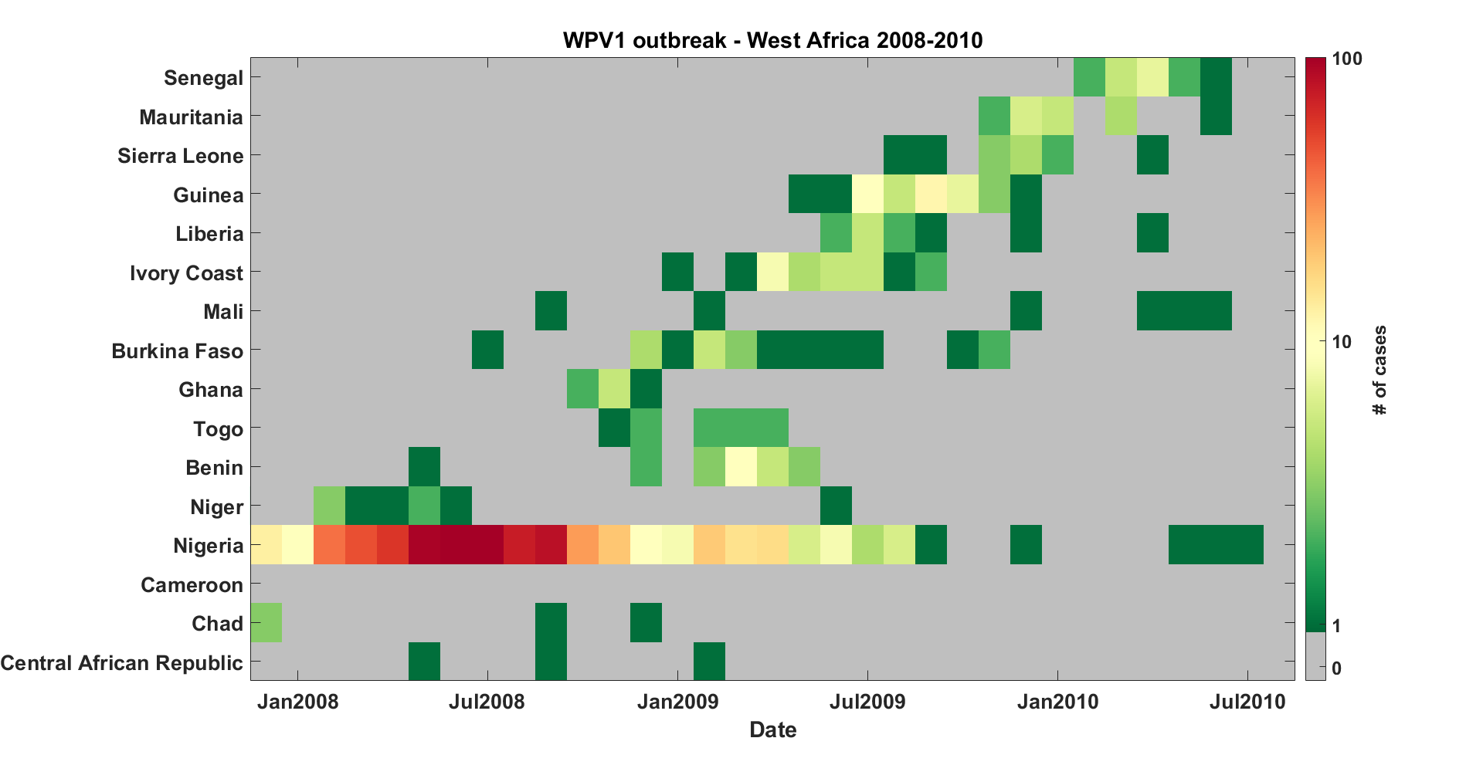

Figure : Wild Poliovirus Type 1 outbreak in West Africa, 2008-2010. Countries are roughly ordered northwest to southeast from top to bottom.

Calibrating the properties of the modeled migration network to this past poliovirus outbreak presents inherent difficulties – due to the case-to-infection ratio, the spread of infection is poorly sampled; disease propagation on the network is stochastic, and only a single observation of propagation on the network is observed; and the propagation process depends not only on the structure of the migration network, but also on the uncertain transmissibility and immunity conditions in the nodes of the network. For these reasons, a detailed calibration of the migration models to the full spatial infection traces is not attempted. Rather, calibration qualitatively targets the temporal behavior of the outbreak, seeking to minimize the differences between a “case-weighted time” in each country from data (Eq. 15) and “incidence-weighted time” from simulation in each country (Eq. 16). The relative amplitudes of the outbreaks in different countries are not targeted as part of the calibration.

|  |  |
| --- | --- |
|  |  |
|  |  |
|  |  |

With *t* stepping in 30-day increments beginning on Jan 1, 2008; indicating the number of cases in country *j* during time bin *t*, and indicating the number of infections in country *j* during time bin *t*. As the exact peak of the Nigeria outbreak may shift from simulation to simulation, is defined relative to that peak in each simulation. The calibration aims to minimize the term defined in Eq. 17 above (in practice, it actually aims to maximize ).

Incremental Mixture Importance Sampling (IMIS) is used to sample and re-sample a 2D parameter space of R0 and overall migration rate.10 IMIS was designed to work with deterministic models and proportionally sample a true posterior density based on an appropriately-defined likelihood function. However, the author has found it effective as a means of maximizing and mapping the surface of an objective function (not necessarily likelihoods) applied to a stochastic model, so long as the stochastic variance in the objective function at a single point is outweighed by the “parameter-based” variation throughout the calibration space - in some sense, as long the objective surface is “smooth”, or has a high signal-to-noise. Additionally, a code base for interfacing IMIS directly to IDM’s computational cluster already exists from previous work.

The model utilized in calibration is not strictly equivalent to that used in the investigations of post-cessation outbreak behavior. The immunity levels in each province are not set equal to each other, but are rather derived from vaccine dose histories reported by acute flaccid paralysis cases during the time period in question.11 Partial immunity is also not treated in the calibration version of the model; transmission takes place only through fully susceptible children. Simulations begin in January 2008, with an outbreak seeded in Nigeria, and run through June 2013 (though the comparison only considers times through July 2010).

Figure 2 presents the results of the calibration; points in the 2D space represent a single sampled pair of infectivity and values, and the color indicating . A broad maximum is apparent around mean migration rates from approximately -3.5 to -2.5 (in log-10 units), representing the preferred region outlined in the figures in the main text; this corresponds to the average child traveling outside of their home state approximately once per year to once per decade. Figure 3 presents the infection traces from two representative simulations in the preferred region under the actual outbreak. Above this range of migration rates, transmission across the region becomes increasingly synchronous, qualitatively ruling out these values as realistic; an example is shown in Figure 4. Below this preferred region, the metapopulations become more disconnected and transmission fails to export broadly across the network; an example is shown in Figure 5.

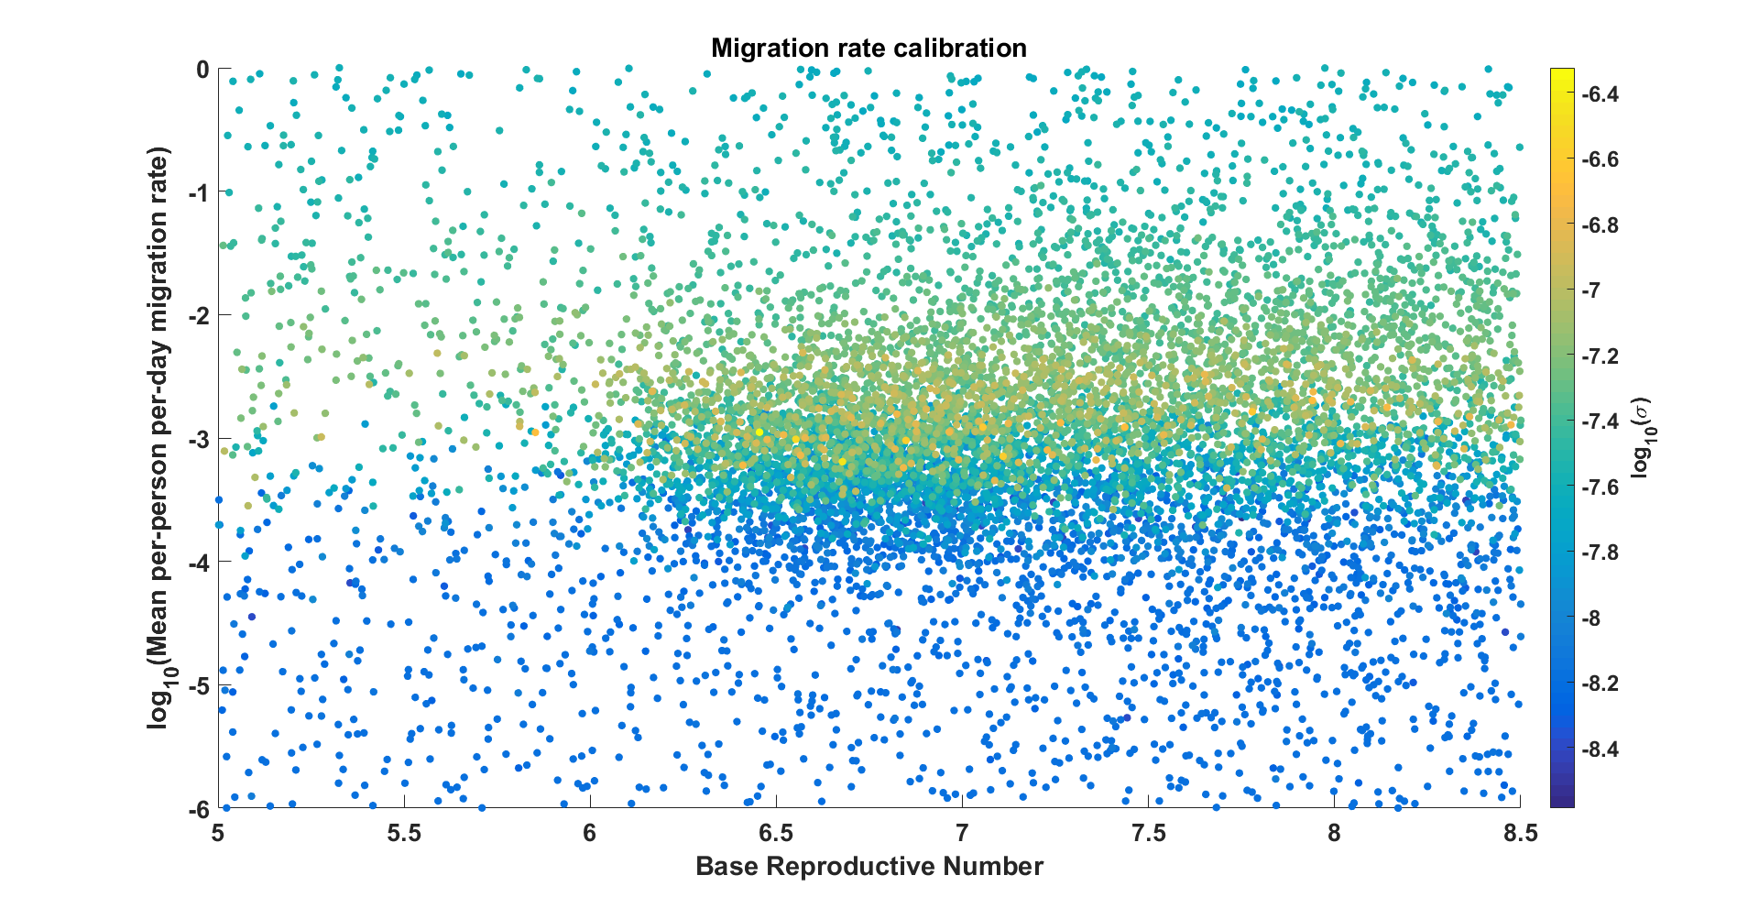

Figure : Results of calibration of migration rates. The x and y- axes represent the infectivity and mean migration rate, respectively, with color indicating the value of the objective function defined in Eqs (15-17). The results indicate a broad maximum around mean migration rates from roughly -3.5 to -2.5 (in log10 units), i.e., the average child leaving their home state approximately once per year to once per decade.

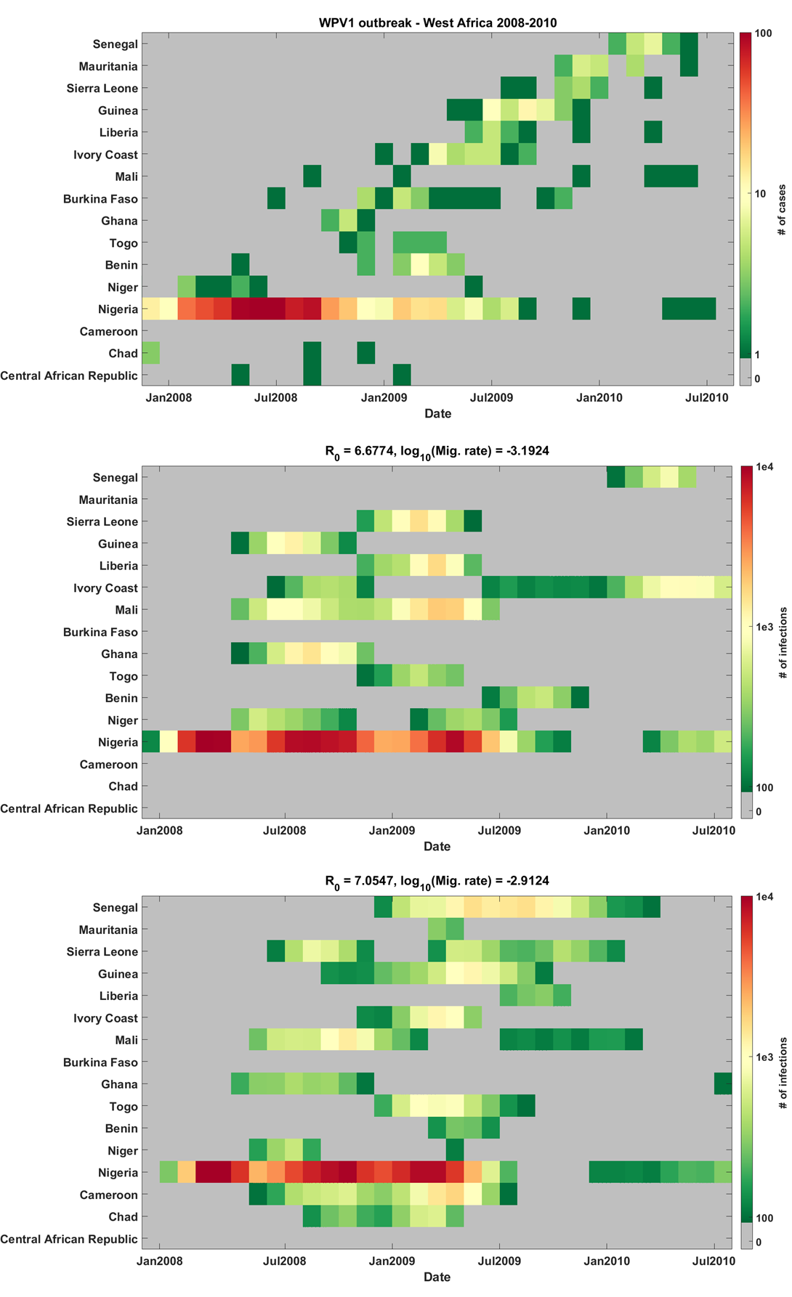

Figure : Top: WPV1 outbreak in West Africa, 2008-2010, representing the calibration target for this exercise. Middle and bottom: Two example simulation outputs from the preferred region of parameter space.

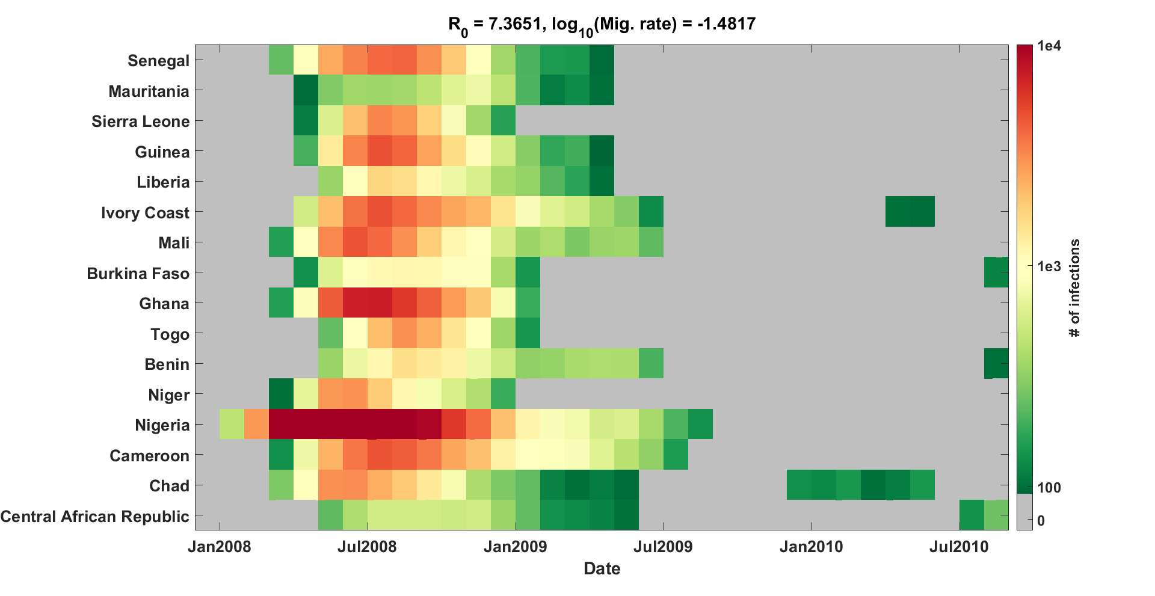

Figure : Example simulation output with migration rate set above the preferred range from calibration. As can be seen, transmission across the region is essentially synchronous, in contrast to the travelling outbreak actually observed.

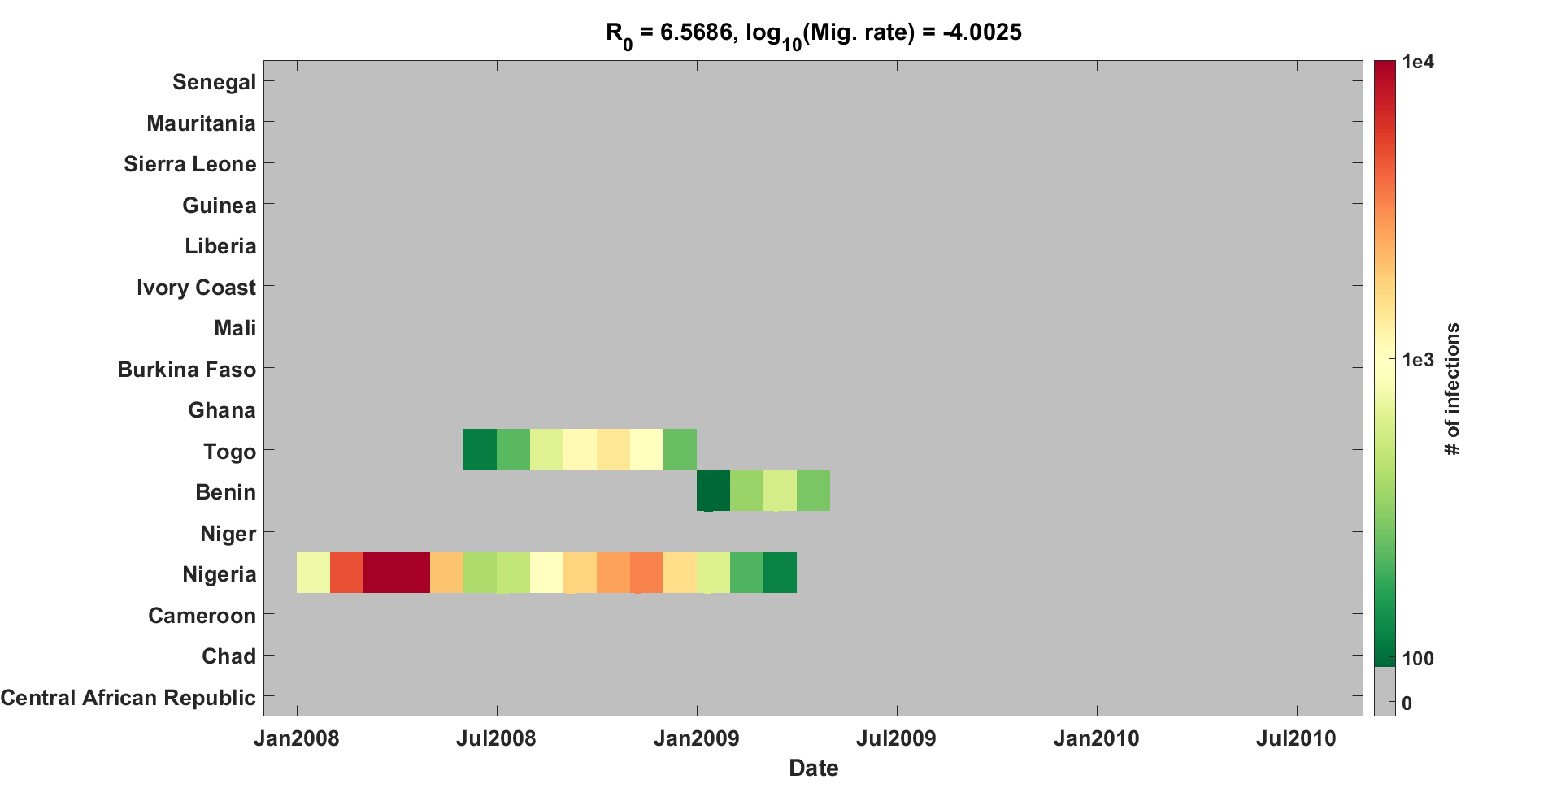

Figure : Example simulation output with migration rate set below the preferred range from calibration. In this case, transmission fails to export broadly across the region (though one or two exportations are not uncommon to observe), in contrast to the travelling outbreak observed in 2008.

While the simulations investigating the risk of Sabin 2 use post-cessation are allowed to explore a wide range of migration rates, this calibration allows for the identification of a preferred region of migration space, aiding interpretability of the results.

**Additional figures**

The simulation metapopulations are generated by applying WHO shapefiles from POLIS to population maps of Africa obtained from the Worldpop collaboration.4,12 Figure 1 illustrates the population map (color) and country/province boundaries (thick/thin black solid lines) that were used. The total size of a given metapopulation is the aggregated sum of the per-pixel population map within the boundaries, and each population is placed at the population-weighted centroid of the province (for purposes of computing distances between metapopulations in the gravity model of migration).

Changing the distance-dependence in the gravity model of migration is found to have a negligible effect on the position of the separatrix line, with an inverse-linear distance-dependence (*c*=1, relatively higher migration rates to provinces of highest population) producing very slightly more risk than an inverse-square dependence (*c*=2, relatively higher migration rates to nearest neighbor provinces). Figure 2 presents the results of this comparison.

Figure 3 shows that increasing the timescale of Sabin 2 reversion from *λ*= 60 days to *λ*= 150 days provides a moderate mitigation of the survival risk, similar to the effect of changing *f* from 0.5 to 0.25 and small compared to the effects of changing R0f or NIPV. However, at the lower values of R0f tested in these scenarios, a longer reversion timescale can have substantial impact, as the effective reproductive number of the circulating Sabin 2 remains well below 1 for multiple generations of infection after the campaigns.

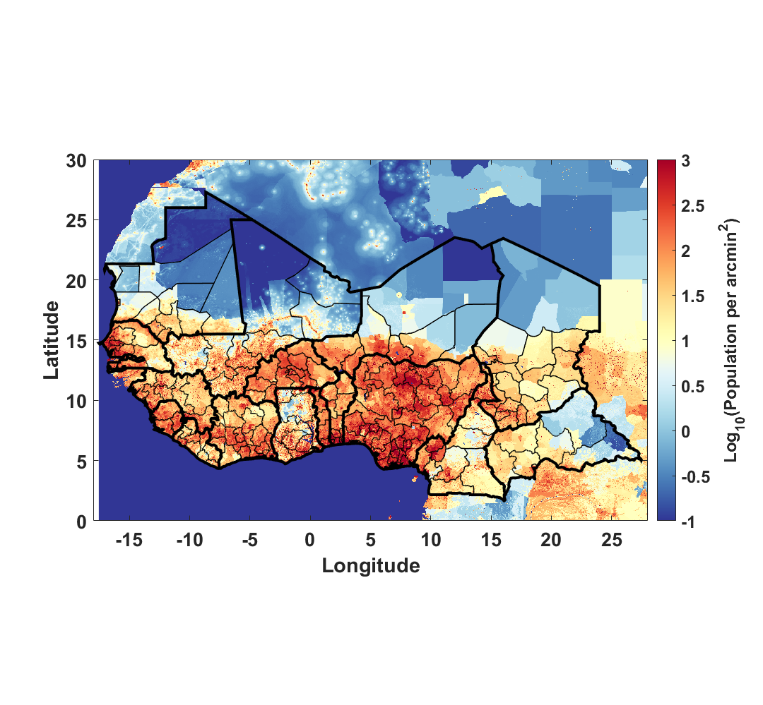

Figure : Population map (color, from Worldpop) and country/province boundaries (thick/thin solid black lines, from POLIS) used to generate the metapopulations for the simulation.4,12 The boundaries and names shown and the designations used in the maps in the supplement of this document do not imply the expression of any opinion whatsoever on the part of the World Health Organization concerning the legal status of any country, territory, city, or area or of its authorities, or concerning the delimitation of its frontiers or boundaries.

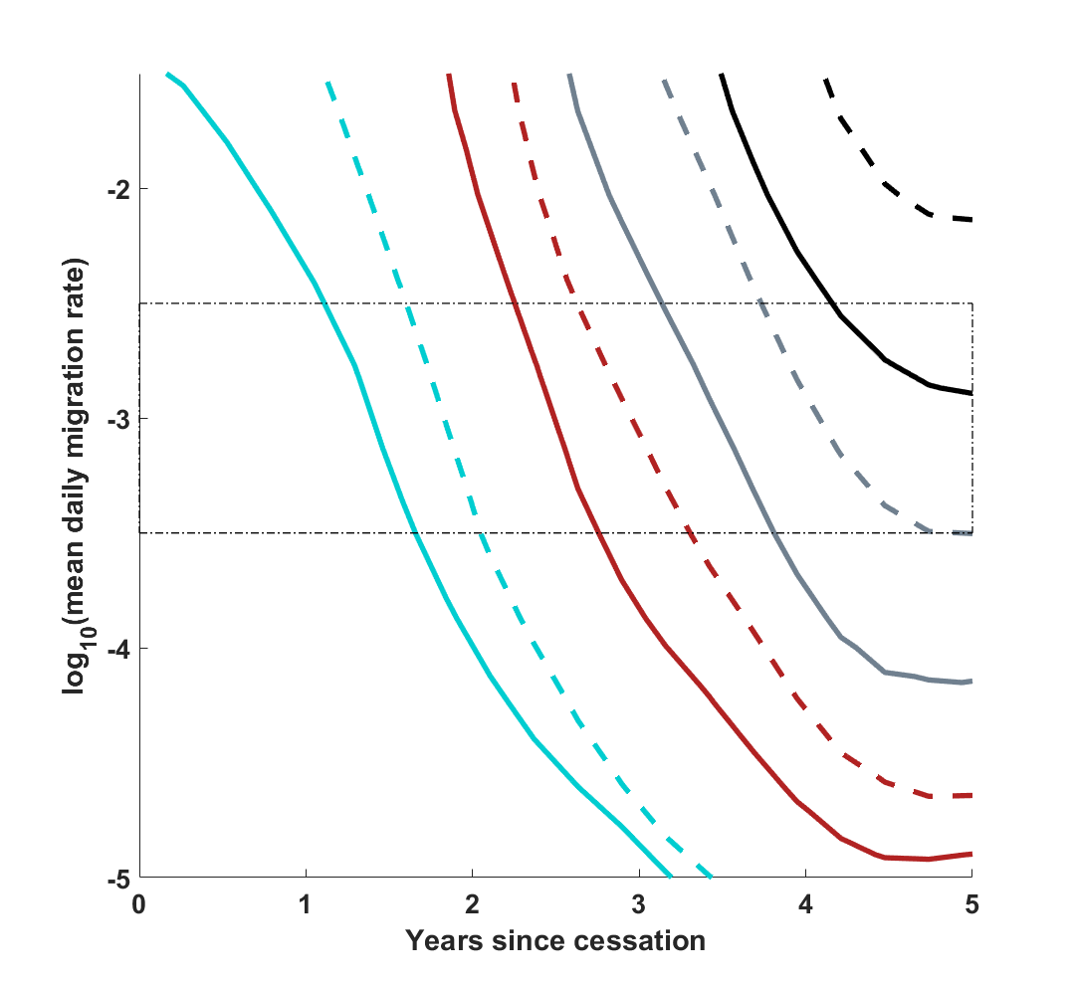

Figure : Position of the 50% separatrix line as the distance dependence in the gravity model of migration varies, at constant *λ*= 60 days, N­IPV= 1, *c*= 1. The solid and dashed lines respectively indicate c = 1 and c = 2, while the cyan, red, grey, and black respectively indicate R0f values of 3, 2, 1.5, and 1.2. The relative distribution of migration rates in the network induces a negligible effect compared with the overall mean migration rate of individuals on the network to all possible destinations.



Figure : Position of the 50% separatrix line as the timescale of R0 reversion varies, at constant f=0.5, N­IPV= 1, *c*= 1. The solid and dashed lines respectively indicate *λ*= 60 days and *λ*= 150 days, while the cyan, red, grey, and black respectively indicate R0f values of 3, 2, 1.5, and 1.2. The final R0 is observed to have the dominant effect. At the higher values of R0f, changing the reversion timescale provides minimal mitigation of the Sabin 2 survival risk, but the effect grows at lower values of R0f, as the effective reproductive rate of Sabin 2 remains below 1 for more transmission generations.

**References**

1 Asturias EJ, Bandyopadhyay AS, Self S, *et al.* Humoral and intestinal immunity induced by new schedules of bivalent oral poliovirus vaccine and one or two doses of inactivated poliovirus vaccine in Latin American infants: an open-label randomised controlled trial. *Lancet* 2016; **388**: 158–69.

2 O’Ryan M, Bandyopadhyay AS, Villena R, *et al.* Inactivated poliovirus vaccine given alone or in a sequential schedule with bivalent oral poliovirus vaccine in Chilean infants: a randomised, controlled, open-label, phase 4, non-inferiority study. *Lancet Infect Dis* 2015; **15**: 1273–82.

3 National Population Commission - Federal Republic of Nigeria, ICF International. Nigeria Demographic and Health Survey, 2013 - Final Report. 2014.

4 POLIS: The polio information system. https://extranet.who.int/polis/Search (accessed Aug 2, 2016).

5 Behrend MR, Hu H, Nigmatulina KR, Eckhoff P. A quantitative survey of the literature on poliovirus infection and immunity. *Int J Infect Dis* 2014; **18**: 4–13.

6 Duintjer Tebbens RJ, Pallansch MA, Kalkowska DA, Wassilak SGF, Cochi SL, Thompson KM. Characterizing poliovirus transmission and evolution: insights from modeling experiences with wild and vaccine-related polioviruses. *Risk Anal* 2013; **33**: 703–49.

7 Hird TR, Grassly NC. Systematic review of mucosal immunity induced by oral and inactivated poliovirus vaccines against virus shedding following oral poliovirus challenge. *PLoS Pathog* 2012; **8**: e1002599.

8 Wesolowski A, Buckee CO, Pindolia DK, *et al.* The Use of Census Migration Data to Approximate Human Movement Patterns across Temporal Scales. *PLoS One* 2013; **8**: e52971.

9 Duintjer Tebbens RJ, Pallansch MA, Kim J-H, *et al.* Oral poliovirus vaccine evolution and insights relevant to modeling the risks of circulating vaccine-derived polioviruses (cVDPVs). *Risk Anal* 2013; **33**: 680–702.

10 Raftery AE, Bao L. Estimating and Projecting Trends in HIV/AIDS Generalized Epidemics Using Incremental Mixture Importance Sampling. *Biometrics* 2010; **66**: 1162–73.

11 Upfill-Brown AM, Lyons HM, Pate MA, *et al.* Predictive spatial risk model of poliovirus to aid prioritization and hasten eradication in Nigeria. *BMC Med* 2014; **12**: 92.

12 WorldPop Collaboration. Worldpop - Selected Data: Africa &gt; Whole Continent &gt; Population 2010. 2012. http://www.worldpop.org.uk/data/summary/?contselect=Africa&countselect=Whole+Continent&typeselect=Population+2010 (accessed Aug 24, 2016).