

A Project Report

On

**“HOSPIQ (Hospital Quick Finder)”**

Batch Details

**GROUP NO: ISR-G07**

|  |  |  |
| --- | --- | --- |
| Sl. No. | Roll Number | StudentName |
| 1 | 20211ISR0056 | AMULYA B |
| 2 | 20211ISR0053 | SNEHA N |
| 3 | 20211ISR0054 | BHAVANA A |
| 4 | 20211ISR0049 | HEMANTH GOVIND RAJ |

**School of Computer Science,**

**Presidency University, Bengaluru.**

Under the guidance of,

Dr. AKSHATHA Y

Assistant Professor

School of Computer Science,

Presidency University, Bengaluru

**CONTENTS**

1. Introduction about Project
2. Literature Review
3. Objectives

## Methodology

1. Timeline for Execution of Project
2. Expected Outcomes
3. Conclusion
4. References
5. **INTRODUCTION**

During medical emergencies, common people always face problems in deciding which hospital they should visit for required treatment. The wander from one hospital to another in search of medical facility, medicines, blood supply, etc. Hospital Finder will solve this problem by allowing people to search for nearby hospitals on the basis of medical treatment, specialist doctors, medicine/blood availability, etc. The Hospital Finder project is an innovative Android application designed to provide users with a simple yet powerful tool for locating hospitals in real-time, ensuring access to medical care is just a few taps away. Developed using Android Studio, the app leverages Google Maps API, location-based services, and a user-friendly interface to offer a seamless experience for users. Upon launching the app, it displays a list of nearby hospitals, complete with essential details such as address, contact numbers, and services offered. This feature is especially valuable in emergency situations, where immediate access to healthcare is critical.

Users can also perform custom searches by entering a hospital’s name, or by filtering hospitals based on specific criteria, such as the availability of certain medical services, such as emergency care or specialized departments like cardiology or pediatrics. The app provides accurate directions to the selected hospital using Google Maps, guiding users with step-by-step navigation from their current location. Additionally, the app is designed to be adaptable across various scenarios, such as traveling or seeking healthcare in unfamiliar regions, making it an essential tool for users who may need assistance in quickly finding medical facilities.

1. **LITERATURE REVIEW**

Existing Methods

* Hospital data API - The Community Benefit Insight data API allows you to retrieve the following types of data: - Hospital data (optionally filtered by state) Link = <https://www.communitybenefitinsight.org/?page=info.data_api>.
* Android based hospital finder app using GPS - To utilize the built-in Global Positioning System (GPS) feature in smartphones to calculate the nearest hospital's location and provide a route from the user's current location through the integration of Google Maps application programming interfaces (APIs). Link https://www.academia.edu/36350507/ANDROID_BASED_HOSPITAL_ FINDER_APPLICATION_USING_GLOBAL_POSITIONING_SYSTEM_GPS.
* Nearest Hospital Tracking and Disease Prediction – this paper focuses on saving patients' time by swiftly locating the nearest hospital, enabling patients to gain more time for understanding their symptoms. Treatment can be tailored based on the patient's disease, ensuring prompt care in nearby hospitals. Link = <https://scholarworks.calstate.edu/downloads/sj139245q>.
* Hospital Locator and Bed Availability Detector for Emergency Cases - The main theme of Hospital Locator and Bed Availability detector for emergency cases is to develop a webservices based system to provide optimal services for the emergency cases. Link = <https://www.irjet.net/archives/V9/i12/IRJET-V9I12142.pdf>
* Domain specific search – The project maintains a cloud-based database of hospitals, clinics, and blood banks. It employs data mining and algorithms to identify optimal hospitals during emergencies. Users register in the application, allowing for cloud-based storage of their data and Electronic Health Records (EHR). The system also assists users in locating clinics and blood banks for specialized medical needs. Link = <https://www.ijatir.org/uploads/613452IJATIR5059-297.pdf>
* Implementation of hospital finder – To develop an application to help and find the location and nearby Ayush hospital with opening time and closing time and by integrating various biomedical data sources, containing information relevant to the hospital demo graphics, their impatient procedure rates, Outpatient department etc. Link = <https://ijrpr.com/uploads/V4ISSUE4/IJRPR11857.pdf>.

**Advantages:**

* + Uses user location coordinates to find nearest hospital.
  + Implements google maps easier to locate the position.
  + User input filters to sort hospitals.
  + Viewing Hospital Details.
  + Suggest Doctor based on symptoms.
  + Appointment with Doctor.
  + View ratings.
  + Hospital distance and route.

**Disadvantages:**

* Limited Accuracy of Location Services.
* The data must be accurate and must reflect real time data.
* Maintenance and Data Updating.
* Battery and Data Usage.
* Need to include all hospitals near use’s vicinity.
* Inaccurate Disease prediction due to lack of physical examining patient.
* Privacy and Data Security Concerns.

**3.OBJECTIVES:**

* The main aim is to quickly locating the nearest hospitals within as per given radius.
* Save patients' time by helping them decide the hospital quickly with the desired medical specialists, treatment and facilities.
* Utilize GPS in smartphones for accurate hospital location and provide route guidance via Google Maps. Allow patients to input symptoms for timely treatment.
* Provide a user-friendly and informative application with details on hospital infrastructure and doctor appointment, availability, including contact information and websites.

**EXPERIMENTAL DETAILS/METHDOLOGY**

Software used: Android Studio

**4.METHODOLOGY**

* Requirement gatherings and Design implementation phase.
* Discuss functional requirements.
* Set up the environment for application development.
* Design UI for the app.
* Plan the task.
* Implement the code and features.
* Testing

**- DESIGN PROCEDURE**

Visual Designer:

1. Open activity_main.xml: Double-click the activity_main.xml file in the Project Explorer.
2. Select Components: Drag and drop components from the Palette (usually located on the left side) onto the design surface.
3. Arrange Components: Use the tools in the Design tab to position and size components.
4. Set Properties: Double-click on a component to open its properties window and customize its attributes (e.g., text, colour, size).

XML Code:

1. Switch to Text Tab: Click on the "Text" tab at the bottom of the editor to view the XML code.
2. Write or Edit Code: Manually write or edit the XML code to define the layout structure and components.
3. Use XML Syntax: Follow the XML syntax rules to create elements, attributes, and nested structures.

**5.OUTCOMES**

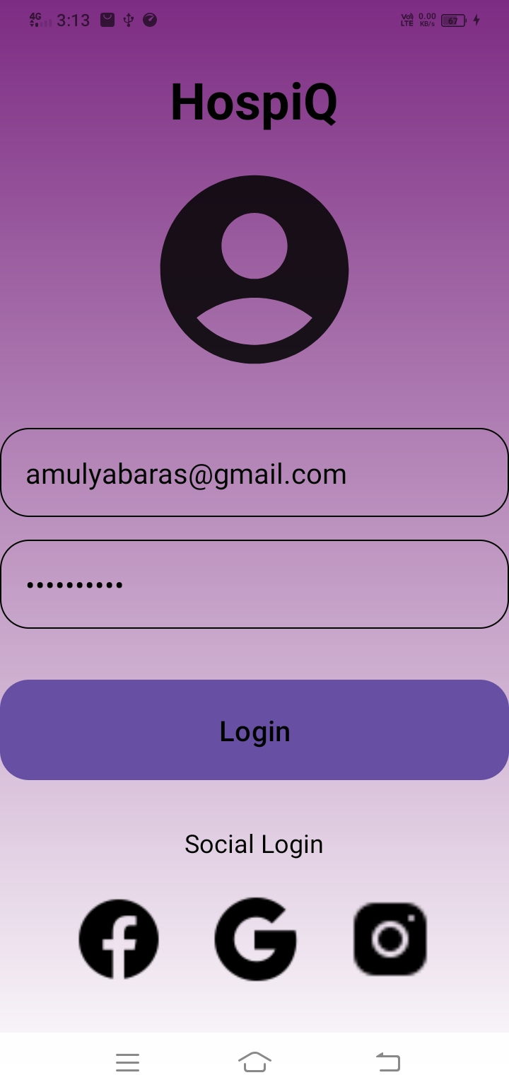

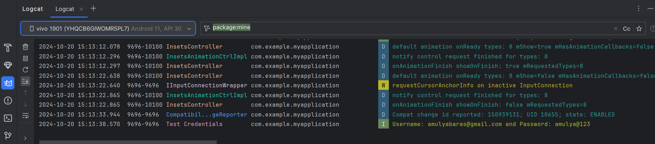

**6. TIMELINE OF THE PROJECT/ PROJECT EXECUTION PLAN**

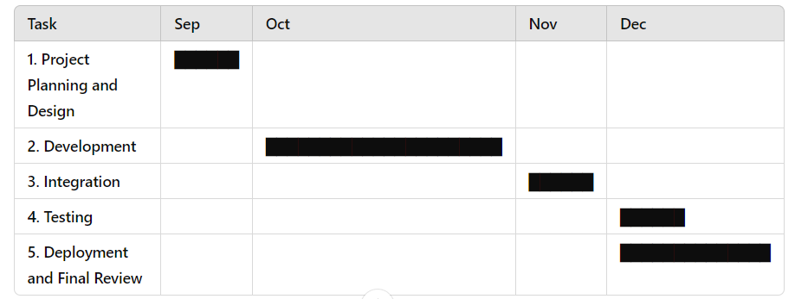

**7.CONCLUSION**

The "Hospital Finder App" represents a significant leap forward in healthcare accessibility and convenience. By harnessing the capabilities of modern technology, this app has successfully addressed the common challenges faced by patients in locating nearby hospitals and specialized medical professionals saving valuable time which can save a person from death in critical and emergency situation.

**8.REFERENCES**

* [**https://github.com/topics/doctor-appointment-booking**](https://github.com/topics/doctor-appointment-booking)
* [**https://github.com/Futsch1/medTimer**](https://github.com/Futsch1/medTimer)
* [**https://www.communitybenefitinsight.org/?page=info.data_api**](https://www.communitybenefitinsight.org/?page=info.data_api)
* [**https://www.researchgate.net/publication/367460409_The_Hospital_Management_System**](https://www.researchgate.net/publication/367460409_The_Hospital_Management_System)
* [**https://www.ijert.org/research/android-based-mobile-application-development-to-connect-local-vendors-with-customers-IJERTV12IS040168.pdf**](https://www.ijert.org/research/android-based-mobile-application-development-to-connect-local-vendors-with-customers-IJERTV12IS040168.pdf)
* [**https://www.academia.edu/36350507/ANDROID_BASED_HOSPITAL_FINDER_APPLICATION_USING_GLOBAL_POSITIONING_SYSTEM_GPS**](https://www.academia.edu/36350507/ANDROID_BASED_HOSPITAL_FINDER_APPLICATION_USING_GLOBAL_POSITIONING_SYSTEM_GPS%20)