Vitals Safety HMI
System Architecture & Debugging Reference
STM32F7508-DK · LVGL v9 · FreeRTOS
Compiled from docs/architecture.md — the project's own generated reference — for use while investigating the intermittent watchdog-reset issue.

Overview
This document describes the three FreeRTOS tasks that make up the application, their priorities and stack sizes, what each does per loop iteration, what shared state each reads and writes, and how data flows between them. Source of truth: Src/main.c.
FreeRTOS configuration relevant to all three tasks (Inc/FreeRTOSConfig.h):
- configTICK_RATE_HZ = 1000 (1 tick = 1ms, so pdMS_TO_TICKS(x) == x)
- configMAX_PRIORITIES = 7
- configUSE_PREEMPTION = 1
- configCHECK_FOR_STACK_OVERFLOW = 2
- heap_4 allocator, configTOTAL_HEAP_SIZE = 32KB
- tskIDLE_PRIORITY = 0 (standard FreeRTOS value)
Stack sizes passed to xTaskCreate() are in 32-bit words on this port (Cortex-M, portSTACK_TYPE = uint32_t), not bytes.
Note on temporary diagnostics: a large fraction of the shared state described in this document is TEMPORARY DIAGNOSTIC instrumentation (counters, timing traces, watermark snapshots) added this debugging session, explicitly marked as such in main.c. It's documented here because it's real state these tasks currently touch, but it's slated for removal once the things it characterizes are confirmed adequate.
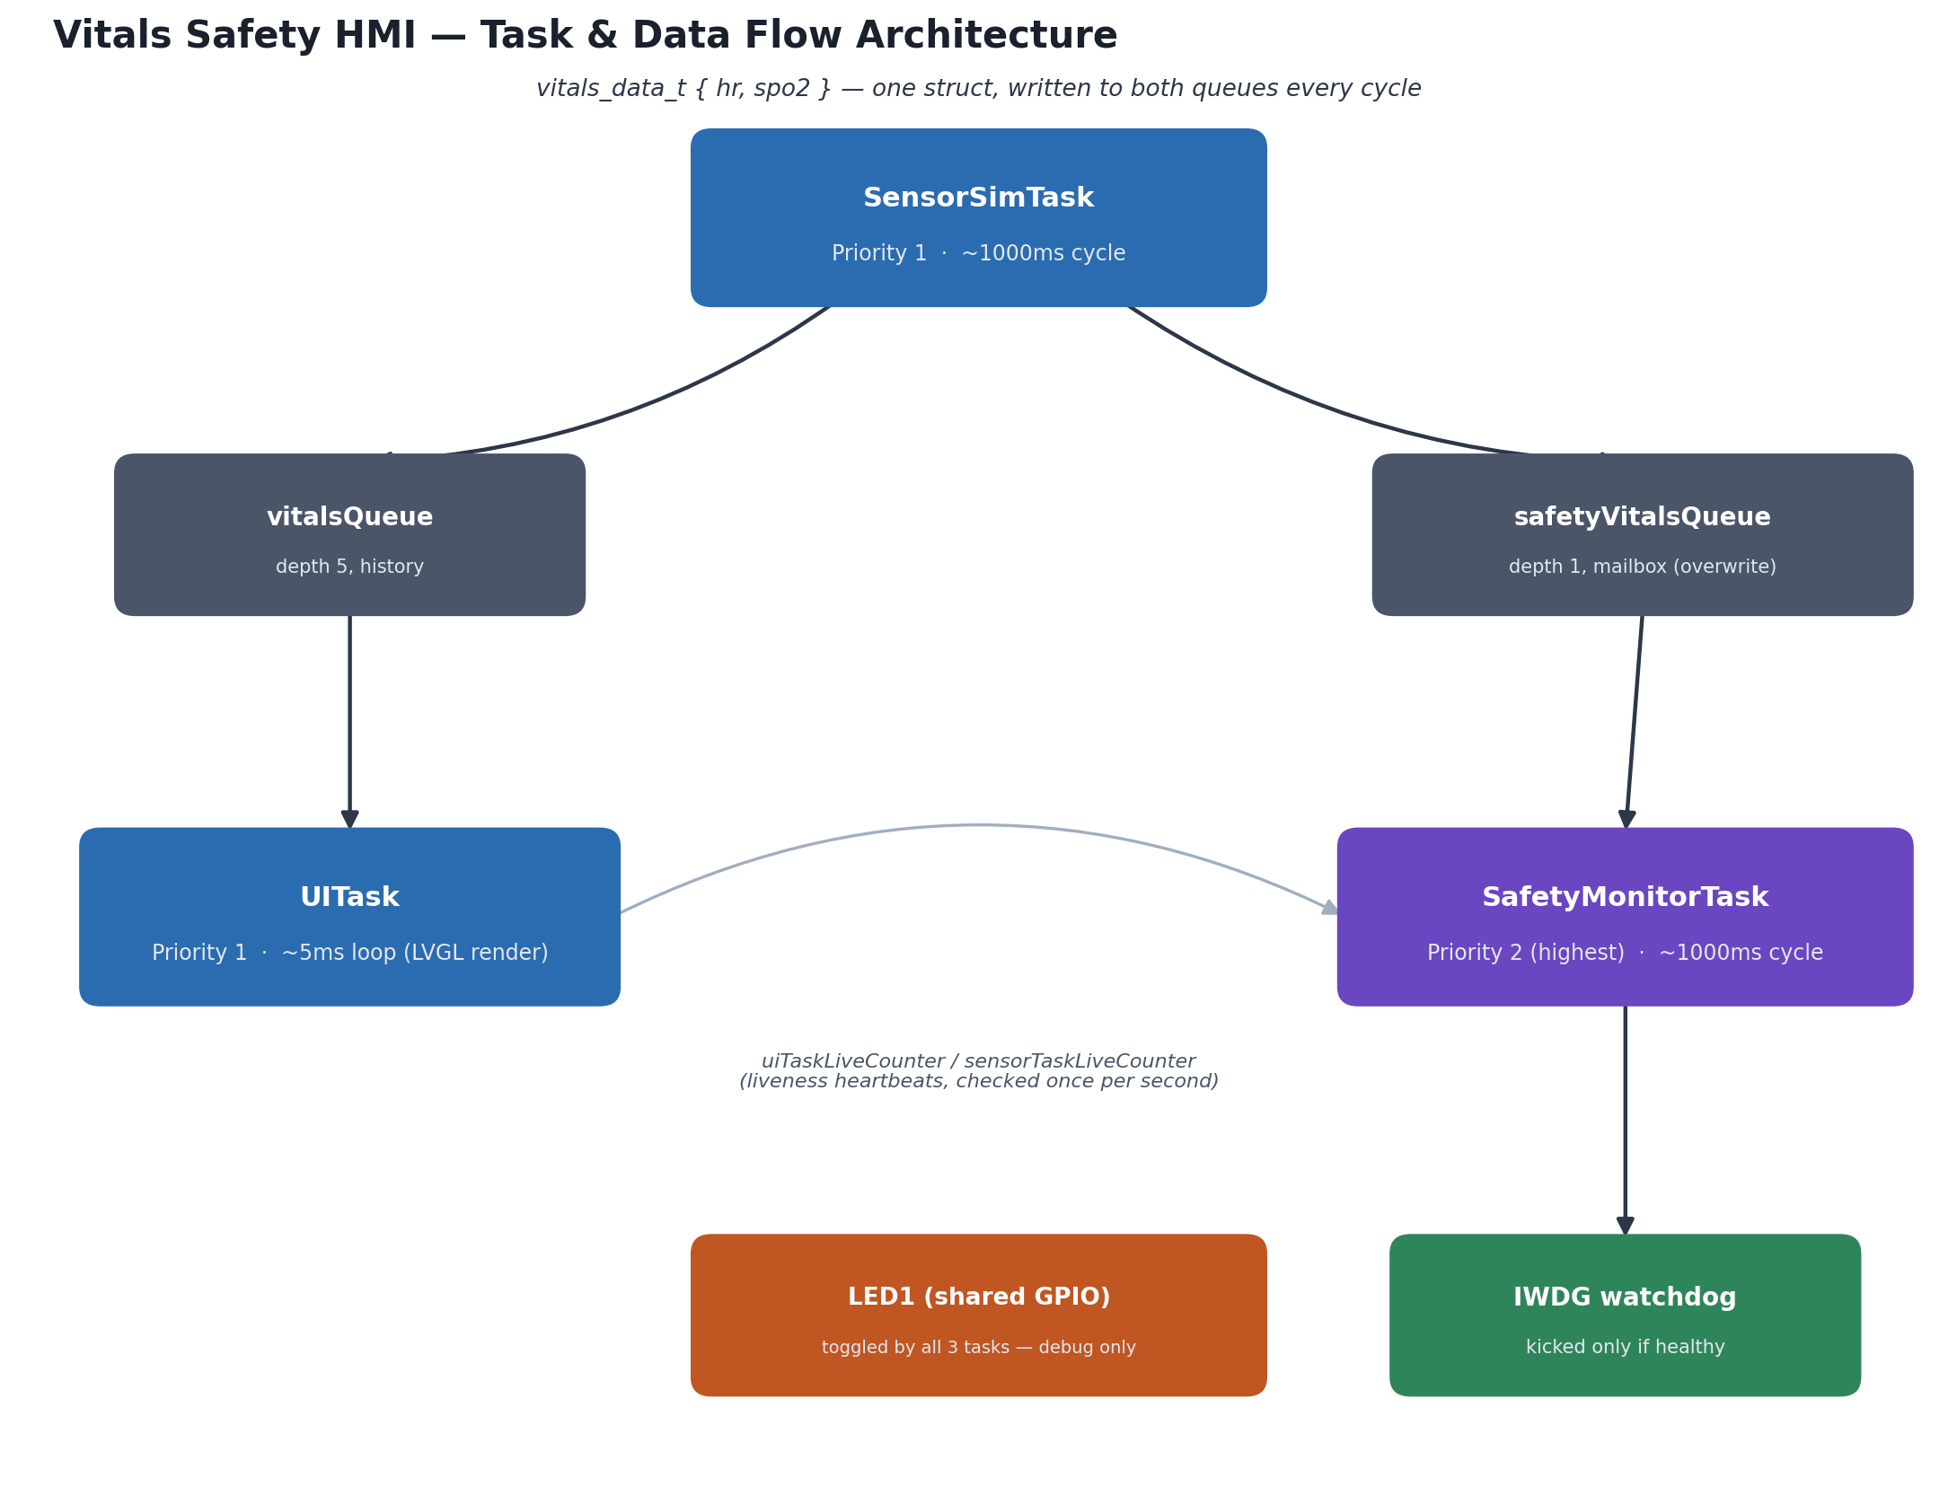
Figure 1 — Task and data-flow architecture: two independent queues carry the same reading to the display and to the safety monitor.

Task summary
 | UITask | SensorSimTask | SafetyMonitorTask
Priority | tskIDLE_PRIORITY + 1 (1) | tskIDLE_PRIORITY + 1 (1) | tskIDLE_PRIORITY + 2 (2) — highest, preempts both
Stack | 2048 words / 8KB | 512 words / 2KB | 512 words / 2KB
Handle | uiTaskHandle | sensoriTaskHandle (sic — typo in main.c) | safetyTaskHandle
Nominal period | ~5ms (busy) | ~1000ms (+20ms on a successful send) | ~1000ms
Main block point | vTaskDelay(5ms) | vTaskDelay(1000ms) | vTaskDelay(1000ms)
Other blocking risk | HAL_I2C_Mem_Read() inside touch read — up to ~450ms worst case across one BSP_TS_GetState() call | None beyond the 20ms debug-flash delay | None
Queues touched | vitalsQueue (consumer) | vitalsQueue (producer), safetyVitalsQueue (producer) | safetyVitalsQueue (consumer)

Both UITask and SensorSimTask share priority 1, so they round-robin/time-slice when both are ready. In practice this rarely matters: SensorSimTask is asleep in vTaskDelay(1000ms) almost the entire time, so UITask effectively has priority 1 to itself.
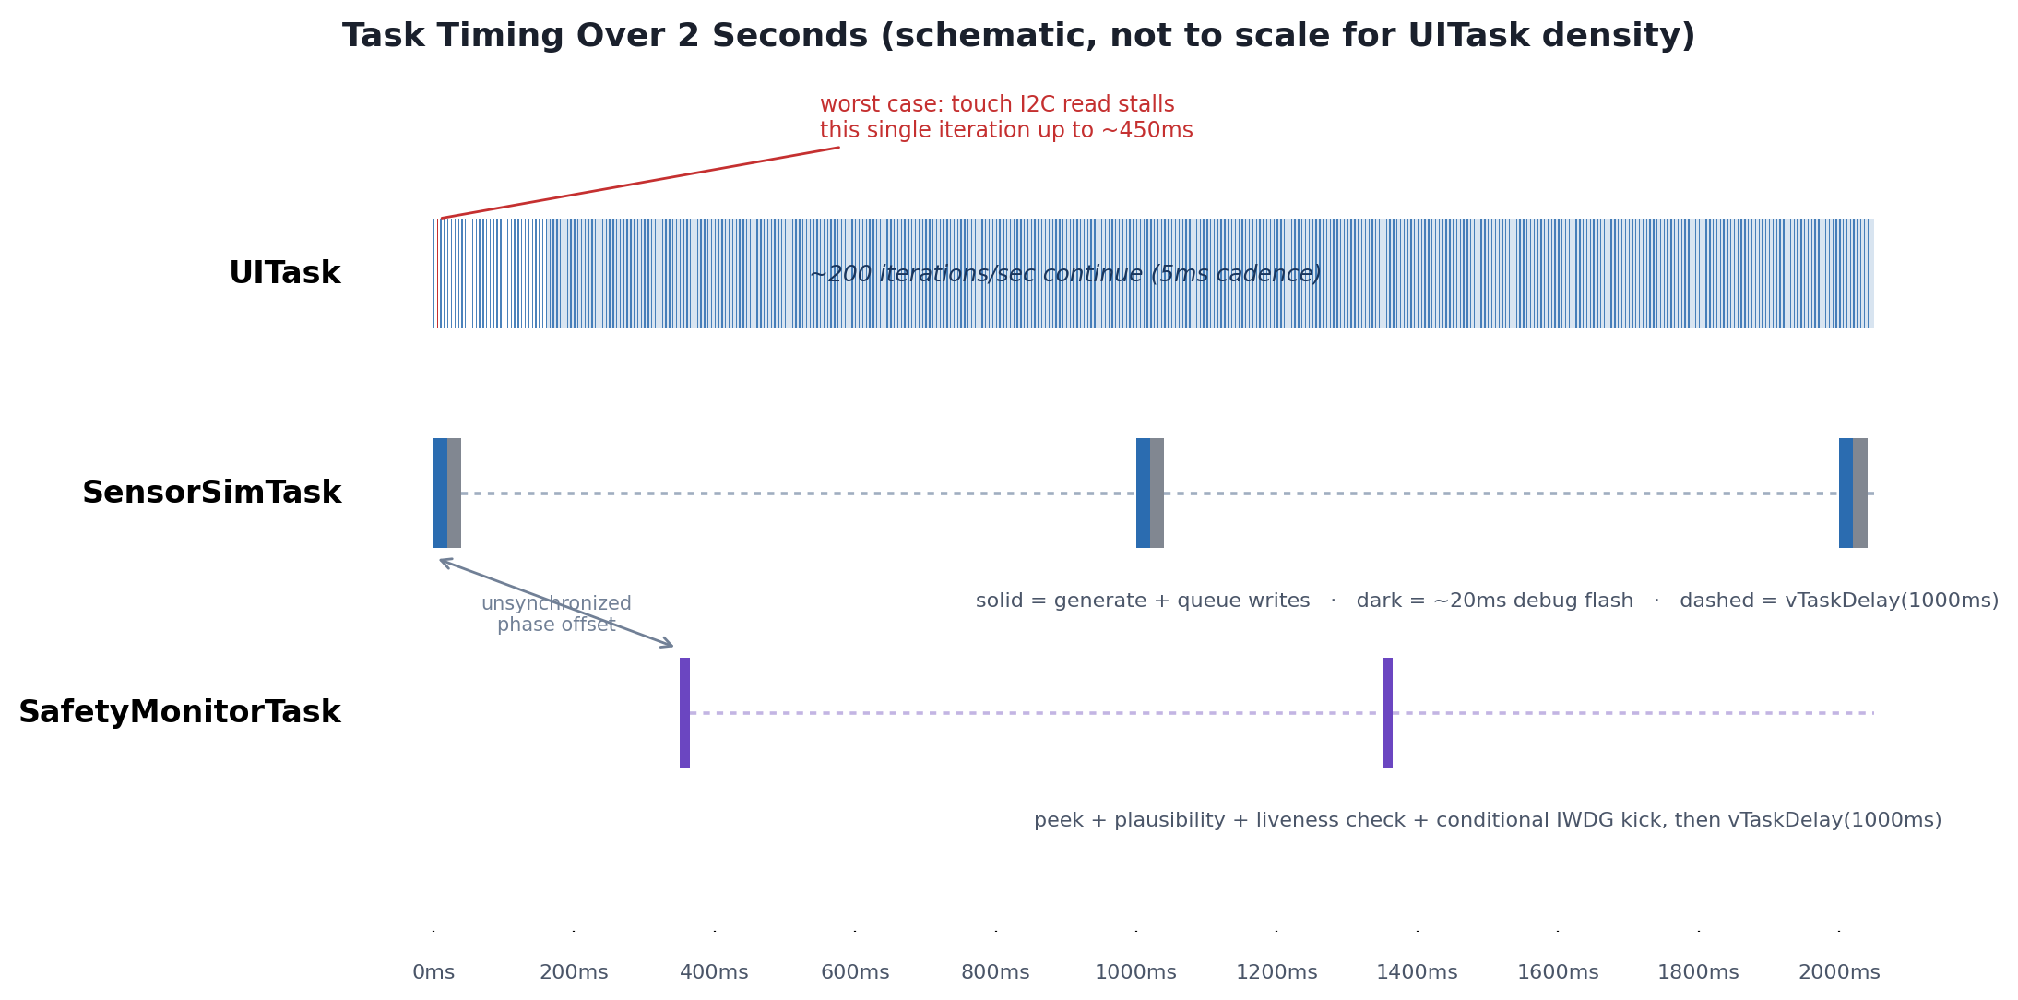
Figure 2 — Relative timing of all three tasks over a 2-second window, showing UITask's dense ~5ms cadence against the two ~1000ms tasks running on unsynchronized phases.

UITask
Priority 1, 8KB stack, handle uiTaskHandle. Owns all LVGL state end-to-end — lv_init(), display/touch driver registration, theme, every widget, and the lv_timer_handler() pump. LVGL isn't thread-safe by default, so every LVGL call is confined to this one task.

One-time setup (before the loop)
- lv_init(), lv_tick_set_cb(HAL_GetTick) — LVGL takes its tick from the same HAL_GetTick() SysTick already drives, rather than a second tick source
- Creates the lv_display_t, registers my_flush_cb (lv_port_disp.c) as the flush callback, points it at lv_draw_buf (the module-static software render buffer)
- BSP_TS_Init() — brings up the FT5336 touch controller over I2C
- Creates the lv_indev_t, registers my_touchpad_read_cb (lv_port_indev.c) as the read callback
- Theme init, then creates every widget: status banner/label, hr_label, spo2_label, the HR trend chart, uptime_label, mem_label

Per loop iteration
- 1. uiTaskLiveCounter++ — liveness heartbeat, read by SafetyMonitorTask
- 2. Record uiLoopStartTick; zero uiTouchReadLastMs (diagnostic)
- 3. Queue poll (timed): xQueueReceive(vitalsQueue, &data, 0) — 0 timeout, pure poll, never blocks. If data is present: updates hr_label/spo2_label/chart, reformats uptime_label, refreshes mem_label via lv_mem_monitor()
- 4. lv_timer_handler() (timed): LVGL's pump — this is where my_touchpad_read_cb() actually runs (if due) and where my_flush_cb() runs if a dirty region needs flushing. Peak duration ≥200ms latches into uiTaskTimerHandlerPeakMs; a peak ≥1000ms toggles LED1 as a visible alarm
- 5. Records this iteration's timings into the uiLoopTrace ring buffer
- 6. uiTaskStackHighWaterMark = uxTaskGetStackHighWaterMark(NULL)
- 7. Blocks: vTaskDelay(pdMS_TO_TICKS(5))

Shared state
Reads: vitalsQueue (produced by SensorSimTask); its own uiTaskTimerHandlerPeakMs/uiLoopTraceIdx; the system tick.
Writes: uiTaskLiveCounter (read by SafetyMonitorTask); uiTouchReadLastMs; the diagnostic peak/trace/watermark fields; the LCD frame buffer via my_flush_cb; LED1 (shared, unsynchronized, with SensorSimTask and SafetyMonitorTask).

Blocks / waits on
- vTaskDelay(5ms) every iteration — the intentional yield
- Not xQueueReceive (0 timeout, never blocks)
Real risk: BSP_TS_GetState() inside lv_timer_handler()'s touch poll ultimately calls HAL_I2C_Mem_Read() with a 50ms HAL timeout, up to 9 such calls in one poll in the worst case (~450ms) if the touch controller is unresponsive or reports too many touches — this blocks the whole task synchronously, it isn't a FreeRTOS-level yield.

SensorSimTask
Priority 1, 2KB stack, handle sensoriTaskHandle. Generates simulated HR (60–100 BPM) and SpO2 (95–100%) via a clamped random walk (small ±1/±2 steps per cycle, not independent jumps), so the values read as a plausible noisy signal.

One-time setup
- data.hr = 75, data.spo2 = 98 (local seed values)
- prng_seed = HAL_GetTick() — seeds the task's private LCG (simple_rand()), a standalone generator, not newlib's rand()/srand()

Per loop iteration
- 1. sensorTaskLiveCounter++ — liveness heartbeat, read by SafetyMonitorTask
- 2. simple_rand() twice — computes a ±2 step for HR and a ±1 step for SpO2, each only applied if it keeps the value within its clamp
- 3. xQueueOverwrite(safetyVitalsQueue, &data) — always succeeds by design; refreshes the depth-1 mailbox SafetyMonitorTask peeks
- 4. xQueueSend(vitalsQueue, &data, 0) — 0 timeout, non-blocking. On success: a visible LED flash (BSP_LED_On, vTaskDelay(20ms), BSP_LED_Off) — an extra ~20ms block on top of the main delay whenever a send succeeds
- 5. sensorTaskStackHighWaterMark = uxTaskGetStackHighWaterMark(NULL)
- 6. Blocks: vTaskDelay(pdMS_TO_TICKS(1000))

Shared state
Reads: none of the cross-task shared state — prng_seed is read-modify-write but private to this task.
Writes: sensorTaskLiveCounter (read by SafetyMonitorTask); prng_seed (private); safetyVitalsQueue; vitalsQueue; sensorTaskStackHighWaterMark (diagnostic); LED1 (shared).

Blocks / waits on
- vTaskDelay(1000ms) — the main ~1Hz period
- vTaskDelay(20ms) inside the debug-flash branch, conditional on a successful send
- xQueueOverwrite / xQueueSend(...,0) are both non-blocking here

SafetyMonitorTask
Priority 2 (highest of the three), 2KB stack, handle safetyTaskHandle. Runs above UITask/SensorSimTask so it can preempt both promptly. Once a second: peeks the latest vitals snapshot and runs a plausibility check, checks both other tasks' liveness counters against their previous values, and refreshes the independent watchdog only if nothing is currently faulted. Detection only — no response/recovery logic exists yet beyond the fault flags and the IWDG.

Per loop iteration
- 1. Plausibility check: xQueuePeek(safetyVitalsQueue, &snapshot, 0) — non-destructive, 0 timeout. If hr<30 or hr>220 or spo2>100: latches safetyFaultPlausibility = true. LED1 toggled as a per-check debug signal
- 2. Liveness check (runs every cycle regardless of step 1): compares uiTaskLiveCounter and sensorTaskLiveCounter against task-local static values from the previous cycle. firstCheck guards the very first pass. If UITask's counter didn't move: latches safetyFaultLiveness = true, sets the UITASK bit in safetyFaultLivenessMask, and captures uiTaskStateAtFault = eTaskGetState(uiTaskHandle). If SensorSimTask's counter didn't move: same latching for the SENSORTASK bit (no state snapshot exists for this one)
- 3. Watchdog: if neither fault flag is set, HAL_IWDG_Refresh(&hiwdg). Otherwise, LED1 toggled instead — refreshes stop unconditionally and permanently once either fault latches, so the IWDG resets the board ~4s later
- 4. safetyTaskStackHighWaterMark = uxTaskGetStackHighWaterMark(NULL)
- 5. Blocks: vTaskDelay(pdMS_TO_TICKS(1000))

Shared state
Reads: safetyVitalsQueue (peeked, not drained); uiTaskLiveCounter, sensorTaskLiveCounter; uiTaskHandle; its own fault flags before deciding whether to refresh the watchdog.
Writes: safetyFaultPlausibility, safetyFaultLiveness, safetyFaultLivenessMask (all latch); uiTaskStateWasSet/uiTaskStateAtFault (diagnostic); safetyTaskStackHighWaterMark (diagnostic); hiwdg via HAL_IWDG_Refresh; LED1 (shared).

Blocks / waits on
- vTaskDelay(1000ms) — the main ~1Hz period
- xQueuePeek(...,0) is non-blocking
- No other blocking calls in this task's loop

Data flow: one value, two independent paths
SensorSimTask computes a single vitals_data_t { hr, spo2 } per cycle and hands the same local struct to both queue writes, back to back — the two paths below always carry identical values per cycle, they never diverge. From there the paths are completely independent: different queue (different depth/semantics), different consumer, different consumer cadence, different purpose.

Path 1 — vitalsQueue → UITask (display)
- 1. Generate (SensorSimTask): clamped random walk updates local data.hr/data.spo2, once per ~1000ms cycle
- 2. Publish: xQueueSend(vitalsQueue, &data, 0) — depth-5 history queue, 0 timeout. If ever full, the value is silently dropped and the debug flash is skipped
- 3. Sit in vitalsQueue until UITask next polls — worst-case wait ~5ms, since UITask polls far more often than SensorSimTask produces
- 4. Consume (UITask): xQueueReceive(vitalsQueue, &data, 0) — 0 timeout, pure poll, never blocks. Most of UITask's ~200 polls/sec find nothing; that's expected
- 5. Apply: on a hit, hr_label/spo2_label text and chart_series are updated directly. uptime_label and mem_label piggyback on the same once-a-second trigger, not on the vitals data itself
- 6. Render: changes are only pixels on screen once this same iteration's lv_timer_handler() call redraws and my_flush_cb() copies into the LCD frame buffer. End-to-end latency: up to ~1000ms for the next SensorSimTask cycle, plus up to ~5ms for UITask's next poll, plus that iteration's lv_timer_handler() cost

Path 2 — safetyVitalsQueue → SafetyMonitorTask (checks)
- 1. Generate: the same cycle, same data struct as Path 1
- 2. Publish: xQueueOverwrite(safetyVitalsQueue, &data) — depth-1 mailbox, always overwrites, always returns pdPASS. No history: a missed cycle would be silently overwritten and never observed — by design
- 3. Sit in safetyVitalsQueue until SafetyMonitorTask's next cycle — up to ~1000ms, since both tasks run on independent, unsynchronized ~1Hz cadences
- 4. Consume: xQueuePeek(safetyVitalsQueue, &snapshot, 0) — non-destructive peek, 0 timeout. If SensorSimTask stalled, the next cycle would peek the same stale value again harmlessly
- 5. Check: hr<30 or hr>220 or spo2>100 sets safetyFaultPlausibility = true on failure
Worth noting honestly: SensorSimTask's random walk is clamped to 60–100 / 95–100, strictly inside these bounds, so under the generator as it exists today this check can never actually fire from real data — it's dormant until either the generator changes or a fault-injection feature is added.
- 6. There is no rendering step on this path — the result is only the latched safetyFaultPlausibility flag, acted on by the watchdog-refresh logic, not displayed anywhere yet
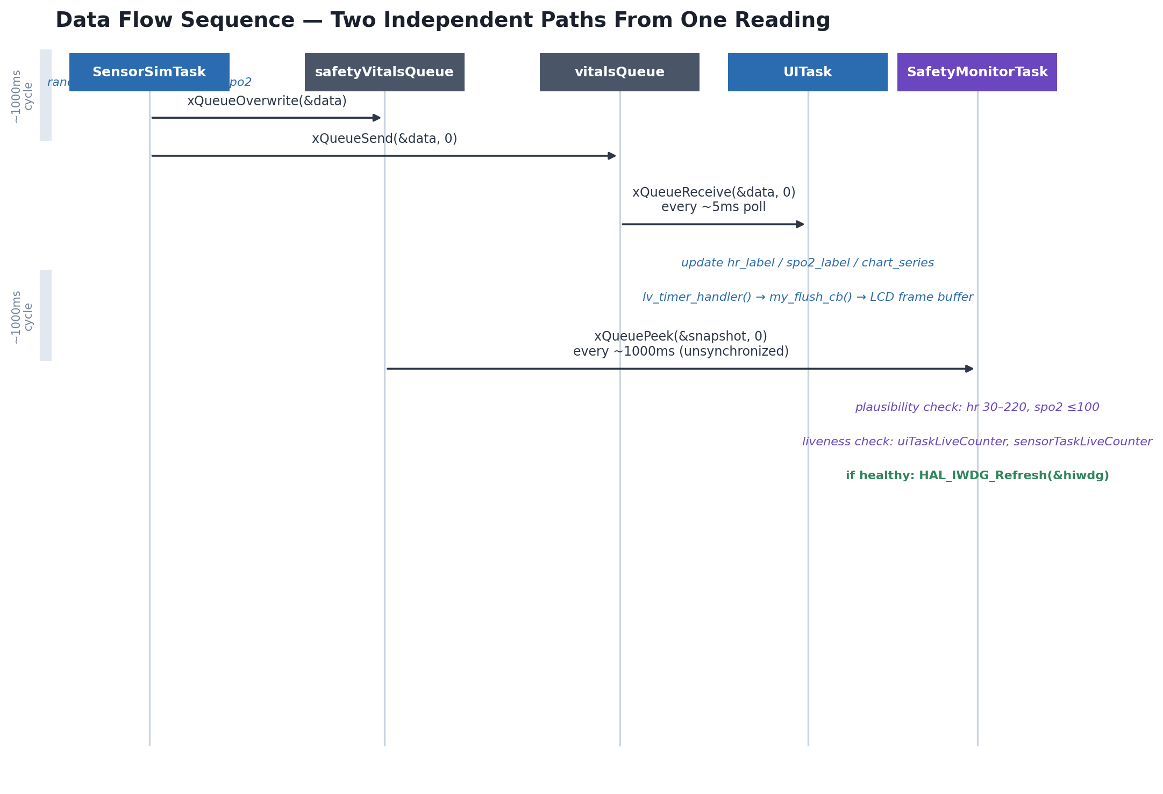
Figure 3 — Sequence view of both data-flow paths from a single SensorSimTask cycle.

Cross-task notes
- LED1 is genuinely shared, unsynchronized state. All three tasks toggle it for different debug purposes (send-success flash, timer-handler-peak alarm, plausibility-check tick, fault indicator). GPIO bit-set/reset is atomic on Cortex-M, so there's no memory-safety race, but blink patterns from different tasks can visually overwrite each other — it's a debug signal, not a reliable indicator of any single task's state.
- The vitals data path is two separate queues, not one: vitalsQueue (depth 5, history) and safetyVitalsQueue (depth 1, mailbox via xQueueOverwrite). Both are written by the same producer pair in SensorSimTask's loop, so they're always refreshed together, but they're independent objects with independent depths and consumers. SafetyMonitorTask never touches vitalsQueue, and UITask never touches safetyVitalsQueue.
- No mutex/critical-section usage anywhere in this file. All cross-task state is either a FreeRTOS queue (safe by construction) or a volatile scalar/small-struct written by one task and read by another, relying on single-word-aligned load/store atomicity on Cortex-M7. This is fine for the scalar liveness counters and latch flags (single writer each), but uiLoopTrace[] entries are multi-field structs written field-by-field — a debugger reading mid-write could in principle observe a torn entry, though since the only reader is a human via breakpoint (not another task), this isn't a real race in practice.

Peripheral pipelines
Both of these run from inside UITask's call to lv_timer_handler() — neither has its own call site in UITask's loop. Both were traced end-to-end this session; this section consolidates those findings.

Display pipeline
LVGL → my_flush_cb() → LTDC frame buffer in SDRAM — confirmed synchronous, no DMA2D, no interrupts.
void my_flush_cb(lv_display_t * disp, const lv_area_t * area, uint8_t * px_map)
{
int32_t w = lv_area_get_width(area);
int32_t h = lv_area_get_height(area);
uint32_t row_bytes = (uint32_t)w * LTDC_BYTES_PER_PX;

uint8_t *dst_start = LTDC_FB_ADDRESS +
(((uint32_t)area->y1 * LTDC_FB_WIDTH) + (uint32_t)area->x1) * LTDC_BYTES_PER_PX;
uint8_t *dst = dst_start;
uint8_t *src = px_map;

for (int32_t row = 0; row < h; row++)
{
memcpy(dst, src, row_bytes);
dst += (uint32_t)LTDC_FB_WIDTH * LTDC_BYTES_PER_PX;
src += row_bytes;
}

uint32_t clean_len = (uint32_t)(h - 1) * LTDC_FB_WIDTH * LTDC_BYTES_PER_PX + row_bytes;
SCB_CleanDCache_by_Addr((uint32_t *)dst_start, (int32_t)clean_len);

lv_display_flush_ready(disp);
}

- No DMA2D. Plain per-row memcpy() with a different source/destination stride. lv_conf.h has LV_USE_DRAW_DMA2D 0 — LV_USE_DRAW_SW (software rendering) is active
- No interrupts. Full NVIC audit found no LTDC_IRQn enable anywhere, and no DMA2D_IRQn either. The LTDC runs free-running off the SDRAM frame buffer
- Confirmed synchronous. lv_display_flush_ready(disp) is called inline, on the same call stack, in UITask context — no async completion to wait for
- Cache clean is currently a no-op. SCB_CleanDCache_by_Addr() exists for when D-Cache is enabled, but D-Cache is currently disabled (a TEMPORARY DIAGNOSTIC to rule out a suspected cache issue) — so this call is harmless but does nothing right now
- SDRAM DMA IRQ is armed (a side effect of BSP_SDRAM_Init()'s mandatory Msp callback) but unused by this pipeline — my_flush_cb()'s plain memcpy() never touches DMA
- Frame buffer: LCD_FB_START_ADDRESS = 0xC0000000, SDRAM, mapped as an 8MB cacheable MPU region. ARGB8888, 4 bytes/px, 480×272 (RK043FN48H panel)

Touch input pipeline
LVGL indev → my_touchpad_read_cb() → FT5336 driver → I2C — confirmed polling mode, current per-transaction HAL timeout 50ms (reduced this session from the original 1000ms).
Call chain: my_touchpad_read_cb() → BSP_TS_GetState() → ft5336_TS_DetectTouch() / ft5336_TS_GetXY() → TS_IO_Read() → I2Cx_ReadMultiple() → HAL_I2C_Mem_Read().
- Confirmed polling, not interrupt-mode. ft5336_TS_Start() calls ft5336_TS_DisableIT() by default. BSP_TS_ITConfig() is never called anywhere in Src/ — the touch INT line isn't armed at the GPIO level, let alone the NVIC
- Current I2C timeout: 50ms (reduced this session from 1000ms, which was sized for a generic HAL example, not this bus — a working FT5336 responds in microseconds to low-single-digit ms)
- No retry. I2Cx_ReadMultiple() calls HAL_I2C_Mem_Read() exactly once; on failure I2Cx_Error() only de-inits/re-inits the bus for the next call
- Worst-case blocking, with both this session's fixes applied: BSP_TS_GetState() sanity-checks the reported touch count against TS_PLAUSIBLE_MAX_TOUCH = 2 (this board's realistic limit, not the FT5336's theoretical max of 5) before looping — a count above 2 is discarded as a sensor glitch. Reachable worst case is now 1 + 2×4 = 9 I2C transactions × 50ms = ~450ms, down from ~21s pre-fix. The common single-failure case (controller unresponsive) is ~50ms
- Timed this session, not just estimated: my_touchpad_read_cb() wraps its own BSP_TS_GetState() call with HAL_GetTick() before/after, into uiTouchReadLastMs — the real duration is visible per UITask iteration via uiLoopTrace
- I2C EV/ER interrupts are armed but idle for this path — a side effect of initializing the audio codec's I2C handle, which this project never uses. HAL_I2C_Mem_Read() is the blocking/polling API, not _IT, so nothing depends on those interrupts firing

Global / shared state reference
Every file-scope variable in main.c, in declaration order. "Read by" only counts reads from task code — a variable inspected purely via breakpoint/Live Watch is marked debugger-only, since that's a human reading it, not another task.

Cross-task shared state
Variable | Type | volatile | Written by | Read by
vitalsQueue | QueueHandle_t | no | main() (created once) | SensorSimTask (xQueueSend), UITask (xQueueReceive)
safetyVitalsQueue | QueueHandle_t | no | main() (created once) | SensorSimTask (xQueueOverwrite), SafetyMonitorTask (xQueuePeek)
uiTaskHandle | TaskHandle_t | no | main() (xTaskCreate output, written once) | SafetyMonitorTask (eTaskGetState)
sensoriTaskHandle (sic) | TaskHandle_t | no | main() (written once) | nobody — captured but never read
safetyTaskHandle | TaskHandle_t | no | main() (written once) | nobody — captured but never read
uiTaskLiveCounter | uint32_t | yes | UITask (++ every iteration) | SafetyMonitorTask (liveness check)
sensorTaskLiveCounter | uint32_t | yes | SensorSimTask (++ every iteration) | SafetyMonitorTask (liveness check)
safetyFaultPlausibility | bool | yes | SafetyMonitorTask (plausibility check, latches) | SafetyMonitorTask itself (watchdog gate)
safetyFaultLiveness | bool | yes | SafetyMonitorTask (liveness check, latches) | SafetyMonitorTask itself (watchdog gate)
safetyFaultLivenessMask | uint8_t | yes | SafetyMonitorTask (|= per stalled task) | debugger-only
uiTouchReadLastMs | uint32_t | yes | my_touchpad_read_cb() (runs inside UITask's own call) | UITask (copies into uiLoopTrace)
uiTaskStateAtFault | eTaskState | yes | SafetyMonitorTask (UITask-fault branch only) | debugger-only
uiTaskStateWasSet | bool | yes | SafetyMonitorTask (reset false every cycle) | debugger-only

vitalsQueue/safetyVitalsQueue aren't volatile because FreeRTOS queues are already internally synchronized — volatile on the handle itself would be meaningless, since the handle is a pointer written once before the scheduler starts. Same reasoning for the three TaskHandle_t values.

Global, but effectively single-task (not cross-task shared)
Included for completeness — these are only ever touched by one task, so they carry no cross-task race concern despite being volatile at file scope.
Variable | Type | volatile | Owner task | Notes
lv_draw_buf | uint8_t[...] | no | UITask | LVGL's software render staging buffer; written/read only inside UITask's lv_timer_handler() call
prng_seed | uint32_t | no | SensorSimTask | Private LCG state for simple_rand(); seeded once, never touched elsewhere
hiwdg | IWDG_HandleTypeDef | no | SafetyMonitorTask | Peripheral handle; HAL_IWDG_Refresh(&hiwdg) is the only touch after init
uiTaskTimerHandlerPeakMs | uint32_t | yes | UITask | Written and read only by UITask; debugger-inspectable too
uiTaskStackHighWaterMark | UBaseType_t | yes | UITask | debugger-only reader
sensorTaskStackHighWaterMark | UBaseType_t | yes | SensorSimTask | debugger-only reader
safetyTaskStackHighWaterMark | UBaseType_t | yes | SafetyMonitorTask | debugger-only reader
lvMemUsedPct / FragPct / FreeSize | uint8_t / size_t | yes | UITask | debugger-only; mem_label's text is formatted from a local, not read back from these
uiLoopTrace / uiLoopTraceIdx | struct[24] / uint32_t | yes | UITask | Written every iteration; debugger-only reader

Not included above: the three static locals inside SafetyMonitorTask (lastUiCount, lastSensorCount, firstCheck) — persistent across calls but scoped to the function, invisible to any other task, so private task state despite static storage duration. Also not included: SD_FatFs, SD_Path, pDirectoryFiles, ubNumberOfFiles, uwBmplen, uwInternelBuffer — these exist in source but inside an #if 0 block, not compiled into the current build.

Known issues / current investigation

Intermittent watchdog reset
Symptom: the board resets unexpectedly and intermittently during operation, consistent with the IWDG firing (~4s nominal timeout) rather than a clean reboot. Root cause not yet identified. Under active investigation.
Ruled out so far — do not re-investigate these:
Hypothesis | Verdict | Evidence
Memory leak | Ruled out | Heap stays flat over time
Stack overflow | Ruled out | Healthy headroom on all three tasks (high-water-mark diagnostics)
QSPI / cache interaction | Ruled out | Persists with D-Cache disabled
ISR-driven LVGL calls | Ruled out | Flush path is fully synchronous, no ISR involved — confirmed by the display-pipeline trace
Chart shift-transition cost | Ruled out | Timing didn't scale with point_count (tested at 30 and at 5)
Touch I2C timeout | Ruled out | Fix applied (1000ms → 50ms), issue persisted after the fix
None of the above explain the symptom. Whatever's causing the watchdog to fire is still open.

