Type Done – Developing Personalized AI Methods for Diabetics

Augustus Madsen

Introduction

Over seven million Americans require daily insulin injections to survive. Many of these insulin dependent individuals receive wrong information regarding their ratios for carbohydrates, blood sugar levels, and unit dosages. Appropriate diabetic care is unique to that specific person. Artificial intelligence can help diabetics better understand their condition, while also making more informed decisions about the kind of plan that is required. Additionally, the use of data science, more specifically analyzing data sets of demographic, health, and other variables can assist with this process. It is important to use the tools at hand to attempt to detect patterns or trends that may lie in certain information that will help make these plans possible. Diabetes requires constant self-awareness, and managing it is a full-time job in and of itself. We have a responsibility to utilize these methods and explore relevant information that may be contributing to different qualities in diabetic patients and determine how to proceed with care that best meets their needs.

The Problem

The issue in diabetics is that different glucose readings could mean very different results depending on the individual. Someone with a glucose level of 200 (high) may function normally compared to someone with a level of 130 (slightly elevated – but close to normal), who could begin feeling manic symptoms. Our healthcare industry is so generalized that these people may receive the exact same recommendation for insulin dosage per meal. This may work for specific amounts of carbohydrates, but it does not factor in the diabetics’ environment, certain demographics, their levels of stress, or anxiety which could all be contributing to the glucose reading. Therefore, these two cases are not equal. The disease effects everyone separately, and it is necessary to take this into consideration.

Addressing the Problem

To figure out the best way to proceed, it was necessary to find a dataset that included glucose readings as well as “less common” information to investigate trends in these variables that may be relevant. The data was pulled from several sources and key characteristics were chosen to pair together in the analysis and determine which personal attributes were resulting in a high blood glucose, as opposed to just more carbohydrates or less of an insulin dosage.

Analysis of the Variables

The analyses was conducted within R, and listed below are several of the results from various methods:

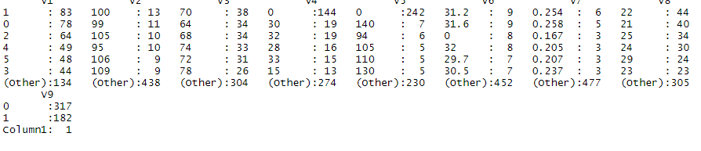

This table reflects a simple summary of the variables in the initial data set, ranging from blood glucose readings, to BMI, to skin thickness and age. This provides a count of results in each column, showing where most individuals fall within the study which reveals trends about the norms and clusters of common measurements. These results help determine where the average diabetic may fall within their age group or body mass index with regards to their glucose reading.

Implications for Diabetics

Limitations of Analysis

Conclusion

This study provides some wonderful insight on the factors that contribute to different glucose readings and A1C levels in diabetics. More than anything, it is important to recognize that everyone requires different treatments. The disease is more than taking insulin before meals. Mental health can contribute just as much – if not more than a high-carb meal. Additionally, a patient’s environment, income, household situation, and relationships can all play a part in these readings. As we have seen from the results, personalized care can be adaptable. A physician could analyze these results and see where a diabetic’s needs fall, and in what capacity, so they can appropriately treat them in those areas that are more impactful on the condition itself. By stopping this generalization of diabetes, we can create a healthier world, by starting with one person at a time.