The Steam Pricing Dilemma

Introduction
In a marketplace as saturated as Steam (over 97,000 premium titles competing for attention), price is the most critical lever a developer can pull. However, pricing is rarely treated as a science. Most independent studios rely on "gut feeling" or surface-level competitor benchmarking, often leading to one of two failures: pricing too high and killing initial momentum, or pricing too low and leaving significant revenue on the table. Moreover, the low barrier to entry on Steam often leads developers into a financial minefield. Without a data-backed pricing strategy, even the most talented and persistent creators risk a commercial failure so severe it shutters their aspirations before they ever have the opportunity to find an audience.

Problem
The central challenge of the Steam marketplace is that "success" is not a singular metric, yet pricing is often treated as a singular, arbitrary decision. For a developer, the primary hurdle lies in the lack of data-driven tools to navigate the three-way trade-off between maximizing immediate Revenue, acquiring a significant Player-base (Peak CCU), and sustaining long-term Engagement (Playtime).
This project seeks to solve this information gap by answering a fundamental question: How can we utilize machine learning to simulate market behavior and identify the mathematical "sweet spot" for pricing across diverse genres? By modeling how price impacts different success metrics, I aim to provide a prescriptive framework that allows developers to align their pricing strategy with their specific business goals.

Dataset
The dataset for this analysis is the Steam Games Dataset available on HuggingFace from FronkonGames. The dataset is loaded using the HuggingFace datasets library to load using a public HuggingFace key. Due to the size of the dataset, the script also saves the dataset into a folder on the script’s folder called “Data”. This reduces execution time by a full minute, since that is how long loading typically took. The dataset is composed of 97,710 rows with 41 columns. Each row was attributed to a different title available on Steam, with columns like Price, Revenue, Genres, etc. There were no duplicate values, but there were about 640000 missing values in 11 columns across the dataset.

Preprocessing
There were six main tasks that needed to be performed as part of the initial preprocessing pipeline.
- Remove Duplicate Entries: I audited the dataset for duplicate observations. While each game has a unique AppID, identifying and removing duplicate names ensures that the genre medians are not skewed by redundant entries or regional variations. Regardless, no entries needed to be removed in this step.
- Remove Games with Missing Names: Data points with null or missing values in the name column were removed to maintain a clean, identifiable dataset, as these entries often represent incomplete or "ghost" listings. There was only one entry that was removed for this reason.
- Calculate Owner Midpoints: The estimated_owners field was provided as a categorical range (e.g., "0 - 20,000"). A more precise value was not provided due to the limitations imposed by Steam. I parsed these strings and replaced them with their calculated midpoint (e.g., 10,000) to transform the feature into a continuous numerical variable suitable for regression.
- Calculate Revenue: Using the newly generated numerical owner counts, I created the est_revenue feature. This was calculated by multiplying each game's price by its estimated_owners midpoint, providing the primary financial metric for the optimization.
- Filter Out Free-to-Play Games: I excluded all titles with a price of $0. These games operate on microtransaction and "Games as a Service" (GaaS) models that do not align with the standard premium pricing model I am attempting to optimize. Since the dataset does not include microtransaction pricing, it is impossible to optimize games under these models, and are thus excised from the dataset.

Data Exploration
The exploratory phase began with a fundamental question: which genres command the highest median revenue on Steam? However, an initial plotting of Revenue vs. Genre immediately revealed a significant structural issue within the dataset that required a pivot in analytical strategy.

The Discovery of "Non-Game" Noise
Initial visualizations showed that the highest revenue was not being generated by traditional games, but by professional-grade software—specifically tools for Video Production, Animation, and Software Development. While Steam is a primary marketplace for entertainment, it also serves as a distribution hub for high-ticket professional utilities. Including these in a "gaming" analysis would fundamentally skew the results, as the pricing power and market behavior of professional production software do not align with the entertainment industry. The graph that led me to this conclusion is shown below:
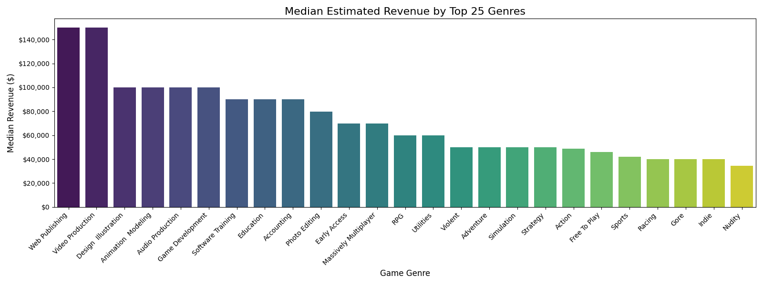

Resolving Genre Mislabeling
Furthermore, a deep dive into the genres column revealed that "Early Access" and "Free to Play" were being treated as distinct categories. Through critical inspection, I determined:
- Early Access is a developmental lifecycle stage, not a genre.
- Free to Play labels were often redundant or inconsistent with the actual pricing data handled in the preprocessing phase.
To ensure the subsequent modeling was grounded in actual gameplay categories, I executed a refinement strategy focused on isolating the entertainment market and normalizing the genre list.

Refining the Genre Landscape
To solve these issues and prepare the data for final visualization, I performed the following 7 tasks:
- Quantified the total number of unique genres present in the raw metadata.
- Created a binary Game column (True/False) to programmatically separate entertainment titles from professional utilities that was determined by the list of genres attributed to the title that was manually curated be me.
- Isolated Early Access into its own binary column to treat it as a developmental feature rather than a content category.
- Removed the "Early Access" and "Free to Play" labels from the primary genre lists to prevent them from diluting content-based analysis.
- Counted the affected titles to understand the volume of "mislabeled" or "unlabeled" entries.
- For titles that were left without a category after the purge (those originally labeled only as Early Access or Free to Play), I created a "No Genre" label to maintain data integrity while acknowledging the lack of specific content tags.
- Recreated the Median Revenue vs. Game Genre graph, strictly excluding non-games to provide a clear, accurate financial benchmark for the actual gaming market.
Performing these steps revealed several key facts:
- There are 1,265 professional software titles that wouldn’t count as games and were removed
- There were 27 titles that only had the “Early Access” genre
- There was 1 title that was labeled as a “Free To Play” genre
- There are 109 titles that had no genres at all
- A total of 137 titles had to be attributed as “No Genre” by me
After performing these preprocessing steps, I recreated the median revenue vs genre graph shown here:
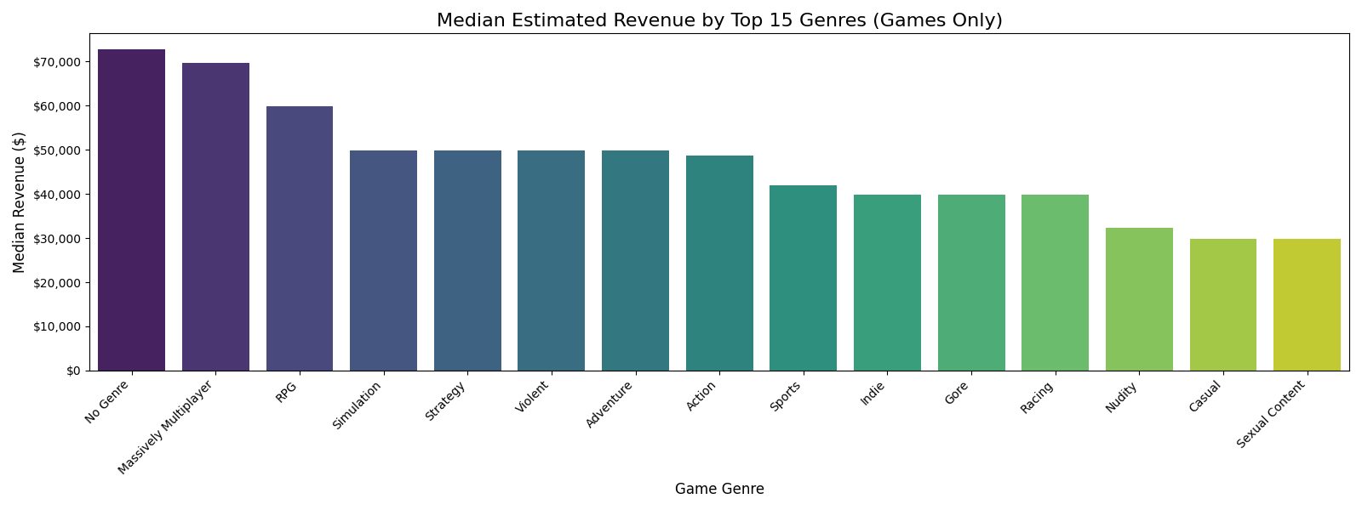
I also decided it would be opportune to create a graph of the counts of each genre, as shown here:
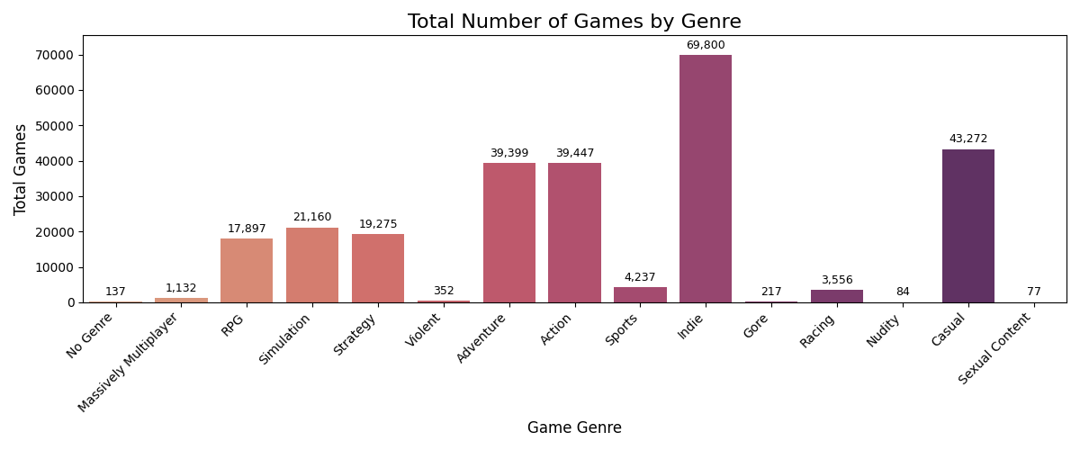
The two graphs show that there were 15 game genres remaining after the cleaning steps. Key findings from the two graphs show:
- Games without a genre lead the dataset with a median revenue exceeding $70,000
- Massively Multiplayer games and RPGs follow closely with $70,000 and $60,000 respectively
- Lower median revenue genres were Casual, Sexual Content, and Nudity. It is likely that these games will have a lower optimal price
I noted a curiousity in the dataset, in which all the revenue numbers are neat, even numbers. This is due to the way Steam represents this data. The figures are represented as ranges in the dataset with discrete endpoints. When calculating the midpoint values, these are also neat and clean even numbers.

Calculating Concurrent Players
I moved on to calculating concurrent player counts. Sometimes high revenue titles do so by incorporating gambling mechanics or other anti-consumer practices that result in high revenue, but low player count. These practices turn players away from future releases from the same publisher or developer. Concurrent player counts thus are a valid measure of a game’s “value” and should be considered when determining a price. However, keep in mind that since the price of a game is a “buy-in” value, it may be that the concurrent player number is a result of the pricing, instead of an accurate predictor. Regardless, it was considered as a factor for determining pricing because it provides insight into how many people play games of a given genre long-term.

The Empty Graph
When plotting the Concurrent Player vs Genre graph, I ran into a curious problem. I will showcase it here:
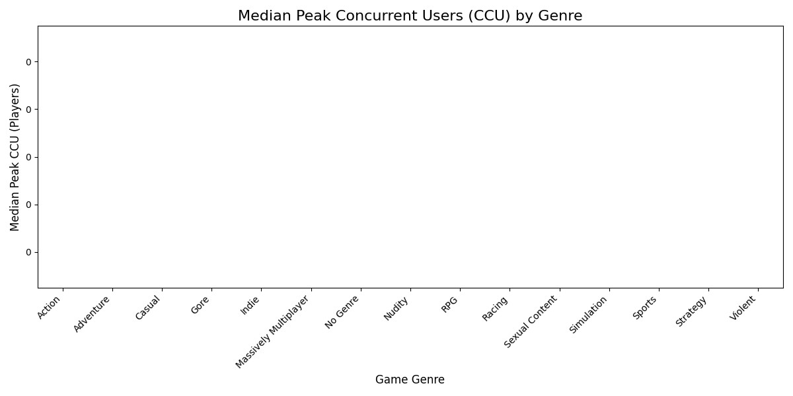
Sharp readers will be able to ascertain the problem after some deliberation. Chiefly that the graph is blank. This is also where I determined perhaps the most important facet of the dataset. The overwhelming majority of Steam games have no active players.
Steam has very low barriers to entry, which means that the marketplace the store is flooded with abandoned student projects, asset flips (titles that leave default placeholder engine assets in place of created assets), and forgotten indie titles that have a Peak Concurrent User (CCU) count of exactly 0. Since median was the metric used to calculate this metric, the tens of thousands of games dragged the mathematical middle point to zero.

Finding Active Games
In order to solve this issue, I had to remove all games that had a peak_ccu of 0. There were 79,340 games that matched this measurement. This accounts for 82.24% of the entire dataset. Removing these games resulted in this Median Peak CCU vs Genre graph:
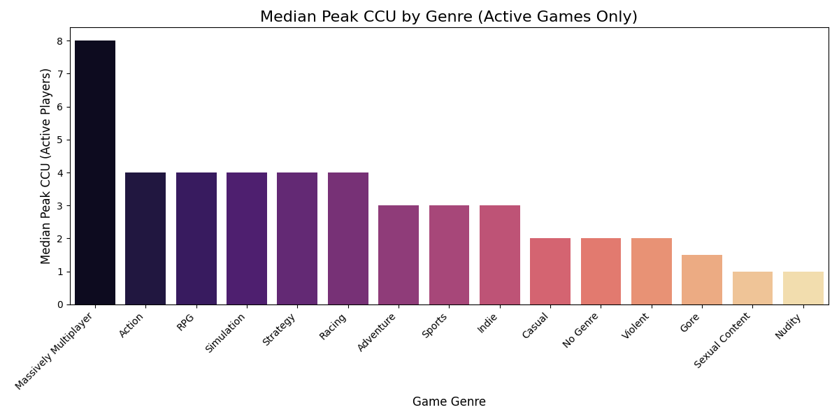
This graph shows that by far the genre with the highest peak CCU is the “Massively Multiplayer” genre. However, also notice that the vertical scale maxes out at about 8. Unfortunately, this is a brutal reality of the Steam Marketplace. 50% of all Action games released on Steam will have a peak CCU at or below 4. The other 50% will be above. This represents a “long tail” where the vast majority of titles will be considered commercial failures while it is the outliers that succeed and gain player counts above 10,000.
After cleaning the dataset for the last time, the median revenue graph is recalculated and displayed here:
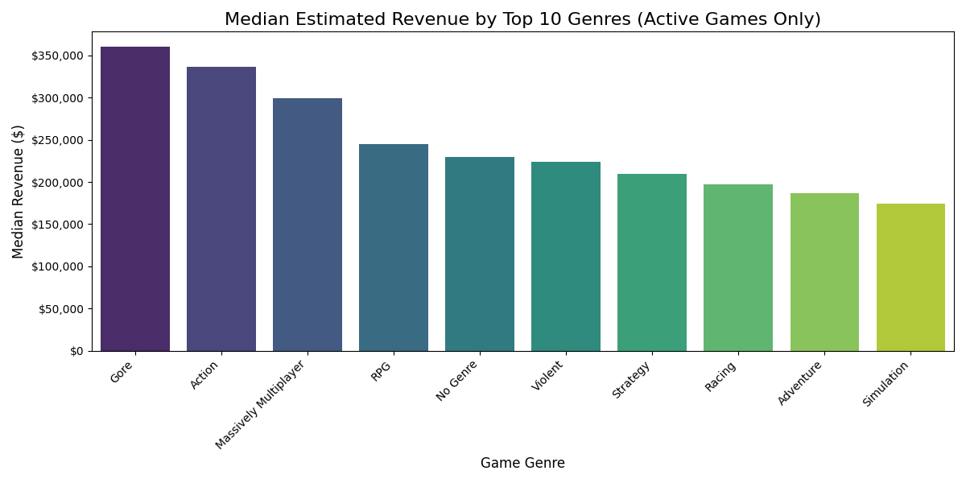
It is apparent that the “Gore” genre produces the most revenue over a game’s lifetime. However, there is an important fact to note.

The Revenue Calculation
If the median peak CCU is so low (8 was considered the best in the genre as shown in the previous graph), why is median revenue so high? This is due to the way that the revenue value is calculated. The revenue column is not part of the original dataset. Instead, the midpoint of the current owners range of values is taken and then multiplied by the price of the game. This creates a problem, however. Since the midpoint from owners from 0 to 20,000 owners is 10,000, this means that the minimum revenue is 10000 multiplied by the cost of the game. Since all free games (price = $0) were removed in the first preprocessing step (since it was impossible to include them in this analysis and still remain coherent), it means the minimum revenue for a $0.99 game (the minimum non-free price set by Steam rules) is 10000x0.99=$9,900 rounded to $10,000. This represents a flaw in the revenue graph here that negatively impacts its usefulness. More importantly, the machine learning model does not take this into account, as it has no way of knowing. This is also why that series of graphs should be disregarded when determining the optimal price per genre. They are only included in this report for completeness and should be disregarded when making any business decision.

Total Playtime
Financial success (Revenue) and viral engagement (Peak CCU) are crucial, but they don't tell the whole story. To truly understand the value proposition of a genre, we must look at Player Retention, measured by Median Playtime.
Does a high price tag guarantee a long, engaging experience? Do certain genres command massive loyalty and hundreds of hours of gameplay? By analyzing the median playtime of the active market (games with >0 concurrent players), we can see which genres keep players coming back for more. This graph was created and shown below:
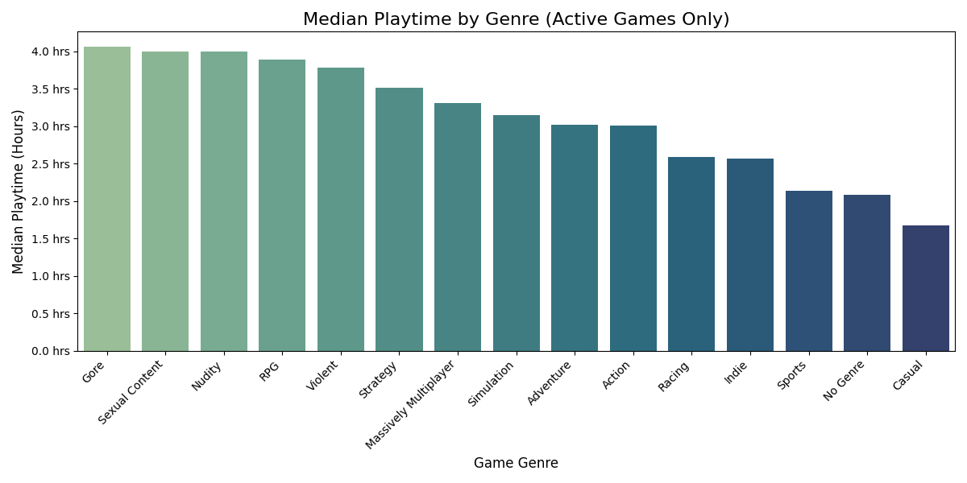

Pricing Optimization
Until now, I have been performing descriptive analytics. Now we perform a pricing optimization, which is a form of prescriptive analytics, and is valuable business intelligence that can improve sales figures for any hypothetical publishing companies that would like to release titles in the near future.

Overall Plan
Our goal is to predict price, but since the dataset is full of games that were priced poorly, the model will only predict average prices, not optimal prices. Instead, I implement a four step plan:
- Create a model to predict estimated revenue
- Feed the model Price, Early Access flag, and the Genre labels
- Create a hypothetical game for a specific genre (e.g., Gore)
- Plot the predictions against the three factors (Revenue, Peak CCU, and Total Playtime) and identify the highest point

Model Implementation and Simulation Strategy
To move from descriptive analysis to prescriptive strategy, we implemented a custom simulation framework designed to stress-test the market response to various price points. This process was executed across three distinct success dimensions: Revenue, Player Acquisition (CCU), and Long-term Engagement (Playtime).

Training the Optimization Engines
We initialized three independent Random Forest Regressors, each trained to predict a specific outcome variable based on the same feature matrix (Price, Early Access status, and Genre composition):

- Revenue Model: Optimized for est_revenue to identify the point of maximum financial return.
- CCU Model: Optimized for peak_ccu to identify the price point that maximizes the simultaneous player base.
- Engagement Model: Optimized for median_playtime_forever (normalized to hours) to identify the pricing threshold that encourages the deepest player investment.

The Pricing-Simulation Loop
For every unique genre in our refined dataset, we generated a synthetic "Active Game" profile. We then utilized the trained models to perform an iterative simulation:
- Price Range: We systematically tested every integer price point from $1.00 to $100.00.
- Predictive Inference: At each individual dollar increment, the model calculated the predicted performance metric while keeping all other variables (such as development status) constant.
- Curve Generation: This generated a series of "demand and revenue curves" for every genre, mapping exactly how performance is predicted to fluctuate as the financial barrier to entry increases.

Identifying the "Sweet Spot"
The "Sweet Spot" is mathematically defined as the global maximum of the resulting simulation curve. In other words, the precise point where the model predicts the highest possible value for the target metric.
- Visualization and Annotation: We plotted these results in a comprehensive grid layout, utilizing distinct color palettes (e.g., royal blue for revenue, dark orange for CCU, and teal for playtime) and annotating the exact dollar amount of the peak.
- Strategic Comparison: By overlaying these different metrics, we can observe the "Trade-off Zone." For instance, a game may find its revenue sweet spot at $24.99, but its player acquisition sweet spot at $14.99.
This multi-model simulation provides a data-driven roadmap for developers, allowing them to select a pricing strategy that aligns with their specific business objectives—whether that is immediate capital generation, brand building, or community engagement.

The Model
To bridge the gap between historical data and prescriptive pricing strategy, this analysis utilizes the Random Forest Regressor as the primary modeling architecture. A Random Forest is an ensemble learning method that operates by constructing a multitude of decision trees during training and outputting the average prediction of the individual trees.

Why Random Forest?
The choice of a Random Forest architecture over traditional linear regression is driven by the inherent complexity of the Steam marketplace. Consumer behavior in digital storefronts is rarely linear; the relationship between a game's price and its commercial success is defined by "thresholds" and "breaking points" rather than a straight line. Random Forest models excel in this environment for several reasons:
- Non-linear Relationship Mapping: The model can capture the "hump-shaped" curves of price elasticity, identifying the specific point where a price increase begins to negatively impact total revenue.
- Interaction Effects: The model naturally accounts for interactions between features. For example, how the impact of "Early Access" status might differ significantly between a "Strategy" game and a "Casual" game.
- Robustness to Outliers: Given the "Long Tail" nature of the Steam dataset, where a few massive hits coexist with thousands of smaller titles, the ensemble nature of the Random Forest prevents the model from being overly skewed by extreme outliers.

Implementation Details
We implemented three distinct instances of the regressor, each consisting of 100 individual decision trees (n_estimators=100). Each model was trained on a high-dimensional feature matrix containing the game's price, its developmental status (Early Access), and its genre composition.
By training these models specifically on Active Games (those with a CCU > 0), we ensured the regressor learned the patterns of viable commercial products. This allows the model to act as a simulator: when we pass it a range of hypothetical prices ($1 to $100), it applies the collective logic of its decision trees to predict the most likely outcome for Revenue, CCU, or Playtime, pinpointing the mathematical "Sweet Spot" for any given genre.

The Results

Dataset URL: https://huggingface.co/datasets/FronkonGames/steam-games-dataset
Steam typically tracks playtime in minutes, so I will convert this data into hours for a clearer business visualization.

