REVUBILLING.COM · HOMEPAGE REVIEW
Thirteen sections, and what to do about each
Written for the doctor who wants the money and the office manager who wants the phone to stop ringing — the two people who actually decide. For each section: what is on the page now, what is wrong with it, and the exact words to use instead.

Fix these two today
Both are removals. Both take minutes. Neither needs copy sign-off, design, or a meeting.
1 — THE BLOG SECTION IS TEMPLATE FILLER (SECTION 12)
The three posts at the bottom of the homepage read "A Business Consulting That Can Produce Anything," "New Consulting For All Kind Offer Business Finance," and "Business development strategies with Saga" — tagged Business, Design, and Marketing. None of it was written for a billing company. It is demo content that shipped with the website template and was never replaced.
It sits directly below the section where you ask for someone's business. Point it at three real posts today, or hide the section until it is.

2 — THE PHYSICIAN STRIP REPEATS ONE CARD FIVE TIMES (SECTION 05)
Five cards, identical text, identical icon, all reading "Trusted by 500+ Physicians." Either placeholder content that shipped or a section nobody filled in.
To a visitor both of these say the same thing: nobody finished this website. That is the worst possible signal from a company asking to handle a practice's money — and it undercuts every other improvement in this document.

Your numbers do not agree with each other
Nothing else in this document should ship until this is settled.
THE CLAIM | WHERE IT SHOWS UP | THE PROBLEM
How many you serve | "500+ Physicians" on the live strip · "400+ practices" in the EHR section · "400+ Physicians" in the draft | Three versions — and practices and physicians are not the same thing. 400 practices could be 1,200 physicians.
Clean claim rate | "97%" in the metrics band · "Up to 99%" in the new strip · "97+% accuracy" in the hero draft | Three different numbers, one page
"200+" | "200+ Insurance Networks" in the metrics band · "200+ Certified Medical Billers & Coders" in the new strip | Same number on two different things, two screens apart. Reads as a copy-paste error.
"50+ specialties" | Metrics band · trust strip · specialties section shows five categories | Said three times, three ways
Consultation length | "30 minute" on the live contact section · "15 minute" in the draft | This one is the ask. Pick 15 — a smaller ask converts better.
"20% increase in revenue" | New trust strip only | No timeframe, no source

WHY THIS MATTERS MORE THAN THE COPY
This audience checks. An office manager comparing three billing companies will notice the same page claiming 97% in one place and 99% in another. The moment one number looks shaky, all of them do — including the true ones. $68M+ recovered is a strong, real number and it deserves to be believed.
What to do: one person owns a single list of approved numbers, each with a source and a date. Every number on the site comes off that list, and nothing goes on the page that is not on it. Also drop "Up to" — a reader hears "up to 99%" as "not 99%."

WHILE YOU ARE AT IT — THE COMPANY HAS THREE NAMES
"Revu Billing" in the hero video and the contact copy, "RevuBilling" throughout the working draft, and "Dental Revu" inside one of the live testimonials. Pick one spelling and make it consistent everywhere, including the logo lockup.

Section by section
In the order they appear on the page, top to bottom.

01. Top Navigation Bar
WHAT IS WRONG
- "Contact Us" and "Request A Quote" go to the same place. Two links competing for one click means neither gets it. The call to drop one is right.
- There is no phone number anywhere on the page. Office managers pick up the phone before they fill in a form. That traffic has nowhere to go.
- "Request A Quote" promises something you cannot give in one click. You cannot price a practice before talking to them about specialty and volume.

THE PAGE ASKS FOR SIX DIFFERENT THINGS
"Request A Quote" (nav) · "Schedule A Demo" (hero) · "Speak With An Expert" (hero) · "Talk to a Billing Expert" (contact section) · "Schedule a Consultation" (draft) · "Book Your Hassle-Free Consultation" (draft contact section).
A visitor should not have to work out which one is real. Pick one wording and use it everywhere. Costs nothing, and it is the single change most likely to bring in more calls.

WHAT TO DO
- Remove "Contact Us." Put the phone number in that spot.
- Change the button to "Schedule a Consultation" and use those exact words everywhere else on the page.
- On phones, make the number a tap-to-call bar fixed to the bottom of the screen.
COPY TO USE
revu BILLING Home About Us Services (000) 000-0000 [ Schedule a Consultation ]

02. Hero Section
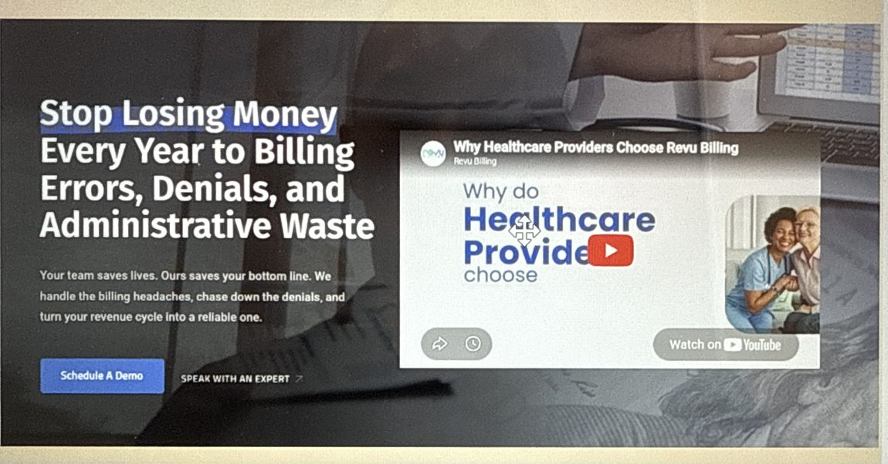
WHAT IS THERE NOW
HEADLINE
Stop Losing Money Every Year to Billing Errors, Denials, and Administrative Waste

UNDER IT
Your team saves lives. Ours saves your bottom line. We handle the billing
headaches, chase down the denials, and turn your revenue cycle into a reliable one.

[ Schedule A Demo ] SPEAK WITH AN EXPERT

VIDEO: "Why do Healthcare Providers Choose Revu Billing"

WHAT IS WRONG
- The headline is all bad news and no relief. It tells a doctor they are bleeding money and stops there. "Administrative waste" is a phrase from a consulting report — nobody says it out loud. It is also the most common opening line in this industry, so it does not set you apart from anyone.
- "Your team saves lives" does not fit most of your clients. A dentist, a chiropractor, an ABA therapist, a mental health practice — none of them describe their work that way.
- "Schedule A Demo" is the wrong button. There is nothing to demo. You are a service staffed by people, not software.
- The video sits in the best spot on the page and it is about you. "Why Healthcare Providers Choose Revu Billing" is a company video where a proof point should be.
WHAT TO DO
- The headline in the working doc is the right call. It talks about the reader's day instead of their losses, and "you and your team" reaches the doctor and the office manager in one line. Two small edits: drop "All Day," and cut the sub-line from 52 words to about 35.
- Take "97+% accuracy" out. The metrics band already says 97% clean claim rate — see the numbers section above.
- Add a small line under the button saying what the call costs in time.
- Move the video below the services section, or swap it for a client saying what changed at their practice.
COPY TO USE
HEADLINE
You and Your Team Didn't Sign Up to Fight Insurance Companies

UNDER IT
Denials, appeals, and payer hold times cost you revenue and cost your front
desk its day. We run your billing end to end — so claims go out clean, money
comes in faster, and your team gets its time back.

MAIN BUTTON Schedule a Consultation
LINK BESIDE IT Talk to a Specialist, Not a Bot
SMALL LINE UNDER 15 minutes with a real biller. No demo, no obligation.

03. Proof & Metrics
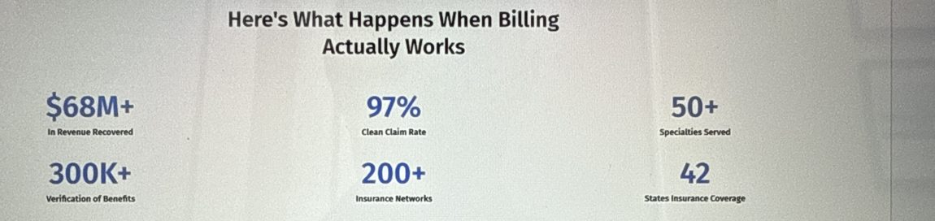

LEAVE THE HEADING ALONE
"Here's What Happens When Billing Actually Works" is genuinely good and already live. The version typed into the working doc has a typo — "Happend" — and switches it to past tense. Do not use that one.

WHAT IS WRONG
- It is in the wrong place. Someone who scrolls once and leaves never sees it. Three of these belong in a thin line directly under the hero.
- Six numbers is too many. Three land. Six blur together.
- Two do not mean anything to a practice. "300K+ Verification of Benefits" measures your workload, not their result. "200+ Insurance Networks" — a practice bills maybe a dozen. "42 States" only matters to a multi-state group.
- The labels are in your language. A doctor does not know what a "clean claim rate" is.
COPY TO USE
$68M+ Recovered for the practices we bill for
97% Claims accepted on the first try
50+ Specialties we bill for

Put these three directly under the hero as one thin line.

04. Core Services
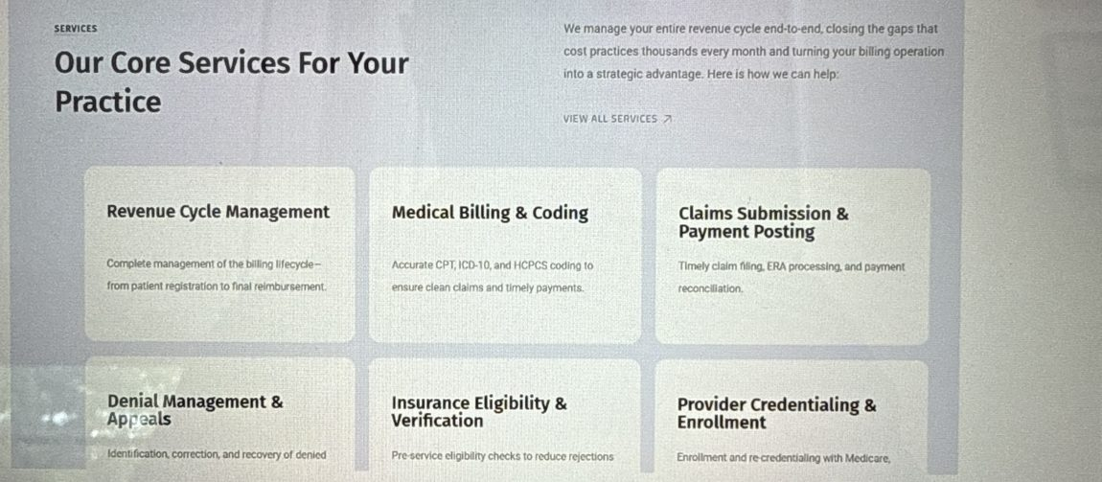
WHAT IS WRONG
- Every card is named after the process. Six industry terms in a row, and not one tells the reader what changes at their practice. The doctor has to translate before they can care, so they do not.
- "Turning your billing operation into a strategic advantage" is a line from a consulting deck.
WHAT TO DO
- Keep all six services — they are the right six. Rename each card by what the practice gets, with the industry term in a small line underneath.
- Nobody loses anything. The doctor reads the headline, the office manager reads the sentence, and Google and any vendor comparison still find the right terms in the small line.
COPY TO USE
Claims go out right the first time
Certified coders check every claim before it is submitted, so it is not
sitting in a rejection queue two weeks later.
Revenue cycle management · CPT, ICD-10, HCPCS and CDT coding

Denials get worked, not written off
Every denial is appealed and followed until it is resolved. You see what
came back, and why.
Denial management & appeals

Coverage is checked before the visit
We confirm benefits ahead of the appointment, so you are not treating
someone whose plan lapsed in March.
Insurance eligibility & verification

Payments get posted and balances get chased
Payments posted daily, aging balances worked on a schedule — not when
someone gets around to them.
Claims submission · ERA processing · payment posting

Your new provider can bill on day one
We handle enrollment and re-credentialing with Medicare, Medicaid, and
commercial payers.
Provider credentialing & enrollment

One monthly report you will actually read
What you collected, what got denied, how long the money took — and what
we are doing about each.
Reporting & analytics

05. "Trusted by 500+ Physicians" strip — FIX TODAY
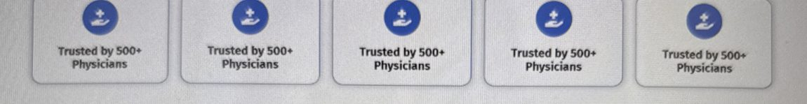
Five cards. Same icon, same words, five times.
WHAT IS WRONG
- This looks broken. Five identical cards. To a visitor it reads as a website that is not finished — the worst possible signal from a company asking to handle their money.
- Fix it today, ahead of everything else here. It is the cheapest change on the list and it costs you credibility every day it stays up.
WHAT TO DO
- The draft is right that it should be five different stats — but settle the numbers first, or the strip's five will contradict the metrics band's six.
- Give each of the two number sections a job. You have two bands of statistics a screen apart doing the same thing. Let this strip carry the who-trusts-us numbers and the metrics band carry the results.
- Drop "Up to." Add a timeframe to the 20% claim or cut it.
COPY TO USE
THIS STRIP (who trusts us)
Trusted by 500+ physicians
200+ certified billers and coders
20+ years in medical and dental billing

METRICS BAND (what we get done)
$68M+ recovered for the practices we bill for
97% of claims accepted on the first try
50+ specialties we bill for

06. Full Visibility Into Your Revenue
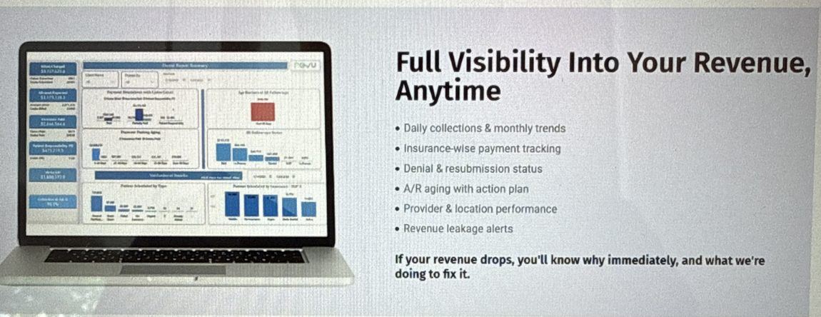

THE BEST SENTENCE ON THE WHOLE WEBSITE IS IN THIS SECTION
"If your revenue drops, you'll know why immediately, and what we're doing to fix it."
Keep it word for word. It says what a practice actually wants from a billing company, in plain language, with no jargon. Strong enough to use in the hero too.

WHAT IS WRONG
- The heading is good and the bullets are the right length. Three of the six labels are just in your language: "Insurance-wise payment tracking," "A/R aging with action plan," "Revenue leakage alerts."

DO NOT MAKE THE SWAP THAT IS IN THE WORKING DOC
The draft replaces the heading with "Complete Revenue Visibility With Data-Driven Management" and turns the short bullets into longer ones — "Identify aging receivables and prioritize recovery opportunities."
The version already live is plainer and better. Leave it and fix three labels.

COPY TO USE
HEADING (keep as is)
Full Visibility Into Your Revenue, Anytime

BULLETS
· What you collected today, and how the month is trending
· What each insurance company is actually paying you
· Which claims were denied, and where each appeal stands
· What is owed, how old it is, and the plan to collect it
· How each provider and location is performing
· An alert the moment money starts slipping through a gap

CLOSING LINE (keep exactly as written)
If your revenue drops, you'll know why immediately, and what we're doing to fix it.

07. Workflow / "Our Framework For Optimization"
WHAT IS THERE NOW
HEADING OPTION: Our Framework For Optimization

Our structured onboarding ensures a seamless transition with zero
disruption to clinical operations.

1 Practice Assessment & Workflow Audit
2 Eligibility Verification & Patient Intake
3 Claim Submission & Coding Accuracy
4 Denial Management & Follow-Up
5 Reporting & Continuous Optimization
6 Ongoing Support & Compliance

WHAT IS WRONG
- It is headed "Workflow (5 Steps)" and there are six.
- Steps 3 to 6 are not onboarding — they are the ongoing service. Mixing "how we start" with "what we do forever" makes going live look like a six-phase project. A practice reads this and assumes it takes months.
- "Our Framework For Optimization" is the most corporate heading in the document. Nobody shopping for a biller is looking for a framework.
- It never answers the three questions that stop the sale: do I change software, what happens to my current biller, how long does this take?
COPY TO USE
HEADING Three steps. No software to buy.

1 A 15-minute call
We ask about your specialty, your software, and what is stuck.
No demo, no slide deck.

2 A free look at your last 90 days
We review your claims and A/R and show you where money is getting
lost — before you sign anything.

3 We start, inside the system you already use
Most practices are fully live in 2–3 weeks. [confirm timeline]

CLOSING LINE
You do not switch software. You do not let anyone go. Your team stops
doing the insurance work and starts doing the patient work.

08. Specialties
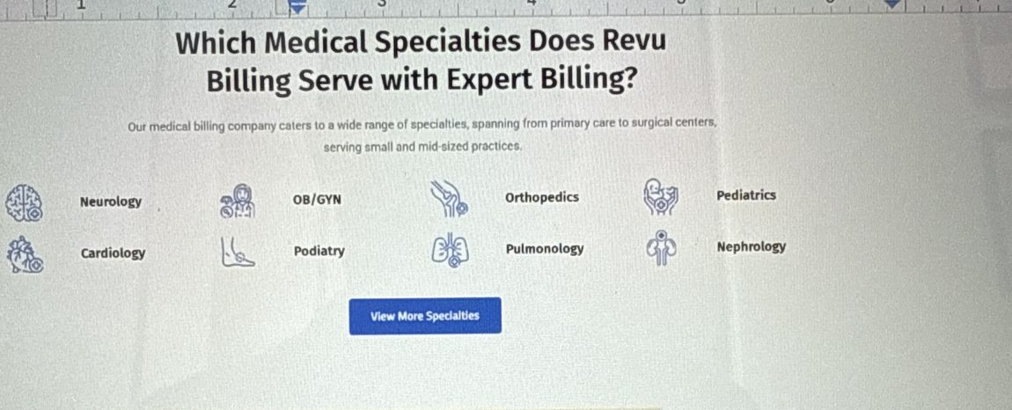
Eight icons on the live page. All eight are medical.
WHAT IS WRONG
- Every signal here says "medical only." The heading says "Medical Specialties," the sub-line says "our medical billing company," and all eight icons are medical. A dentist, an ABA provider or a therapist lands here, concludes you do not do their kind of work, and leaves.
- "Serving small and mid-sized practices" tells a large group they are the wrong fit.
- The heading is a search-engine question, which on a homepage reads like an FAQ entry.

THE CHANGE IN THE WORKING DOC IS THE MOST VALUABLE EDIT IN IT
Switching "Medical" to "Healthcare," and replacing the eight medical icons with five categories — Medical, Dental, Mental Health, ABA Therapy, Chiropractic — fixes a section that currently hides a whole side of the business. Do it.

WHAT TO DO
- Keep the "View More Specialties" button and say the five are groupings. Otherwise five categories sit right next to "50+ Specialties Served" and the two look like they contradict each other. Naming the 50+ here resolves it.
- Drop the question heading, and make "small, mid and large" concrete.
COPY TO USE
HEADING
We bill for practices like yours

UNDER IT
Medical, dental, and behavioral health — 50+ specialties in all, from a
solo chiropractor to a multi-site surgical group. Same team either way,
whether you bill 200 claims a month or 20,000.

CATEGORIES
MEDICAL DENTAL MENTAL HEALTH ABA THERAPY CHIROPRACTIC
(each one links to its own page)

BUTTON View all specialties

09. EHR Integrations
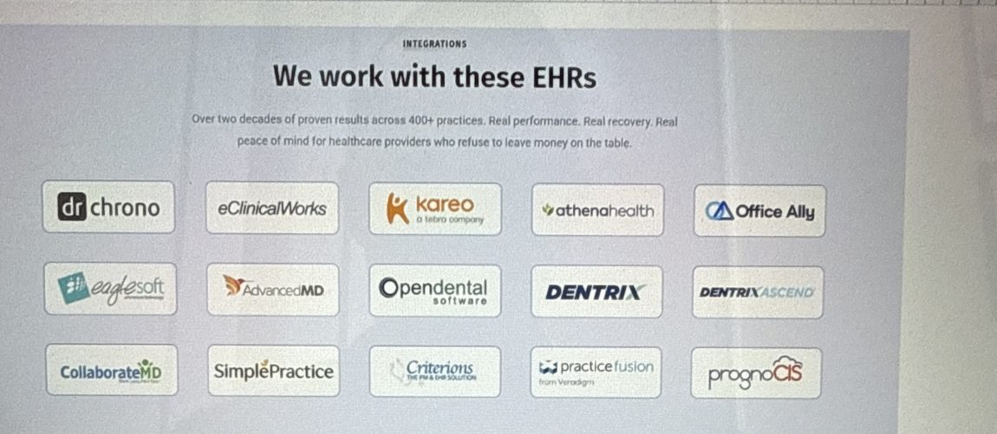
Fifteen logos. The strongest objection-killer on the page.

THE LOGO WALL IS EXCELLENT — DO NOT TOUCH IT
Fifteen real systems spanning medical, dental and behavioral health. It answers "will you work with what I already have?" better than any sentence could, and the mix quietly proves you are not medical-only. Keep every logo.

WHAT IS WRONG
- The sub-line has nothing to do with EHRs. "Over two decades of proven results across 400+ practices. Real performance. Real recovery. Real peace of mind…" is a proof statement sitting under an integrations heading. Someone scanning for "do you support Dentrix?" gets three sentences of advertising instead of an answer.
- "Real performance. Real recovery. Real peace of mind." is filler where a useful line should be.
- No fallback. Anyone whose system is not on the wall assumes the answer is no, and leaves.
- This is also where "400+ practices" lives — which conflicts with "500+ Physicians" two sections up.
WHAT TO DO
- The working doc marks this "same as is." Keep the logos as is, but rewrite the two lines above them — reframe from "look what we integrate with" to "you do not have to change anything."
- Move the "two decades / 400+ practices" sentence up to the metrics band, where proof belongs.
COPY TO USE
HEADING
We work in the system you already use

UNDER IT
Your team keeps its logins, its workflow, and its data exactly where they
are. Don't see yours? We've onboarded on 30+ systems — ask us. [confirm]

(logos below, unchanged)

10. Testimonials
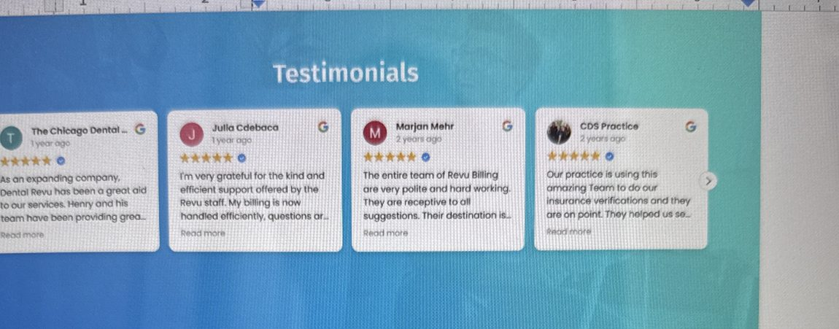
Four Google reviews, dated 1–2 years ago, each cut off at "Read more."

THE NOTE IN THE WORKING DOC IS RIGHT
"Needs enhancement here, picture with name and credentials and the testimonial, and not those Google reviews with dates (2+ years old)." Agreed on all three counts. Here is what else is worth fixing while you are in there.

WHAT IS WRONG
- The dates are the loudest thing on the cards. "2 years ago" on a service business reads as "no recent happy customers."
- Every quote is cut off at "Read more." Nobody clicks. So the actual substance — what changed — is invisible. A reader sees five stars and half a sentence.
- The quotes praise politeness and responsiveness. Genuinely nice, but that is not why a practice switches billing companies. Not one quote mentions money or time.
- No role, no specialty, no practice size. An office manager believes another office manager at a practice her size — that is the whole mechanism.
- One review says "Dental Revu" while the site says "Revu Billing."
- "Testimonials" as a heading is a filing label, not a reason to read on.
WHAT TO DO
- Lead with three written, attributed testimonials. Keep the Google widget, but move it below them — it is real and verifiable, so it works as corroboration even though it is weak as the lead.
- When you collect the new ones, ask three questions: what was broken before, what is different now, and one number if they will give you one.
- Get written permission before publishing any named quote.
COPY TO USE
HEADING
What changed after they switched

EACH CARD
Photo · Name · Role · Practice type and size · City
then a quote about one specific problem that went away.

THE SHAPE TO AIM FOR
"We were writing off about $8,000 a quarter in denials nobody had time to
appeal. Now they're worked before I even see them."
— Name, Office Manager, 4-provider pediatric dental group, Naperville IL

Google reviews widget sits below these, not above.

11. Contact Us / Final Call to Action
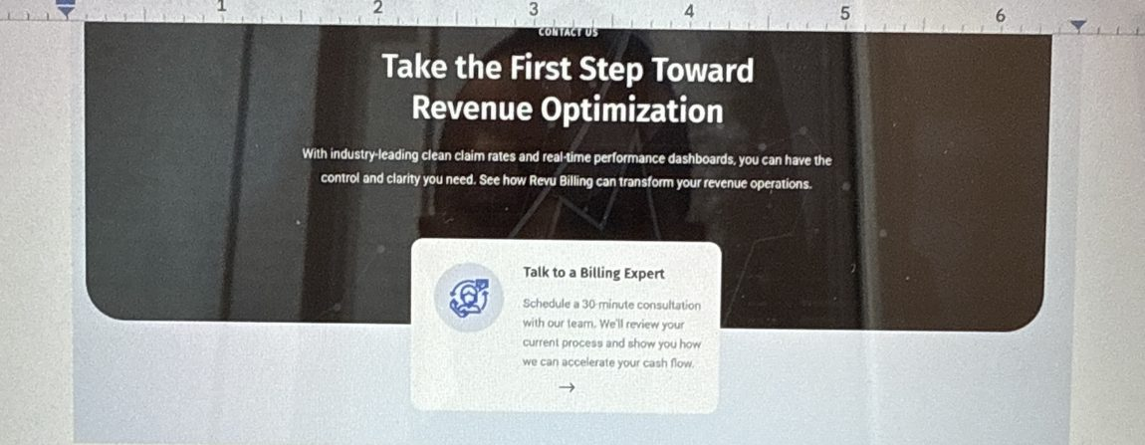
WHAT IS THERE NOW
Take the First Step Toward Revenue Optimization

With industry-leading clean claim rates and real-time performance dashboards,
you can have the control and clarity you need. See how Revu Billing can
transform your revenue operations.

CARD: Talk to a Billing Expert
Schedule a 30 minute consultation with our team. We'll review your current
process and show you how we can accelerate your cash flow.

WHAT IS WRONG
- "Revenue Optimization" is the most jargon-heavy heading on the page — and it is the last thing a reader sees before deciding whether to contact you.
- The sub-line is a feature list at the exact moment the reader needs a reason. "Industry-leading clean claim rates and real-time performance dashboards" is a spec sheet, not an invitation.
- 30 minutes here, 15 minutes in the draft. This number is the ask — pick one, and pick 15.
- "Book Your Hassle-Free Consultation" is a sixth call to action, and "Hassle-Free" is back after being dropped from the hero. Naming the hassle plants it.
- The compliance sentence in the draft is in the wrong section. "We monitor evolving HIPAA and payer regulations continuously, ensuring your revenue cycle stays compliant and uninterrupted" is almost word for word step 6 of the workflow table. It looks like a paste that landed here by accident.
- "Talk to a Billing Expert" and "Talk to a Specialist, Not a Bot" are two names for the same person.
WHAT TO DO
- Reuse the closing line from the "Sound familiar?" section so the page ends on the idea it opened with.
- Give three ways out at three levels of commitment — book, call, or send a file. The third one converts the doctor who is curious but not ready to talk.
COPY TO USE
HEADING
We take the insurance work. You keep the patients.

UNDER IT
Fifteen minutes with a billing specialist — your specialty, your software,
what is actually stuck. No demo, no obligation.

BUTTON Schedule a Consultation
BESIDE IT Call (000) 000-0000

UNDER
Rather not talk yet? Send us last month's A/R aging report and we'll tell
you what we see.

12. Blog / "Our Recent Posts" — FIX TODAY
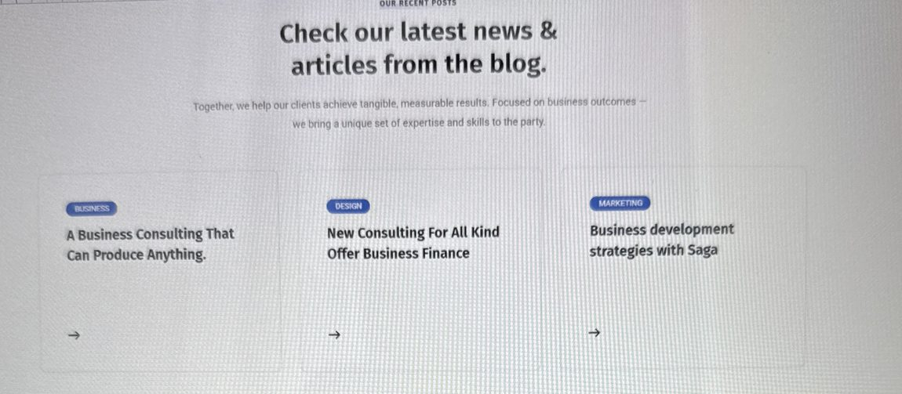
Template demo content, live on the homepage.

THIS IS NOT A BLOG WITH THE WRONG TOPICS — IT IS PLACEHOLDER TEXT
"A Business Consulting That Can Produce Anything." · "New Consulting For All Kind Offer Business Finance" · "Business development strategies with Saga." Tagged Business, Design, Marketing. The sub-line ends "we bring a unique set of expertise and skills to the party."
None of it was written for a billing company. It is demo content that shipped with the website template and never got replaced — Saga is almost certainly the theme's name. It is sitting directly beneath the section where you ask for someone's business.

THE GOOD NEWS
You already have real posts — there are published articles on dental insurance billing, verification services, and vendor comparisons. The section is not empty, it is just wired to demo data. This is a settings fix, not a writing project.

WHAT TO DO
- Today: point the section at your three most recent real posts, or hide it until someone can. Hiding takes two minutes and is far better than what is there now.
- The note in the working doc asks whether doctors and managers care about a blog. They will if the posts answer a question they actually have — cost, denials, credentialing timelines. They will not if it is about CRM.
- Rewrite the heading and cut the "expertise and skills to the party" line entirely.
COPY TO USE
HEADING
Billing questions we get asked a lot

UNDER IT
Short, practical answers from the people who do this every day.

PICK THREE POSTS THAT ANSWER A REAL QUESTION, e.g.
· What does a billing company actually cost?
· Why clean claims still get denied
· How long credentialing really takes

13. The section that is missing
The page goes: here is your problem, in general terms → here are our numbers → here is our service list. There is never a moment where a visitor thinks "that's my office." Nothing on the page describes their actual day.
This is the fix for the wrong-pain-point note. It is also how you talk to the doctor and the office manager at once without building two websites — each reads their own column and skips the other.
WHAT TO DO
- Add a short two-column block between the hero and the services section.
- Every line is a specific thing that happens in a real practice, not a category. That is the whole reason it works.
- On phones the columns stack, but keep both role labels.
COPY TO USE
HEADING Sound familiar?

IF YOU OWN THE PRACTICE
· You are producing more than you are collecting, and cannot say where the gap is.
· You find out about aging balances when they get written off, not before.
· You are paying staff to redo work an insurer already denied once.
· One person understands your billing. If she leaves, so does the process.

IF YOU RUN THE FRONT OFFICE
· Forty minutes on hold to fix one claim.
· Appeals stacking up while patients are checking in.
· You are the only one who knows the payer portals, so you cannot take a day off.
· Patients calling you about bills you did not send.

CLOSING LINE We take all of it. You keep the patients.

Where to start
WHEN | WHAT | WHY
Today | Remove the two unfinished sections — the template blog posts (12) and the five identical physician cards (05). | Both are removals, both take minutes, neither needs sign-off. They undercut everything else on the page.
This week | Settle the numbers and the company name. | One approved list, a source and date per number. Nothing else here should ship first.
Next | One call to action, then the copy — hero, the six service cards, the specialties section. | Six different asks become one. All text edits, no design needed.

One pattern worth naming
The rewrite keeps making the copy more technical, not less.
The services cards become "converting billing operations into a measurable, strategic asset." The revenue visibility section loses its short bullets for "identify aging receivables and prioritize recovery opportunities." The workflow becomes "Our Framework For Optimization." The contact section picks up a HIPAA compliance sentence pasted from somewhere else.
All of it is well written, and all of it would land with a hospital CFO or a procurement team. But the brief was doctors and office managers — and in several places the copy already on the live site is the plainer of the two versions.
A quick test for any line before it ships: would an office manager say this sentence out loud to a colleague? If not, it needs rewriting, however professional it reads.

Homepage only, nav to footer. The same three problems — the quote/demo call to action, category language, and numbers that do not match — almost certainly repeat on the specialty and services pages, which would be the natural next pass.

