REVUSYS CRM · OPERATIONS PLATFORM
VOB Section — Review & Improvement Recommendations
VOB Admin Dashboard as seen by the Doctor and Office Manager roles
Item | Detail
Screen reviewed | Revusys / VOB Admin Dashboard — software.framecho.ae/admin/dashboard
Roles in scope | Doctor and Office Manager (screenshots captured under the “Manager” role)
Evidence | 3 screen captures of the live environment, dated Aug 25, 2026 (captured Aug 27, 2026)
Review type | Content, language, information design and usability — no code changes made
Findings | 18 findings across 6 areas: 5 marked P1 (accuracy / trust), 8 P2 (usability), 5 P3 (polish)

1. Executive summary
The VOB dashboard is clean and loads the right kind of information, but in its current form it works as an internal admin readout rather than a tool a Doctor or Office Manager can act on. Five points summarise the review:
- Two cards show the same number. “VOBs” and “Verifications” both read 35,234, with nothing on screen to explain the difference. Anyone who spots this will start to doubt every other figure on the page.
- Nothing on the page is actionable. “Pending QC 173” and “Ineligible 1,088” are the two numbers that require someone to do something, and neither can be clicked through to the underlying list.
- The numbers have no time period. A single date sits in the header with no label, no range selector and no “last updated” stamp, so it is impossible to tell whether the figures are for today, this month, or all time.
- Demo and developer content is visible to end users — “Demo VOB Agent” in Top Agents, and raw system route names such as “onboarding-admin.dashboard” in the activity log.
- The Doctor is being shown a manager's screen. Agent productivity, QC queues and activity logs are back-office concerns; a Doctor needs patient-level eligibility and benefits detail instead.
None of these are large engineering items. The majority are label, wording, link and layout changes that can be delivered in one sprint; only the role-specific Doctor view is a larger piece of work.

2. How to read this document
Each section below contains a snip taken from the live screen. Red boxes with numbers mark the specific element being discussed, and the table underneath uses the same numbers. Priorities are used as follows:
Priority | Meaning
P1 | Affects accuracy or user trust in the data — recommend fixing before wider rollout.
P2 | Usability or clarity gap — users can complete the task, but with unnecessary effort or risk of misreading.
P3 | Presentation and consistency polish — low effort, improves the professional finish.

3. Summary of findings
ID | Area | Finding | Priority | Figure
F1 | Page header | Header date is unlabelled and does not match the current date; no period filter, refresh or “last updated” stamp | P1 | Fig 1
F2 | Page header | Page title and subtitle are written in internal admin language; “VOB” is never expanded for clinical users | P2 | Fig 1
F3 | Page header | Four tabs have no selected state; “Day End Report” vs sidebar “Day-End Report”; “Entries” vs “Entry History” unclear | P2 | Fig 1
F4 | KPI cards | “VOBs” and “Verifications” show the identical value (35,234) with no stated difference | P1 | Fig 2
F5 | KPI cards | No definitions or tooltips on any card; three near-identical patient/entry totals with no stated relationship | P2 | Fig 2
F6 | KPI cards | “Pending QC” is not clickable and carries no ageing, ownership or SLA context | P2 | Fig 2
F7 | KPI cards | Labels are ALL CAPS and abbreviated (“VOBS”); no trend or comparison against a previous period | P3 | Fig 2
F8 | Eligibility | “Active / Inactive / Ineligible” do not say active what; the three sum to Total Patients but this is never shown | P2 | Fig 3
F9 | Eligibility | “Ineligible 1,088” has no drill-down and no reason breakdown | P2 | Fig 3
F10 | Layout | Ineligible card sits alone leaving a large empty panel, which reads as a broken or missing card | P3 | Fig 3
F11 | Charts | “Eligibility Status Distribution” donut has no legend, labels, values or tooltips; colour is the only encoding | P2 | Fig 4
F12 | Charts | “Operational Processing Overview” compares four near-identical values; Pending QC is invisible at this scale | P2 | Fig 4
F13 | Charts | Status counts do not reconcile with the cards above (Approved 34,893 vs Patients Reviewed 34,892); denominator not stated | P1 | Fig 5
F14 | Charts | Non-zero counts of 10 are displayed as “0.0%”, which reads as nothing to do | P1 | Fig 5
F15 | Tables | Demo data (“Demo VOB Agent”) is visible; entry count 35244 is missing its thousands separator | P1 | Fig 6
F16 | Tables | Activity log shows raw system route names, truncated mid-word, instead of plain-English actions | P2 | Fig 6
F17 | Tables | Audit trail identifies users by first name only; date format differs from the rest of the page | P3 | Fig 6
F18 | Roles | The Doctor sees a back-office manager view rather than patient-level benefit information | P2 | §5

4. Detailed findings

4.1 Page header, title and navigation
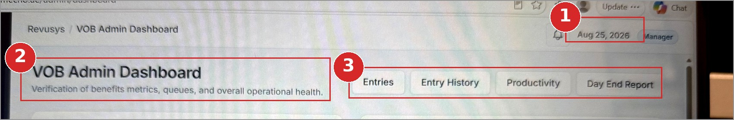
Figure 1 — VOB Admin Dashboard header, title and tab strip
# | What we see today | Recommended change
1 | An unlabelled date, “Aug 25, 2026”, sits next to the notification bell. The screen was captured on Aug 27, so the date is either stale or refers to something else. There is no date-range selector, no refresh control and no indication of what period the figures cover. | Label it explicitly: “Data as of 25 Aug 2026, 4:40 PM” with a refresh icon beside it. Add a period selector (Today / Last 7 days / Month to date / Custom) that drives every card and chart on the page, and show the selected period under the page title.
2 | “VOB Admin Dashboard” with the subtitle “Verification of benefits metrics, queues, and overall operational health.” The word “Admin” is wrong for a Doctor or Office Manager, and the subtitle describes the system rather than the user's job. | Title by role: “Verification of Benefits (VOB) — Overview” for the Office Manager and “Patient Benefits” for the Doctor. Subtitle: “Track benefit verifications, quality checks and patient eligibility for your practice.” Expand VOB on first use on every page.
3 | Four controls — Entries, Entry History, Productivity, Day End Report — look like identical buttons with no selected state, so the current view is not identifiable. The sidebar writes the same item as “Day-End Report”. “Entries” and “Entry History” are not clearly different. | Use a proper tab control with an active state (filled tab or underline). Standardise on “Day-End Report” everywhere. Rename for clarity: “Entries” → “Today's Entries”, “Entry History” → “All Entries”. Add search, filter and export controls to this row.

4.2 Key metric cards
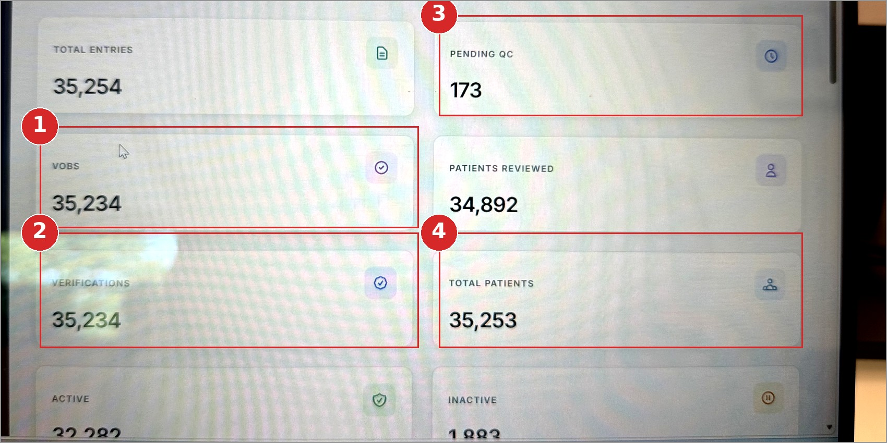
Figure 2 — The eight metric cards at the top of the dashboard
# | What we see today | Recommended change
1 | The card is labelled “VOBS”. The acronym is never expanded on the page and the plural is set in capitals, which is not the correct form. | Rename to “VOBs Completed” in sentence case and add an information icon with a one-line definition. Expand the acronym in the page subtitle so clinical users are not left guessing.
2 | “Verifications” shows 35,234 — exactly the same value as “VOBs”. Nothing on screen explains how the two differ, and a reader will reasonably conclude one of them is broken. | Either remove one card, or define the two distinctly (for example “VOBs Submitted” against “Benefits Verified”) and make sure the numbers differ. If they are genuinely the same measure, keep one card and use the freed space for something actionable.
3 | “Pending QC 173” is the one figure on this screen that requires action, but it cannot be clicked, and gives no sense of how old the queue is, who owns it, or whether it is within target. | Make the card a link to the filtered QC queue. Add a supporting line beneath the number — for example “Oldest 3 days · 12 over SLA” — and colour the card amber or red once a threshold is passed. Consider a “Assign / Review now” action on the card.
4 | “Total Patients” (35,253), “Total Entries” (35,254) and “Patients Reviewed” (34,892) are three near-identical large numbers presented with equal weight and no stated relationship, so the reader cannot tell whether the small differences are meaningful or a data problem. | Group the cards under section headings — Workload, Patients, Eligibility — and add a definition tooltip to each. Where one number is a subset of another, state it on the card (“34,892 of 35,254 entries”). See Appendix A for how these figures reconcile.
Applies to all eight cards:
- Labels are set in ALL CAPS, which slows reading and gives every card the same visual weight — nothing stands out as needing attention.
- No card shows a trend or comparison (vs yesterday, vs last week), so there is no way to tell whether a number is good or bad.
- No card shows a denominator or percentage, so the numbers carry no context.
- Eight cards is a lot of screen for a total of three or four decisions. Consider two “act now” cards at the top, with the rest demoted to a smaller summary strip.

4.3 Eligibility cards
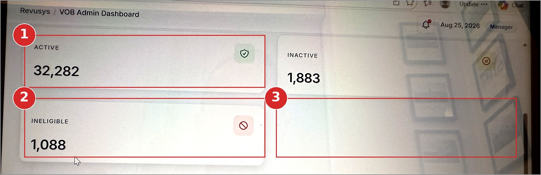
Figure 3 — Active, Inactive and Ineligible cards
# | What we see today | Recommended change
1 | “ACTIVE 32,282” does not say active what — patients, insurance policies, or VOB records. A Doctor will read this as active patients, which may not be what it counts. | Rename to “Active Coverage (patients)” and add a tooltip: “Patients whose insurance coverage is currently active.” Apply the same treatment to “Inactive” → “Coverage Inactive / Terminated”.
2 | “INELIGIBLE 1,088” is clinically and financially the most important figure in this group, yet it cannot be opened, carries no percentage, and gives no reason for the ineligibility. | Make the card a link to the filtered patient list. Show the share alongside the count (“1,088 · 3.1% of patients”) and add a reason breakdown — policy terminated, service not covered, no plan found, verification failed.
3 | The Ineligible card sits alone on its row, leaving a large empty panel to its right. Several reviewers will read this as a card that failed to load. | Place Active, Inactive and Ineligible in a single three-across row under an “Eligibility” heading, or fill the empty slot with the ineligibility reason breakdown.
Worth surfacing: these three cards add up exactly to Total Patients (32,282 + 1,883 + 1,088 = 35,253). Showing that relationship on screen — “of 35,253 patients” under the group heading — is the quickest way to give a manager confidence that the numbers are sound.

4.4 Eligibility and processing charts
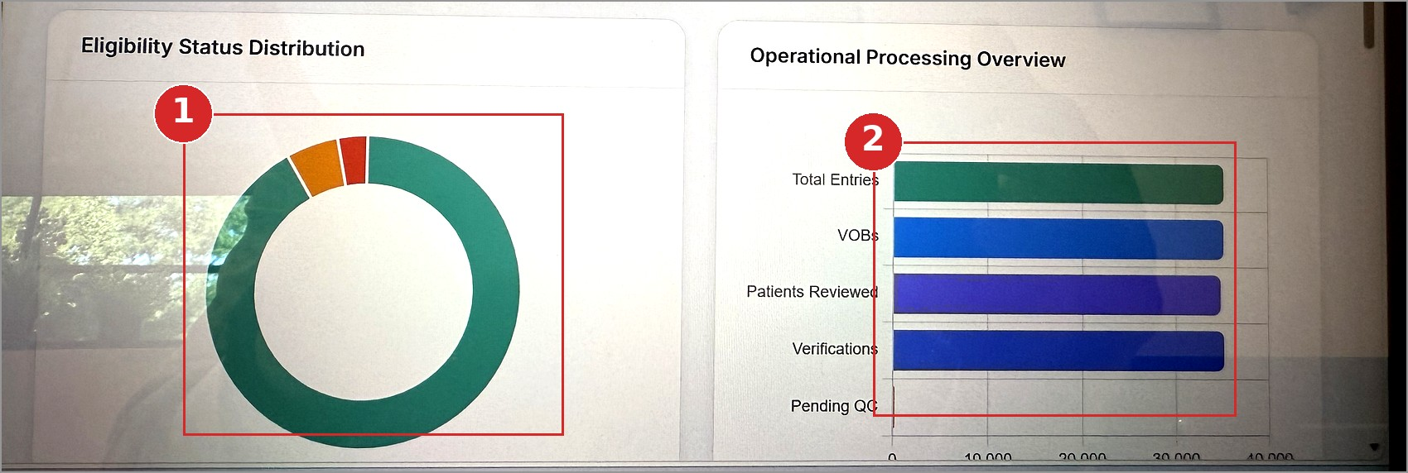
Figure 4 — Eligibility Status Distribution and Operational Processing Overview
# | What we see today | Recommended change
1 | The donut has no legend, no labels, no values and no tooltips. The two small slices (orange and red) cannot be identified at all, and colour is the only thing distinguishing the segments — a problem for colour-blind users. It also repeats the three cards directly above it. | Add a legend showing label, count and percentage — the Processing Status chart further down the page already does this and should be the pattern. Add hover tooltips and a text alternative. If the intention is only to show the split, a single horizontal stacked bar inside the eligibility section would do the job in a fraction of the space.
2 | Four of the five bars are near-identical in length (35,254 / 35,234 / 34,892 / 35,234) so the chart shows no meaningful variation, while the fifth (Pending QC, 173) is too small to be visible. The chart occupies half the row and communicates nothing. | Replace with a funnel showing the drop-off at each stage with counts and conversion percentages, so the reader can see where entries are lost. Show Pending QC separately as a queue indicator against target rather than on the same axis as a 35,000 figure.
Both charts also need: a stated period and “as of” timestamp, consistent title capitalisation, a value axis label, and an export option for reporting.

4.5 Processing Status Distribution
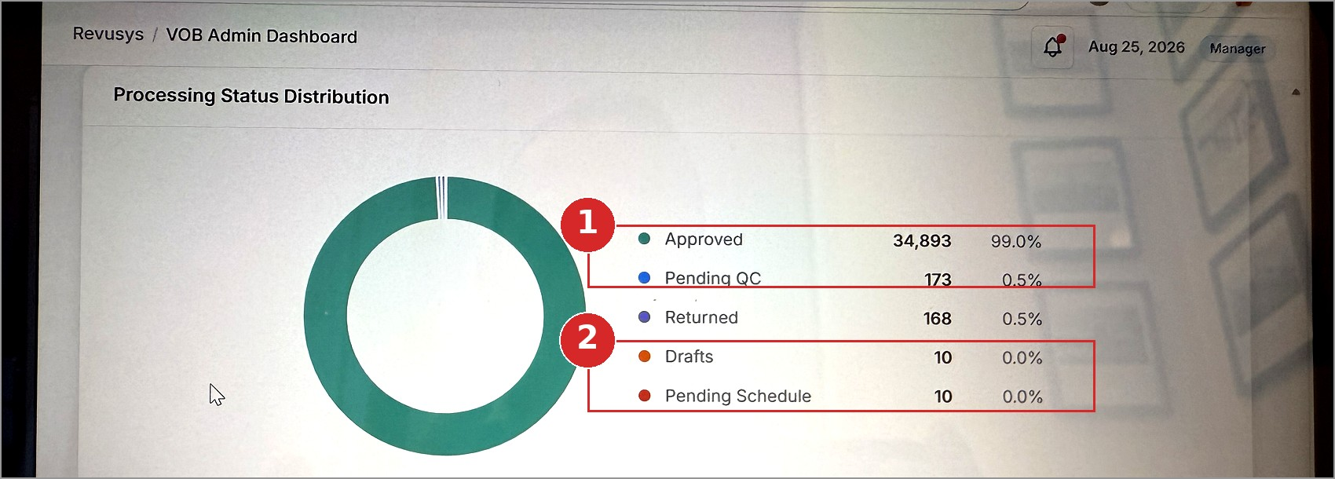
Figure 5 — Processing Status Distribution with legend
This is the best-presented component on the page — the legend carries label, count and percentage together, and it should be the template for every other chart in the VOB section. Two issues remain.
# | What we see today | Recommended change
1 | “Approved 34,893” does not match “Patients Reviewed 34,892” on the cards above, and no denominator is stated anywhere, so the reader cannot tell what the 99.0% is a percentage of. | State the denominator in the chart subtitle — “of 35,254 VOB entries” — and align the underlying definitions so that Approved and Patients Reviewed either match or are clearly labelled as different measures. Make each legend row clickable through to that queue.
2 | “Drafts 10” and “Pending Schedule 10” are both shown as “0.0%”. Displaying a real backlog as zero tells the manager there is nothing to do, when in fact there are twenty items sitting in those states. | Display small values as “<0.1%” rather than rounding to 0.0%, and never round a non-zero count to zero. Add a tooltip for “Returned” (“Returned to the agent for correction”) since the term is not self-explanatory.

4.6 Top Agents and Recent Activity Logs
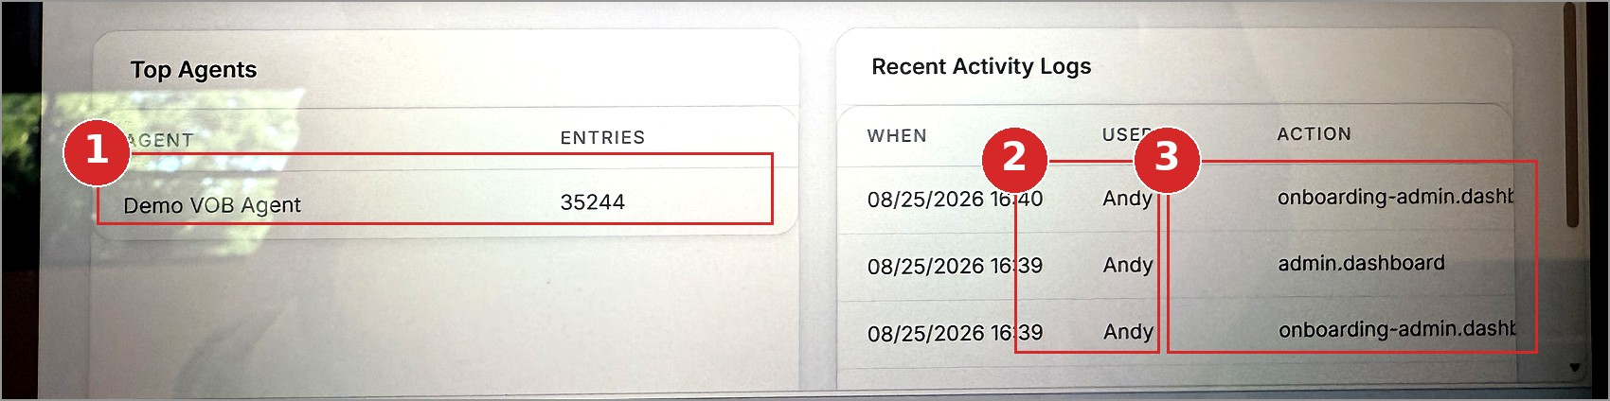
Figure 6 — Top Agents table and Recent Activity Logs
# | What we see today | Recommended change
1 | The table holds a single row, “Demo VOB Agent”, with 35,244 entries — demonstration data visible in a screen used by Doctors and Office Managers. The number is also printed as “35244” without a thousands separator, unlike every other figure on the page. | Remove demo and test records from the production environment. Format the number as 35,244. Turn this into a management tool by adding the columns a manager actually reviews: QC pass rate, returned %, average turnaround and entries against target, ranked top five.
2 | The User column shows a first name only (“Andy”), which is not enough to identify a person in an audit trail where several staff may share a first name. | Show full name and role — “Andy Mancini · Office Manager” — and link through to the user record.
3 | The Action column prints raw system route names (“onboarding-admin.dashb…”, “admin.dashboard”) and truncates them mid-word. This is developer output rather than user-facing language, and it makes the audit trail unusable for its purpose. | Map each route to plain English — “Viewed Onboarding Admin Dashboard”, “Approved VOB #12345 for J. Smith”. Widen the column so entries are not truncated, add a relative time (“2 days ago”) beside the timestamp, and add a “View all activity” link.
Also on these two panels:
- Dates read “08/25/2026 16:40” here but “Aug 25, 2026” in the page header — choose one format and apply it across the section.
- Column headers are ALL CAPS and low contrast against the white panel.
- Both panels leave large blank areas when there is little data; a proper empty state (“No agent activity recorded for this period”) reads far better than white space.

5. Recommendations by role
The single biggest improvement available is to stop showing both roles the same screen. The content below assumes the same underlying data, presented differently.

5.1 Doctor
A Doctor does not manage a QC queue or an agent roster. What they need before seeing a patient is whether the benefits are confirmed, what the patient will owe, and what is blocking treatment.

Remove from the Doctor view
- Top Agents, Recent Activity Logs, Pending QC, Total Entries, Operational Processing Overview — all internal operations content.

Show instead
- Patients awaiting verification — with how long each has been waiting.
- Verified and ready to schedule — the queue the Doctor can act on today.
- Not eligible / action needed — with the reason shown against each patient.
- Benefits expiring in the next 30 days — so re-verification is scheduled before treatment.
- Patient drill-down carrying insurance carrier, plan, effective dates, copay, deductible met, out-of-pocket remaining and any authorisation requirement.

Language for the Doctor view
Current term | Suggested for Doctor | Reason
Pending QC | Being checked by our team | “QC” is an internal process name
Returned | Sent back for correction | “Returned” could be read as returned by the insurer
Drafts | Not yet submitted | States what still needs to happen
Pending Schedule | Awaiting scheduling | Clarifies who is waiting on whom
Ineligible | Not eligible — action needed | Signals that something must be done
VOB / VOBS | Benefits verification | Avoids an internal acronym in a clinical view

5.2 Office Manager
The current layout is closer to right for this role, but it reports rather than directs. Every number a manager looks at should lead somewhere.
- Make every metric card a link into its filtered work queue — Pending QC, Returned, Drafts, Pending Schedule, Ineligible.
- Add ageing and SLA context: oldest item in the queue, count over target, and a today-vs-yesterday comparison on each card.
- Add threshold alerts — a banner when Pending QC or Ineligible passes an agreed level, so the manager does not have to check the dashboard to find out.
- Build out per-agent performance (entries, QC pass rate, returned %, average turnaround) so Top Agents supports a real conversation about workload.
- Provide the Day-End Report as a direct PDF/Excel export from the dashboard, with the selected period applied.
- Show who is assigned to the current queue, so work can be reassigned without leaving the page.

6. Wording changes — current vs suggested
These are drop-in text changes requiring no data model work.
Current wording | Suggested wording | Why
VOB Admin Dashboard | Verification of Benefits (VOB) — Overview | “Admin” is inaccurate for both roles; the acronym is expanded on first use
Verification of benefits metrics, queues, and overall operational health. | Track benefit verifications, quality checks and patient eligibility for your practice. | Describes the user's job rather than the system's contents
VOBS | VOBs Completed | Correct plural form; states what is being counted
VERIFICATIONS | Benefits Verified — or remove the card | Currently duplicates VOBs exactly (see F4)
PENDING QC | Pending Quality Check | Expands an internal abbreviation
PATIENTS REVIEWED | Patients with a Completed VOB | “Reviewed” is ambiguous — reviewed by whom, and for what
TOTAL ENTRIES | VOB Entries Created | Says what an entry is
TOTAL PATIENTS | Patients on File | Distinguishes it from patients with a VOB
ACTIVE / INACTIVE | Active Coverage / Coverage Inactive | States that the status belongs to the insurance coverage
INELIGIBLE | Not Eligible — action needed | Plain English, and signals that follow-up is required
Returned | Returned for Correction | Removes the ambiguity with insurer returns
Drafts | Draft — not submitted | States the consequence of the status
Pending Schedule | Awaiting Scheduling | Consistent tense with the other statuses
Day End Report / Day-End Report | Day-End Report | Currently inconsistent between the tab and the sidebar
Entries / Entry History | Today's Entries / All Entries | Makes the difference between the two views explicit
admin.dashboard | Viewed Admin Dashboard | Replaces a system route with user-facing language
Aug 25, 2026 (unlabelled) | Data as of 25 Aug 2026, 4:40 PM | Removes the ambiguity about what the date refers to
0.0% (for a count of 10) | <0.1% | Never present a non-zero backlog as zero

7. Suggested order of work

Quick wins — text, labels and formatting only
- Remove demo records from production (F15).
- Fix the “0.0%” display and the missing thousands separator (F14, F15).
- Apply the wording changes in section 6, including the Day-End Report inconsistency (F2, F3, F7).
- Label the header date and add a “last updated” stamp (F1).
- Give the tab strip an active state (F3).
- Add a legend to the Eligibility donut, matching the Processing Status chart (F11).

Next — usability
- Make metric cards and legend rows link into their filtered queues (F6, F9, F13).
- Add definition tooltips to every card (F5, F8).
- Add the period selector and apply it across the page (F1).
- Replace the Operational Processing Overview with a funnel, or remove it (F12).
- Rewrite the activity log actions in plain English and widen the column (F16, F17).
- Group the cards into Workload / Patients / Eligibility sections and close the layout gap (F10).

Larger piece of work
- Build the role-specific Doctor view described in section 5.1 (F18).
- Reconcile the underlying metric definitions so Approved, Patients Reviewed, VOBs and Verifications are each defined once and used consistently (F4, F13).

Appendix A — How the figures on screen reconcile
The numbers shown on Aug 25, 2026 do tie together, which is a good sign. The problem is that none of these relationships are visible to the user. Showing them would remove most of the confusion described in section 4.
Relationship | Result | What it tells us
Active 32,282 + Inactive 1,883 + Ineligible 1,088 | = 35,253 | These three are patient coverage statuses and add up to Total Patients — worth stating on screen
Total Patients | 35,253 | Matches the eligibility group exactly
Approved 34,893 + Pending QC 173 + Returned 168 + Drafts 10 + Pending Schedule 10 | = 35,254 | The processing statuses add up to Total Entries, so Total Entries is the correct denominator for that chart
Total Entries 35,254 − Drafts 10 − Pending Schedule 10 | = 35,234 | This equals both “VOBs” and “Verifications” — strong evidence the two cards are the same measure shown twice (F4)
Approved 34,893 vs Patients Reviewed 34,892 | differs by 1 | Two measures that look identical but are not; needs a definition or a fix (F13)
Total Entries 35,254 vs Total Patients 35,253 | differs by 1 | Suggests one patient with two entries, or a leftover test record — worth confirming

Appendix B — Suggested card definitions (tooltip text)
Ready-to-use wording for the information icon on each card.
Card | Tooltip text
VOB Entries Created | Every VOB record created in the selected period, including drafts and items awaiting scheduling.
VOBs Completed | Entries that have been submitted for verification. Excludes drafts and items awaiting scheduling.
Benefits Verified | Entries where benefits were confirmed with the insurance carrier.
Pending Quality Check | Completed entries waiting for a second review before they are approved.
Patients with a Completed VOB | Distinct patients who have at least one approved verification in the selected period.
Patients on File | All patients in the system, regardless of verification status.
Active Coverage | Patients whose insurance coverage is currently active.
Coverage Inactive | Patients whose coverage has lapsed or been terminated by the carrier.
Not Eligible | Patients whose plan does not cover the requested service, or where no active plan was found.

Prepared from screen captures of the live VOB Admin Dashboard dated Aug 25, 2026. No changes were made to the application as part of this review.

