REVU BILLING · FIRST DRAFT FLYER · TCC MOBILE CREATIVE
They are not three flyers. They are one flyer with three headlines.
Everything below the hero — the service list, the stats, the QR block, the contact details — is the same on all three. File 2 rearranges it; files 1 and 3 are identical below the fold. So the real decision is which headline, and after that, one layout question.

SHORT ANSWER
Go with 2.pdf — "You Worked for the Patient. We Work for the Payment." It is the only headline that works the same in a dental office, a chiro office, and a medical practice, and its layout is the most readable of the three. It is also the only one whose second QR code actually goes somewhere.
But none of the three is ready to print yet. The headline is the easy part — the problems are in the bottom two-thirds, and they are the same problems on all three. See "Fix these before it prints" below.

Best, better, good
Judged as a leave-behind for a cold walk-in — handed to whoever is at the front desk, read for about five seconds, then either kept or binned.

BEST — 2.pdf — "You Worked for the Patient. We Work for the Payment."

You Worked for the Patient. We Work for the Payment.

Tired of the paperwork. Tired of the phone calls. Tired of finding out,
months later, that something didn't get paid and nobody caught it in time.
You didn't get into this for the tired part.

PROS
- The only headline that survives all three specialties. "Patient" is the one word a dentist, a chiropractor, an MD and a therapist all use about their own work. Nothing in it belongs to one field.
- It says what the company does in seven words, with no industry vocabulary at all. That is rare, and it is the whole job of a leave-behind.
- The symmetry makes it stick. Someone who reads it once at a counter can repeat it to the doctor later — which is exactly what has to happen for this to work.
- It reaches both readers at once. "You worked for the patient" is the clinician; "tired of the phone calls" in the sub-line is the front desk.
- Best layout of the three. The stats sit in a 2x3 grid at roughly twice the size, so the labels are actually readable. The contact block is a vertical list instead of a two-column jumble. The HIPAA badge sits beside the contact details, where it reads as a credential rather than floating mid-page.
CONS
- Longest sub-line of the three at 42 words. The "Tired of…" repetition carries it further than plain prose would, but it can lose a sentence without losing anything.
- "We work for the payment" can be misread as "we are in it for the money" by someone skimming. The parallel structure defuses it — but read it out loud to a few people before committing.
- The bottom half is denser than 1 and 3: six stat tiles, five contact lines and the badge all live in the lower third.

BETTER — 3.pdf — "How Old Is Your Oldest Unpaid Claim?"
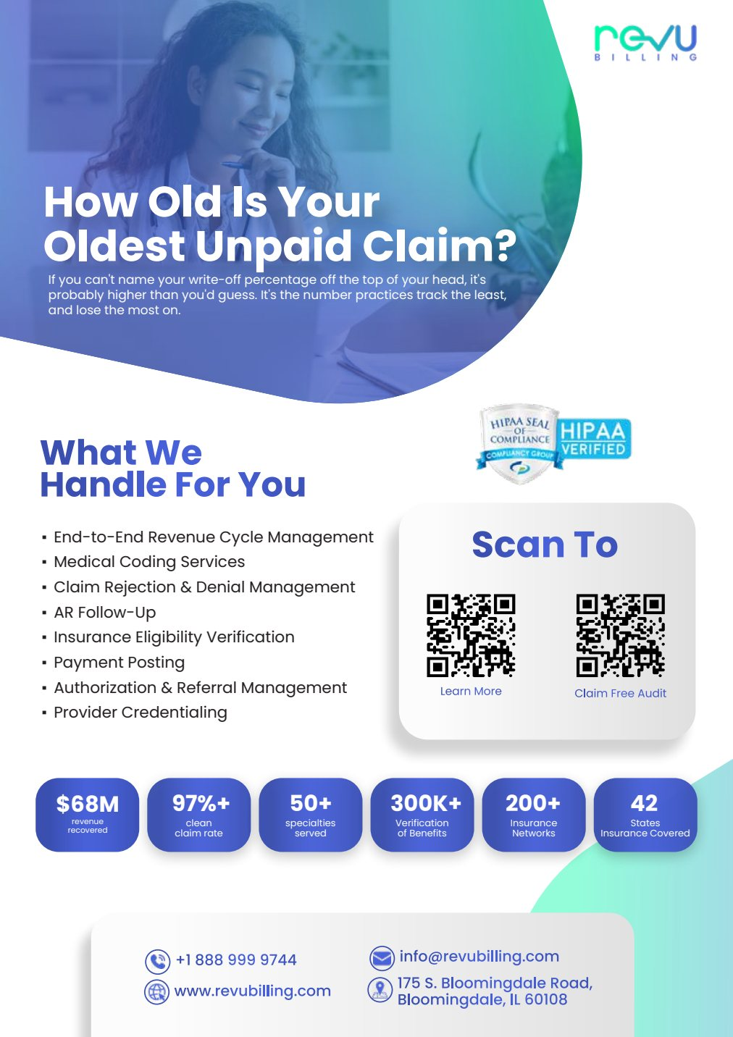
How Old Is Your Oldest Unpaid Claim?

If you can't name your write-off percentage off the top of your head, it's
probably higher than you'd guess. It's the number practices track the least,
and lose the most on.

PROS
- The sharpest hook of the three. It is a real question with an uncomfortable answer, and it lands hardest on the person actually holding the flyer — the office manager is the one who knows.
- Concrete where the others are broad. It names a specific thing sitting in their system right now.
- Excellent for a targeted drop — if you already know a practice has an A/R problem, or as an email subject line, this is the one.
CONS
- The doctor cannot answer it. Most owners have no idea what their oldest unpaid claim is, and do not want to be reminded. On a flyer that has to work for both readers, that is a real cost.
- A question with no answer on the page is weak as a leave-behind. The reader thinks "I don't know," feels slightly caught out, and moves on. A statement gives them something to keep.
- "Write-off percentage" is jargon — the exact kind of language we are pulling out of the website. It is in the second sentence of the flyer.
- Worst contrast of the three. The sub-line is thin light text sitting over the darkest part of the photo. Hard to read on a counter, and it will disappear entirely if anyone photocopies it.
- Both QR codes point to the same page — see below.

GOOD — 1.pdf — "Unlock the Revenue You've Already Earned"
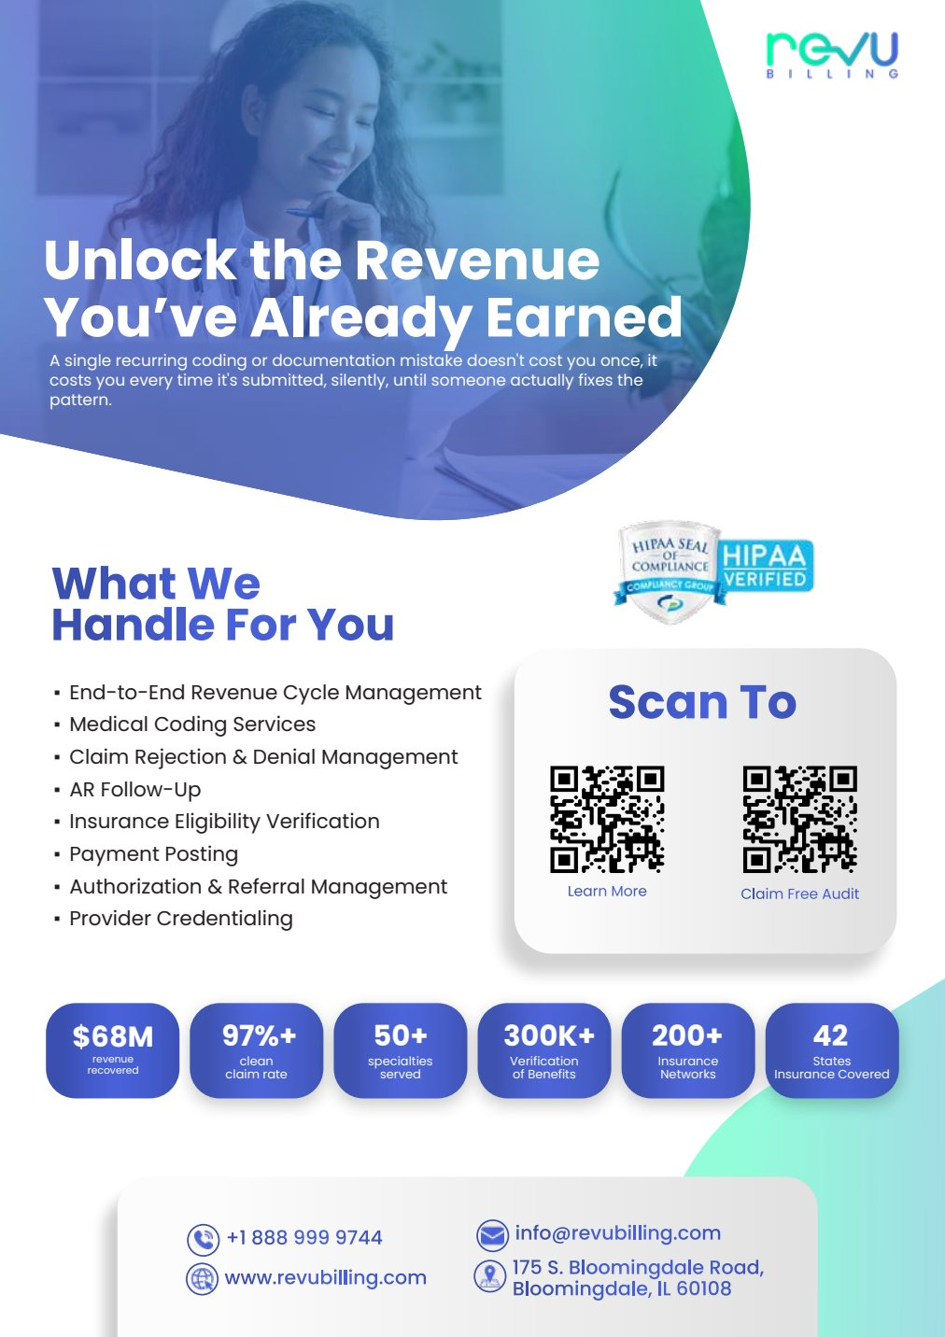
Unlock the Revenue You've Already Earned

A single recurring coding or documentation mistake doesn't cost you once,
it costs you every time it's submitted, silently, until someone actually
fixes the pattern.

PROS
- Safest of the three. Nothing in it excludes any specialty, and it makes no accusation — it is an offer, not a diagnosis.
- The sub-line is the best writing in all three drafts. A recurring mistake does not cost you once, it costs you every time it is submitted, silently. That is a genuine insight and it is worth keeping somewhere — a follow-up email, the website, a second flyer.
CONS
- The headline is the most-used line in the entire billing industry. Some version of "unlock the revenue you have already earned" is on hundreds of competitors' sites. It will not stop anyone at a front desk, and it makes you sound like everyone else at exactly the moment you need to sound different.
- It is backwards. Weak headline, strong sub-line — and nobody reads the sub-line if the headline does not stop them.
- The sub-line is a paragraph, not a flyer line. Thirty words of reasoning that need to be read carefully. On a counter, that never happens.
- Same as 3: six stat tiles squeezed into one row, so the labels are close to unreadable. And both QR codes go to the same page.

Verified defect: three of the six QR codes are wrong
I decoded every QR code in all three PDFs. Here is where they actually go.
FILE | "LEARN MORE" QR | "CLAIM FREE AUDIT" QR
1.pdf | revubilling.com | revubilling.com — same page. Broken.
2.pdf | revubilling.com | revubilling.com/request-a-quote/
3.pdf | revubilling.com | revubilling.com — same page. Broken.

WHAT THIS MEANS
On 1 and 3, the free-audit offer goes nowhere. Both codes land on the homepage. Someone scans it expecting a free audit, gets a generic homepage, and that is the end of it — you have spent the visit and lost the lead at the last step.
Even on 2, the promise does not match the destination. The flyer says "Claim Free Audit"; the page says "Request A Quote." Those are two different offers, and the second one asks for more than the first promised. It is the same call-to-action problem as the website — this is now a seventh different wording across Revu Billing's material.

Fix these before it prints
These apply to all three equally — they are in the shared two-thirds of the page. Ranked by how much each one costs you at a cold visit.
01 — BIGGEST
Nothing on the flyer says you serve dental or chiropractic
There is no mention of dental, chiropractic, mental health or ABA anywhere on the page. Combined with the next item, a dental front desk will read this as a medical billing company and bin it. For a flyer whose whole job is to work in all of those offices, this is the one thing that has to change.
Add one line, under the logo or above the contact block:

MEDICAL · DENTAL · CHIROPRACTIC · MENTAL HEALTH · ABA THERAPY

02
"Medical Coding Services" is the second line of the service list
One word, and it tells a dental office the flyer is not for them. Same problem the website has, and it is cheaper to fix here.
Medical Coding Services -> Medical & Dental Coding

03
The eight-item service list is eight lines of industry vocabulary
"End-to-End Revenue Cycle Management," "AR Follow-Up," "Payment Posting," "Authorization & Referral Management." A doctor reads that and learns nothing about what changes for them. On a website you have a minute; on a flyer you have five seconds, so it hurts more here. Cut to four, outcome first.
Claims go out right the first time
Denials get appealed, not written off
Coverage checked before the visit
New providers credentialed and billing on day one

04
Six stats is four too many
"300K+ Verification of Benefits," "200+ Insurance Networks" and "42 States Insurance Covered" mean nothing to one practice deciding whether to call — they describe your workload, not their result. On 1 and 3 the six tiles are squeezed into a single row and the labels are barely legible. Keep three, at size.
$68M recovered for the practices we bill for
97%+ of claims accepted on the first try
50+ specialties, medical through behavioral health

05
The offer is the strongest thing on the page and it is in 8pt grey
"Claim Free Audit" is the actual reason someone would call. Right now it is a caption under a QR code. If the offer is a free look at their claims, say it at a size someone can read from arm's length — and use one QR code, not two. The website address is already on the flyer, so the "Learn More" code is doing nothing the URL does not.
06
It is A4, not US Letter
All three are 8.27 x 11.69 inches — European A4. Printed in the US it will either scale down and sit crooked in the margins, or get cropped at the edges. Ask for 8.5 x 11 with proper print bleed before anything goes to a printer.
07
Nobody's name is on it
A cold leave-behind should carry the rep's name, or blank space to write it in. Otherwise the front desk finds a flyer at 4pm with no memory of who dropped it off at 10am — and the one thing that makes a cold visit worth more than a mailer is that a person came by.
08
The sub-headline sits on the photo
On all three it is light text over a busy image; on 3 it is nearly unreadable. Flyers get photocopied and faxed around an office, so it has to survive black-and-white. Either darken the image behind the text or move the sub-line off it.
09
Make the numbers match the website
$68M and 97%+ appear here and on the homepage. The homepage already has three different versions of the clean-claim number and two different physician counts — do not let the flyer add another. Whatever gets locked in as the approved figure goes on both.

What to send back to the designer
Build on 2.pdf. Keep its headline and its layout — the 2x3 stat grid, the vertical contact list, the badge beside the contact block.
Trim the sub-line by one sentence: "Tired of the paperwork. Tired of the phone calls. Tired of finding out months later that something didn't get paid. You didn't get into this for the tired part."
Then the nine fixes above — the specialty line and the service list are the two that decide whether a dental office keeps it.
Keep 1's sub-line somewhere. The line about a recurring mistake costing you every time it is submitted is the sharpest thing anyone wrote across the three drafts. It is wasted under a headline nobody stops for, but it would work well in a follow-up email or on the website.

Reviewed as a cold-visit leave-behind for a single flyer covering medical, dental and chiropractic. All three PDFs are one page, A4, from the same TCC Mobile first draft dated 25 August.

