[Date]

Alyssa Pilbrow

[Company name]

[Company address]

[Document title]

[Document subtitle]

Table of Contents

Section A: Requirements Planning 2

Business Requirements 3

Statement of Problem or Need 3

Stakeholders 3

List of Business Requirements 3

Business Solution 4

Options Considered 4

Recommended Solution 5

Key Features 5

Justification 5

User Stories 6

Requirements 6

Section B: Technical Planning 7

Architecture 8

Web Framework 8

Data Access Design 8

Collections 8

Relationships 8

Functional Decomposition 8

Security Design 8

Security Mechanisms 8

User Roles and Permissions 8

Section C: User Interface Design 8

Wireframing 9

Mock-ups 9

# Section A: Requirements Planning

## Business Requirements

### Statement of Problem or Need

Piers is an art dealer, who is moving into framing full-time and reducing dealing to a smaller portion of his income. He is a sole trader and would like the flexibility of two websites he can manage in once place. He uses the brand name ‘Sink’ across art and framing, as his full name – Pier Abbenes – is difficult to spell. He would like to be able to sell art pieces from his collection and would like to do it somewhere that they can show a bit of their style as opposed to selling it on a general site like trade me. He would also like a web presence for his framing business.

These services are both separate and target a quite different clientele, and therefore need to be kept separate so as not to deprecate the value of/ confuse the target audience of either site. However, it would be nice to keep some level of cohesion between the two websites as they will both be under the Sink brand name. If he does maintain a physical store, it would be called Sink and both businesses could be run from the same place.

Piers already has the domain name ‘Sink’ and hosting on AWS, but no currently active website.

### Stakeholders

* Piers Abbenes
* Art Collectors
* Framing Clients

### List of Business Requirements

* Art sale space
* Framing sales space
* Same domain name
* Contact methods for each business
* Quality images of artwork for sale
* Information on artwork including dimensions and a story about the artwork
* Ability to search for different artworks
* Information on Piers as a collector
* Online contact form
* minimalistic art sales space
* Examples of framing work
* Visuals of different faming options
* Piers should be able to upload, edit, and manage art inventory
* Mark artwork with different tags like sold or under negotiation
* Solution should look good regardless of how many artworks are for sale
* It should be easy for people to find the T&Cs
* Should be able to archive art pieces
* Ability to make announcements

#### Non – Functional Requirements

* SEO – should come up on Google search
* Security & Privacy
  + Only Piers and anyone else that is authorised should be able to make changes to the chosen solution.
  + Authentication for Admin users / guest users.
  + Contact forms should be secure from form field manipulation attacks, such as SQL injection or cross-site-scripting.
  + Protection from DDoS Attacks
  + Privacy policy, shipping and any other disclaimers linked
* Reliability & Performance
  + Site must be hosted somewhere reliable to users and not have periods of downtime
  + Loading should be fast and communicated with user – such as through loading bar animations, or lazy loading.
* Useability
  + Website must be simple and easy to navigate, with high-contrast text/background at appropriate sizing – particularly Fine Arts clients are more likely be older, therefore both less tech savvy with worse vision.
  + Website should otherwise comply with web usability standards outlined by Web Accessibility Initiatives (<https://www.w3.org/WAI/fundamentals/accessibility-usability-inclusion/>), notably standards regarding elderly, and alt text.

## Business Solution

### Options Considered

* App
* Separate Website
* Singular Website

*App Based Solution*

One solution considered is a mobile application. This solution would keep in mind the fact that most people are browsing and shopping using their mobile phones – in fact, many users use their phones when they are searching for a particular product or service. So, a framer such as Piers may reach a larger audience who are browsing for his service despite not making framing sales online. A mobile-based app could be successful in converting searches to in-person purchases.

However, a main con to this solution is the Fine Arts clientele. When shopping for larger purchases (such as fine art, which can be in the 1000’s), users are more likely to use their PC or laptop[1]. In the case of our audience, an older clientele will find small mobile devices hard to use as they are not tech savvy, and the small screen size. Quality images of large pieces may be harder to view and harder to display in a way that does justice to the piece.

*Website, singular domain, and backend*

One solution considered is a website using one domain and a singular backend. This is a great solution as it means Piers will not have to buy a new domain or pay for additional hosting, and he can manage the content of both ‘sites’ through one backend. This allows the pages for both businesses ‘sites’ to remain cohesive, as design aspects such as fonts, colours, headings, page breaks etc can be re-used easily (particularly as we are considering using React). If there is a change made to one component it will change for both businesses retaining cohesion.

This can also be an issue as if Piers decides to retire a site, it may be difficult for him to take one offline without removing the other. If, for example, Piers decides he no-longer wants his art dealing up he may have to pay a developer to remove the art dealer side of the website and incur more costs. If he decides one site needs a different look, it may require him to separate the sites or pay a developer to re-do the components.

*Website, separate backend and website*

One solution is to develop two separate websites with separate backends. This would allow for full separation between the two businesses, which could be a great for Piers to make management easier through separation. If his business needs change it will be much easier for him to drop one site completely or completely re-work one website without touching the other.

However, this comes with cons as he will need to sign-in and manage two separate domains and may need to spend additional money on domain name and hosting. It will also mean one more account to keep track of, and if he is to keep the branding cohesive any universal change (such as a change in the logo image) will have to be done twice. This may also cause Piers to have to find a different domain name to just ‘Sink’ which may

## Recommended Solution

We recommend a website be used for both your high-end art clients and framing clients. This is because it will be easy to separate the two distinct types of clients.

For the high-end art clients who are looking to find quality artwork for a high price then the art website will offer a place for them to browse the collection on a site that is sophisticated and elegant.

For the people looking for a framing solution who do not want to spend too much money, the framing website will provide a range of different solutions on a site that is simple and gives the users the impression that the work is both affordable and quality.

### Key Features

Both websites function separately, on one domain, with cohesive branding and style conventions. This allows Piers to reduce running and hosting costs and keeps his ‘Sink’ branding tight across uses.

The simple, chic design works well both for providing an upmarket experience for those who are browsing fine art as well as being easy to navigate and uncomplicated for those looking for a framing solution.

### Justification

Using a web solution, we will be able to keep the two businesses apart from each other while still using the same site. This will also mean that Piers can manage both sides from the same site.

A web site would make it easy for an art collector to look through Piers art collection without adding the extra steps involved in using an app. The web site would also allow Piers to show off a some of his style through the general look of the site.

### User Stories

*Framer*

Person with a low budget who wants an easy framing solution.

I am looking for an affordable framer on Google.

I am wanting an uncomplicated way to contact for a quote.

I am a millennial and want to make contact online, so I am looking for a website where I can easily contact the framer.

I am an older client who is less technically inclined, and I want to be able to visit the framer in person to discuss my project.

I am on a budget looking for a low-cost framing solution which is better than I can do at home, but not for a premium rate. I want to see examples of this budget framer’s work so I can be confident I will get a satisfactory product.

I want a low-cost solution without feeling like I am paying for a cheap job, so a website with clean and modern branding would make me feel like I am paying for a mor e premium service.

I would like to see what the different framing options look like before I commit to one.

*Fine Arts*

I am an older client who collects New Zealand art and I want to be able to see high quality images of Pier’s collection before I commit to a piece.

I am a new client, and I would like to have a better understanding of Piers as a collector before I commit to doing business with him.

I am a smaller collector of New Zealand art, and I only have a few pieces. I want to be able to see the art as well as read about why it is special.

I am an older client wanting to contact Piers about art, using email or phone. I find navigating websites difficult, and I would rather have a conversation.

I want to be able to focus on the art that I am looking to by without being distracted by the website too much.

I am a collector of a specific type of art, and I would like to be able to search for specific pieces based on parameters.

I am a client looking for art to suit a particular space and I am wanting to know the dimensions of a piece before I seriously consider a piece.

I would like to be able to view the art pieces from a few different angles or at least see a few different images of the art piece I'm looking to buy.

*Website Owner*

I want a website I can easily upload, edit, and manage my art inventory as it changes.

I do not want anyone else to be able to make changes to my site.

I want to be able to mark listing as sold, under negotiation, or available.

I want a website which can display as little or as many pieces as I need at any time, as I have a constantly changing inventory.

I want my shipping terms and any other binding general terms and conditions on my website and easily accessible.

I want an archive of my favourite pieces available on the website.

I want a website which quickly conveys my brand as an art broker dealing in expensive pieces, as well as a framer doing quality framing for a budget price. A cohesive identity using the same brand name and conventions without cheapening the art broker side, nor turning away customer who would be looking for framing services.

I would like to be able to make announcements on my website, such as if I am unavailable for a period.

#### Context Diagram

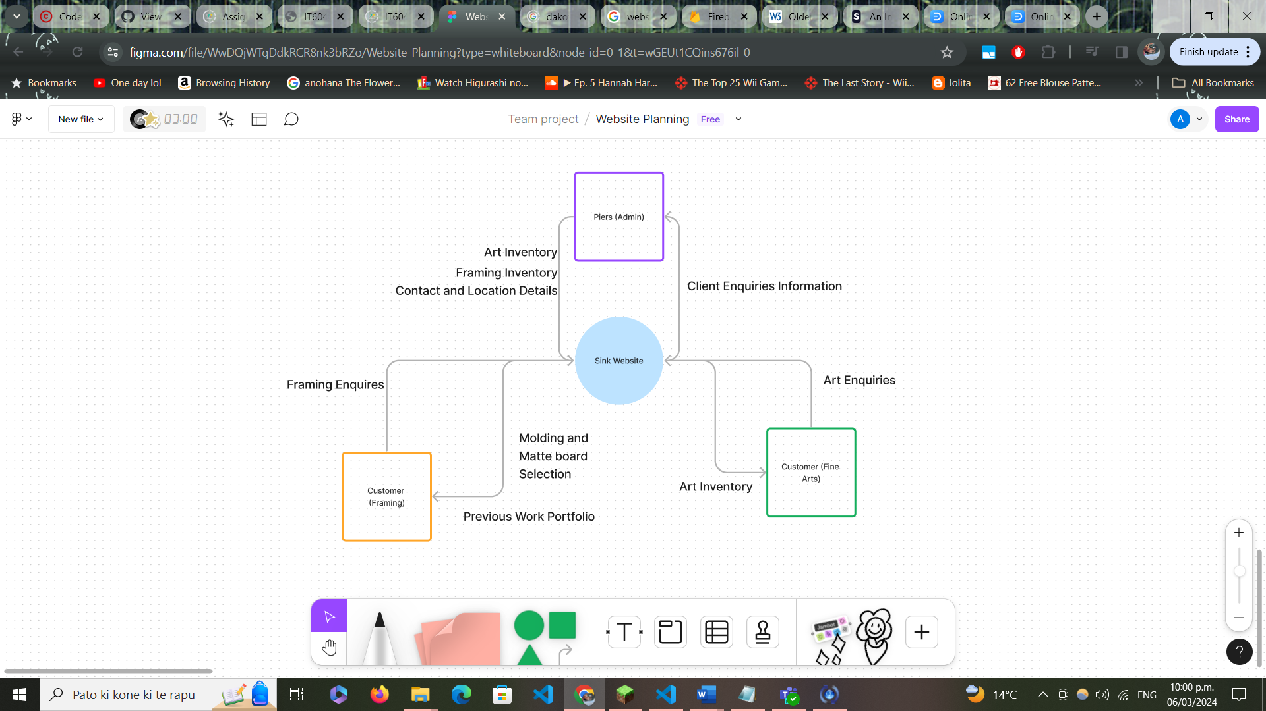

### Requirements

#### Business

* Website should have cohesive design between both segments to maintain branding
* Ability to Create, Read, Update and Delete both art and framing listings.
* Gallery for previous framing work
* Gallery for previously sold art works
* Gallery for available moulding and matte board
* Contact form for both fine arts and framing
* Location on map/ address available
* About page for Piers
* Privacy Policy and other disclaimers
* Announcement Banner – announce temporary closure or other important thing on homepage of each business

#### Security

* Authorization & Authentication
  + Only Piers should be able to access the backend of the site, where he can make edits to listings and other details. There should be a sign-in page which authenticates his credentials to access the backend.
  + There will also be authorization for Pier’s user and any other site user as a ‘Guest”. Piers will have CRUD authorization, and all other users will be view only. Developers will also have full admin privileges.
  + Contact forms should be secure from form field manipulation attacks, such as SQL injection or cross-site-scripting.
  + Protection from DDoS Attacks
  + Privacy policy, shipping and any other disclaimers should be available for all users to view

#### Quality

* Usability
  + Website should comply with Web Accessibility Standards
    - Consider elderly clients – who's needs have heavy overlap with other disabilities. This is because they make a key part of our users.
    - Key needs to consider for elderly include vision, physical ability, hearing, cognitive ability.
  + Website should be easy to navigate with clear and consistent design
    - This should apply both to the front-end interface and the backend interface Piers will interact with.

#### Other

* SEO
  + Googling Sink Framing vs Sink Fine Arts

# Section B: Technical Planning

## Web Framework

[MongoDB, Node.js + Express, React – FigJam (figma.com)](https://www.figma.com/file/xGSvoio4V1TzhDlw1nFYSY/MongoDB%2C-Node.js-%2B-Express%2C-React?type=whiteboard&node-id=0-1)

## Data Access Design

### Collections

|  |  |  |
| --- | --- | --- |
|  | Parameters | Data type |
| Art Piece | Name | string |
| Date | Date |
| Dimensions | string |
| Artist | string |
| Medium | string |
| Description | string |
| Images | Array of strings |
|  | | |
| Artist | Name | string |
| Date of Birth | string |
| Description | string |
|  | | |
| Moulding | Name | string |
| Profile | string |
| Finish | string |
| Colour | String array |
| Timber | String array |
| Dimensions | string |
| Description | string |
|  | | |
| Matteboard | Name | string |
| Thickness | string |
| Colours | String array |
| Finish | string |
| Materials | String array |
| Description | string |

### Relationships

## Functional Decomposition

<https://www.figma.com/file/WwDQjWTqDdkRCR8nk3bRZo/Website-Planning?type=whiteboard&node-id=0-1&t=n0pbiu0hbPFH1eeT-0>

### Security Design

### Security Mechanisms

* Authorization and Authentication
  + Firebase
* Use JWT tokens to prevent cross site request forgery
* Limit request from any one IP address to reduce the risk of DDOS attacks

### User Roles and Permissions

Admin/ Piers

* Fine Arts
  + CRUD New Art Listing
  + CRUD Entry in Past Works Gallery
* Framing
  + CRUD New Moulding or Matte board
  + CRUD New past works gallery
* RU About Page
* RU Privacy Policy and Disclaimer
* CRUD Physical Location
* CRUD Announcement
* Access to front and back end

Guest

* View Only – Front End
* Can submit contact form
* No access to Back End

# Section C: User Interface Design

<https://www.figma.com/file/QGlBE8w2lljzvk1XNgqKeC/Untitled?type=design&node-id=0%3A1&mode=design&t=JQ5nRhzYe4A9IV4M-1>

1. <https://www.storyly.io/post/investigation-into-online-shopping-habits-mobile-vs-desktop>