Tables

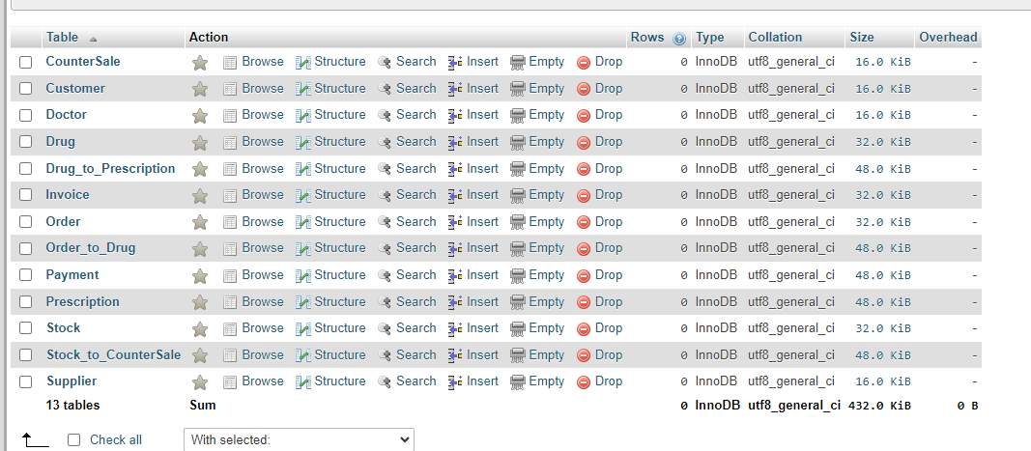

I believe that all the fields are self-explanatory.

CounterSale: 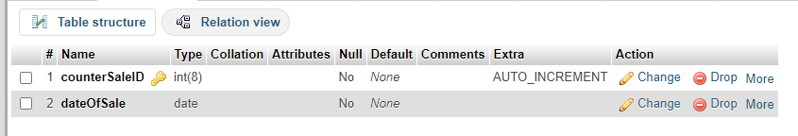

Customer:

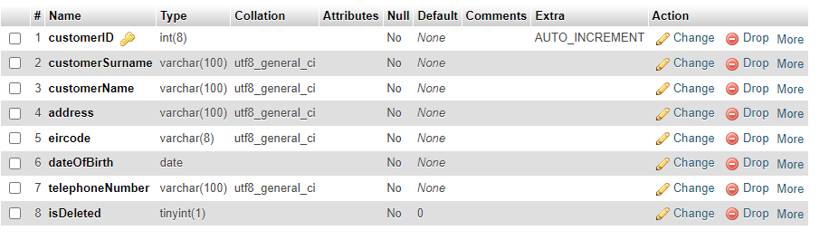

Doctor:

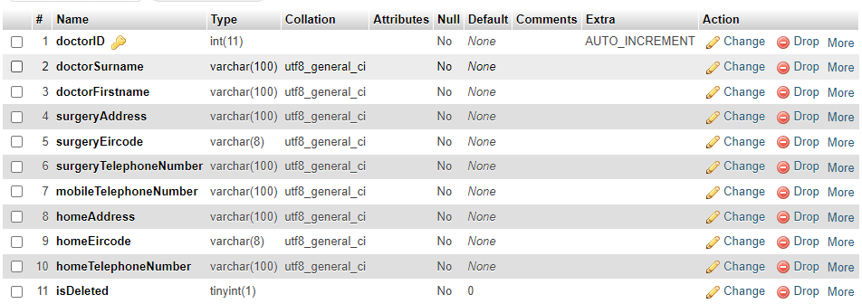

Drug:

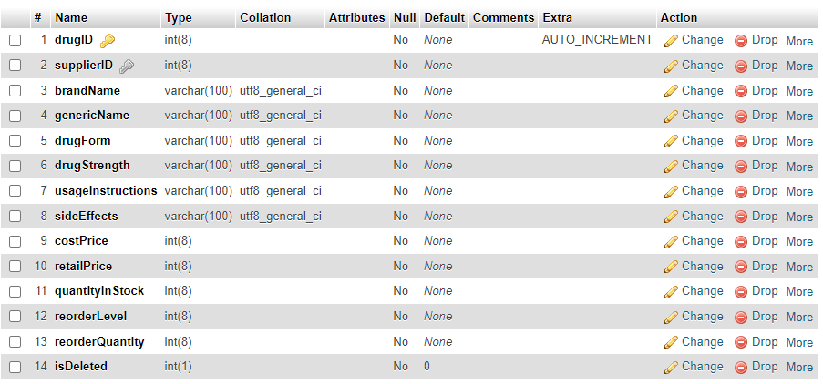

Drug_to_Prescription:

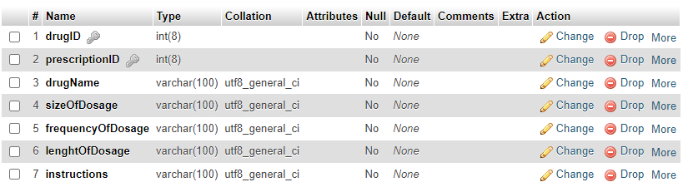

Invoice:

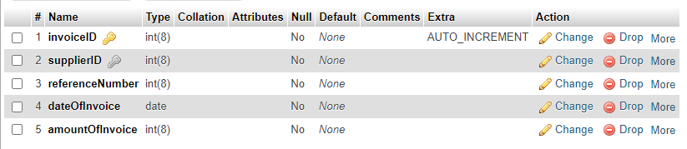

Order:

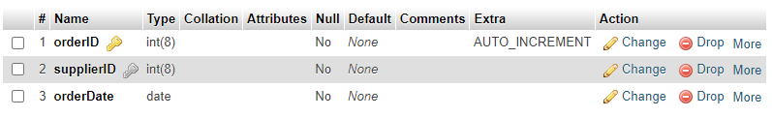

Order_to_Drug:

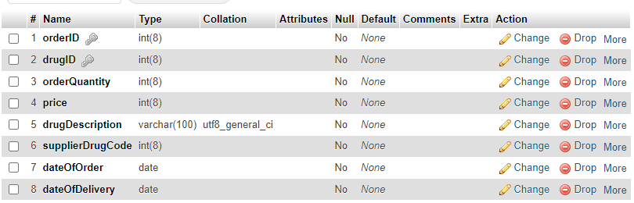

Payment:

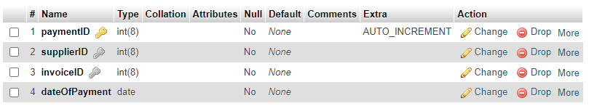

Prescription:

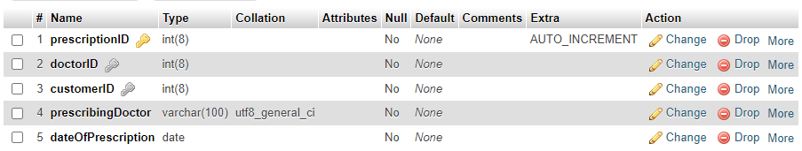

Stock:

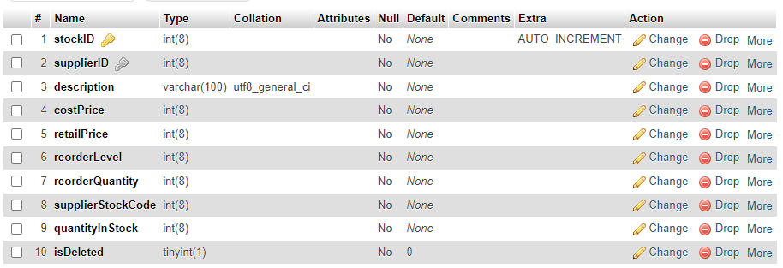

Stock_to_CounterSale:

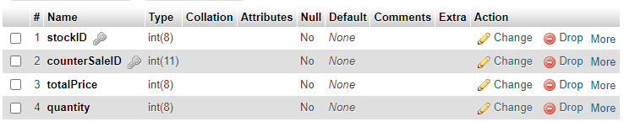

Supplier:

