Crystal Application Tutorial: Comparing with steady state nucleation data

# Load data and set the view

* Load the Crystal application (Click on the crystal application  on the top toolbar)
* Reduce the number of views to 1 (Top right corner)

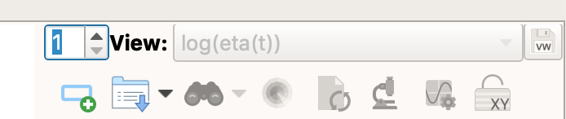

* Open the folder RepTate/RepTate/data/Crystal/CoccorulloMacromolecules2008/

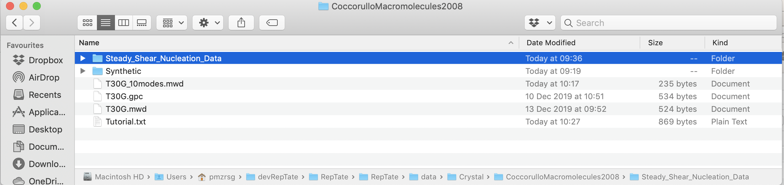

* From the folder ‘Steady_Shear_Nucleation_Data’ drag and drop all files on to the Reptate window

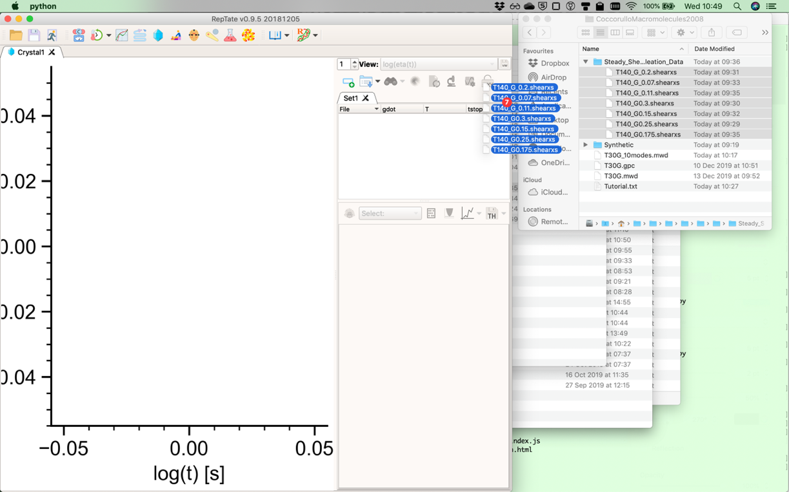

* Select 'Steady Nucleation' View

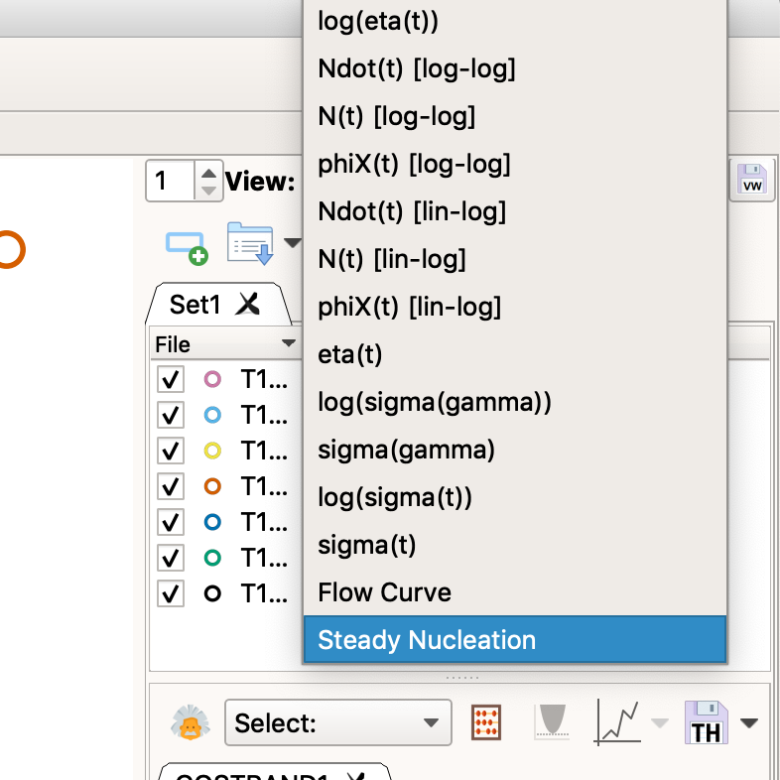

# Set-up a fast-running calculation

* Load GO-polyStrand model (choose the model from the drop down list and then click the theory icon )

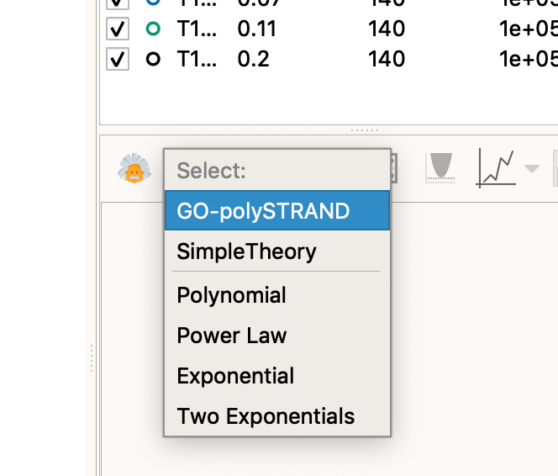

* Click 'Get modes MWD data'

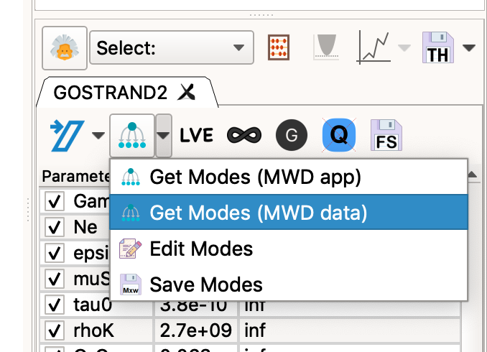

-In the pop-up window set Me=4400, tau_e=9.0E-8 and the number of modes to 10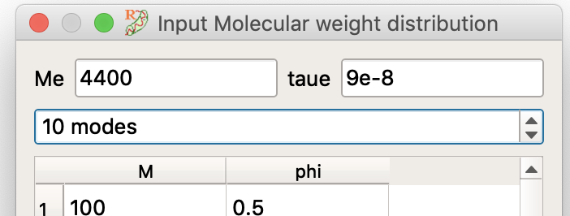

In a text editor, open 'T30G_10modes.mwd' and copy whole file contents to the clipboard.

* Click on the first element of the table and paste the copied file (use ctrl-v or a similar keyboard shortcut)

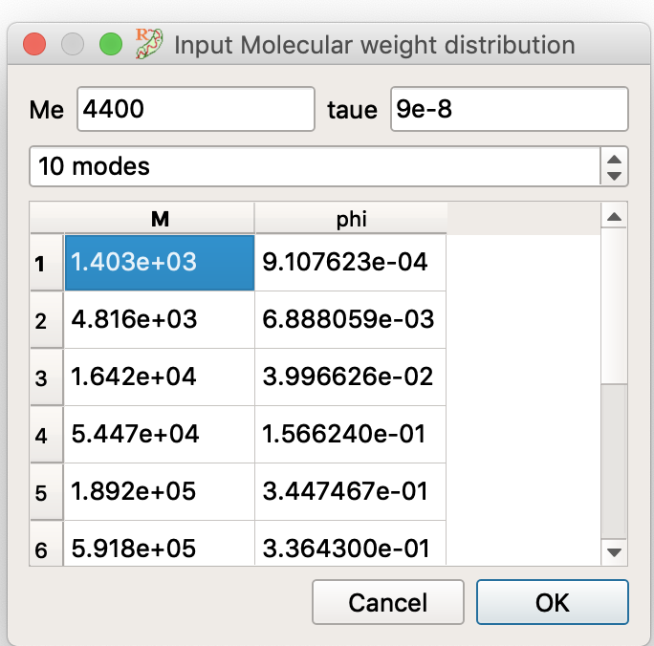

Close the mode window by clicking 'Ok'

* Back in the theory window, turn on the modulus correction button and set Gamma=4.3 and GNO=5.06E5

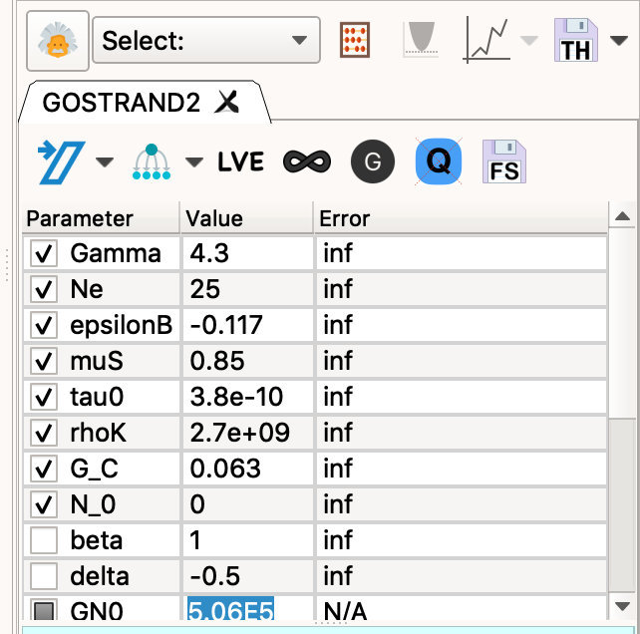

* Other parameters default to the correct values, here's a full list.
* Gamma 4.3
* Ne 25
* epsilonB -0.117
* muS 0.85
* tau0 3.8e-10
* rhoK 2.7e+09
* G_C 0.063
* N_0 0
* beta 1
* GN0 506000
* Hit compute, and the calculation should take about 15 secs (depending on how good your laptop is!)

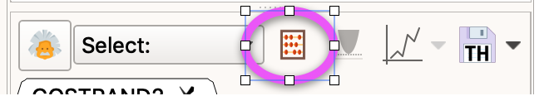

* You should see (open symbols are experiments and closed symbols are the model)

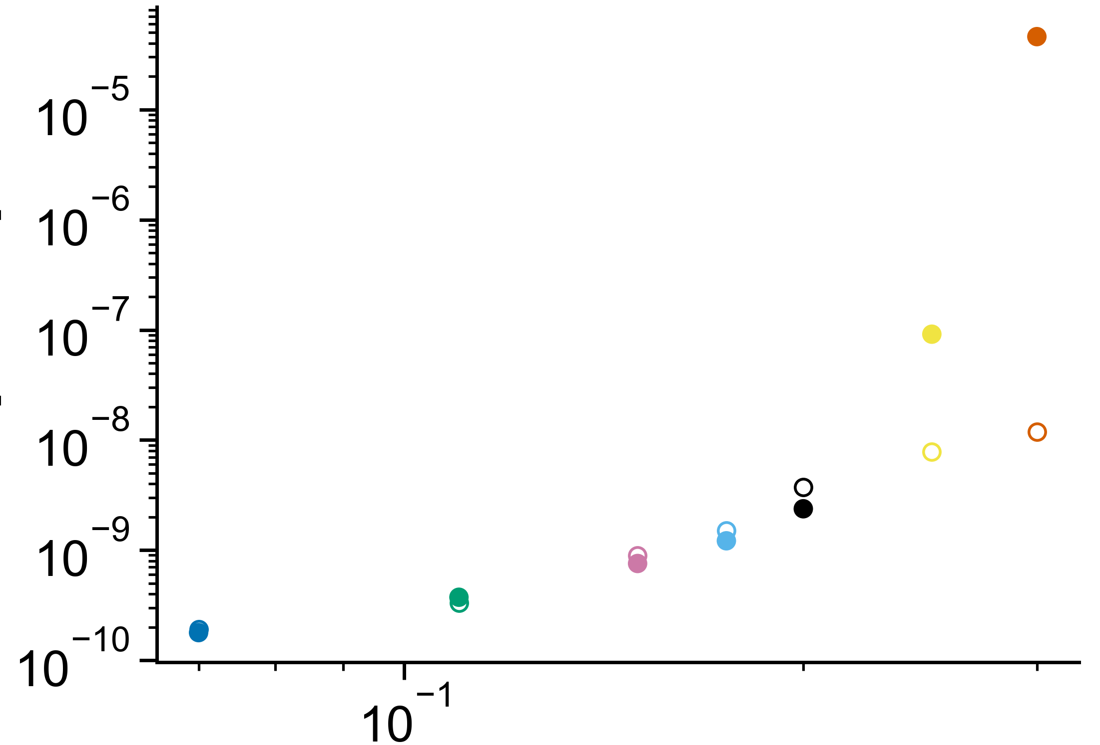

# Adjusting the view

* Click ‘show/hide’ toolbar’  (top right corner underneath the views selector)
* 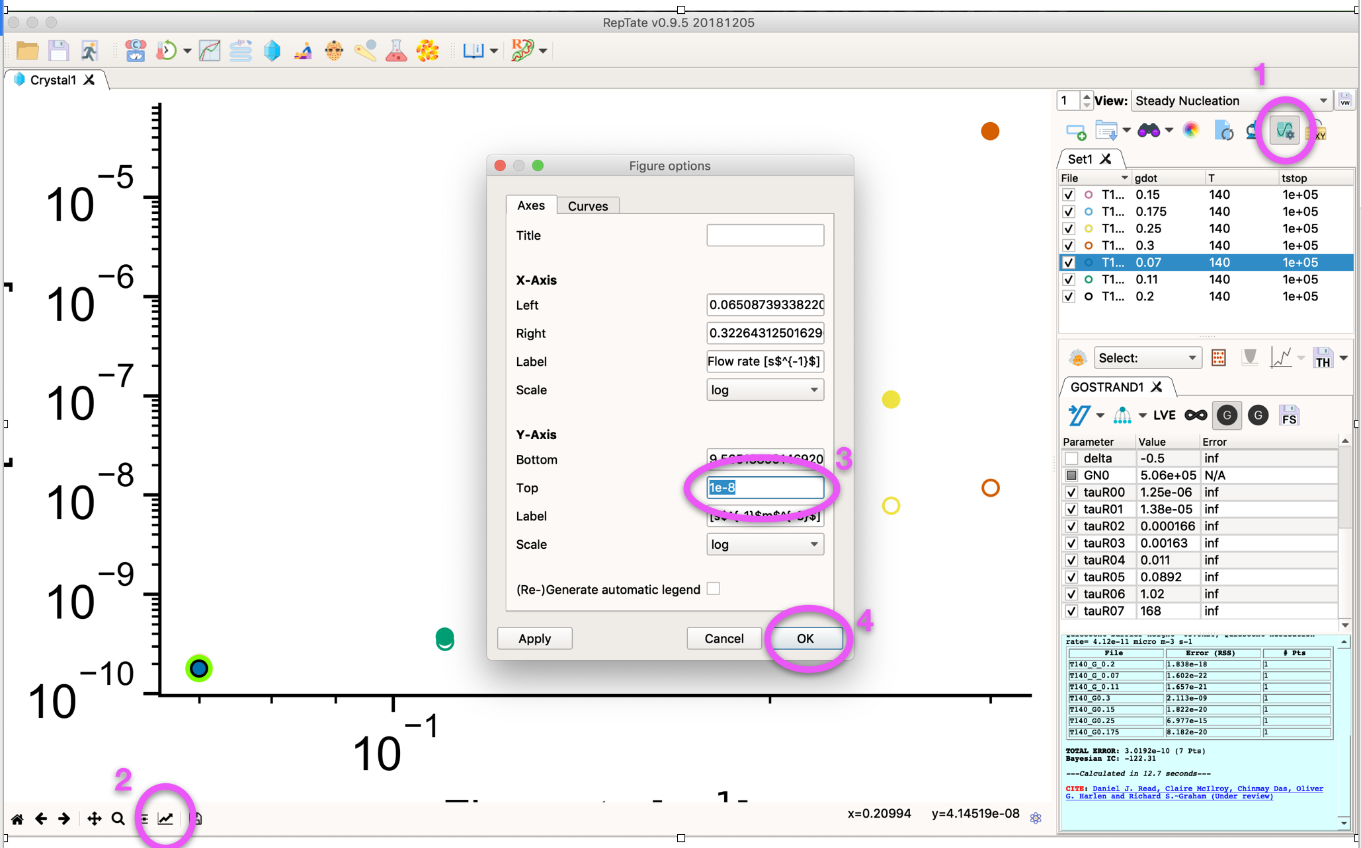
* Click the ‘Edit axis’ button () to bring up the axis properties
* Change the Y-Axis: Top value to ‘1e-8’
* Click ‘Apply’ or ‘Ok’

# Things to try

* Change Gamma to adjust the sensitivity to shear
* Make *small* changes to epsilonB to adjust the quiescent barrier (equivalent to changing temperature)
* Adjust tau0 to scale all nucleation rates
* Change the molecular weight distribution by clicking ‘Get modes (MWD data)’ and changing the Molar Mass values (M) by hand. You can also change phi but this needs to add up to 1.
* Increase the resolution of the molecular weight distribution by copy/pasting the modes from the file ‘T30G.mwd’ (this has 23 modes, should give similar results and will take a 4 mins to calculate)