SWE30010 – Managing IT Projects

Learning Summary Report

Nguyen Dinh Nhat Minh (103802490)

**Portfolio Submission Due**

All Grades: Week 13 Monday (8th April 2024), 11:59PM

**Portfolio Interview Dates**

Distinction / High Distinction: Week 13 Thursday (11th April 2024), (15 minutes per student)

Self-Assessment Details

The following checklists provide an overview of my self-assessment for this unit.

|  |  |  |  |  |
| --- | --- | --- | --- | --- |
|  | Pass (D) | Credit (C) | Distinction (B) | High Distinction (A) |
| Self-Assessment (please tick) |  |  |  | X |

*Self-assessment Statement*

|  |  |
| --- | --- |
|  | Included (please tick) |
| Learning Summary Report | X |
| **All** Pass Tasks are Compete on Canvas | X |

*Minimum Pass Checklist*

|  |  |
| --- | --- |
|  | Included (please tick) |
| All Credit Tasks are Complete on Canvas | X |

*Minimum Credit Checklist, in addition to Pass Checklist*

|  |  |
| --- | --- |
|  | Included (please tick) |
| Interview booked | X |
| All Distinction Tasks are Complete on Canvas | X |
| Other pieces (please specify) |  |

*Minimum Distinction Checklist, in addition to Credit Checklist*

|  |  |
| --- | --- |
|  | Included (please tick) |
| Software Project Document [Plan, Design, QA] meet HD criteria and standards | X |
| Research Article / Essay meets HD criteria and standards | X |
| Other pieces (please specify) |  |

*Minimum High Distinction Checklist, in addition to Distinction Checklist*

# Declaration

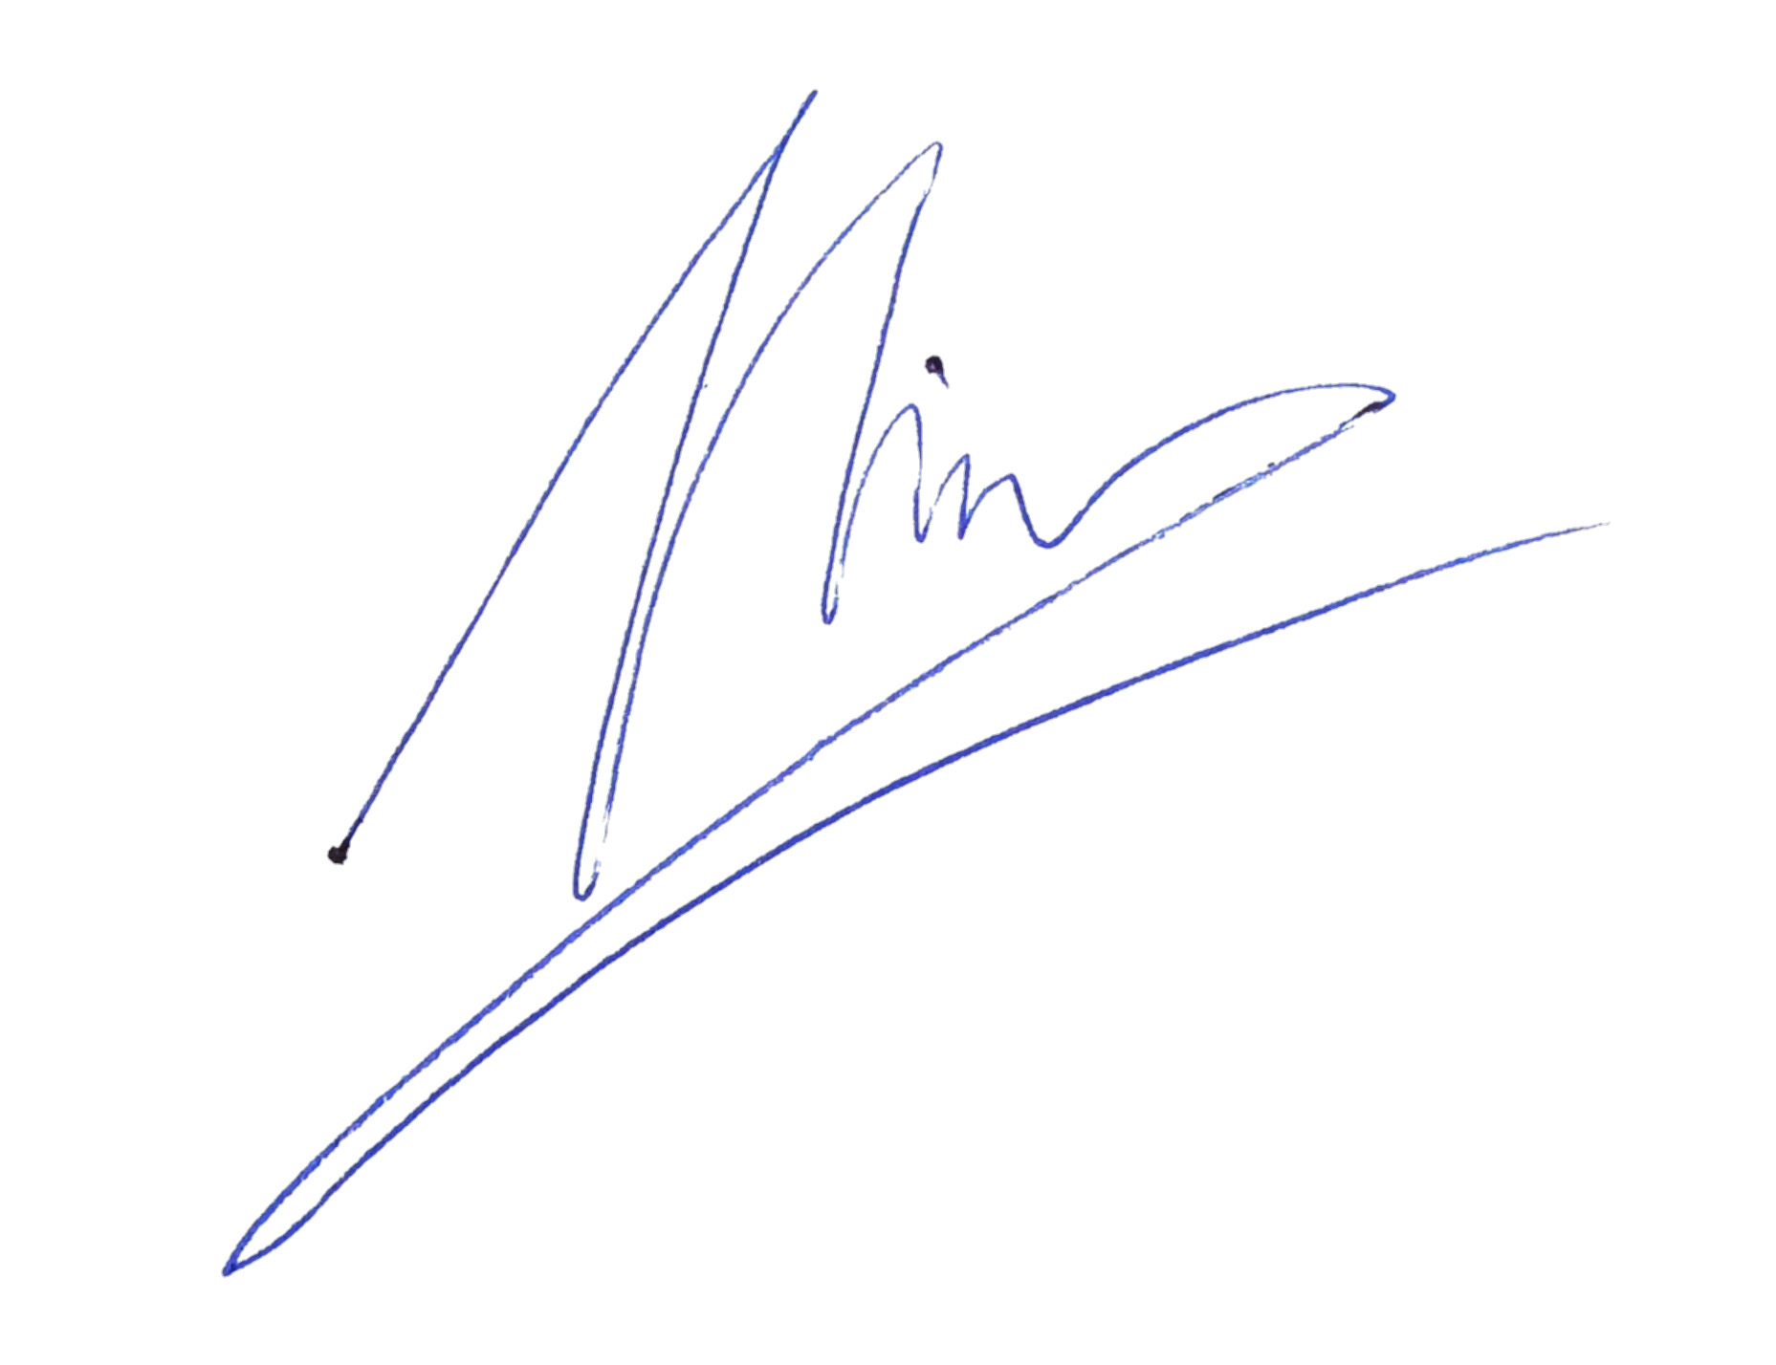I declare that this portfolio is my individual work. I have not copied from any other student’s work or from any other source except where due acknowledgment is made explicitly in the text, nor has any part of this submission been written for me by another person.

Signature:

# Portfolio Overview

This portfolio includes work that demonstrates that I have achieve all Unit Learning Outcomes for SWE30010 Managing IT Projects to a **High Distinction** level. The portfolio can be seen at the portfolio section at the end of the Learning Summary Report

I believe I have gone above and beyond my capabilities to earn the High Distinction mark, the reasons are as follows:

* **Project Plan and Documentation**: I studied the material intensively to proposed and came up with the planning for both my group work and my individual work. For more details, in both cases, I oversee creating the product backlog, the detail work plan, and document the features of our application.
* **Team Collaboration and Leadership**: I motivate everyone in my group to finish their defined task so as the development of the application can go swimmingly, I did this though monitoring the process of doing group works to ensure everyone contribute in one way or another as well as giving everyone a fair shot of doing what they do best as well as trying to wiggle in some task more challenging so they can grow their skills.
* **Project Success Stories**: The result of planning, monitoring, and developing our product turns out very well as we can develop our product’s first sprint with a great degree of functionality and quality. This is merely my own effort; it took a whole team to do this.
* **Software Proposal and Research**: Within my Credit, Distinction and High Distinction tasks, I was able to do all of the previous point again but with just myself and I have learnt a lot of things doing these tasks. It quite eye-opening for me.

# Reflection

## The most important things I learnt:

On a general level, leadership, communication are two of the most important aspects I have learnt in this unit. As it is my first time assuming the leader role in a unit, I have learnt a lot about management and communication within a team to make my team the best they can be.

On the technical level, scrum, and agile concept are also quite important in my opinion. These concepts have really given me a different perspective on how I look upon software development. I also got to learn about other traditional software development management, but those maybe too unrealistic at time, while agile reign supreme with its speed, flexibility and adaptability.

## The things that helped me most were:

Canvas material is where I got most of my knowledge from, without it, I can not even begin to study this subject seriously. The material given as well as the external resource recommendations given by the modules helped me understand the unit on a deeper level.

My lecturer is also helpful in the way that he guides me and my team through how to tackle with assignments. He also gave us pieces of his practical knowledge that in a way helped us gained experience talking with him also,

## I found the following topics particularly challenging:

The quality assurance as well as the risk management topics are rather complex at time. I understand that these are some of, if not the most important aspect of any project. Hence, I tried to digest them as hard as possible, but some aspect are rather abstract and can get frustrating at time.

## I found the following topics particularly interesting:

I enjoy the management topics (SDLC, tracking and monitoring, and planning) because I believe leadership is the most important skill that everyone should have, and the material given in these topics had helped me figuring out how to deal with working with/leading a team.

## I feel I learnt these topics, concepts, and/or tools really well:

Trello is definitely a new tool for me, but it did not take long for me to realise how useful it is. Trello helped me grasp the concept of Kaban board and showed me how it can be implemented in my private life as well as my work life in general.

I also noted the importance of the product backlog for an agile team also, it does created a comprehensive list of tasks we need to do, but also does not enforced any task to be doing first, making it a great tool for planning software development where iteration matters a lot.

## I still need to work on the following areas:

It is safe to say that I could utilise my time better, as I often have rushed tasks and might require some refinement. I would like to also improve my communication skill in a sense that I need to remember the tasks that I assigned/was assigned to so as to better keep track of the project’s overall progress.

## This unit will help me in the future:

This project is universal in my opinion, because should I follow the tech lead role in the future, it will definitely give me a boost in my skill in managing software development. But should I choose to not pursue tech leading, skills like planning and communicating still transfer really well in other aspect of life.

## If I did this unit again I would do the following things differently:

Study more external materials: So as to expand my leadership and/or my technical literacy so as to gain more knowledge into what I am doing.

Plan weekly tasks more spread out: I may have assigned too little task in the first few weeks of the unit and cramped it at the end, which in hindsight is not a good thing for my team as they could benefit from more time to do their tasks.

Take extra time to digest materials: I would like to take my time to really understand and deep dive into the material so as to understand it thoroughly. Further increasing my capability and competency.

**Portfolio**

**Evidence of Pass tasks**

Individual

Group

**Evidence of Credit tasks**

**Evidence of Distinction Task**

**Evidence of High Distinction Task**