Executive Summary: Apartment feature that influences price the most

Objective
This project aimed to uncover which apartment feature drives prices up: bedrooms, bathrooms or parking spaces, adjusting for location and apartment size. The analysis concluded that bathrooms influence price more than the other two features.

Key Findings
- There is a very strong positive correlation (0.7) between the number of bedrooms and monthly rental prices; this means that price tends to increase with the number of bedrooms. Further analyses indicated that each additional bedroom drives apartment prices up by R1 351.93. Additionally, we evaluated an R-squared score of 49%, which tells us that almost half of the variability in monthly rental prices can be explained by the number of bedrooms.

- There is a very strong positive correlation (0.83) between the number of bathrooms and monthly rental prices; this means that price tends to increase with the number of bathrooms. Further analyses indicated that each additional bathroom drives apartment prices up by R2 786.51. Additionally, we evaluated an R-squared score of 69%, which tells us that more than half of the variability in monthly rental prices can be explained by the number of bathrooms.

- There is a moderately strong positive correlation (0.44) between the number of parking spaces and monthly rental prices; this means that price tends to increase with the number of parking spaces but not at a consistent pace. Further analyses indicated that each additional parking space drives apartment prices up by only R662.98. Additionally, we evaluated an R-squared score of 19%, which tells us that less than one fifth of the variability in monthly rental prices can be explained by the number of parking spaces.

- The bathrooms outperform bedrooms and parking spaces in the three metrics. This indicates that bathrooms have the strongest influence on price out of all three.

Visual Insights
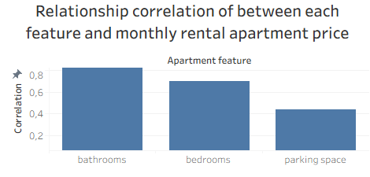
The number of bathrooms have shown the strongest relationship with monthly rental prices, which is 19% stronger than the correlation between number of bedrooms and price.
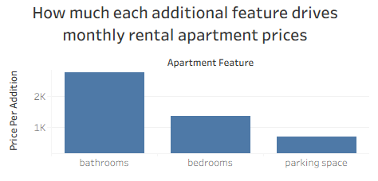
Each additional bathroom drives up monthly apartment prices by R2 786.51, that is a R1434.58 price difference from bedrooms.

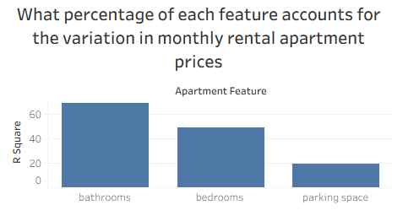
Bathrooms account for 69% of the difference in monthly apartment prices.

Conclusion
As we have discovered in this report, out of bedrooms, bathrooms and parking spaces, the number of bathrooms stands out as the feature with the most influence on apartment prices.

