Version Controlling with Git in Visual Studio Code and Azure DevOps 20/06/2025

https://www.azuredevopslabs.com/labs/azuredevops/git/

https://www.azuredevopslabs.com/labs/azuredevops/pullrequests/

note we’re working with the following accounts:
https://dev.azure.com/garthjon/DevOpsTraining (for dev ops) and...
https://github.com/garthajon/azure (for the git repo)

Firstly let’s configure git to put a name and email address against whichever changes we commit/make. In visual studio code within the directory which is your git/dbt repo run the following commands (changing the name details to whichever is appropriate for the user making changes to your project):

git config --global user.name "Garth Jones"
git config --global user.email garthjon@outlook.com

Committing a change to a branch in your local repo

Within your dbt/git repo within visual studio code, make a change within one of the files for example to one of the dbt models, it could be a change in SQL or just adding a comment.

Still in visual studio on the left hand side click on the source control icon (the icon that looks like a git branch symbol), and you should be able to see that you can commit (big blue commit button) all of the changes which you made and add a comment for those changes (the comment box above the big blue button), all note the ‘stage changes’ feature where you can opt to only commit specific changes rather than all of the changes

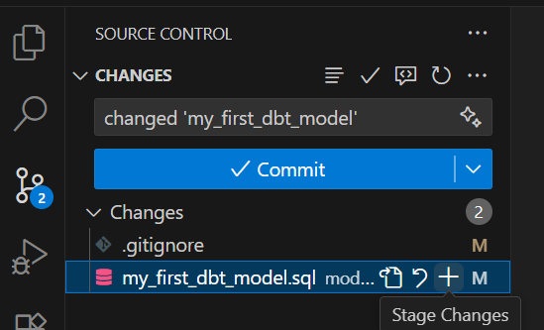

I leave the comment as is and click commit and this commits all two changes to the code, but only to the ‘local branch’ on my local machine. Note I can a warning message observing that I have not staged any changes i.e. specified which specific changes I want to commit:

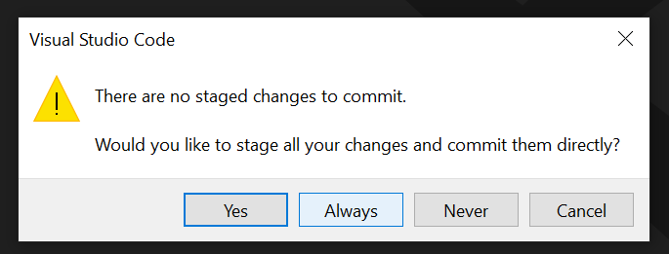

thus, I stage all changes and commit all of them and also specify that I want to always do that when I commit.

Next I click ‘sync changes’ remembering that the local dbt/git repo is linked to a remote ‘azure’ dbt/git repo, I add a comment, click sync and click okay to push these changes to the main branch in the remote azure dbt/git repo:

