About Angul
Planning a Trip to Angul? Here's our list of 6 top Tourist Places to visit in Angul
Angul is a town in the Indian state of Odisha. Angul, also pronounced as Anugul, was formed after the bifurcation of the Dhenkanal district in the year 1993. The region of Angul was dominated by tribal groups like Gond & Kandhas. As the times advanced, the land of Angul saw many events of invasion by Afghans and later on by the Britisher.
Entrenched closer to the southern shoreline of Bay of Bengal, Angul is elevated at 640 feet above the sea level & sprawls across 6232 sq. km. It is surrounded by Dhenkenal and Cuttack in East, Sambhalpur in West, Sundargarh in North & Nayagarh in South.
Before the industrial revolution that changed the landscape of Angul, historically Angul was a land of different tribes who commanded over small citadels. According to popular folklore, the name Angul is said to be derived from a local chieftain named ‘Anu’ started a futile rebellion against the King. The locals referred to that period as Anugol (Anu's war), subsequently, the name “Anugol” stuck and the town came to be known as “Angul” as we know it now.
Top 6 Places to Visit in Angul
Saila Srikhetra
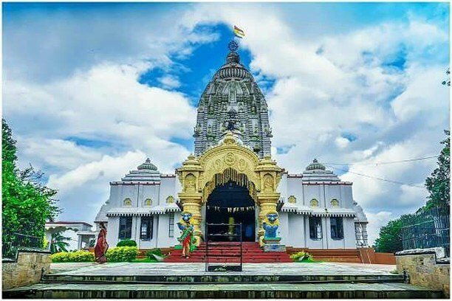
The Jagannath Temple at Angul is known as “Saila Srikhetra” situated on the top of Sunasagad hill. The foundation of this grand temple was given on 21.2.1996 to build the temple like the model of world-famous Lord Jagannath Temple of Puri.
Goddess Hingula
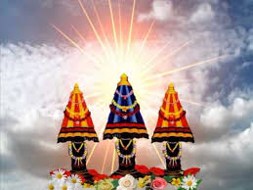
Goddess Hingula is situated on the bank of the river Simhada in the West of Talcher. it is located at a distance of 14 km. from Talcher. There is a temple Goddess Hingula here. Hingula Yatra is observed here for 9 days during the month of March-April(Chaitra). It is believed that Holy Places of Hingula are situated outside of India like in Karachi and Kabul, so both Hindus and Muslims worship at this holy place.
Lovi Thakurani, Garh Santry
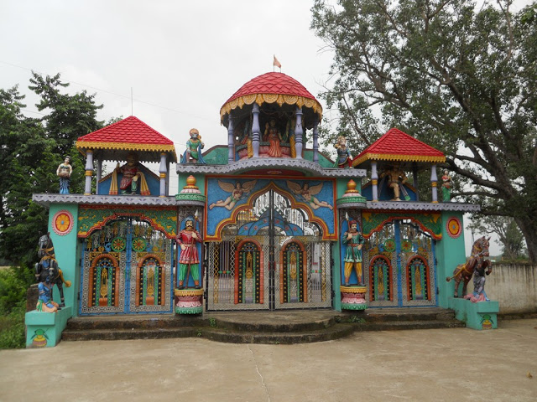
Lovi Thakurani Yatra, the annual ceremonial function of Goddess Lovi, is observed every year on Kartik Purnima day. Garh Santry, seventeen kilometers away from the district headquarters town Angul, is the village abode of the presiding deity Lovi. It was the time when Lord Sri Ram was returning to Ayodhya after the invasion of Lanka, boarding his speak Viman, He could notice that a Devi of Lanka, who was being worshiped by Ravan with plenty of animal sacrifices, was following Him maintaining a distance. When asked about her intentions of leaving the land of Lanka and following him, she narrated how she was being honored in the kingdom of Ravan.
Deulajhari, Athamallik
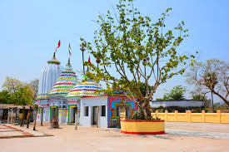
It is a famous Saivism pilgrimage place as well as famous for its divine water spring. As per local believes and ancient records there were eighty-four springs. But many of them are hidden in the jasmine forest. Now twenty-four springs are alive. Among these, the springs bearing the names like Agnikunda, Taptakunda, Himakunda, Annantakunda and Labakusa Kunda are prominent ones.
Kosala Ramachandi Temple
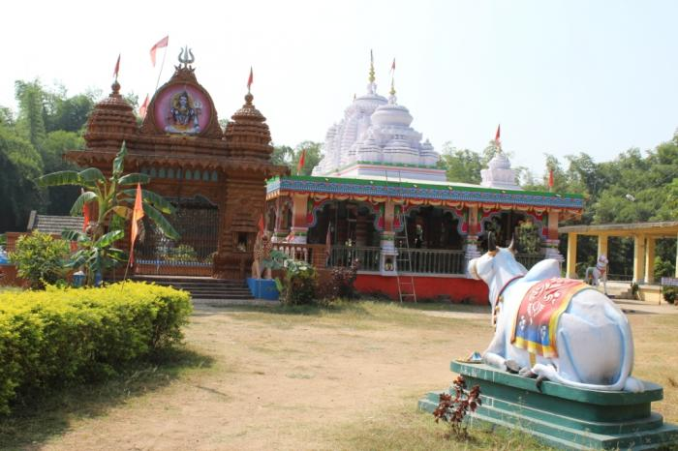
Kosala village is known for its shrine dedicated to Goddess Ramchandi. She is believed to be possessed of great powers. On the foundation of the old temple, one magnificent temple was constructed. A Yatra is held here on the second day of Krushna Pakshya Bhadra. This Yatra is known as Ramchandi Yatra or Kaduali Yatra (July- August). This Yatra is celebrated with a big ceremony every year.
Rengali Dam
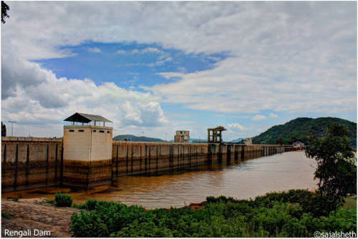
A dam has been constructed across the river Brahmani at Rengali. One Hydro electrical power project of 120 MW capacity has been installed here. It is about 85 kms from Angul, located on N.H. Rengali amidst picturesque environs and it is a nice place for a group picnic.
How to reach Angul
By Air
Nearest Airport is Biju Patnaik International Airport, Bhubaneswar. The distance is around 150 Kms.
By Rail
It is around 140 KMs from State Capital and well connected by Rail. From Angul Railway Station, it is about 4 KMs.
By Road
It is around 140 KMs from State Capital and well connected by Road. The temple is situated on the roadside of National Highway on Sunasagad Hilltop.
Best Time to Visit Angul
The best time to visit Angul is in winter. The Picnic spots are well visited during months November-February. The city is marked by many festivals all year round including Trade Fest Cultural Events, Book Fairs, Lord Biswakarma Puja in Nalco Nagar(September) and Amusement rides during major fests.
Weather of Angul
Ganjam's maximum summer temperature is 40°C; the minimum winter temperature is 22°C. The mean daily temperature varies from 33°C to 38°C.

