About Balangir
Planning a Trip to Balangir? Here's our list of 9 top Tourist Places to visit in Balangir
Balangir is an important commercial city with a rich cultural heritage. The place is famous for its beautiful setting with many old temples and shrines and the indigenous tribes that dwell here since time immemorial.
Balangir in Odisha is proud of its rich cultural heritage. A planned township established way back in 1871, Balangir was once a tiny hamlet until Ram Chandra Deo III made it his capital. Famous as the cultural hub of Western Odisha, particularly for its indigenous tribe Kosali’s folk art and dance, Balangir is known for its temperate climate and many temples, parks, picnic spots, age-old buildings and the famous Sambalpuri cotton fabric.
Top 9 Places to Visit in Balangir
Bhima Dunguri
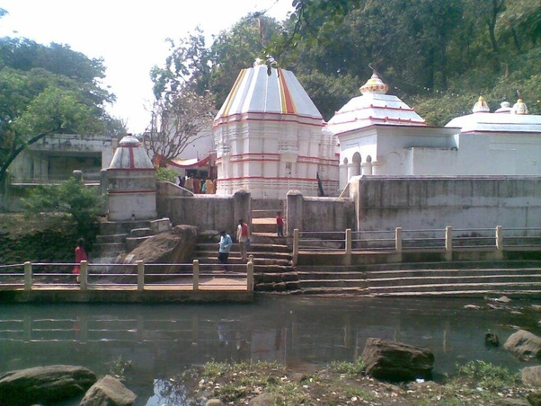
Bhima Dunguri, famous by its ancient natural caves which are lying scattered at different places of the hilly area. The panoramic view of this area is unparallel during the spring season, so any kind of tourists is definitely enchanted here due to its beautiful landscape.
Kumuda Pahad
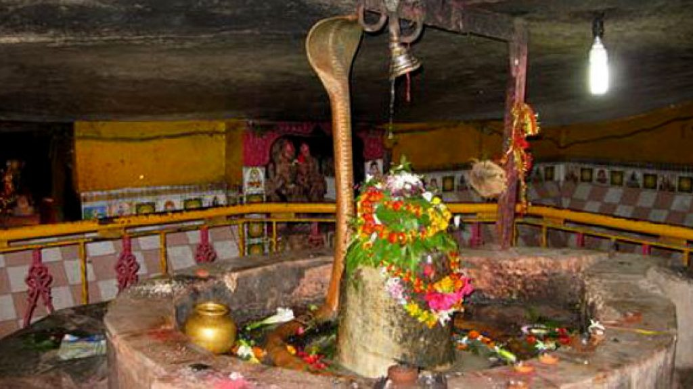
Kumuda Pahad is a natural splendorous place of great tourism interest. As its name suggests, it is a hilly area where Lord Dhabaleswar is embodied in a very big natural spacious caves measuring an area of 80 feet by 40 feet. There are also 3 other caves nearby. The temple is just 40 feet above from the hill foot.
Turekela
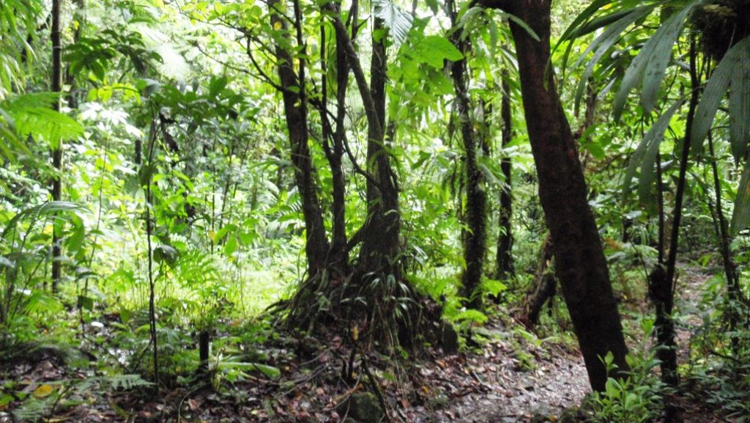
Turekela is important for viewing colorful wildlife like Tigers, Deers, Bears, Foxes, Elephants, Wild Birds, Monkeys, Wolfs etc. The chirping birds perched on trees are a thrill to the searching eyes. School and College students, weekend tourist and leisure tourist throngs here to celebrate new years in the lap of nature.
Gaikhai M.I.P
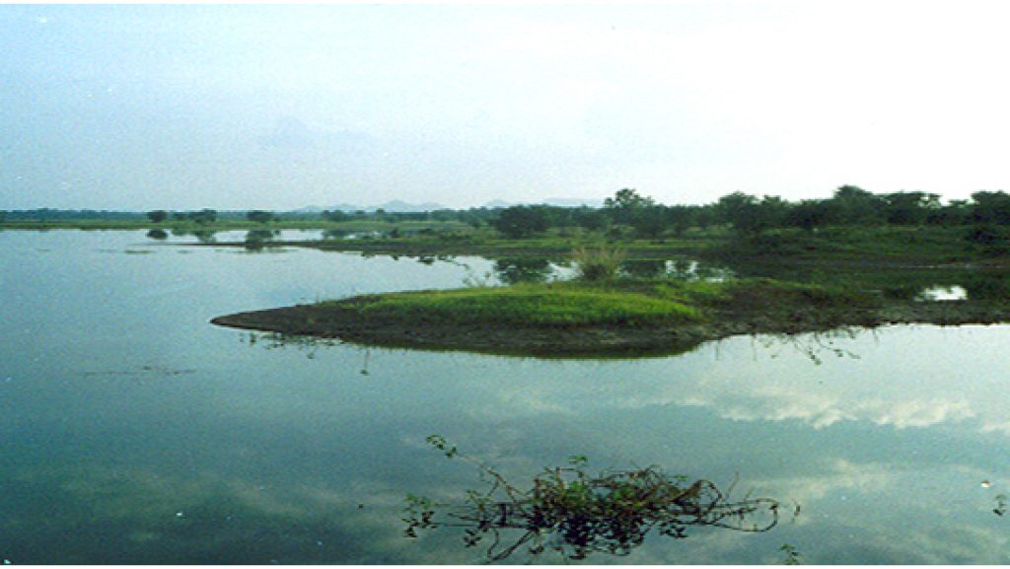
A place of great scenic beauty, Gaikhai is surrounded by green capped hills on three sides. The water mass here dazzles with natural scenery and offers a cool breeze to the visitors. An ideal place for group camping, the place also is thronged with picnickers all year round.
Jogisarda
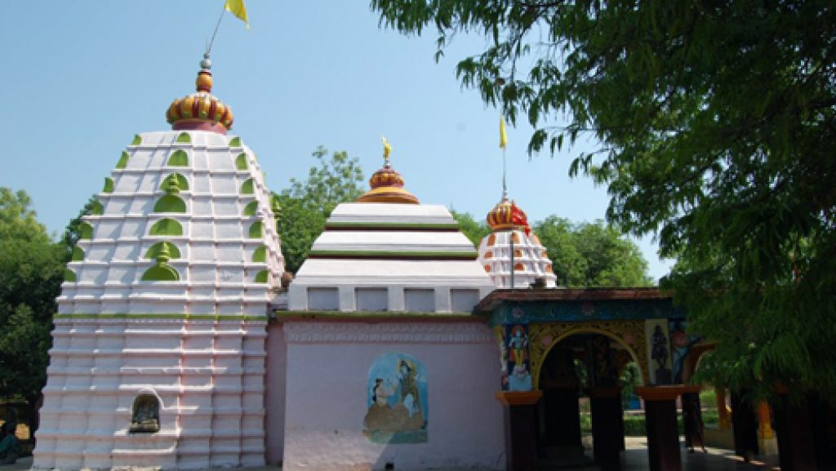
Jogisarda's place is eminent for its Jogeswar Temple. It is believed that all wishes are fulfilled who worship the Jogeswar Mahadev. Devotee from far-flung came here on the occasion of Mahashivaratri to fulfill their wishes during Sital Shasthi Yatra the marriage of Lord Shiva and Goddess Parbati.
Saintala Chandi Temple
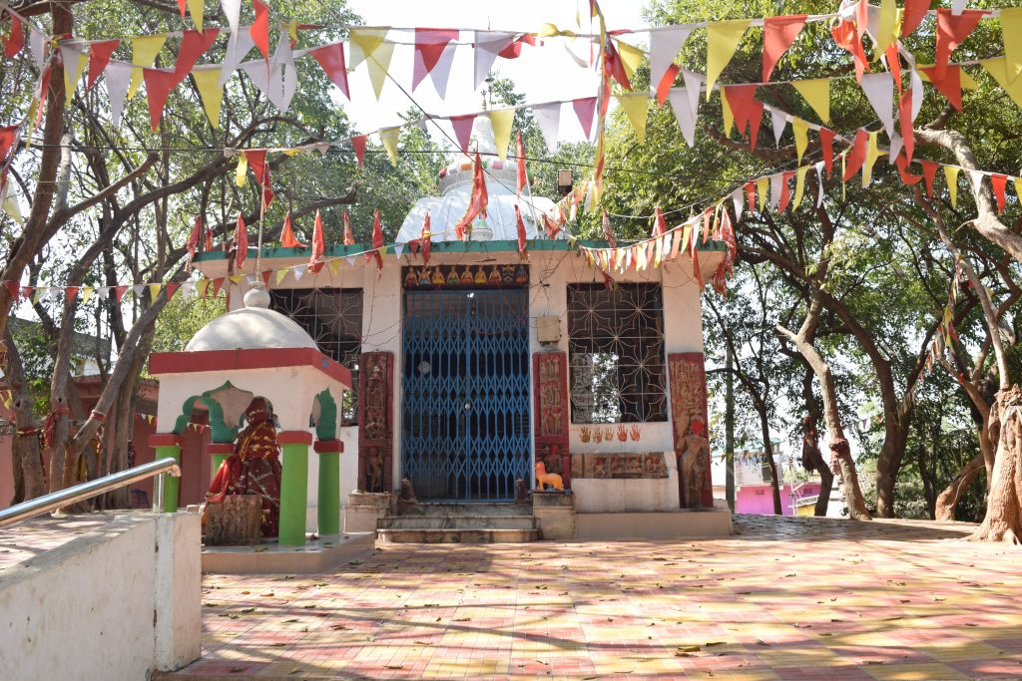
Saintala, situated 35 km away from Balangir, is a place of interesting archaeological and historical importance. The place houses the famous Maa Chandeshwari Thakurani Temple where Goddess Chandi in Mahishasuramardini avatar is the consigned deity. This temple is believed to belong to the Somvansi period.
Ranipur Jharial
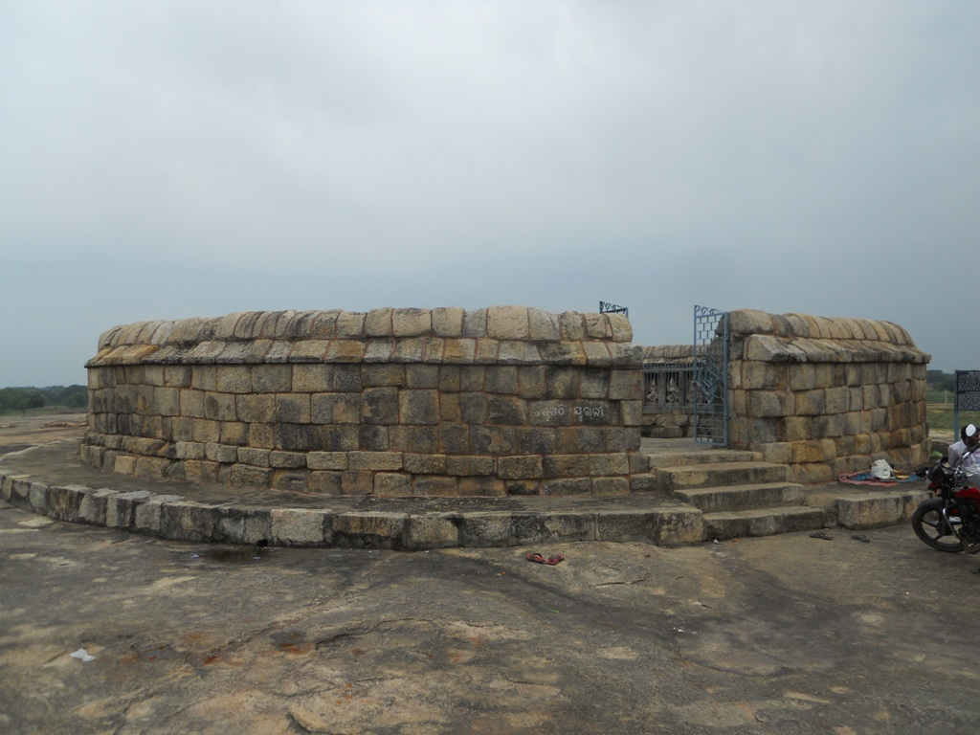
Ranipur and Jharial are the twin villages that are 104 km away from Balangir. In ancient times, Ranipur was the place where the queens of Patnagarh used to stay and Jharial used to be a fort. The place is of religious importance as various cults, such as Vaishnavism, Saivism, Buddhism and Tantrism flourished here. The Tong river, also known as Tong Jor, flows by the hamlets.
Pataneswari Temple
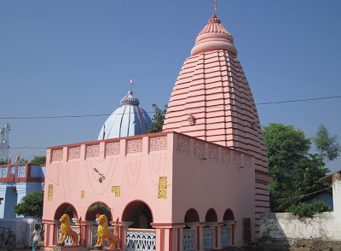
Patnagarh, a small town of Balangir houses some enticing ancient temples. The Parameswari Temple was constructed in the Chalukya style of architecture. The Someswar Siva Temple is a 12th century old temple which is an important pilgrim.
Harishankar
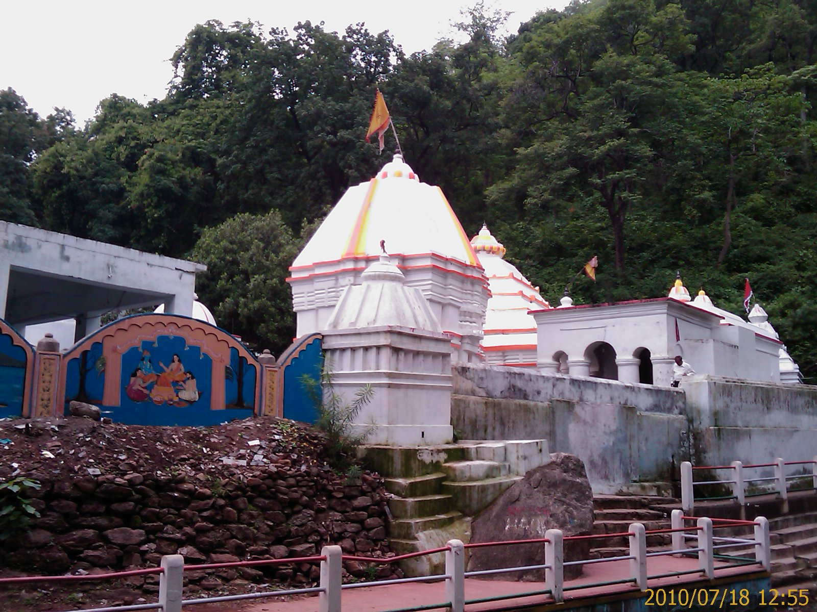
Harishankar stands on the slopes of the Gandhamardan Hills. It is a place of magnificent natural beauty and a Hindu pilgrim spot too. A perennial stream passes by the place. The place is famous for the Hari Shankar Temple which is devoted to Lord Vishnu as well as Lord Krishna.
How to reach Balangir
By Air
Raipur in Chhattisgarh is the nearest Airport. The nearest Airport in the state is situated at Bhubaneswar. Bhubaneswar is around 321 km away from Balangir.
By Rail
The Balangir Railway Station is an important junction of the South Eastern Railway that falls on the Jharsuguda-Sambalpur-Titlagarh line. The city is well connected to other parts of Odisha via a good network of trains. There are trains connecting Balangir with the major cities of India as well.
By Road
Balangir is well connected by road. The state government-owned buses are available from other cities and towns to reach Balangir.
Best Time to Visit Balangir
The best time to visit Balangir would be a time when you can completely soak in the experience and not worry about such hassles. The weather of Balangir is favorable along with the best of activities during this particular time in Balangir. If you are thinking about when to go to Balangir then, come visit Balangir at it's the best time which is winter. From November to March you can enjoy your stay at Balangir.
Weather of Balangir
Balangir has the tropical savanna climate prevailing. It is warm every month with both a wet and dry season. The highest average temperature in Balangir is 42°C in May and the lowest is 21°C in January. The weather and climate of Balangir are suitable for a sun vacation.

