About Balasore
Planning a Trip to Balasore? Here's our list of 9 top Tourist Places to visit in Balasore
A premier Tourist attraction of Odisha, Balasore is the main place of the Balasore District. It is a culturally rich district and is also historically popular. It is the residential place of Fakir Mohan, known as the savior of the Odia language. This city is also full of industrial factories such as Birla Tyres and Oriplast. The Balasore Railway Station is one of the most important too.
Balasore is considered as one of the coastal districts of the Indian state of Odisha. Widespread irrigation arrangement within Balasore District is praiseworthy. This place is also growing fast as an industrialized area. High-end trading goods like Plastic, Rubber, Alloy and Paper are counted among major industrial products of this area. Getting a boost in the commercial field, the district is equally blessed with culture and heritage.
Top 8 Places to Visit in Balasore
Talasari-Udaypur Beach
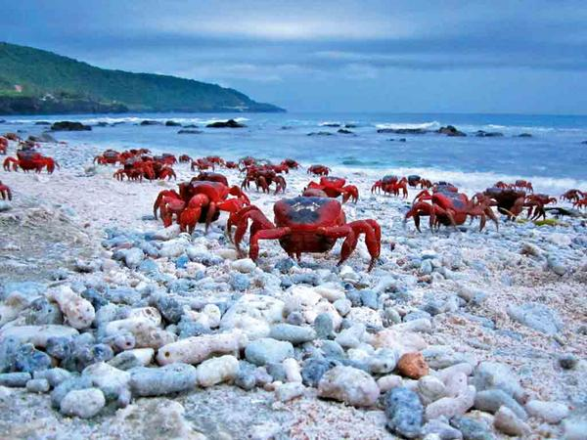
The long stretches sandy beaches with red crabs and whistling casuarinas at Talsari-Udaypur beach attract tourists. Tourists can enjoy the marine drive from Talsari to Udaypur sea beach (3 km) in a cool and calm atmosphere. The sunrise and sunset at Talsari and Udaypur beach is really pleasant scenery for nature lovers.
Jagannath Temple
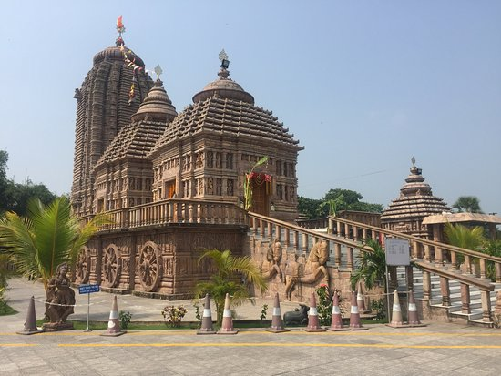
Emami Jagannath temple is the newly constructed Jagannath Temple is a wonderful architectural model that attracts a good number of visitors to this site. Made in the year 2015 with a red stone having many side deities in the temple campus.
Khirachora Gopinath Temple
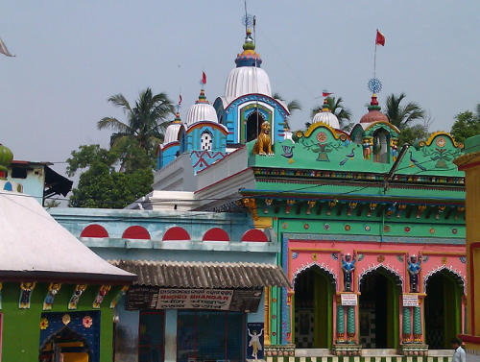
Famous for Khirochora Gopinath temple, Remuna has been a seat of Vaishnawite Culture for centuries, Madhabendra Puri the teacher of Shri Chaitanya and Shri Chaitanya himself visited Remuna and offered their worship to Khirochora Gopinath. Today hundreds of devotees gather daily for the sacred Darshan of the Lord. Specially prepared milk is the most delicious Prasad of the temple.
Chandipur Beach
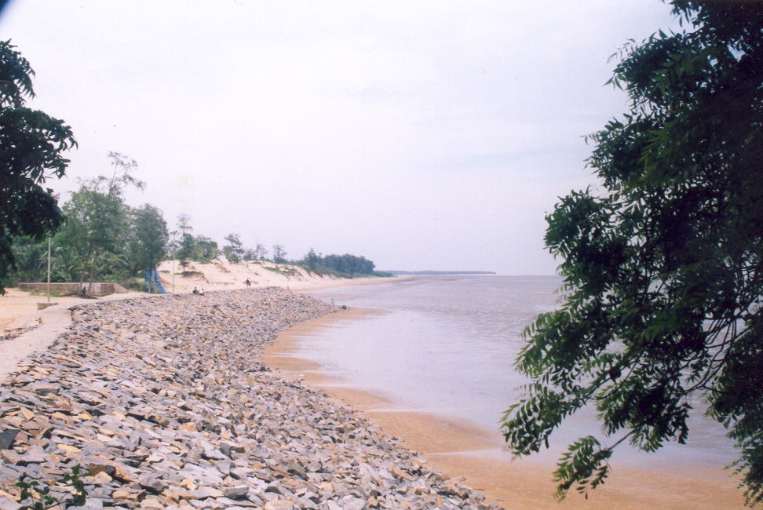
Chandipur is one of the most popular tourist destinations in India. The sea beaches of Chandipur have succeeded in attracting tourists from all over the world. The Chandipur beach has its own unique character which sets it apart from all other beaches of India.
Panchalingeswar Temple
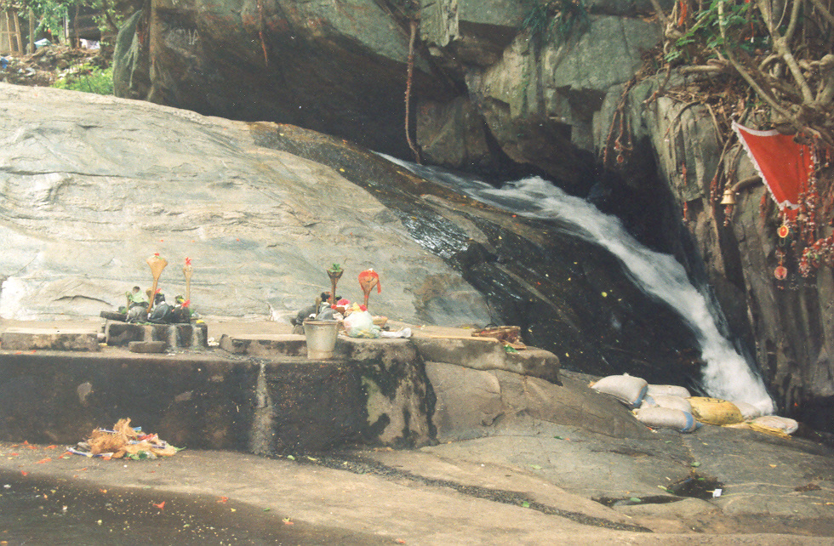
Ensconced in the verdant environs of Nilagiri, the five Lingams at Panchalingeswar, the revered venue for numerous devotees, are bathed by the iridescent and sparkling waters of a perennial stream. Legend has it that these Lingams were installed in this beautiful abode by King Banasura himself.
Chandaneswar Temple
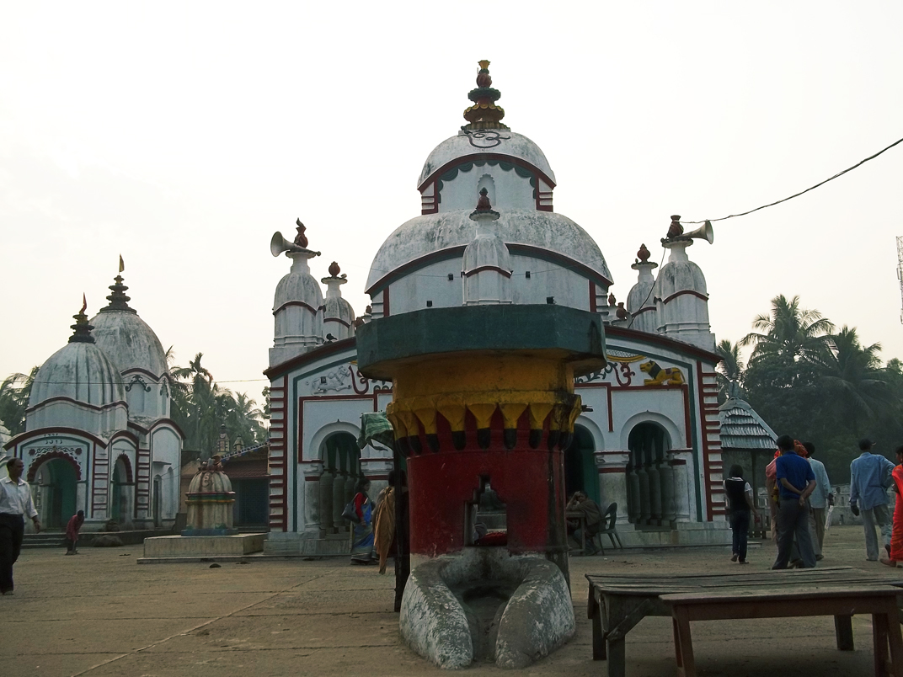
This temple is famous as a Shiva Temple. In the month of Chaitra i.e. in the last month of the Bengali calendar year, an annual fair is organized around this temple. Pilgrims from all over the country, especially from Odisha, Bengal, Bihar come to this fair.
Bichitrapur Mangrove Reserve

Odisha's second mangrove forest, Bichitrapur is the perfect weekend destination for Tourists seeking solitude and seeking a break from the maddening city life.
Kuldiha Wildlife Sanctuary
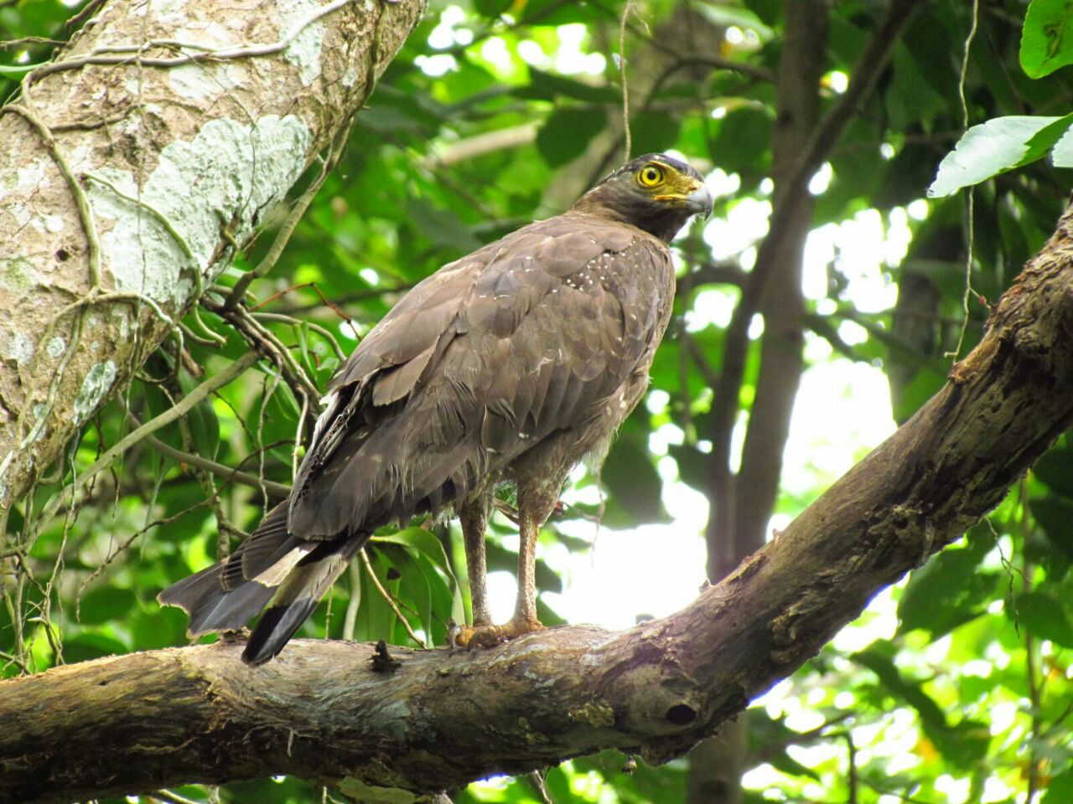
Abode of the elephants and the Indian Gaur, Kuldiha leaves the visitors stunned with its natural beauty and rich Flora and Fauna.
How to reach Balasore
By Air
The nearest Airport is Biju Pattnaik International Airport, Bhubaneswar. From there you can get other communication facilities.
By Rail
Balasore Railway Station is well connected to other main cities in India. You can easily get regular trains from other Indian cities.
By Road
Balasore is well connected through roadways to major cities in India. Other nearest bus stoppage is Digha.
Best Time to Visit Balasore
Winters in Balasore mark the best time to visit the city. This season is known to be the most pleasant time of the year with a cool and comfortable climate even during the peak winter months. While it is cold enough to layer on some warm clothes, it doesn't get too chilly to enjoy the city and its attractions.
Weather of Balasore
Balasore enjoys a predominantly tropical climate. The place is generally hot and humid, with May being the hottest month with average 40⁰C, and December the coolest with lowest 20⁰C.

