About Bargarh
Planning a Trip to Bargarh? Here's our list of 9 top Tourist Places to visit in Bargarh
Bargarh is an important district in Odisha situated in the western part. It is popularly called at “Rice Bowl of Odisha”. This district came into existence in the year 1992 by splitting from the Sambalpur district. Mostly people engaged themselves in cultivation. Due to the good water supply for cultivation from the Hirakud canal, people always busy in it through out the year. Bargarh is also called a business hub of western Odisha. “SAMBALPURI SAREES” originated from the Bargarh district itself.
As per history, Veer Surendra Sai has fought the famous war against the British in a place called Debrigarh which is a peak of Barapahar mountain range. His fight against the British Raj particularly after the First War of Independence in 1857 was remarkable in the history of freedom struggle in India.
Top 9 Places to Visit in Bargarh
Goddess Patharasini of Arjunda
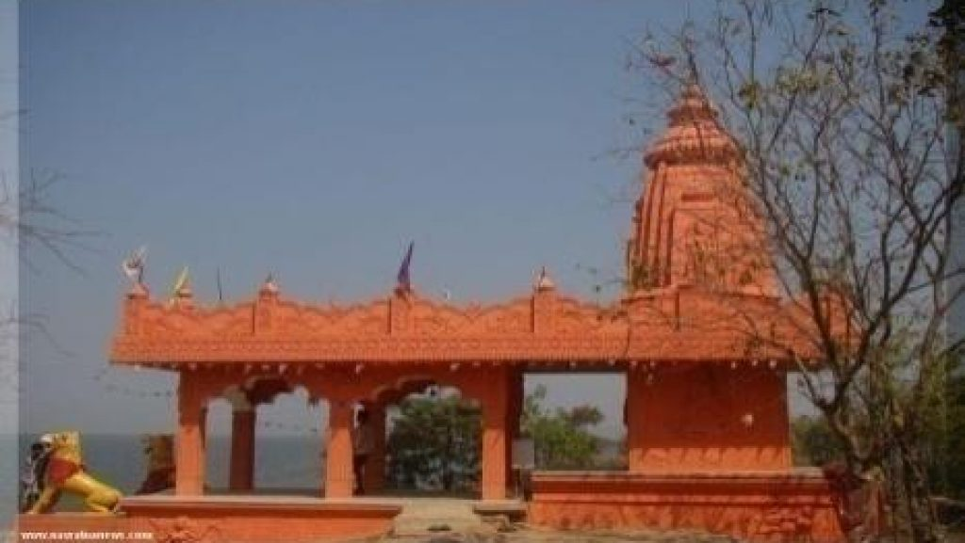
Arjunda is a village situated at the northern end of the Barapahar forest range on the bank of river Mahanadi. It belongs to the block Ambabhona of the district. Surrounded by dense forest, it exists in between the Bandijharia fountain and the Kedarnath fountain. Goddess Patharasini is worshipped here in a temple. The Chandrasini of Chandrapur, Padmasini of Padampur and Patharasini of Arjunda are sisters according to a legend. It is a famous visiting spot. The boating facility is an added attraction to it.
Boudh Bihar of Ganiapali
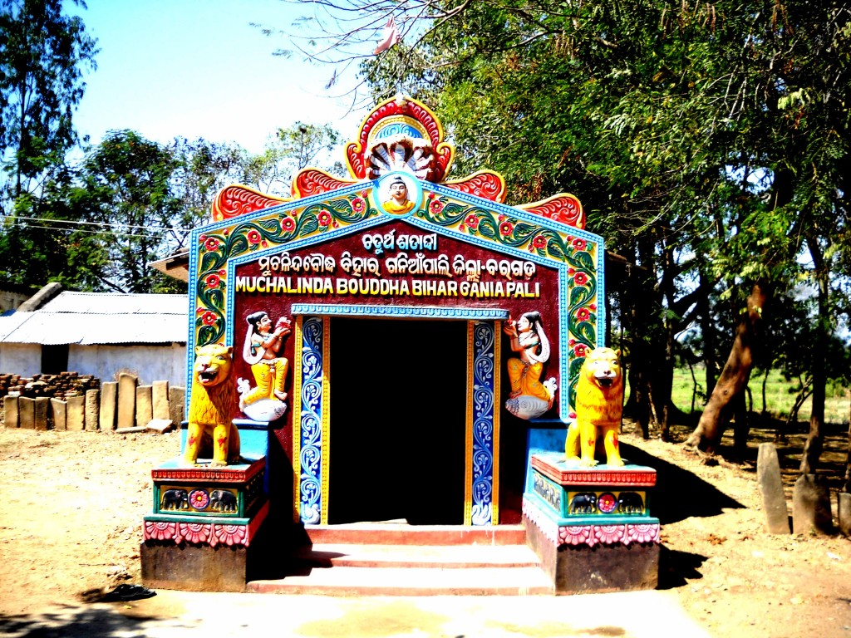
The historically famous village Ganiapali was believed as a Buddhist spot in the past. A rare Buddha statue sitting in Lotus Posture with a snake on his head with its hood expanded used to attract Tourists. But this rare monument was stolen from the spot in 2007 and it is yet to be traced.
Baseikela Gada
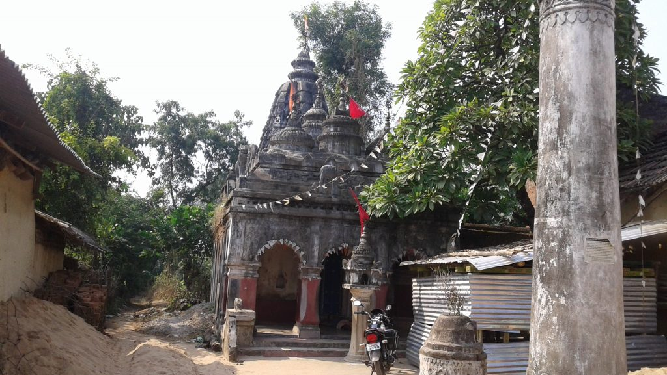
Baseikela Gada is situated in Bheden Block. Bheden Jamindar Raja Manohar Singh, the close associate of Veer Surendra Sai had made fortification at this place. Situating on the bank of river Jeera it attracts thousands of people every year. The natural beauty of this place mesmerizes the visitors. The remnants of the fort remind the past glory and struggle of the Jamindars and make this place more significant. This place is famous for its Ghitghiti Pathar which was producing sound when British soldiers were approaching the native fighters.
Papanga Mountain & Budharaja
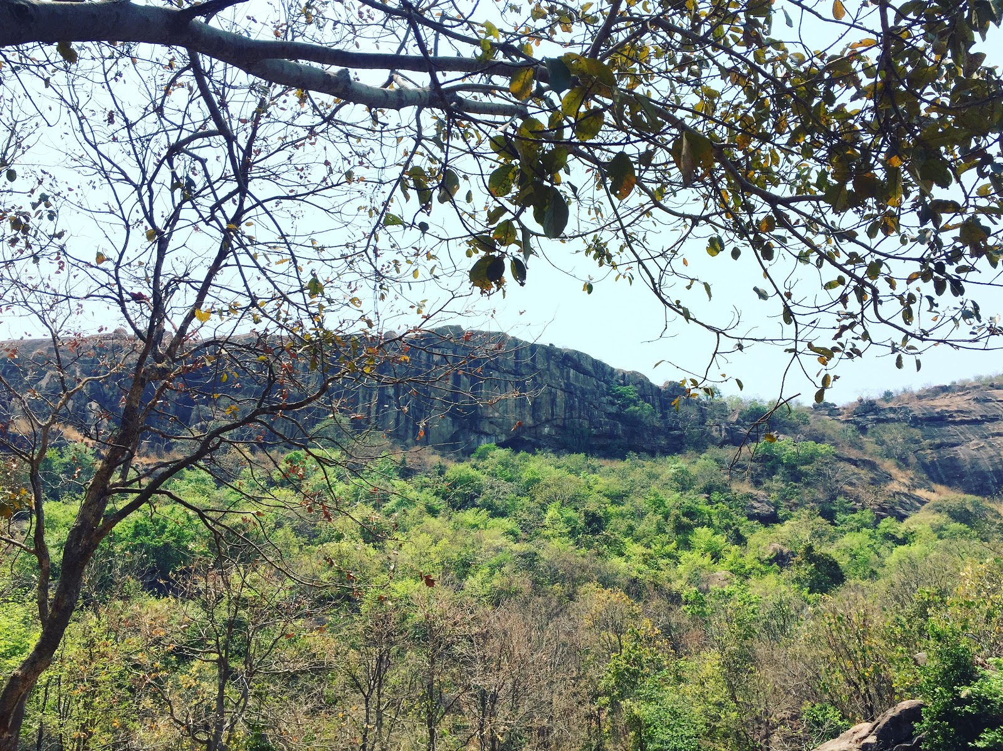
Budharaja mountain is situated near the village Papanga that belongs to the Bheden block. There is a temple in the outskirt of the village Papanga and at the foot of the mountain in which Budharaja is worshiped. The mountain is 600 feet above the ground. There is a beautiful forest garden named Bankhol on it. There are also many other beautiful sites such as a temple Lord Shriram, a Yogashram, a Mango Grove and a triangle-shaped pond. The mountain is intimately associated with the rebellion Vir Surendra Sai fought against the British. The origin of the deity Budharaja in the mountain is traced back to the 17th or 18th centuries by historians. The festival known as Banabihar is observed here on the day of Chaitya Purnima which attracts people from different parts of the district as well as outside.
Giri Gobardhan of Dekulba
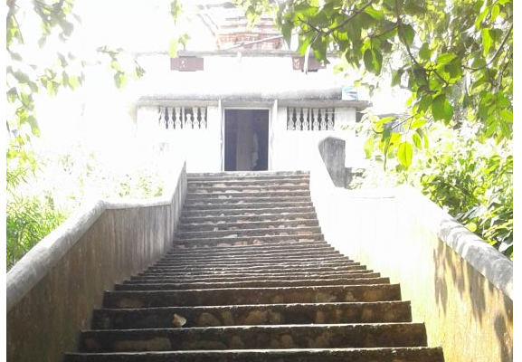
The village Dekulba exists near Talmenda, a village existing on the eastern side of Saharatikra Chowk. The village is famous for Giri Gobardhan, a nice visiting spot. It is a witness to the very popular Krishna Cult of Odisha. Lord Krishna, who otherwise is known as Bishnu and Shri Jagannath is the revered deity here. The spot is named after Lord Krishna, who is believed to have lifted the mountain Gobardhan for the well being of His people. The festival of Giri Gobardhan is observed here every year on the occasion of Pratipada in the month of Kartika.
Bindhyabasini of Sankrida
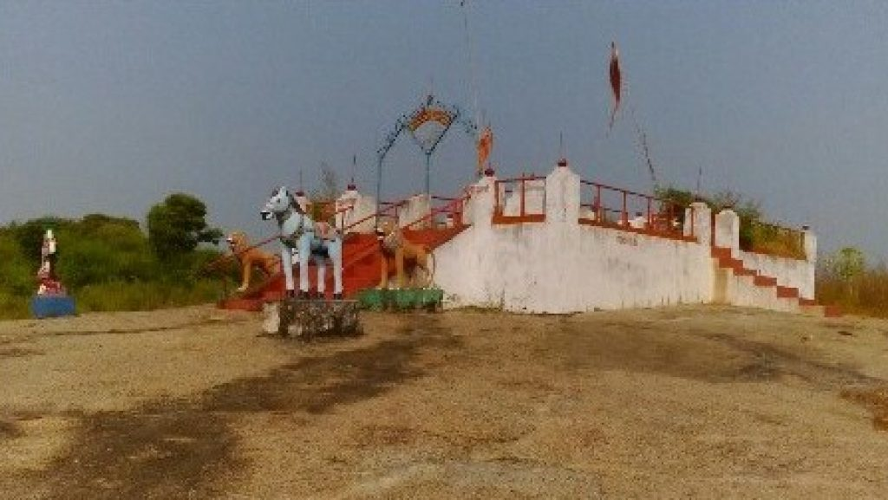
Sankrida is a village in the Bheden block of the district. The Bindhyabasini mountain exists near the village Sankrida. Bindhyabasini the Goddess is worshiped here and the mountain is named after her. The Goddess exerts tremendous religious influence on the people of this area. The mountain covers an area of 200 acres along with 50 acres of pastureland at the foot. The villagers of Sankrida have donated 27 acres of land for the management of the rites and rituals of the Goddess.
Nrusinghanath Temple
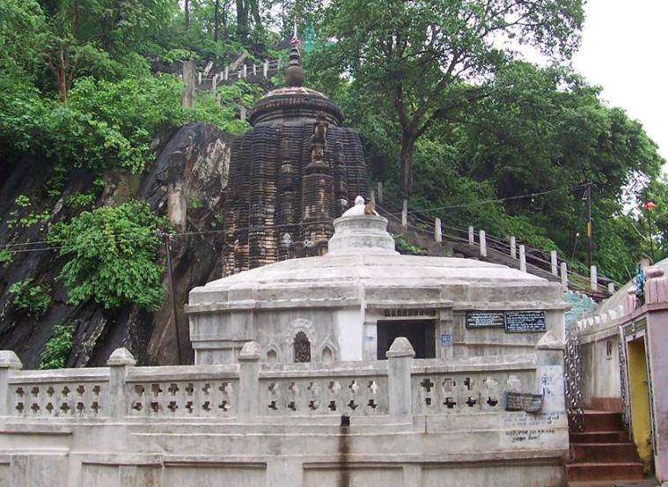
Located on the outskirts of the main town of Bargarh in the foothills of the Gandhamardhan Parvat, Nrusinghnath Temple is one of the most significant temples in the region and is dedicated to Lord Vishnu in the form of Lord Narasimha. The temple is said to have been established in the early 14th century by a local king, and hence it is of great religious as well historical prominence.
Six of the Astasambhus
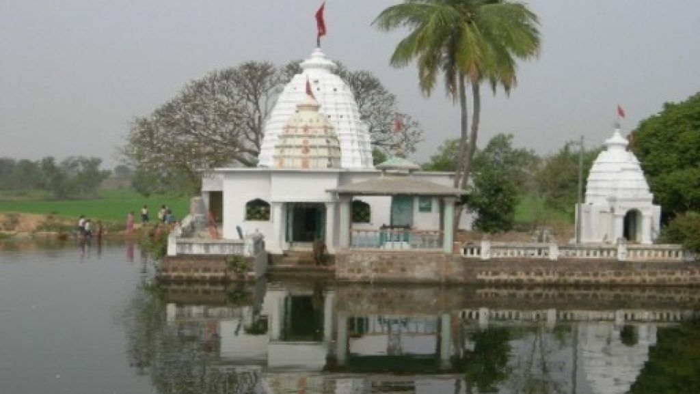
Ashta Shambhu is a complex of 8 Shiva temples that are spread across the district and were built several centuries ago when the region was under the reign of the Chauhan dynasty. These temples are frequented by hundreds of Hindu devotees every year and are considered as significant sites amongst Shaivites. If you are a history lover, then you must visit these temples as they are also known for their historical significance. Bimaleswar Temple, Kedarnath Temple, Balunkeswar Temple and Baidyanath Temple are some of these 8 Shiva temples.
Debrigarh Wildlife Sanctuary
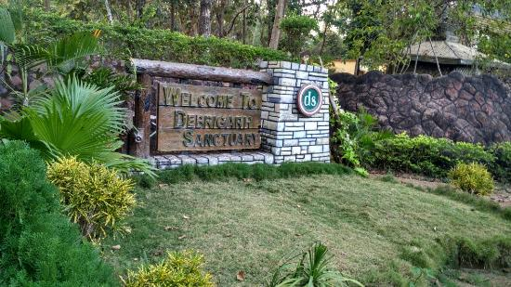
This sanctuary is nestled in the Baraphad Hills that lie at an altitude of 2267 feet above sea level. The place is famous for being the base for Veer Surendra Sai, a freedom fighter who was said to be caught here by the British officials. The place is now converted into a wildlife sanctuary. Animals like Indian Bison, Elephants and Black Bucks are the most important in the region. The sanctuary also hoes to an artificial water reservoir, Hirakud reservoir that attracts a number of birds that migrate here during the winters. The reservoir is the third largest congregation of birds in Odisha.
How to reach Bargarh
By Air
The nearest Airport is Raipur to reach Bargarh. It is 206 km away from Bargarh Other Airport is Biju Pattnaik International Airport, Bhubaneswar. It is 256 km away from Bargarh.
By Rail
Bargarh Road is the nearest Railway Station. Bargarh Road is connected to all major cities of the country.
By Road
There are no bus routes from other major cities to Bargarh. The nearest bus stoppage is Burla. It is 32km away from Bargarh.
Best Time to Visit Bargarh
The best time to visit Bargarh for hot-weather activities is from mid-February to early April and from late October to early November.
Weather of Bargarh
In Bargarh, the wet season is oppressive and overcast, the dry season is mostly clear, and it is hot year-round. Over the course of the year, the temperature typically varies from 56°F to 106°F and is rarely below 51°F or above 112°F.

