About Bhadrak
Planning a Trip to Bhadrak? Here's our list of 9 top Tourist Places to visit in Bhadrak
Bhadrak in Odisha is almost a relic city that has held on to its culture and historic ethos while moving ahead with progress and time. Archaeological remains suggest that Bhadrak was an exceedingly prosperous region for the state, in terms of Maritime efforts, Trade and Commerce, from the age of the Puranas. The 16th century was when the last indigenous king ruled this district, Mukunda Dev, after which the Muslim and Mughal rulers took over. Further, Bhadrak played an important role in India's long-drawn freedom struggle, so much so that even Mahatma Gandhi visited it more than once in appreciation of the people's patriotic fervor.
Today, Bhadrak is dotted with remains of Hindu temples, Dargahs and Buddhist shrines and Caves pointing to a cultural and religious milieu that isn't seen too often in India. Ancient relics and vibrant local culture, replete with fanfare and festivities, make this city one that many prefer to visit when heading to the East Coast.
Top 6 Places to Visit in Bhadrak
Baba Akhandalamani
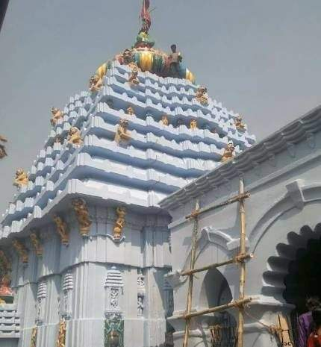
Akhandalamani Temple is situated at Aradi, about 52 km from Bhadrak. The presiding deity here is Lord Shiva; the deity is referred locally by the name ‘Baba Akhandalamani’. The temple was built by the King of Konika Shri Harihara Bhanja and his chief queen Satyabhama Patadei. The temple is about 150 ft high and all the stones used for its construction were brought from the historic hill of Lalitgiri near Chandikhol.
Maa Bhadrakali
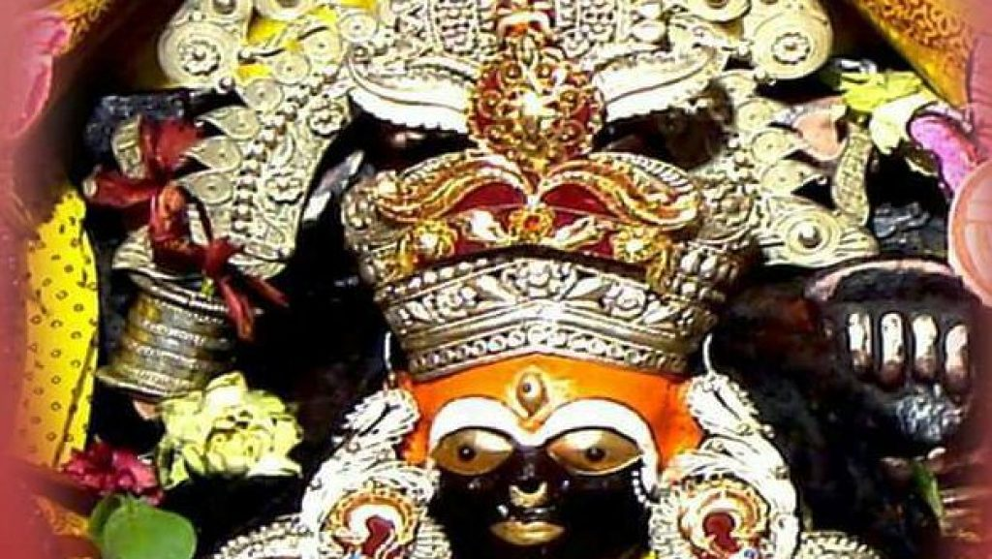
The famous temple of Goddess Bhadrakali is located on the outskirts of the village Aharapada which is at a distance of 8 km away from Bhadrak town in the southwest direction. One has to go via Santhia and Utarabahini in the south-west direction of Kacheri Chhaka of Bhadrak town to reach the shrine. The popular belief is that the name of the Town has been derived from the name of the deity.
Maa Dhamarai
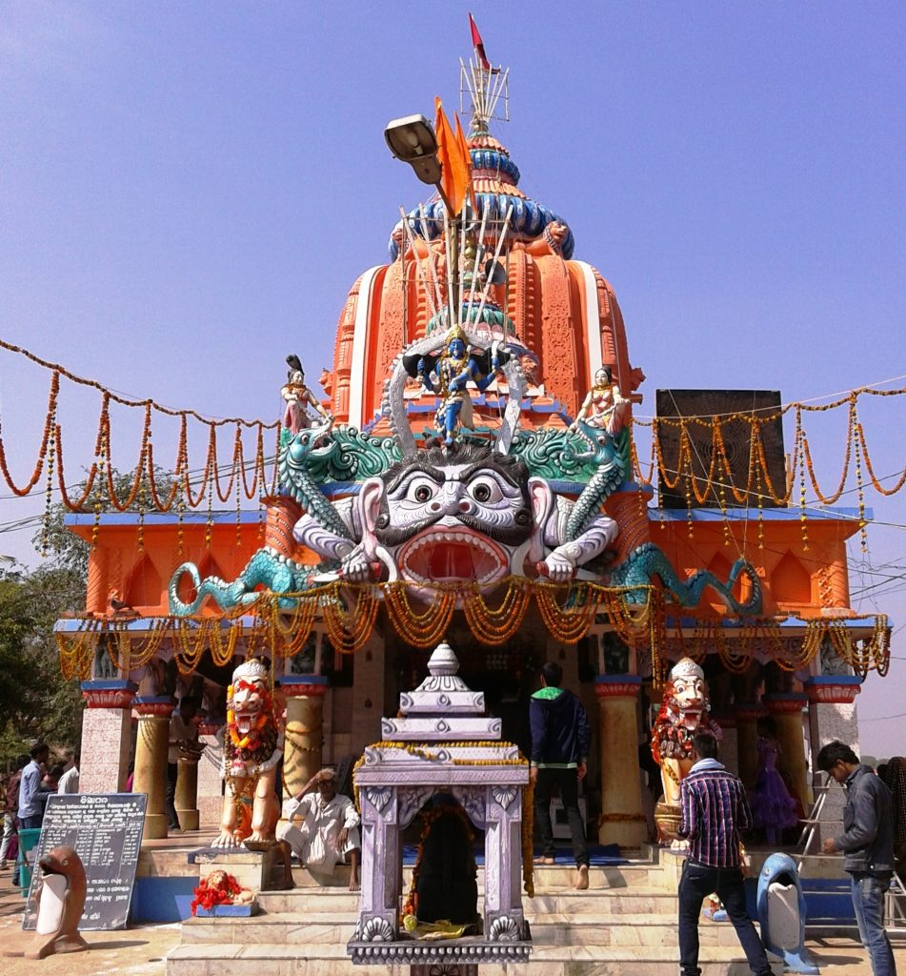
The temple of the Goddess Dhamrai is at Dhamara a small coastal township, where the river Dhamra meets the Bay of Bengal. According to one of the historical legends, one merchant namely Dhaneswar who often traded with the Singhalies(Srilanka) had brought a deity namely “Pashana Mangala” from Srilanka and had established the same at Dhamara on his way back home. The said deity, later on, came to be known as MAA DHAMARAI.
Sri Biranchi Narayan
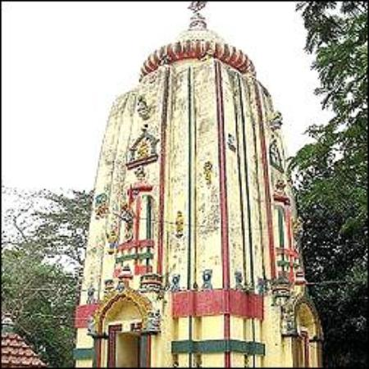
Sri Biranchinarayan Temple is in Palia village, which is located 15 km south of Bhadrak, on the way from Bhadrak to Chandabali. Biranchi Narayan is another name for Lord Surya, the Sun God of light and luster. The existing temple is dedicated to Biranchinarayan, who is enshrined as a roughly four-faced image of the Sun. A square stone slightly tapering towards the top contains four carved images of the Sun-god in relief, on the four sides of a slab. The figures hold two lotuses in two hands, as usual and are depicted standing on chariots drawn by seven horses. Architecturally, the temple can be dated to the 13th century. It was renovated and reconstructed at the beginning of the 20th century by the generosity of a local Jamindar.
Eram(Raktatirtha)
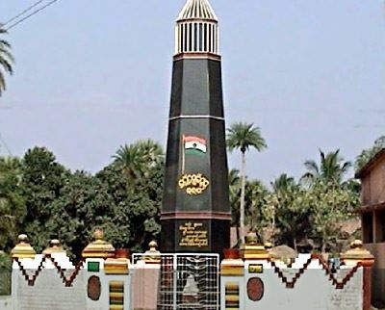
This famous place of sacrifice located 16 km away from Basudebpur of Bhadrak district. One side of this land is bounded by the Bay of Bengal and the other three sides are surrounded by two rivers the Gameye and Kansabansa. Secured by these natural boundaries this place is used as a citadel by the freedom fighters. Due to these natural boundaries, it was used by the freedom fighters as a place of public meeting. Starting from 1920 prominent nationalist leaders of ODISHA like Utkalmani Gopabandhu Das and Utkal Kesari Dr. H.K. Mahatab perform public meetings at that place several times to propagate the Gandhian ideals of freedom struggle. The Unpleasant Incident During the time of the Quit India Movement this field of Eram was frequently used by the freedom fighters for public meetings and agitation against foreign rulers. On 28th September 1942, there was a huge gathering at that place. Afraid by this gathering a police force from Basudebpur police station, lead by DSP Kunjabihari Mohanty march towards Eram. Like Jaliyanawalawag here DSP Kunjabihari Mohanty acted as General Dayar and opened fire to the huge gathering at 6:30 PM, who were performing the agitation against the foreign rulers in a peaceful way. Since the field was bounded from three sides, therefore, no one able to get escape as of the field and within some minutes 28 persons get dead on the spot and 56 get injured, another person among the injured gets dead later on. Among the dead include one woman named Pari Bewa, who is regarded as the only lady martyrs of ODISHA.
Entry Point to Bhitarkanika
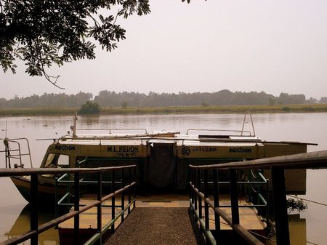
Bhitarkanika was under the jurisdiction of the erstwhile Kanika Estate. It is covered with deep mangrove forests and saline rivers and was declared a sanctuary on 21.04.1975. It is a world-famous place for natural crocodile breeding. Located in the estuarial region of Brahmani-Baitarani, in the northeastern place of Kendrapara districts, the national park covers an area of 672 sq km of mangrove forests and wetland.
How to reach Bhadrak
By Air
There is no Airport in Bhadrak. The nearest Airport is Biju Pattnaik International Airport at Bhubaneswar. It is 114 km away from Bhadrak.
By Rail
Bhadrak Railway Station is well connected to all major cities in India. You can directly reach here.
By Road
The nearest bus stoppages are Bhadrak, Chandbali and Pattmundai. Chandbali is 57 km away from Bhadrak. These stoppages are well connected to major cities.
Best Time to Visit Bhadrak
The best time to visit Bhadrak in India is from January until April and July until December when you will have a pleasant till very hot temperature and limited till mediocre rainfall.
Weather of Bhadrak
Bhadrak has a moderate climate prevailing. There is a lot of rainfall in the summer, and in the winter it is quite dry again. The highest average temperature in Bhadrak is 41°C in May and the lowest is 22°C in January. The weather and climate of Bhadrak are suitable for a sun vacation.

