Bhubanswar emerged with century old name as Temple city is the capital city of Indian state Odisha. Currently the city has flourished with a new name and that is Smart City of Odisha. It is also named as Ekamra Kshetra due to its religious establishments.
About Bhubaneswar
The Temple city got its name due to hub of 7000 temples once upon a time. The state capital of Odisha is a sprawling metropolis that very ably preserves the balance between upholding olden values and cultural heritage on one hand and being able to conform to changing modern times on the other. Literally the city's name is based on the Lord Shiva, who is also named as Tribhubaneswara, “Lord of the three worlds”.
On the year 1948 the foundation of the modern Bhubaneswar city was laid. The city is designed by famous German architect Mr. Otto Konigsberger. As a smart city, Bhubaneswar is providing all modern facilities for your tour. It is the hub of Night Bars, Pops, Disco, Luxury Hotels, Rocking Music and many more that will satisfy you needs. Bhubaneswar being the center for religious tourism has a number of majestic temples built centuries ago which have still retained their original over all these years.
Top Attractions in Bhubaneswar
Lingaraj Temple
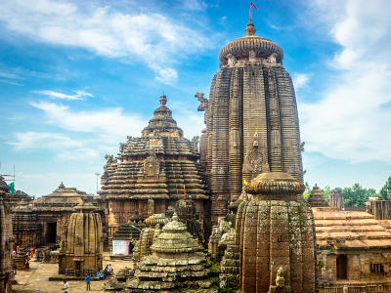
Lingaraj Temple is one of the oldest and largest Hindu temples in Bhubaneswar. The temple is the most prominent landmark of the Bhubaneswar city and also one of the top places to visit in Bhubaneswar.
Dedicated to Harihara, a combined form of Vishnu and Shiva, Lingaraja Temple was built in 11th century CE by King Jajati Keshari of Somavanshi dynasty. He started the construction of the temple while he shifted his capital from Jajpur to Bhubaneswar. But historians believe that the temple might have been existed from 6th century CE. It is said that when the construction of Lingaraj Temple was about to complete, the Jagannath cult started growing. This belief is further empowered with the fact that Lord Vishnu and Lord Shiva are worshiped here.
Chandan Yatra and Ratha Yatra are the other two important festivals celebrated at Lingaraj Temple with great pomp and fervor.
Ananta Vasudeva Temple
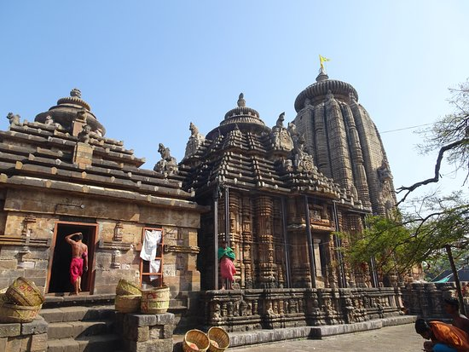
Ananta Vasudeva Temple is a famous Hindu Temple located on the eastern bank of Bindu Sarovar in Bhubaneswar. Dating back to 13th century AD, Ananta Vasudeva Temple is the worship place of the complete idols of Lord Krishna, Lord Balarama and Goddess Subhadra. According to the legends, Lord Vishnu was worshiped at the place where Ananta Vasudeva Temple stands at present. The new temple was built in the 13th century by Queen Chandrika, the daughter of Anangabhima III, during the reign of the king Bhanudeva. The Marathas, who extended their empire up to river Mahanadi, were responsible for renovating the Vishnu Temple at Bhubaneswar in the late 17th Century.
Parasurameswara Temple
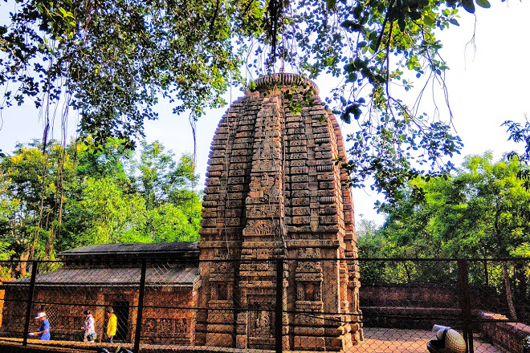
This temple is counted among one of the oldest existing temples in India. Parasurameswar temple was constructed between the 7th and 8th century AD. The temple is built in the Nagara style and is dedicataed to Lord Shiva. The temple is exemplary of the stone craving mastery of the artisians and is decorated with the most intricate carved sculptures.
Mukteshwar Temple
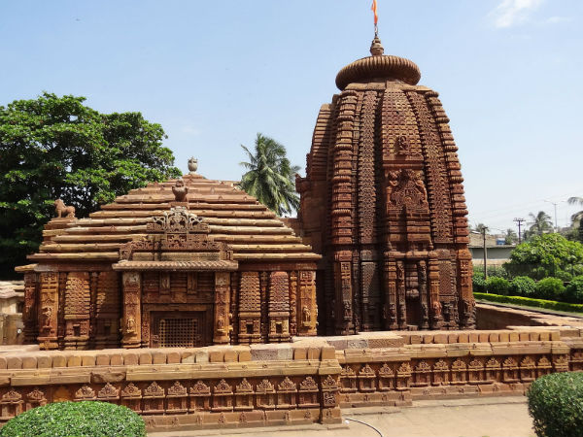
This temple was built in the 10th century and is considered to be the gem of Odisha architecture. The famous arched gateway of the temple makes it unique amongst the other major temples in Odisha.
Brahmeswara Temple
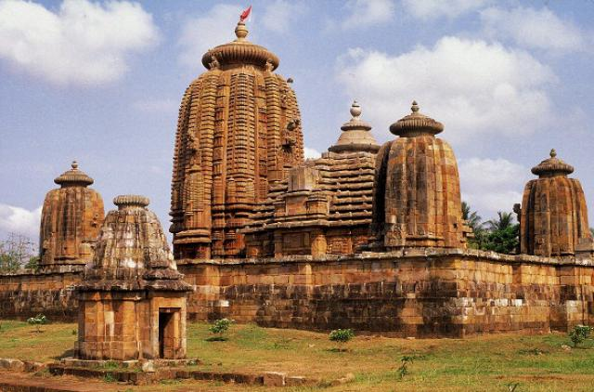
This temple is built in 9th century AD and dedicated to Lord Shiva and is a perfect example of the Kalinga style architecture. The temple complex contains a main shrine surrounded by 4 similar shrines. The doorways are ornate with stone carved figures and the 9 planets in Indian astrology.
Vaital Temple
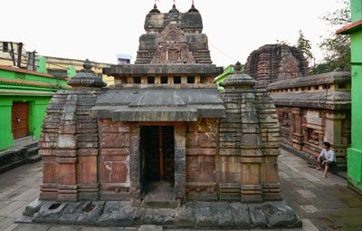
An 8th century construction, Vaital Deul is the epitome of grace and charm. The delicate carvings of figurines and strong tantric influences on the temple make Vaital Deul an interesting study. The temple remains open from morning till late in the night.
Bindu Sagar
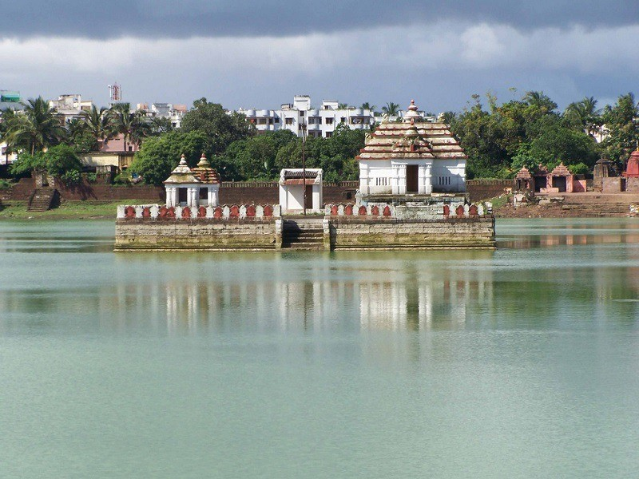
One of the most auspicious lakes in Odisha, Bindu Sarovara is located close to the temple of Lingaraj. Also known as Bindu Sagar, this hallowed attraction is a must see site for the devotees paying visit to the Lingaraj Temple.
Dhauli Giri(Shanti Stupa)
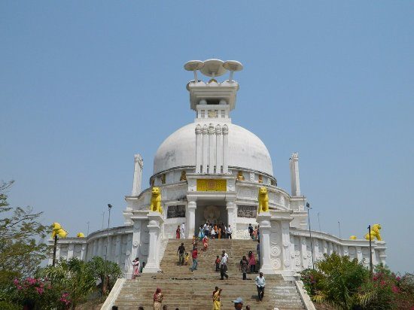
Also known as Peace Pagoda, is a Buddhist structure built jointly in 1972 by the Japan Buddha Sangh and the Kalinga Nippon Buddha Sangh. Situated on the opposite hill of Dhauli Giri, it was built through the Indo-Japanese collaboration. Stupa is domed on top with mushroom-like structures and adorned with ‘speaking’ stone panels. Reclining Buddha, an elephant procession, the bodhi tree and footprints of Buddha bearing the Chakra(wheel) adorn the main stone panels. The panels also comprise a sleeping beauty fanned by female attendants, procession on horseback and Emperor Ashoka renouncing war by offering his sword to Lord Buddha at Dhauli Giri.
Odisha State Museum
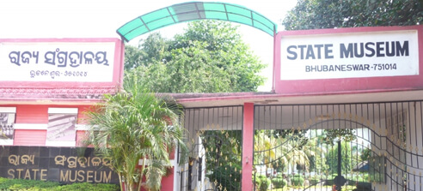
The Odisha State Museum is a treasure trove of archaeological findings which include Buddhist and Jain sculptures, coins and inscriptions from ancient Kalinga Jewelery, Folk musical instruments, Weapons and Tools.
Museum of Tribal Art and Artefacts
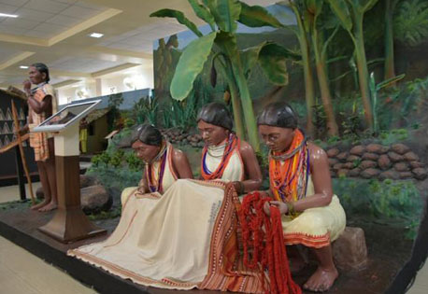
Museum of Tribal Art and Artefacts is home to displays to everything connected with the life of Odisha's tribal people. Exhibition rooms of the museum are adorned with primitive murals and house traditional Costumes, Jewelery and Household Appliances. In the museum are also housed hunting equipment such as Bows and Arrows, Axes and Traps for birds and fish, which indicate the life-style of the tribal people of Odisha.
The museum is also home to a wide variety of Indigenous tools, Weapons and Ritual objects. Currently housing about 2,247 artefacts, the museum is located in a 12-acres campus that is run by the Tribal Research and Training Institute. Museum is home to Dresses and Ornaments, Dokra items and weapons of offence.
Artefacts providing an insight into the lives of Odisha's 62 tribes also include Defence, Agriculture Tools, Household objects and Terracotta items.
Pathani Samanta Planetarium
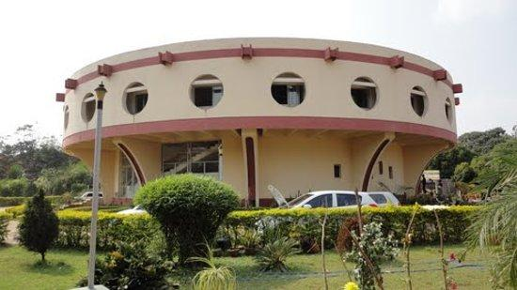
Pathani Samanta Planetarium aims to make people aware about Astronomy, Astrophysics and Space Science. The Planetarium also aims to generate awareness among them regarding their environment. It offers regular shows about outer space to create awareness in the field of Astronomy, Astrophysics and Space Science. Shows organised by the Planetarium include night sky watch, audio visual program, poster shows and display of astronomical instruments.
Ekamra Kanan
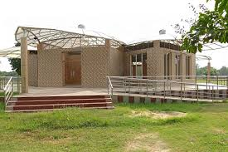
Ekamra Kanan is located at IRC Village, Nayapalli. Within 512 acres area of the park are present a Lake, Rose Gardens and Nursery. In the park, Tourists can also find boating facilities, a pyramidal greenhouse and playgrounds for children.
Udayagiri & Khandagiri
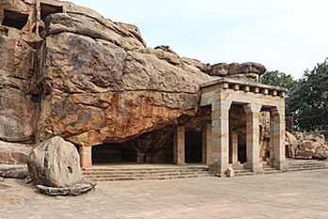
Udayagiri and Khandagiri Caves are a glorious element of Odisha Tourism. Around 6km east of Bhubaneswar, the twin caves rise abruptly from the coastal plain. Partly natural and partly artificial, these caves are comprised of small blocks which were once used by the mendicants for meditation. While Udayagiri has 18 caves, the Khandagiri has 15. The most significant of these caves group is Ranigumpha in Udayagiri part of the cave and is a double-storeyed monastery. There are certain blocks in these caves where one can see Brahmi inscriptions.
64 Yogini Temple
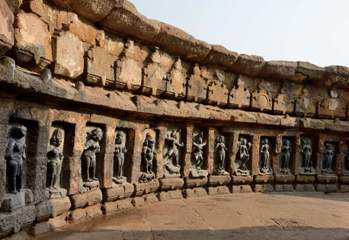
64 Yoginis Temple is a must see must explore tourist attractions in Bhubaneswar. Situated at Hirapur, this temple was built in 9-10th century AD and is dedicated to Yoginis, the attendant of the great Goddess. The temple gets immense importance among the followers of Tantra as it is one of the only four Yogini temples in the country dedicated to the esoteric cult of tantra. The temple wall is engraved with the images of 64 Yoginis along with the image of Mahamaya, the presiding deity.
Raja Rani Temple
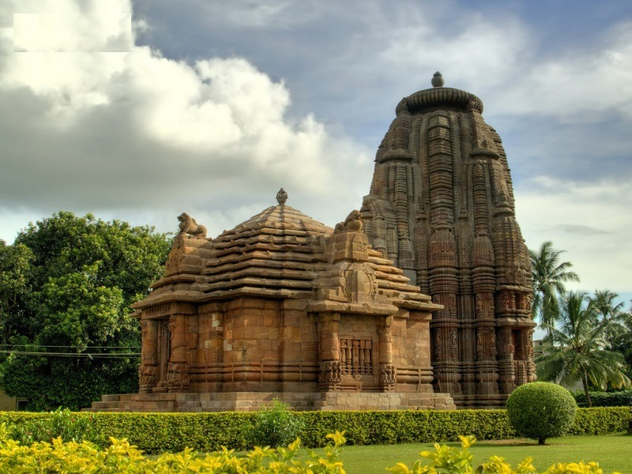
This temple dating from 11th century, is famous for its sculpted figures and the successive tiers of projections rising to form its 18 meter high tower. Spire, reminiscent of the temples of Khajuraho, along with a square sanctuary and its interior and exterior surfaces are the chief features of the temple. Fine sculptures of dikpalas or guardians of the eight directions carved around the shrine are prominent highlights of the temple.
ISKCON Temple
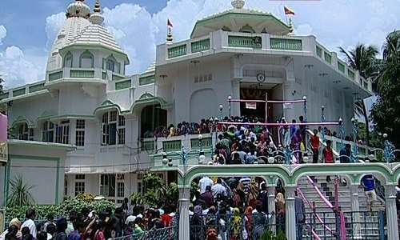
ISKCON Temple contains idols of deities like Krishna, Balaram, Gaura Nithai, Subhadra and Jagannath. Focused on propagating and educating spiritual knowledge, techniques of spiritual life to society at large and consciousness of Krishna, the temple follows the great scriptures of India, Bhagavad Gita and Srimadd Bhagavata.
Nandankanan
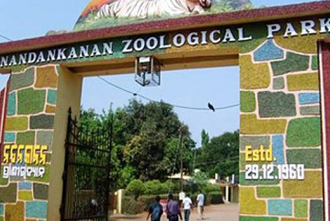
Nandankanan or ‘The Garden of Heavens’ lies in the vicinity of the Kanjia Lake and Chandaka forest. It is home to 120 different species of animals including mammals, reptiles and birds. It is extremely popular for its white tigers. The zoo houses aquaria, a reptile park and orchid house.
How to reach Bhubaneswar
By Air
The Biju Patnaik International Airport is the only International Airport in the state of Odisha and is located in Bhubaneswar. It is well connected to most Indian cities as well as major international cities.
By Rail
Bhubaneswar Railway Station is the main railhead connecting the city with several Indian cities. There are regular superfast trains available from Kolkata, Mumbai, Delhi, Chennai, Hyderabad, Bangalore etc. From the station, you can take private Cabs or Taxis to reach anywhere in the city.
By Road
To reach in and around the city, you can get various modes such as Buses, Taxi and Auto Rickshaw. Bhubaneswar Bus Station is 8 km from the city and you can get buses which are operated by Odisha State Road Transport Corporation(OSRTC). Private buses are also easily available from there.

