About Boudh
Planning a Trip to Boudh? Here's our list of 9 top Tourist Places to visit in Boudh
The district of Boudh is also known as Bauda. This district is located in the central part of Odisha. It's the Mahanadi River that uses to flow at the southern side of this district. This also forms the northern and western boundary of this district. Right at the other side of Mahanadi River, the Balangir district is located. At the northwest side of this district Subarnapur and the northeast side to this district, Angul is located. Well, the Nayagarh district is located on the southeast side of Boudh. On the south side, Phulbani borders its and on the southwest, Kalahandi borders this district.
Boudh is famous for its century-old aesthetically built temples, ancient Buddha statues and caves. With the spread of Saivism, Vaishnavism along with a number of other shrines. The natural beauty and glamor of these places keep the visitors spellbound.
Top 7 Places to Visit in Boudh
Padmatola and Satakosia Sanctuary
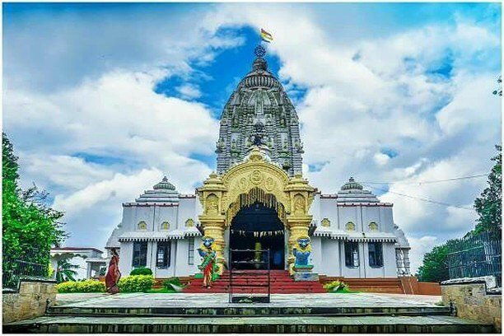
The majestic Satakosia Gorge derives its name from Sata(seven) and Kosh(two miles) meaning 14 miles or 22 km long. The majestic Satkosia gorge acclaimed as one of the most enchanting spots in the country is, in fact, the meeting point of Chhotanagpur plateau forests, dry deciduous forests and moist peninsular Sal forests and is a stronghold of Tiger, Leopard, Elephant, Spotted Deer, Chousingha, Sloth Beer and varieties of resident and migratory birds and different species of reptiles.
Marjakud Island
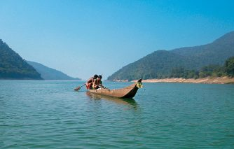
Marjakud is a wonderful island located on the opposite side of Boudh town in the river Mahanadi. About three thousand people are living here. Maa Pitabali is the presiding deity of this place. It is an ideal place for a picnic.
Bhairabi Mandir Purunakatak
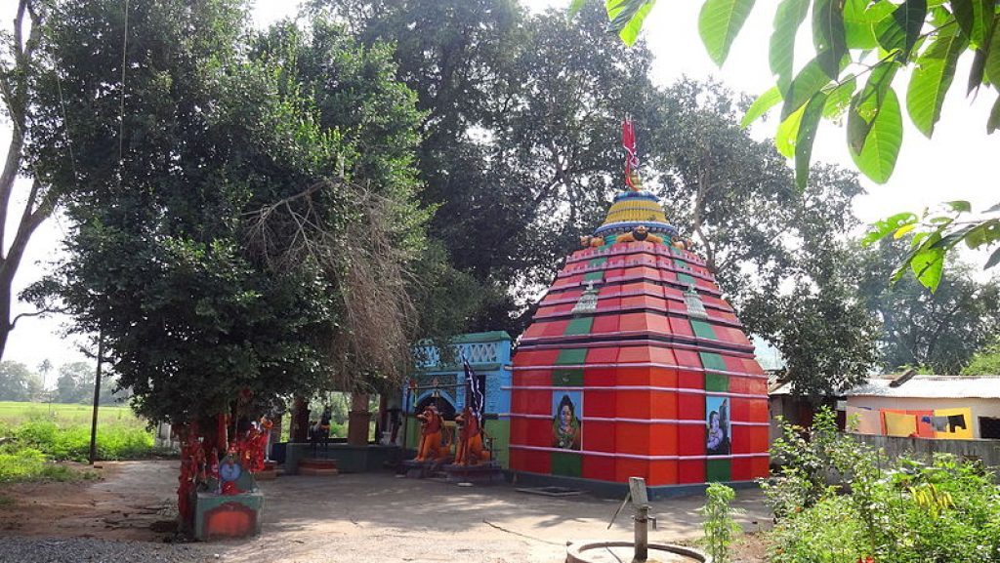
Purunakatak, situated at a distance of 30 km. from Boudh on Boudh-Daspalla road, is a trading center of some importance. Goddess Bhairabi is the presiding deity of the place. Previously the deity was being worshiped in a thatched hut, but recently a local businessman has constructed a temple. Goddess Bhairabi was the presiding deity of the then Samanta Raja Sarangadhara Mahapatra, who was the Samanta Raja of the last King of Brahmin dynasty of the 10th century AD, late Raja Gandhamardana Dev of Dhrutipura of Gandharadi.
Jogindra Villa Palace
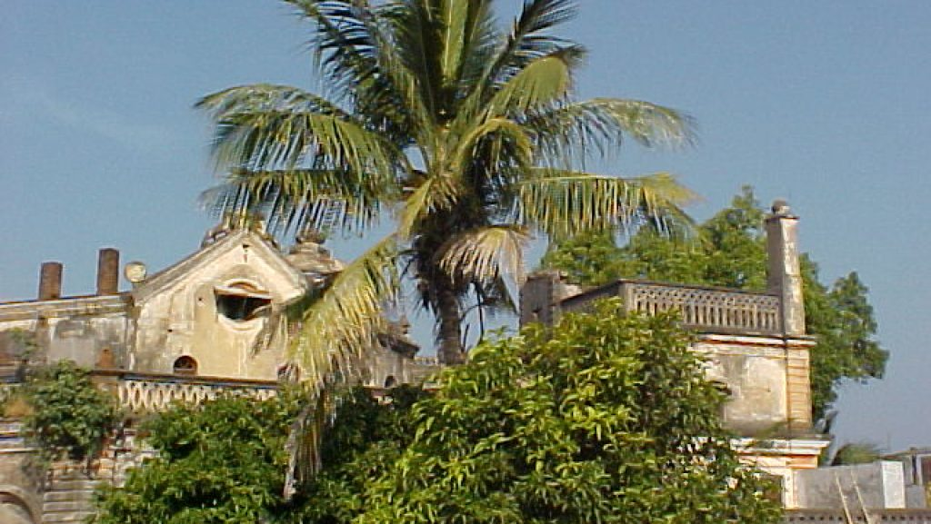
This is the palace of the king of Boudh locally known as Rajabati. This was constructed during the reign of Raja Jogindra Dev, who was a benevolent and generous ruler. The palace is a picturesque and handsome building commanding a fine view of Mahanadi.
Jagati(Charisambhu Temple)
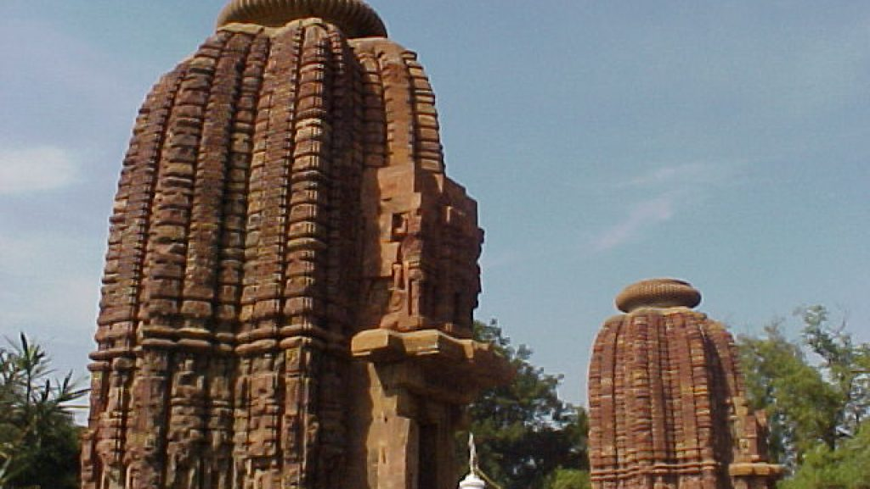
Charisambhu temple is situated at a distance of 16 km from Boudh town near the village at Gandharadi and Jagati, ancient Jagatipur the Capital of the Somabansi King Jajati. The famous twin temple is a combination of Nilamadhava and Siddheswar. These temples were constructed in 8th Century AD. under the patronage of Banja rulers of the Khinjali Mandala These two temples were built on one platform, exactly similar to each other. Archeological Survey of India has preserved these temples as an exquisite Pilgrim Place.
Dambarugada
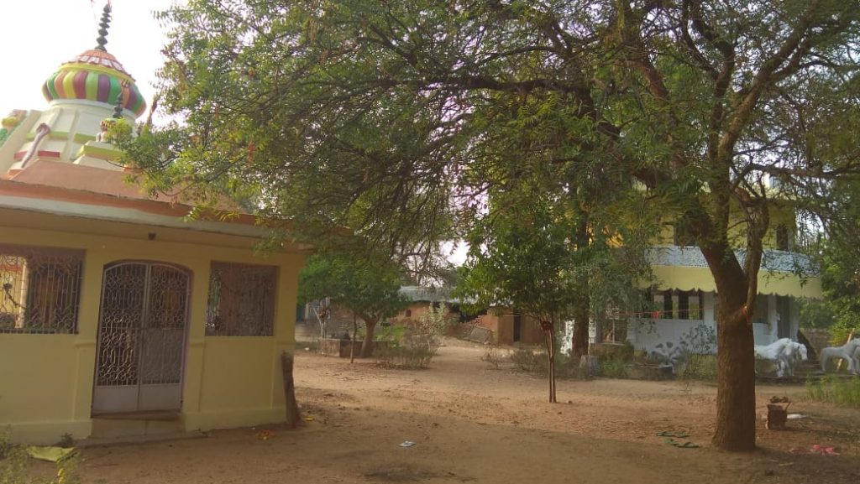
The Dambarugada mountain is situated at a distance of 20 Km. from Boudh town toward Boudh to Balangir road. The name the place is Sangrampur. The river Mahanadi flows down the mountain which makes for a visually stunning sight. The mountain gives a curve look from all of its sides. The height of the mountain is 70 feet.
Nayakpada Cave
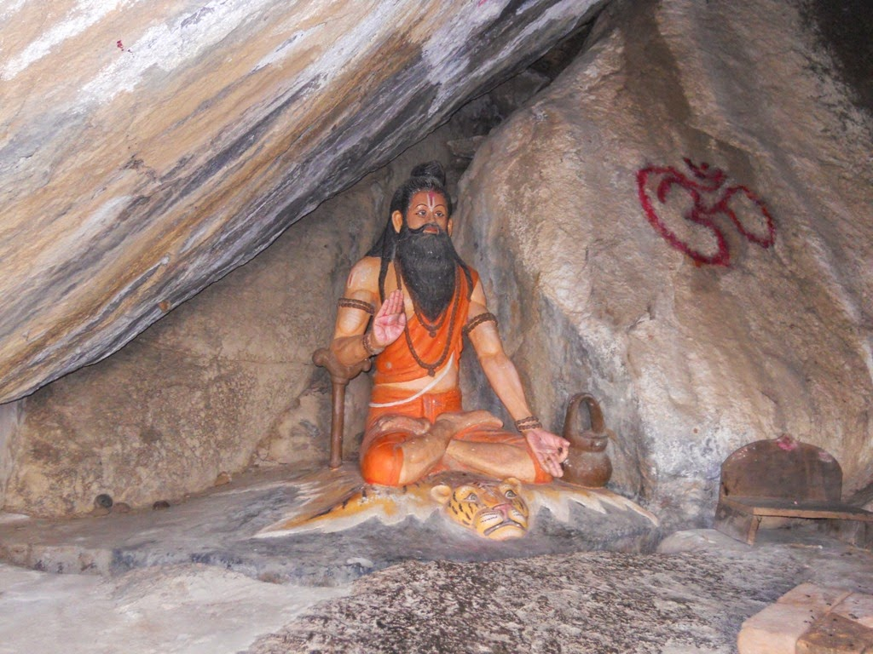
The Nayakpada Cave is located at a distance of 12 km from Boudh town. This cave was said to have been associated with mythology. According to a narration in MadalaPanji and some historical evidence, during the reign of Emperor Sovan Dev the Jabana king Raktabahu had attacked ShrikhetraPuri. With the apprehension of damage to deity Sri Jagannath the powerful Bhanja ruler of Oddradesha(present Boudh area) who believed in Vaishnavism and worshiped Lord Nilamadhaba at Gandharadi, took away the deities to Dhritipura under their domain. As they believed Sri Jagannath(Purushottam) as Parama Vishnu and undergrounded(Patali) the deities near Gopali village, twelve miles from their capital. The then Gopali village known as Gopalpur situated adjoining to the south part of this Naikpada cave.
How to reach Boudh
By Air
Boudh does not have any Airport, Biju Pattnaik International Airport in Bhubaneswar is the nearest Airport to reach here.
By Rail
There are no regular trains from other major cities to Boudh. The nearest Railway Station is Rairakhol, 24 km away from Boudh.
By Road
Boudh is well connected to other major cities of the country via regular buses.
Best Time to Visit Boudh
The best time to visit Boudh in India is from October to March when you will have a pleasant till very hot temperature.
Weather of Boudh
Boudh has a very much varied climate. The district comes under the ambit of Western Central Table Land characterized by hot and moist sub-humid climate. The month of May as the hottest month reach a daily maximum temperature of 44⁰C and the winter lowest temperature is 10⁰C. The average annual rainfall of the district is 1510.33 mm.

