Chilika Lake is the largest internal saltwater lake in Asia, it is a paradise on earth for bird watchers and nature lovers. The pear shaped lake is dotted with a few small islands and has fisheries and salt pans around its shore.
About Chilika
At a distance of 44 km from Puri, Chilika Lake is Asia's biggest inland saltwater lagoon situated near Satapada in Odisha. Located at the mouth of the Daya River, Chilika Lake is the largest coastal lagoon in India and also the second largest saltwater lagoon in the world after the New Caledonian barrier reef in New Caledonia.
The lake is studded with small islands including the most charming Honeymoon Island and the Breakfast Island. Spreads across 1,100 sq. km, the pear-shaped lake extends from Bhusandpur in Puri district in the North to Rambha-Malud in Ganjam district in the South, separated from the Bay of Bengal by a 60 km long narrow strip of marshy islands and sand flats. The lake is an ecosystem with large fishery resources. It sustains more than 150,000 fisher folk living in 132 villages on the shore and Islands. In 1981, Chilika Lake was designated the first Indian wetland of international importance under the Ramsar Convention.
The lake also acts as one of the most supportive ecosystems in the name of Chilika Lake Sanctuary. It is the largest wintering ground for migratory birds on the Indian sub continent. Birds from the Caspian Sea, Lake Baikal, Aral Sea and other remote parts of Russia, Kirghiz steppes of Mongolia, Central and Southeast Asia, Ladakh and Himalayas come here. White bellied sea eagles, Graylag Geese, Purple Moorhen, Jacana, Herons and Flamingos are among the many species which make the lake a bird watcher's delight. Chilika in fact, is home to one of the world's largest breeding colonies of Flamingos.
Being richly famous for the presence of aquatic wildlife, Chilika Lake sanctuary also houses Irrawaddy dolphins which are different from the other dolphins as their color and dorsal fin being less prominent. Apart from the avifaunal species, the region also highlights varied wild animals such as Blackbuck, Golden Jackals, Spotted Deer and Hyenas. Chilika Lake Sanctuary is favorably known for its dynamic sunrise and sunset views. One of the most famous tourist attractions near Chilika Wildlife Sanctuary is Kalijai Temple, devoted to Goddess Kalijai. Makar Sankranti is celebrated with great pomp and cheer at the temple that attracts numerous travelers & devotees.
Chilika Lake is the most popular destination for eco-tourism in Orissa. Apart from having the presence of exotic wildlife in the area, the lake and its vicinity hold a rich floral system with abundance of aquatic as well as non aquatic plants. The recent environmental survey revealed the presence of more than 710 species of plants in and around Chilika Lake. Such a huge variety of Flora and Fauna including numerous rare and endangered species of all forms has been the main reason for considering Chilika Lake as Ramsar site.
Boating at Chilika is one of the most popular activities. Chilika Lake can be visited year round however the time from November to February is the best time to visit Chilika Lake. Especially, it is the season for migratory birds and hence it is even more exciting to explore this lake during these months.
Top Attractions in Chilika
Nalaban
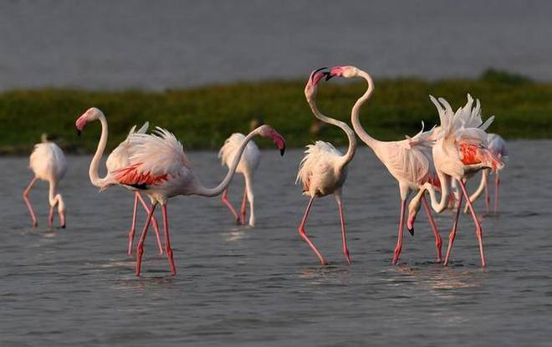
Situated in the heart of Chilika, Nalabana Island deserves a special mention since it is a prime refuge point for thousands of resident and migratory birds. It got the status of a sanctuary in 1987 and specially acts as a treat for the bird-watchers during winter season. One can look out for birds like Spoon billed Sandpiper, Black tailed Godwit, White Bellied Sea Eagle and get delighted by watching them hopping on the water.
Kalijai Temple
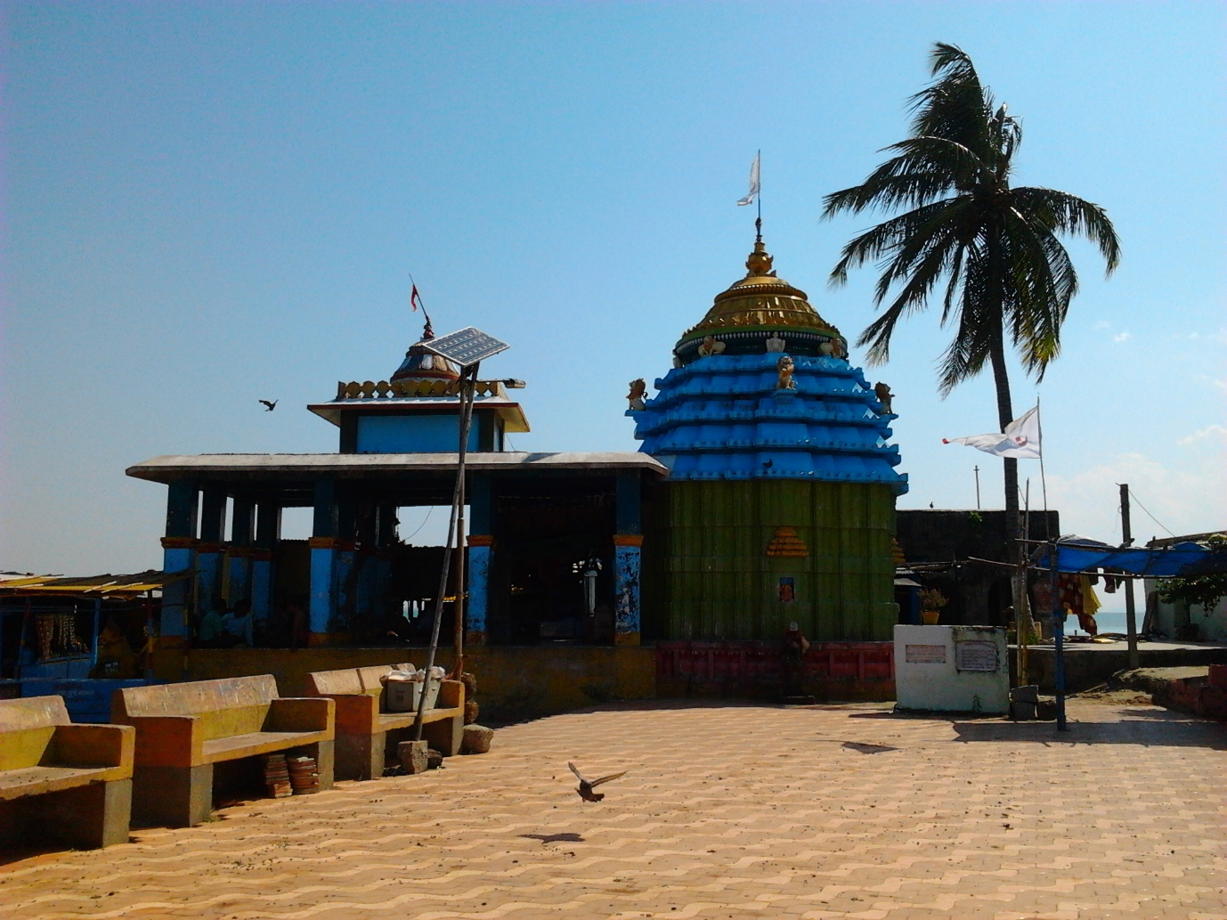
Island of Goddess Kalijai is the most frequent spot for tourists. The island is famous as a center of religious worship due to the temple of Kalijai. There is a story behind the place which is centered around an innocent girl called “Kalijai” who got married and was going by boat along with here in-laws through this lake. In between, heavy storms came and everybody including Kalijai died in that storm. Local Tourists, Sailors and Fishermen pray Goddess Kalijai everyday for their safe journey in the lake.
Satapada
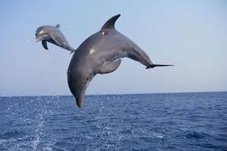
Satapada is the ultimate place to watch Irrawaddy dolphins. If you're lucky then you will able to see dolphins during your boat ride in Satapada. Since last few years this spot is a major tourist attraction because of the development of Dolphin sanctuary.
Honeymoon Island
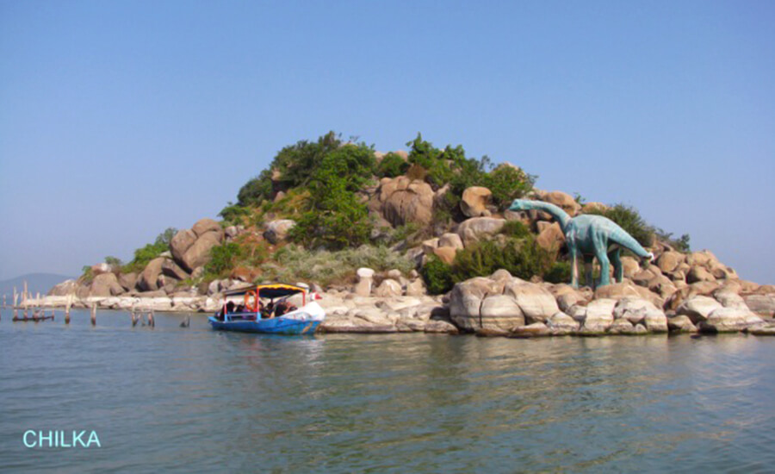
It is situated in the Rambha Bay near Sankuda Island. This land is also called as Barkuda Island. Britishers used this land for picnic purposes. The waters around the island are very clear and the ambiance is perfect to enjoy your day here.
Beacon Island
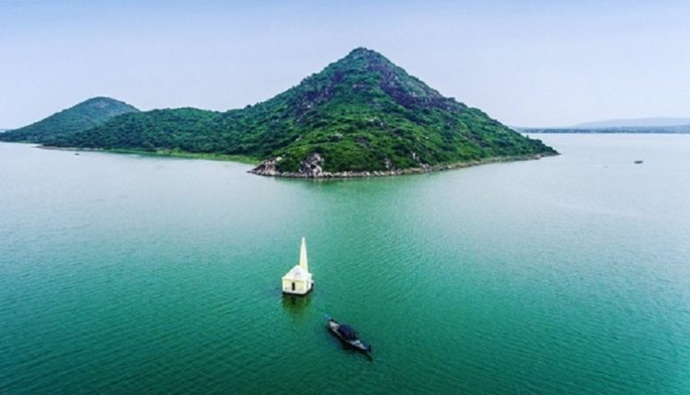
This island is an architectural marvel with a conical pillar and a small room constructed on the submerged mass of rock in the Rambha bay near Ghantasila hill. The pillar was constructed to put a light on the top. The water spread around the Beacon Island is very charming, surrounded by the Eastern Ghat.
Birds' Island
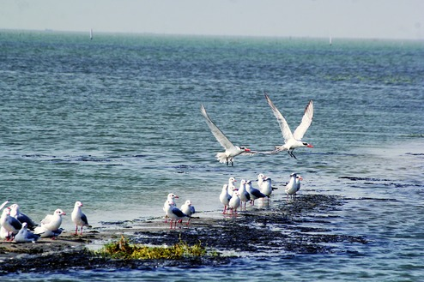
This is a hillock with huge exposed hanging rocks. The island is covered with Herbs, Shrubs, Trees and Creepers. The granite rocks are remnants of Eastern Ghats. Some of the huge rocks are painted white because of the folic acid from the droppings of the birds. During winter, the migratory birds are coming to this land in a large proportion.
Breakfast Island
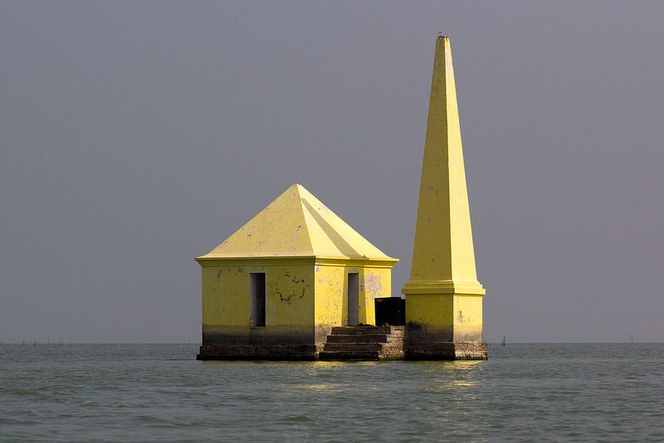
This is a hillock with huge exposed hanging rocks. The island is covered with Herbs, Shrubs, Trees and Creepers. The granite rocks are remnants of Eastern Ghats. Some of the huge rocks are painted white because of the folic acid from the droppings of the birds. During winter, the migratory birds are coming to this land in a large proportion.
Mangalajodi
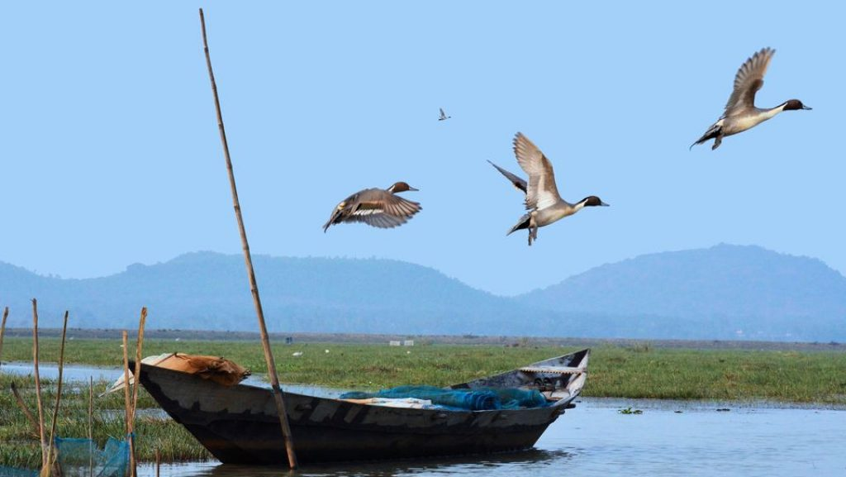
This is another bird's paradise which has been attracting a lot of Tourists over the years. If you are a photographer who loves clicking varied wildlife in pristine locations, then do spend some time in Mangalajodi where you can get some wonderful pictures of birds. Every year during winters, the place is inhabited by nearly hundreds of species of migratory birds along with the residential ones and the sight of them together is truly captivating!
How to reach Chilika
By Air
Bhubaneswar is the nearest Airport to Chilika. As there are no direct flights to Chilika, one must arrive at Bhubaneswar before boarding a Taxi or Bus to Chilika.
By Rail
Balugaon and Puri are the nearest Railway Stations to reach Chilika Lake. You can also come to Bhubaneswar through Rail and come by Cab or Bus to Chilika.
By Road
In NH-5, there are a lot of Buses from other major cities of India that are going along the route that helps one for their Chilika trip by Bus or by Cab, Taxi and solving the puzzle of how to go to Chilika.

