About Cuttack
Planning a Trip to Cuttack? Here's our list of 20 top Tourist Places to visit in Cuttack
Once known as the former capital city of Odisha, Cuttack is currently renowned as the commercial city and cultural capital of Odisha. This second-largest city of the Indian state Odisha is always buzzing with cultural activities and plays host to a variety of festivals like the Baliyatra, which commemorates the ancient trade links the countries like Java, Bali and Sumatra, Durga Puja and the Kite Festival which is held in the month of January.
The city said to be the commercial capital due to most of the small and large business houses of Odisha belong to Cuttack only. The city is also known as the millennium and sliver city of India as well. Due to the world famous filigree work is done on the silver Ornaments and Jewelry. The ivory and the brass work being done along with the textile industry of the state have brought it into the limelight. Cuttack is the most chosen place for affordable shopping all over the state. The city is also known for the best variety of evening tiffin and snacks item.
Top 20 Places to Visit in Cuttack
Nemala
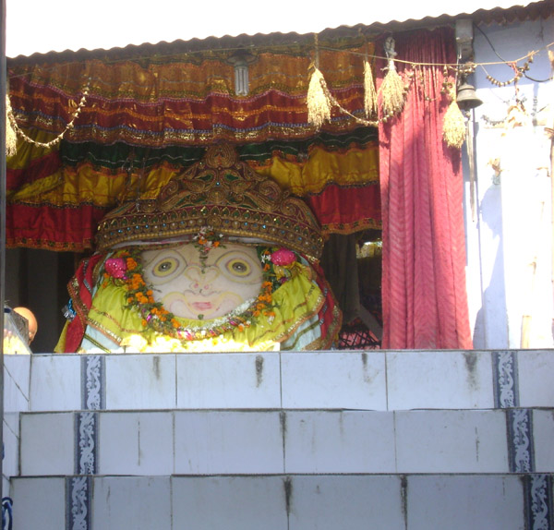
The village of Nemala, a small place with less than a few thousand inhabitants, is relatively unknown in India but well-known to the people of Odisha. It is the Samadhi of Achyutananda, one of the five Panchasakha, who propounded the bhakti cult in Odhisa. Achyutananda is also famous for his prophetic sayings written by him is known as ‘Malika’. The place lies on the banks of river Chitrotpala.
Ansupa
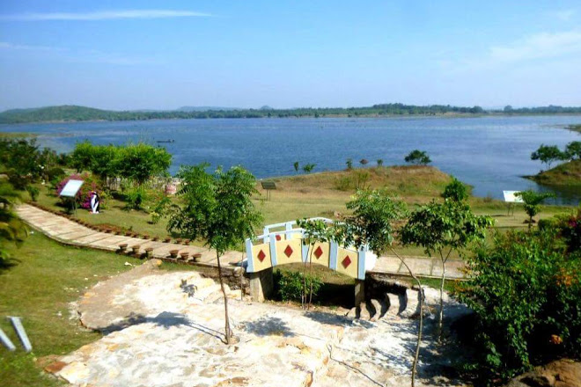
Ansupa Lake is one of the largest freshwater lakes of Odisha situated in Banki, Cuttack. It was created by Mahanadi and got a shape like the hoof of a horse. It spreads over a vast area of 141 hectares and surrounded by Saranda Hills in its length. It is about 65 km away from Bhubaneswar and 70 km away from Cuttack. The lake is a small compare to Chilika Lake, but a picturesque lake that offers asylum to migratory birds in winter. The water spread is ideal for fishing and boating.
Sri Sri Ramanath Dev – Baidyanath Dev
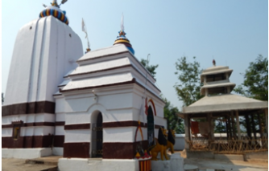
Sri Sri Ramanath Jew and Baidyanath, the ancient temple is situated in the Bank of River Mahanadi built by king Dahlia in 1460 A.D. But the legend says that Maryada Purush Rama Chandra & Devi Sita were worshiped Lord Shiva in this place during the exile. So both temples were named after Pravu Sri Rama & Devi Sita. The Ramanath Temple is situated at the top of Hill & Baidyanath Temple is situated at the bottom of Hatia Hill.
Sri Sri Swapneswar Dev
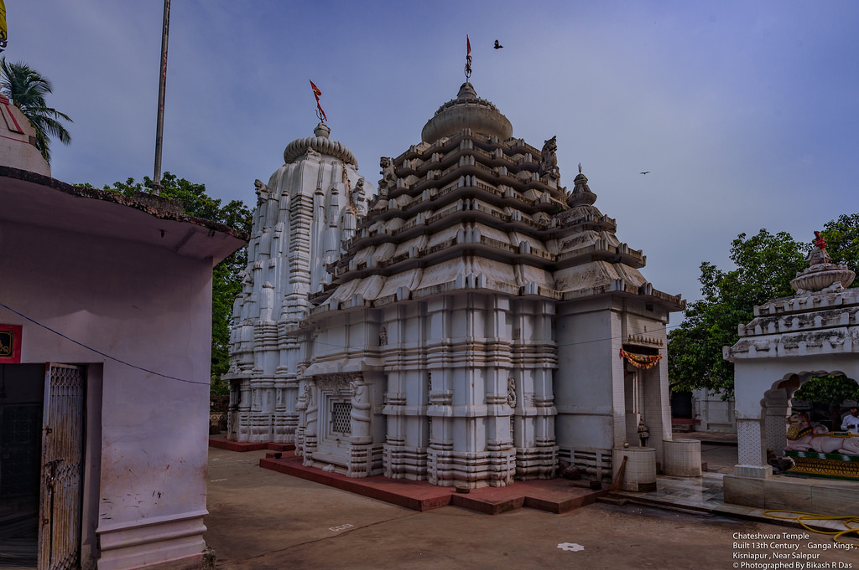
This famous temple at Sankhamerilies on the northern side of River Mahanadi built by Balabhadra Mangaraj the King of Badamba Gadajat in between 1690 AD to 1734 AD. This village Sankhamari was also the first village of Badamba Gadajat and was established by Sri Hatta Kishore, the first King of Badamba Gadajat on 1305 AD. The attraction of the temple is that the snakebite patients are cured through worshiping and Dharana near Lord Shiva.
Sapanpur
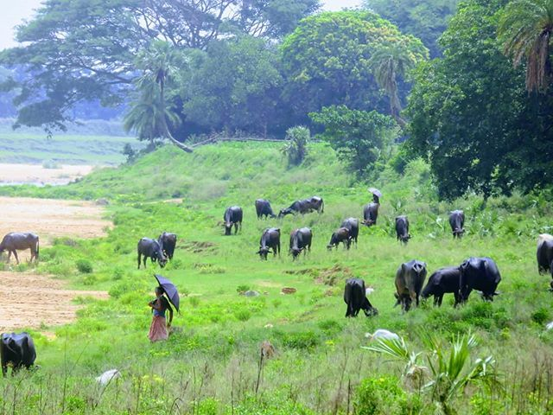
This is a small village, famous for its surrounding natural beauty with a series of small hills dotting the green farmland. There is an Ashram established by Mahima Gosain in mid 19th century on a hillock on the outskirts of the village. The Ashram is known for having a spiritual effect.
Simhanath
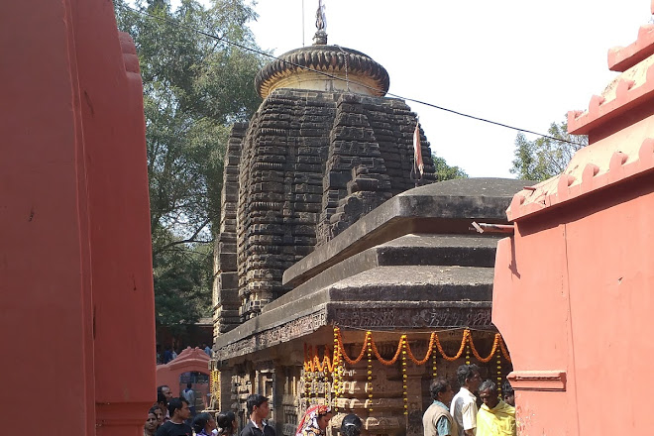
It is a small island on the river Mahanadi. The presiding deity is Lord Shiva, Shambunath. Besides, other temples like Raghunath and Dakshina Kali are situated on this small island. The Simhanath Temple is ancient and thronged by devotees round the year.
Satyabhamapur
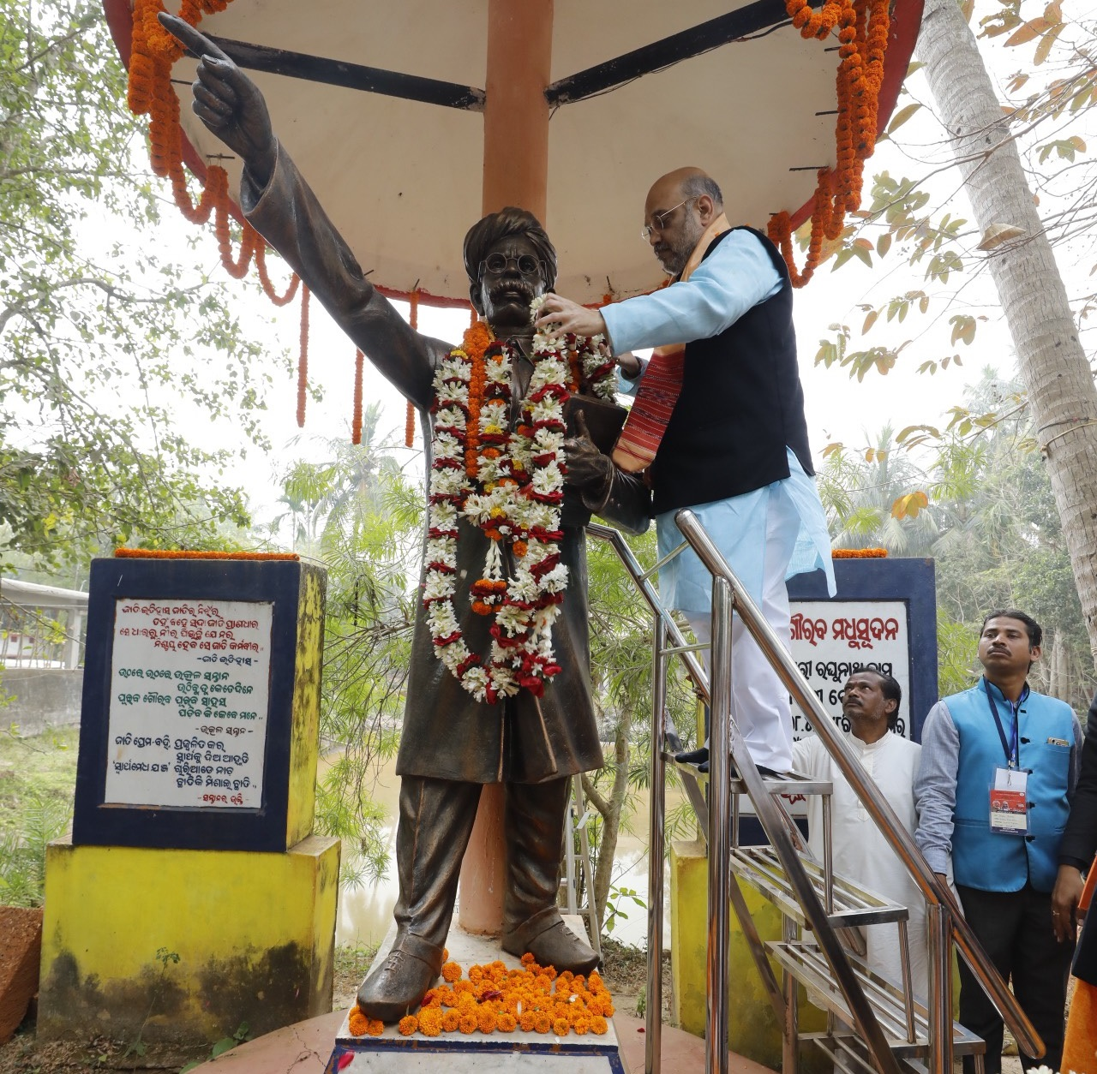
It is a small village in Cuttack famous for giving the state a legend who later known as Utkal Gourav, Madhusudan Das(Madhu Barrister) was born here on 28th April 1848. He was the first graduate, MA and BL of Odisha. Madhusudan Das worked hard for the social, political and economic uplift of people of Eastern India. He rendered his admirable service to the nation as a very successful lawyer, social reformer and patriot. He was also an excellent orator in Odia, English and Bengali. He wrote a number of poems and articles in Odia and English to arouse a sense of patriotism in people.
By his long political fight, he united Odisha & modern Odisha took birth on 1st April 1936. This day is celebrated as Utkala Dibasa.Utkal Gourav Madhusudan Das died at the age of 85, on 4th February 1934. His immense contribution towards the state and nation would be admired forever.
Prasanna Purusottam Dev
This Temple of Tigiria is counted as one of the oldest and is the second-highest temple of Odisha. The site of the temple is memorizing. The temple was built in 1787 by Sri Sankarshan Mandhata & completed by Sri Banamali Champatsingh Mohapatra the then king of the Tigiria State.
Pragala Pitha
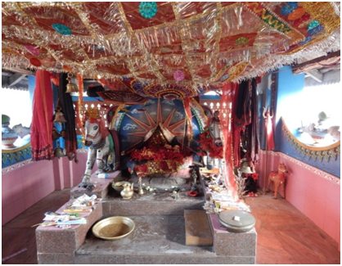
This place is known for the presiding deity of the place - Maa Pragala Pitha, the family Goddess of the ruling chief of Narasinghpur. Legend states that Pragala, was the daughter of King Dharam Singh, who sacrificed her life to save the life of her father from the attack of the King of Angul. The deity is worshiped in the form of a sword. It is also a picnic spot mainly in the winter season.
Niali Madhab
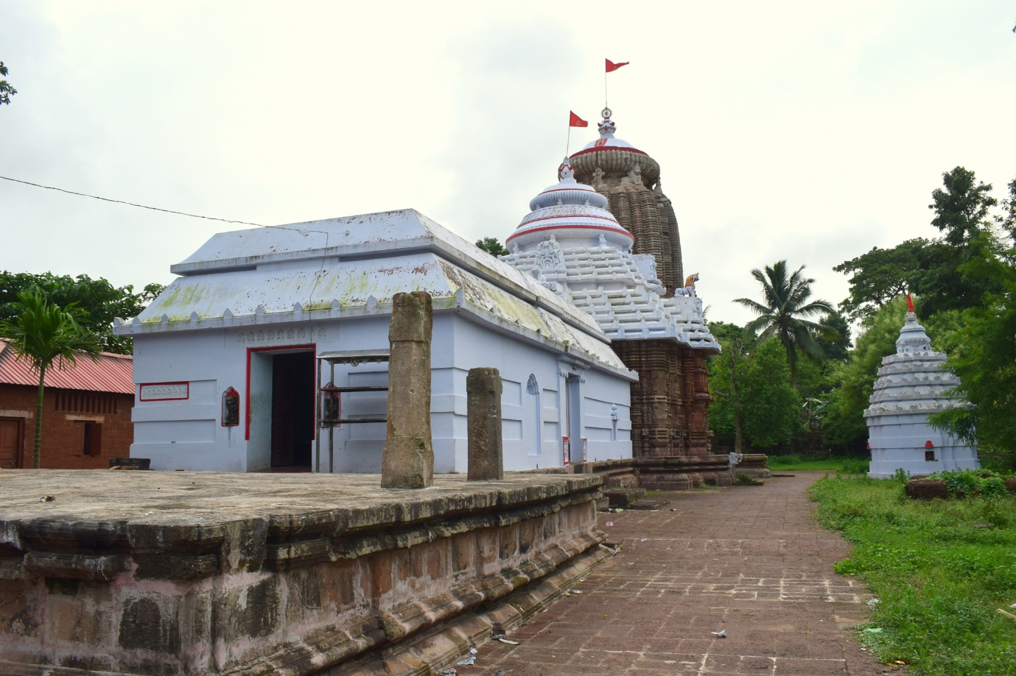
Niali Madhab is a religious center, famous for the shrine of Radha Madhab. It is situated on the banks of the sacred river Prachi.
Naraj
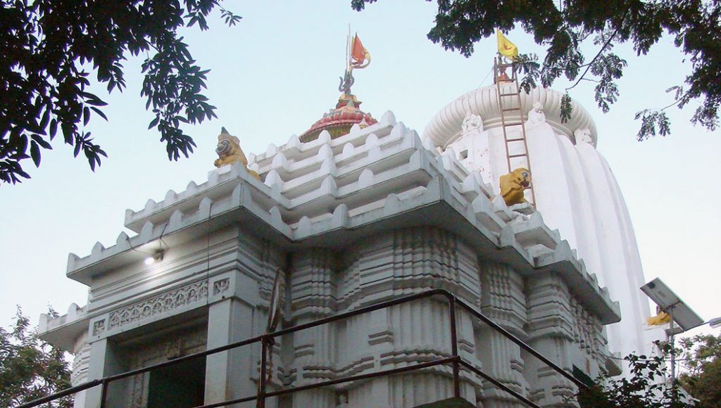
Naraj is a tourist destination, situated on the origin of river Kathajodi a tributary of Mahanadi gives a panoramic view of the vast expanse of the river Mahanadi. There are many Buddhist images found. The place is frequented by devotees offering prayers at Lord Sidheswar. This is also a beautiful picnic spot.
Maninag Cave - Jaluka Hills
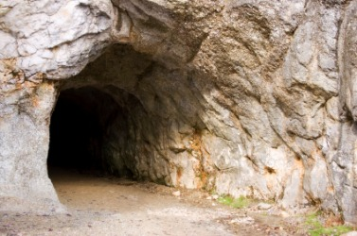
This cave is situated on the west side of River Birupa and east of the famous Manduka Hill named after the Saint Manduka. There are six hills surrounding the site. The hill is spread over 3 kms in length and half a kilometer in with embracing the famous Mani Nag Cave and other sacred places. These individual strategic locations on the hill hold religious and mythological significance.
Maa Dhakulei Pitha, Pratap Nagari
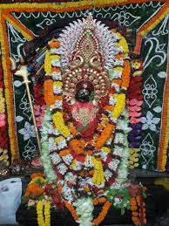
This is a beautiful scenic and a religious destination, adjacent to Puri Main Canal and Kuakhai River, where water flows perennially throughout the year. There is a beautiful Jain Museum adjacent to Maa Dhakulei temple constructed by Jain devotees for long. The place is famous for firework that takes place during Dola Purnima.
Dhabaleswar
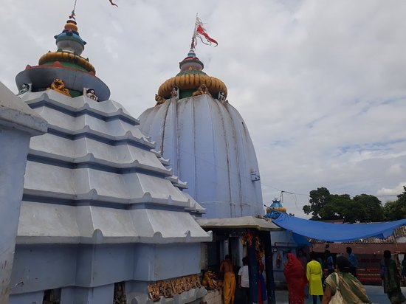
Dhabaleswar is popular for the temple of Lord Shiva that stands on a hillock in the middle of the river Mahanadi. Located in an island on the river near Mancheswar village of Athagarh block, 37 km from Cuttack city, the temple is embellished with stone carvings that date back to the early 10th and 11th century. It is said King Purusottam Dev established the temple in the middle of the river Mahanadi so that his queen Padmabati could worship Shiva. However, the historians are silent over the exact timing of its establishment. According to old scriptures, this sacred place was known as Hariharpitha.
Damdamani Pitha
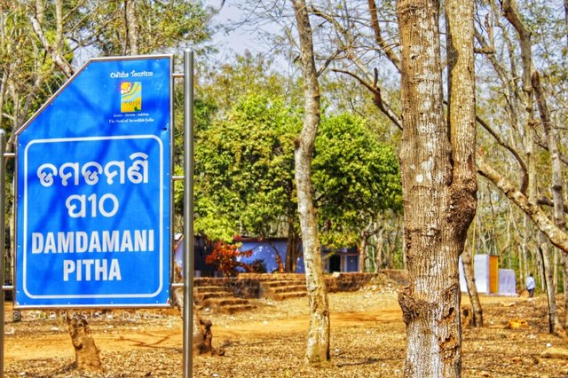
This religious destination is named after the Goddess Dam Damani, situated amidst a green forest of Dalijoda and a perennial stream flowing nearby. This is an ideal place for picnickers and devotees. Legend states, that the Pandavas during the exile had remained incognito near the kingdom of Birat. The forest was a hunting ground of a king, but today is a part of the National Forest Reserve.
Cuttack City
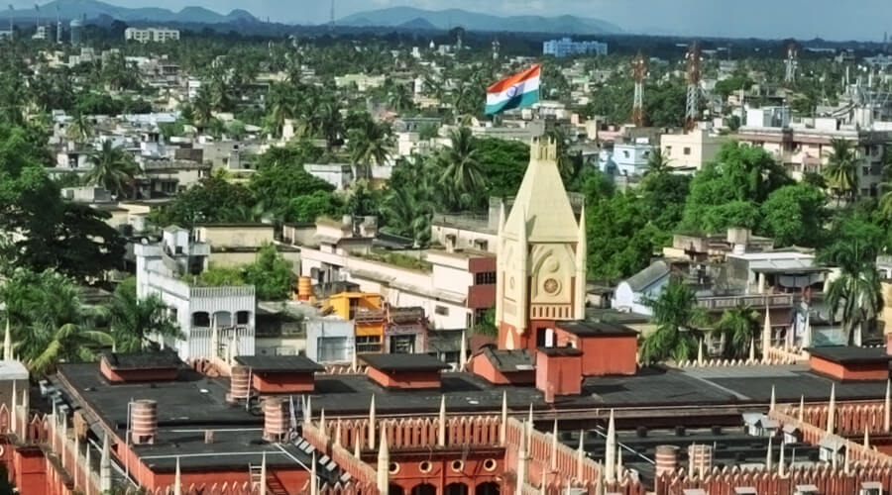
Cuttack, one of the oldest cities in India dating back to 1000 years built by King Ananga Bhimadev-III. This silver city was the former capital of Odisha. Hemmed on the north and south by river Mahanadi & Kathajodi afforded a natural fortified base for the kings of the yore. The 11th century embankment of Kathajodi, the ruins of Barabati Fort, the shrine of Katak Chandi, the Quadam-i-Rasool, Netaji Subhas Bose Memorial(birthplace of Subhas Bose), the Maritime Museum and some old churches are the major attractions of the city. Cuttack is known as the ‘Silver City’ due to its finest Filigree works, the best in the country.
Bhattarika

It is a scenic spot with a shrine of Goddess Bhattarika frequented by picnickers all year-round. Situated on the south of river Mahanadi.
Banki Charchika
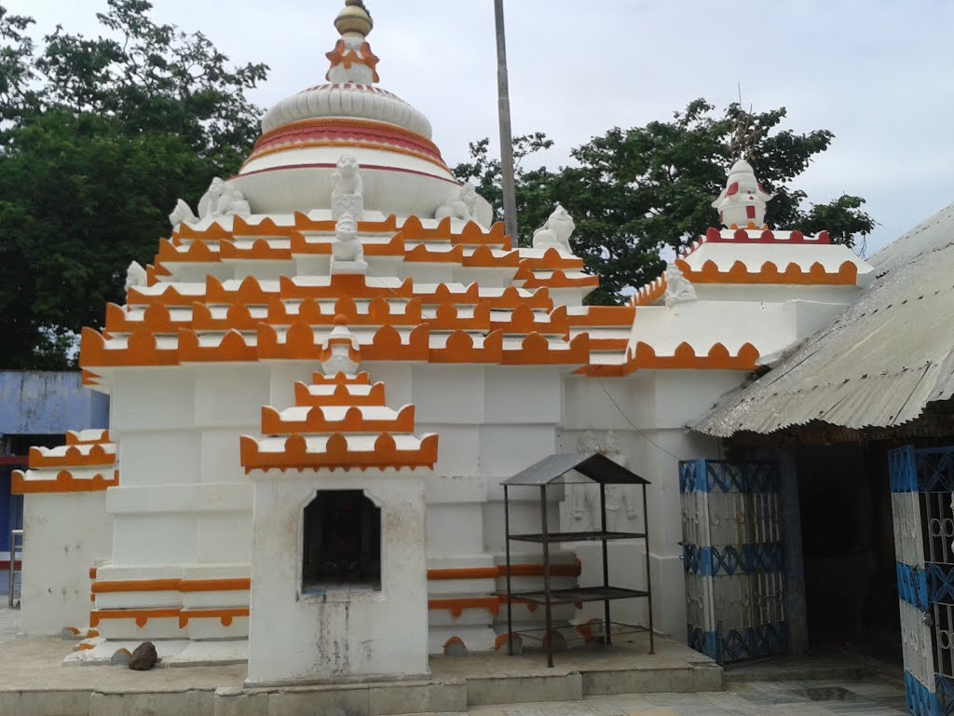
Lies on the south of river Mahanadi and is the shrine of Goddess Charchika, which is one of the eight Shrines of Odisha.
Netaji Birth Place
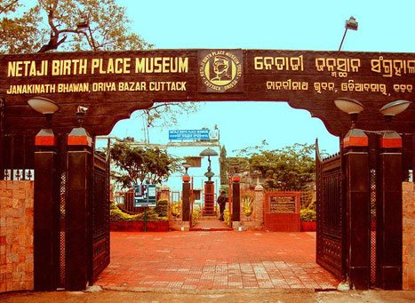
Cuttack is the birthplace of Netaji Subhash Chandra Bose, the famous freedom fighter. He was born on 23.1.1897, at their ancestral house, Janakinath Bhawan at Odia Bazar and spent his early childhood here. Subhash Chandra Bose studied at Ravenshaw Collegiate School and later went to Calcutta to pursue higher studies. The grand house has been now been converted into the Netaji Birth Place Museum and exhibits memorabilia associated with the great leader, which is worth seeing.
Barabati Fort
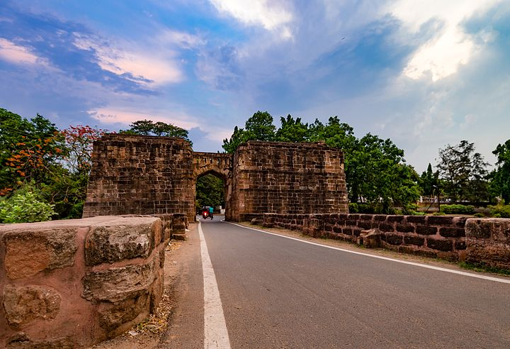
The ruins of Barabati Fort with its moat and gate and the earthen mounded of the nine-storied palace of the Ganga dynasty lie on the bank of the river Mahanadi as the silent witness of the vicissitudes of Odishan history. Another item of interest is the Barabati stadium adjacent to the fort. The stadium with its impressive structures covers an area of twenty-five acres and affords sitting capacity for thirty-five thousand persons. Its delightful soft green turn hums almost daily with programs of sports events and cultural functions.
Barabati Stadium
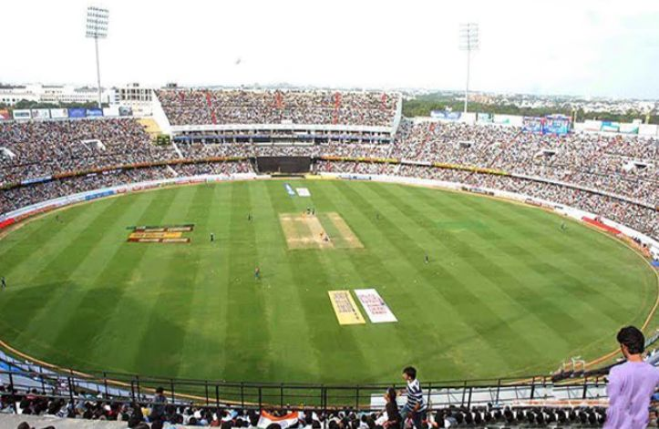
Modern Cuttack boasts of Barabati Stadium, an important venue for international cricket matches. It is the home ground of the Odisha cricket team and is operated by Odisha Cricket Association. The Barabati Stadium is one of the older grounds in India, having hosted several cricket matches.
How to reach Cuttack
By Air
Bhubaneswar's Biju Patnaik Airport is the nearest Airport to Cuttack. The Airport has regular flights to major Indian cities like Kolkata, Delhi, Mumbai, Chennai, Hyderabad and Visakhapatnam.
By Rail
The city is well connected with all the major parts of the nation through rail networks. Lying on the Kolkata-Chennai line, many Super Fast expresses and locals trains passing through the city.
By Road
Bus services are excellent in Cuttack. The National Highway connects the city with the major and nearby cities. One can find buses as well as taxis which will take people in and out of the city with ease.
Best Time to Visit Cuttack
The winters are mild with minimum temperature touching 8 degrees Celsius. The best time to visit this city is from October to March.
Weather of Cuttack
The average temperatures in Cuttack vary somewhat. Considering humidity, temperatures feel hot for most of the year with a low chance of precipitation most of the year. If you're looking for the very warmest time to visit Cuttack, the hottest months are May, April and then June. See the average monthly temperatures below. The warmest time of year is generally mid-May where highs are regularly around 101.6°F(38.7°C) with temperatures rarely dropping below 80.7°F (27.1°C) at night.

