About Deogarh
Debagarh District, also known as Deogarh District is a district of Odisha state, India. Debagarh is the former capital of Bamanda or the Bamra princely state of British India. The king of this princely state belongs to the Ganga Vamsi dynasty and one of the extended royal family of Gajapati emperor of Odisha. It is located in the northern part of the state. Located in the North-Western region of the state, it is the headquarters of Debagarh District that was created on 1 January 1994, after being bifurcated from Sambalpur District.
Top Attractions in Deogarh
Katasar Ghat

Katasar Ghat is on the high way from Deogarh to Angul. It is under Kankarkhol reserved forest area. The place is surrounded by dense forests. At the top of the ghat, there is a temple of Goddess Banadurga and the temple of Lord Shiva. A natural stream is flowing inside the temple premises.
Gohira Dam
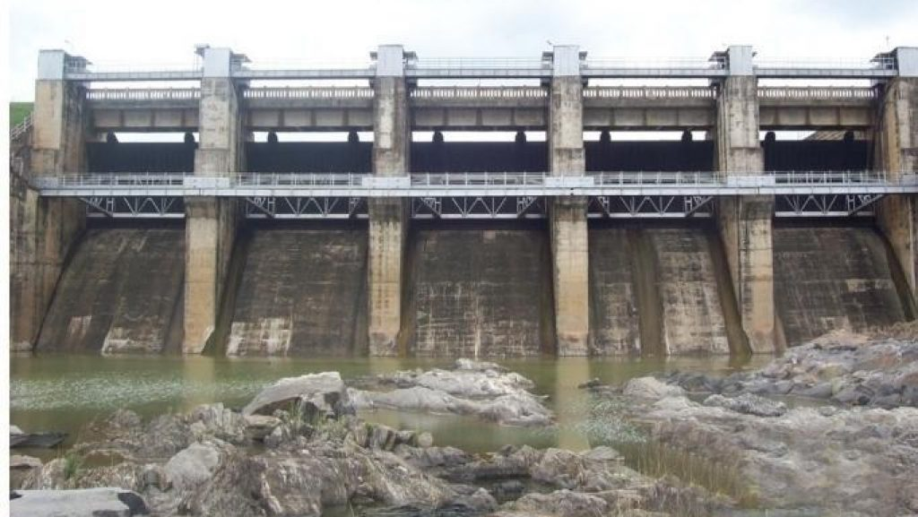
Gohira Dam is an ideal place for picnic. It was constructed in the year 1981. The Dam is one of the biggest assets from the aspect of tourism and water resource project. The catchment area covers about 336 Sq. kms and irrigates over to 8000 hectors of agricultural land. Near the dam is a temple of Lord Shiva which was constructed by the villagers in 1980.
Jagannath Temple, Deogarh
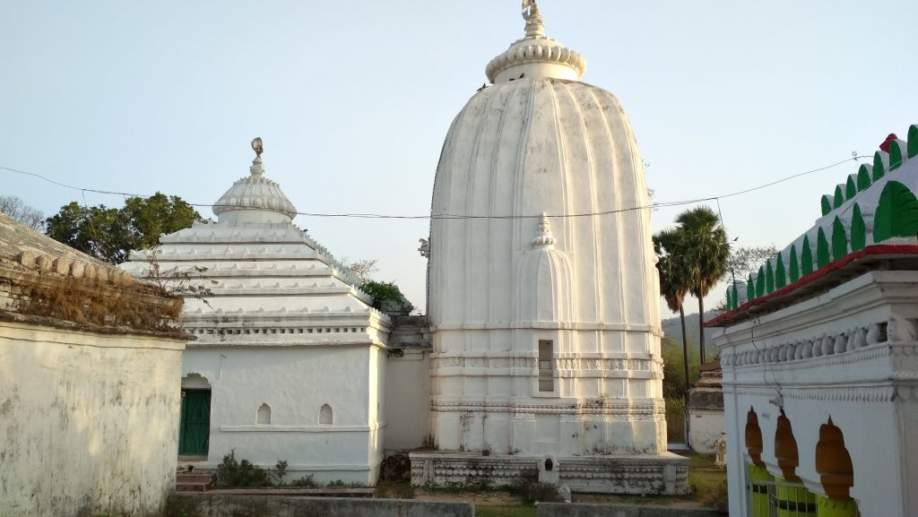
Located at Purunagarh, the old capital of Bamra State, this temple is one of the oldest among the series of temples in Deogarh town. It was built by Raja Pratap Rudra Deb in the year 1705. This is the first and foremost Jagannath temple in Bamanda State. It is a historical monument of artistic glory and heritage of the Ganga dynasty. The remarkable structures are replicated on the Kalinga style of temple architecture.
Daragadi Stream
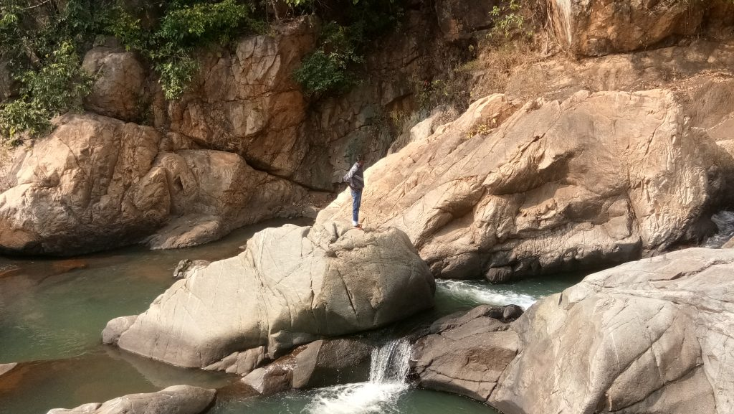
This tourist spot is situated in the Tainsira village, which is a meeting point of 3 districts namely Deogarh, Sundargarh and Angul. It is around 70 Kilometer from District headquarter and 22 kilometers from Thianal Bus Stop on National Highway connecting Pallahara and Deogarh. Deep Forests, sky touching blue mountains, murmuring sound of Daragadi Stream attracts thousands of visitors to this place.
Jhadeswar Temple
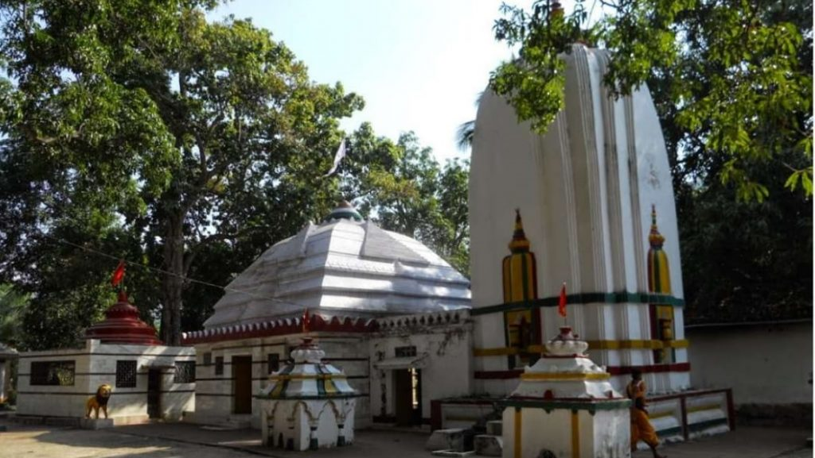
The temple is easily accessible from the Private Bus Stand of Deogarh. It is situated at a distance of 3 Kms to the left of NH-200 under the Chikini Ghati approachable by all-season roads. The temple was constructed by Deba Durllav Deb, a scion of the royal family during the rule of Raja Brajasundar Deb in the year 1854 and is one of the oldest temples of Bamanda. The presiding deity is Lord Shiva.
Olata Bata
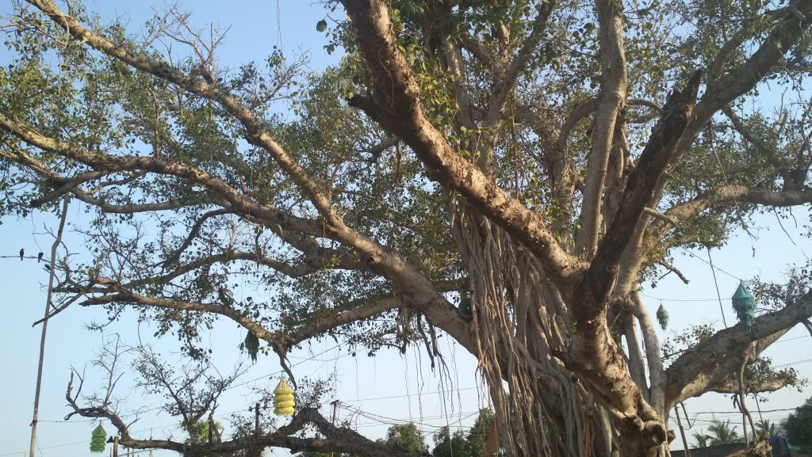
The Olata Bata, a giant ficus tree located in the Purunagada part of the town greets the visitor on entry to Deogarh Town from the Sambalpur side. The inverted leaves of this tree bear religious sanctity and are considered a strange botanical phenomenon.
Deojharan Fall
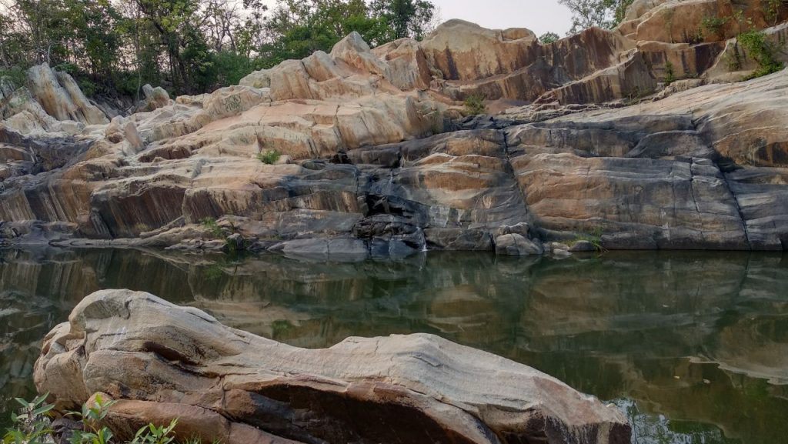
Deojharan - springs is a popular picnic spot. The scenic surrounding and flowing jharan presents an inviting atmosphere during winter. According to local lore, this place in the dense forest was the camping ground of the forces of Bamanda when there was a conflict between Bamanda and Rairakhol due to some trade and commercial passage reasons.
Kailash Palace
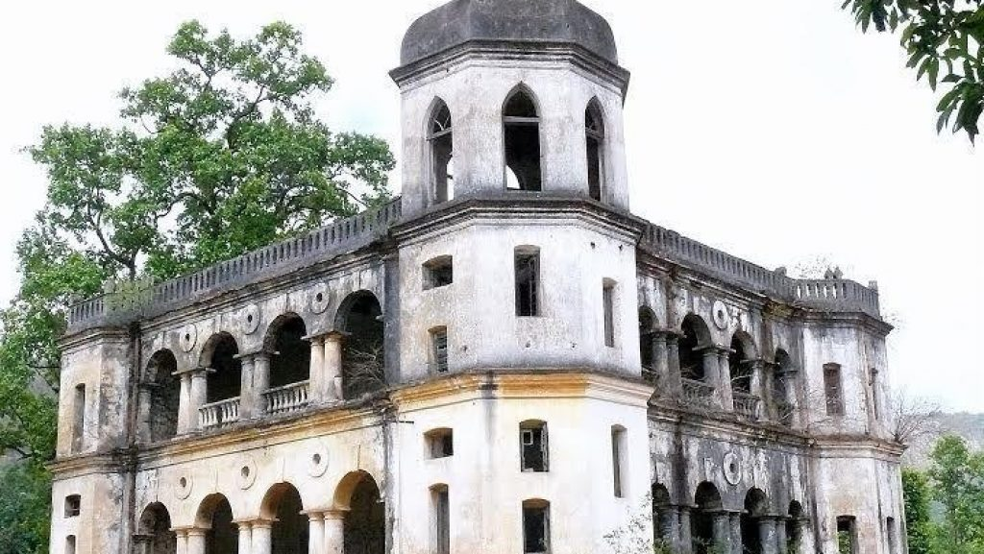
This resort for the retreat of the royals was built by Raja Dibya Shankar Deb between the years 1916 and 1919. Kailash is ideally located with its beautiful mountain clad valley on the side of NH-49 within a distance of 15 Kms from Deogarh town. The kings of Ex-Bamanda estate have left behind many heritage buildings as their honeymoon places inside hills and mountains.
Koradkot Fall
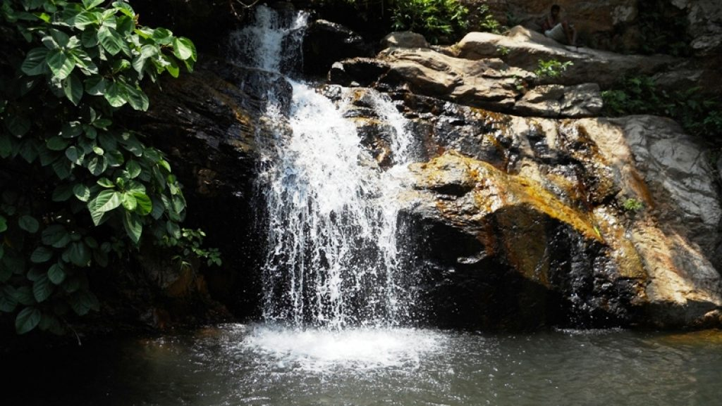
Koradkot is the 2nd waterfall of Deogarh. During the reign of Raja Sachidananda Tribhuban Deb, the waterfall was a source of hydro-electricity energy, the 1st of its kind in Odisha and 2nd in Asia. During winter the picnickers rush here and enjoy the scenic spot with the chirping of birds, murmuring sound of waterfall and trekking.
Pradhanpat
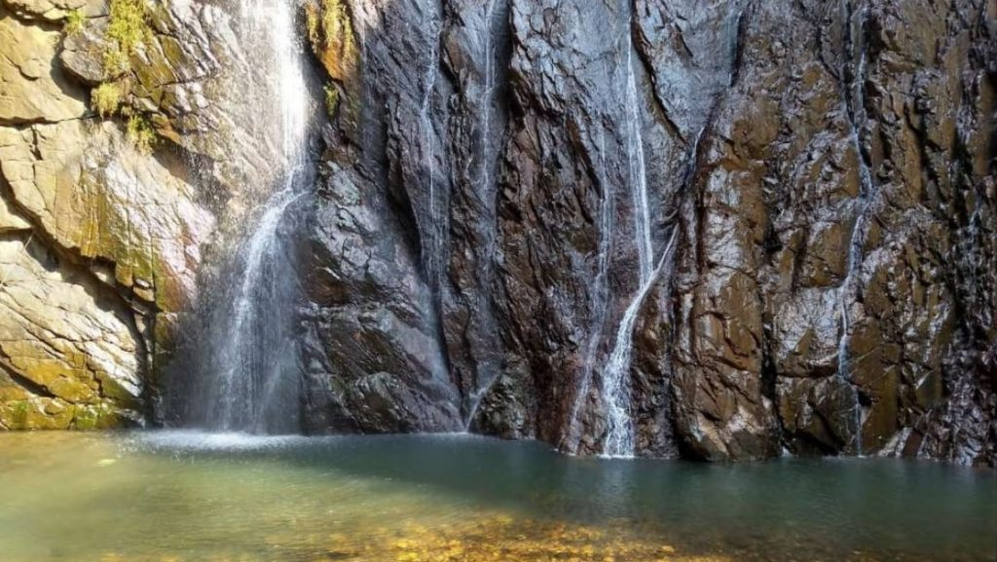
This is a famous tourist destination of Deogarh. The waterfall itself is the biggest asset having natural panorama. Poets and nature-loving celebrities from all over India come to visit this place. The Shakti Peetha of Maa Pradhani and the temple of lord Champakaswar have a strong religious significance and rich cultural heritage. People enjoy religious spectacles and worship them since time immemorial. It is a real retreat to the worshipers that the waterfall is free from the clamour and chaotic disturbances.
How to reach Deogarh
By Air
The nearest Airports for visiting places of interest in the Deogarh District are at Bhubaneswar(265 km), Raipur(376 km) and Jharsuguda(98 km).
By Rail
The nearest railheads for Deogarh are at Sambalpur(90 km), Bamra on the Tatanagar-Bilaspur section of Howrah-Nagpur-Mumbai line(103 km), Jharsuguda(98 km) and Rourkela(115 km).
By Road
You can easily get regular buses to Deogarh from other major cities of the country.
Best Time to Visit Deogarh
The best time for visiting the holy pilgrimage of Deoghar is in winters, especially during the months from October until March. The summers are unbearably hot while the monsoons might dampen your plans, although it's lovely and inviting if the rainfall is more than average.
Weather of Deogarh
The Deogarh lies on 197m above sea level Deogarh's climate is classified as tropical. In winter, there is much less rainfall in Deogarh than in summer. According to Köppen and Geiger, this climate is classified as Aw. The average annual temperature is 26.5°C in Deogarh. In a year, the average rainfall is 1540 mm.

