About Dhenkanal
Planning a Trip to Dhenkanal? Here's our list of 6 top Tourist Places to visit in Dhenkanal
Dhenkanal town, east-central Odisha state, eastern India. The town is named for Dhenka, a medieval chieftain of the Savara people. It is a marketplace for Rice, Oilseeds and Timber and is a center of Handloom weaving. Dhenkanal was formerly the capital of the princely state of Dhenkanal, which was incorporated in 1949 into what became Odisha state in 1950.
With a long, rich history of strong rulers that date back to the 15th and 16th centuries, Dhenkanal is filled with imposing palaces and forts, and intriguing archaeological remains of eras gone by. Much of the region is covered in dense foliage and gushing rivers, such as the Brahmani and Mahanadi and is home to myriad species of Flora and Fauna. These areas are bound to excite travelers who have a penchant for wildlife and natural wonders. A number of temples also dot this scenic city, notching up its Tourism quotient quite high.
Top 6 Places to Visit in Dhenkanal
Kapilash
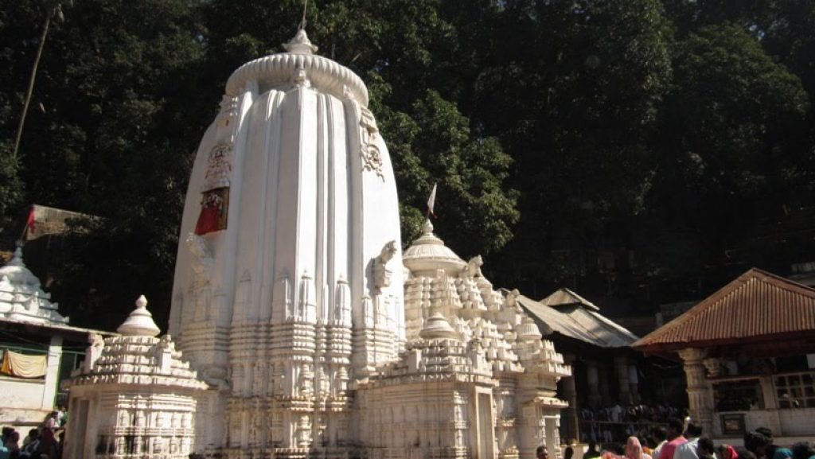
It is one of the famous Saiva Pitha of Odisha and also a well-known tourist place. This place is allegedly known as Second Kailash. The way to the temple consists of 1352 steps.
The temple was constructed in 1246 AD by King Narasinghdeva-I. Marichi kunda & Payamruta kunda exist on the right and left side respectively of the main temple. A number of festivals are celebrated here at Kapilas. But the celebration of Maha Shivaratri is a festival to watch.
Joranda
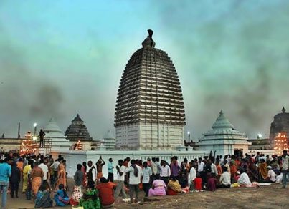
Famous as the religious headquarters of Mahima Dharma, Joranda houses the Samadhi of Mahima Gosain, the preacher and propounder of the Mahima Cult. The other sacred temples are the Sunya Mandira, Dhuni Mandira and Gadi Mandira. Pilgrims in large numbers pour into the Joranda fair for celebrations.
Saptasajya
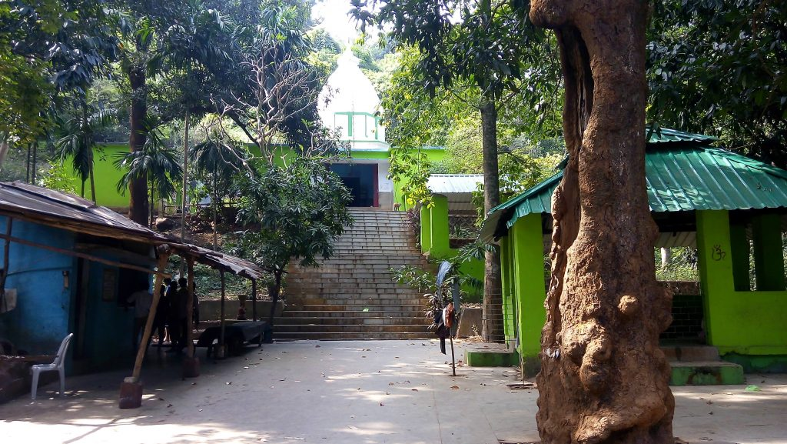
A place of scenic beauty, Saptasajya is situated at a distance of about 11 km to the south of Dhenkanal town. According to legends, ‘Pandavas’ spent some days of their incognito life(Agnuata vasa) in these hills. The temple of Raghunath, built in honor of Lord Rama, Laxman and Sita by Rani Ratnaprava Devi of Dhenkanal attracts large crowds every year on the day of Ramanavami, in the month of March-April. A small spring flowing close by enhances the beauty of the place. It is an ideal place for picnic and relaxation.
Saranga
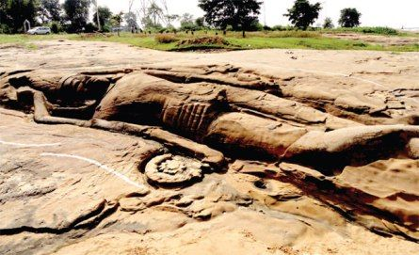
At this place, you will find an Anantasyi image of Lord Vishnu, on the rocky bed of the river Brahmani at Saranga. The hoods of Ananta, the serpent king spread over the head of Lord Vishnu as the crown and cover. The primal lotus, housing Brahma, the creator originates from Vishnu's navel, the Supreme Being enjoying the deep delight of his cosmic sleep in the waters of the river Brahmani.
Kualo
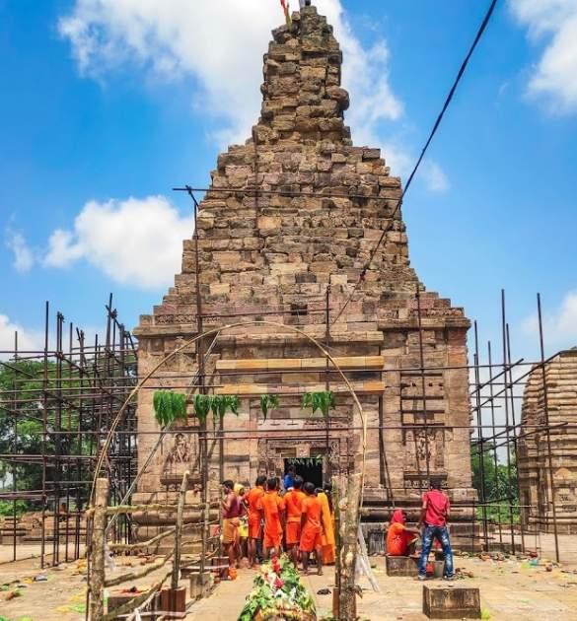
72 km from Dhenkanal, Kualo is famous for housing a plethora of temples dedicated to Lord Kanakeswar, Baidyanath, Paschimeswar, Balunkeswar and Kapileswar. In its ruined form, the temple of Kanakeswar is about 24 meters high and preserves some of the earliest specimens of sculptures representing ancient temple building activities in Odisha.
Dandadhar Dam
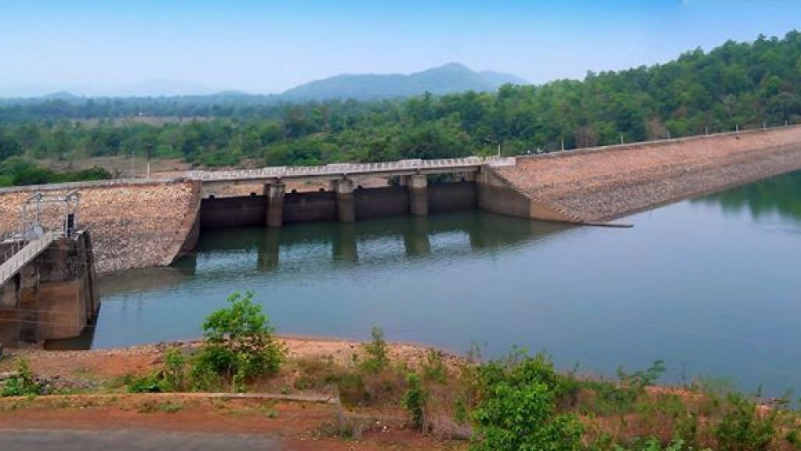
67 km from Dhenkanal, Dandadhar is the site of an irrigation project on the river Ramial - an ideal place for outings. Its blue expanse of sparkling waters caged in a sun-bathed valley is a thrill for the searching eyes.
How to reach Dhenkanal
By Air
Dhenkanal is not well connected to other major cities of the country via regular flights. The nearest Airport is in Bhubaneswar at a distance of 90 kms.
By Rail
It is around 90 KMs from State Capital and well connected by Rail.
By Road
You can easily get regular buses to Dhenkanal from other major cities of the country.
Best Time to Visit Dhenkanal
The time between the months of November to February as the best time to visit Dhenkanal. Summers are scorching whereas during winters the temperature comes down to the bottom of the mercury level. Plan your trip to Dhenkanal by getting to know the season, climate and places to visit in Odisha at which time of the year.
Weather of Dhenkanal
Dhenkanal District has a moderate climate. The District experiences hot with high humidity during April and May and cold during the winter months, i.e. December and January. The monsoon generally breaks during the month of June with the average annual rainfall being 1421.1 mm.

