About Gajapati
Planning a Trip to Gajapati? Here's our list of 5 top Tourist Places to visit in Gajapati
Gajapati is a district of Odisha, India. It was created from Ganjam District in October 1992. Gajapati district was named after Maharaja Sri Krushna Chandra Gajapati Narayan Dev, the Raja Sahib of the Paralakhemundi estate(The first Prime Minister of the state), who is remembered for his contribution in the formation of a separate state and inclusion of the Paralakhemundi estate in Odisha. The district headquarters at Paralakhemundi, formerly a princely estate, have been clustered within a radius of approximately 5 kilometers around the geometric center of Paralakhemundi.
Top 5 Places to Visit in Gajapati
Maharaja Gajapati
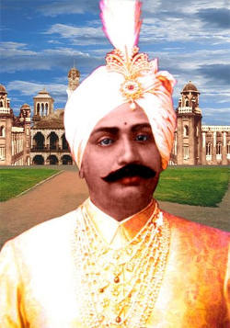
The king of Paralakhemundi Shri Krushna Chandra Gajapati Narayan Deo had the kingship of the majestic Gajapati rulers, who continued to be the supreme authority of Odisha for more than seven centuries. Also, he was the first Prime Minister of Odisha.
Brundavan Palace
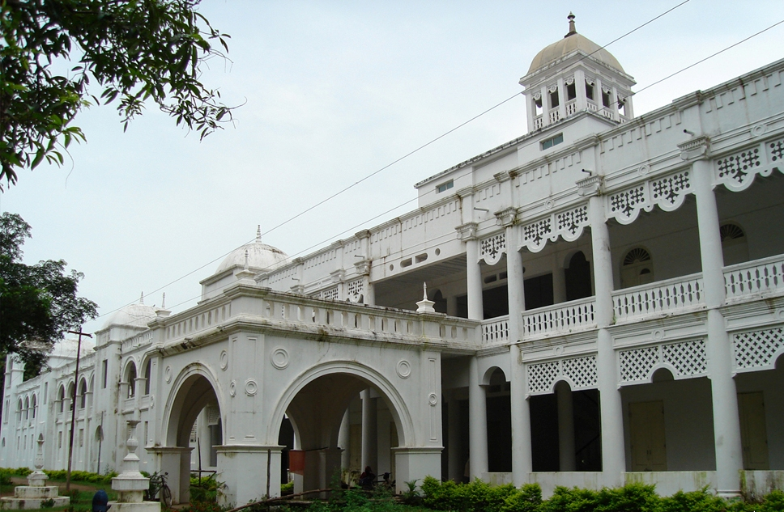
The Palace was made by the Maharaja of Paralakhemundi for their use during summer. It is situated on the bank of river Mahendratanaya surrounded by thick Teak trees. The palace is three-storied including an underground floor. There an underground connection to it with the main palace of Maharaja.
Chandragiri
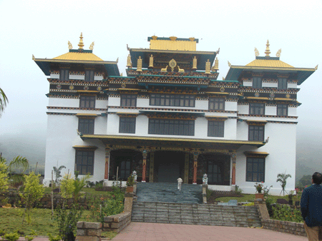
Chandragiri is located in Lobarsing Gram Panchayat of Mohona Block. It is famous for the Buddhist temple, the highest in South Asia. In 2010 it was inaugurated by His Highness Dalai Lama.
During these cultural festivals, the Chandragiri uses to become a more prominent and amazing place. The seasonal fruits cultivated here have really added more popularity for this place. It is also the place where different dog breeds are generated. It is also famous for making or carpet and garments.
Gandahati Waterfall
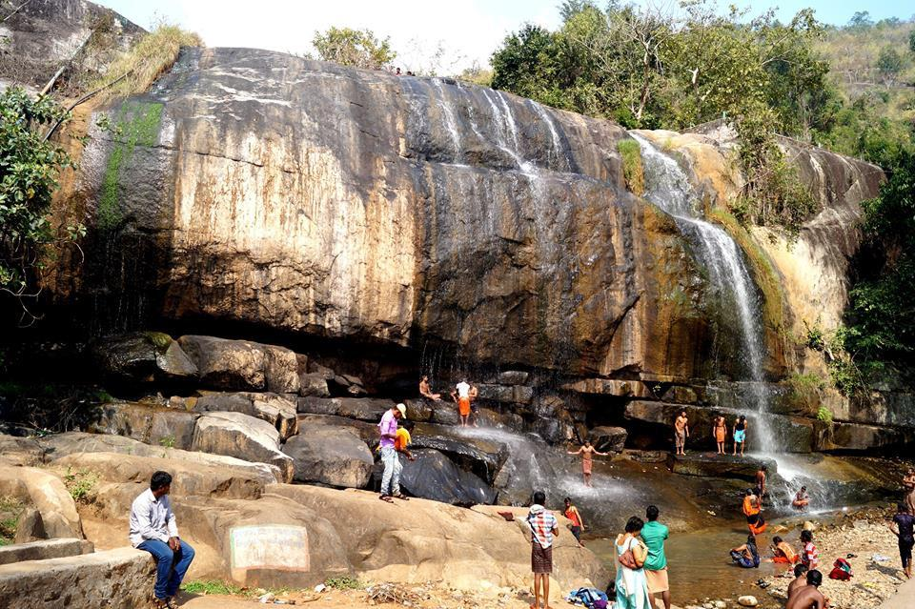
From the main town Paralakhemundi, the Gandahati Waterfall is located at a distance of 30 km. the glittering waterfall located here has made this place more popular among the visitors. This waterfall is surrounded by dense and green forest that supplies the best shelter for wild animals such as elephants. These elephants use to arrive at the Gandahati Waterfall from the other side of the hill. Here they use to bath, play and drink water. There is also an amazing Hindu temple located close to the Gandahati Waterfall.
Mahendra Giri
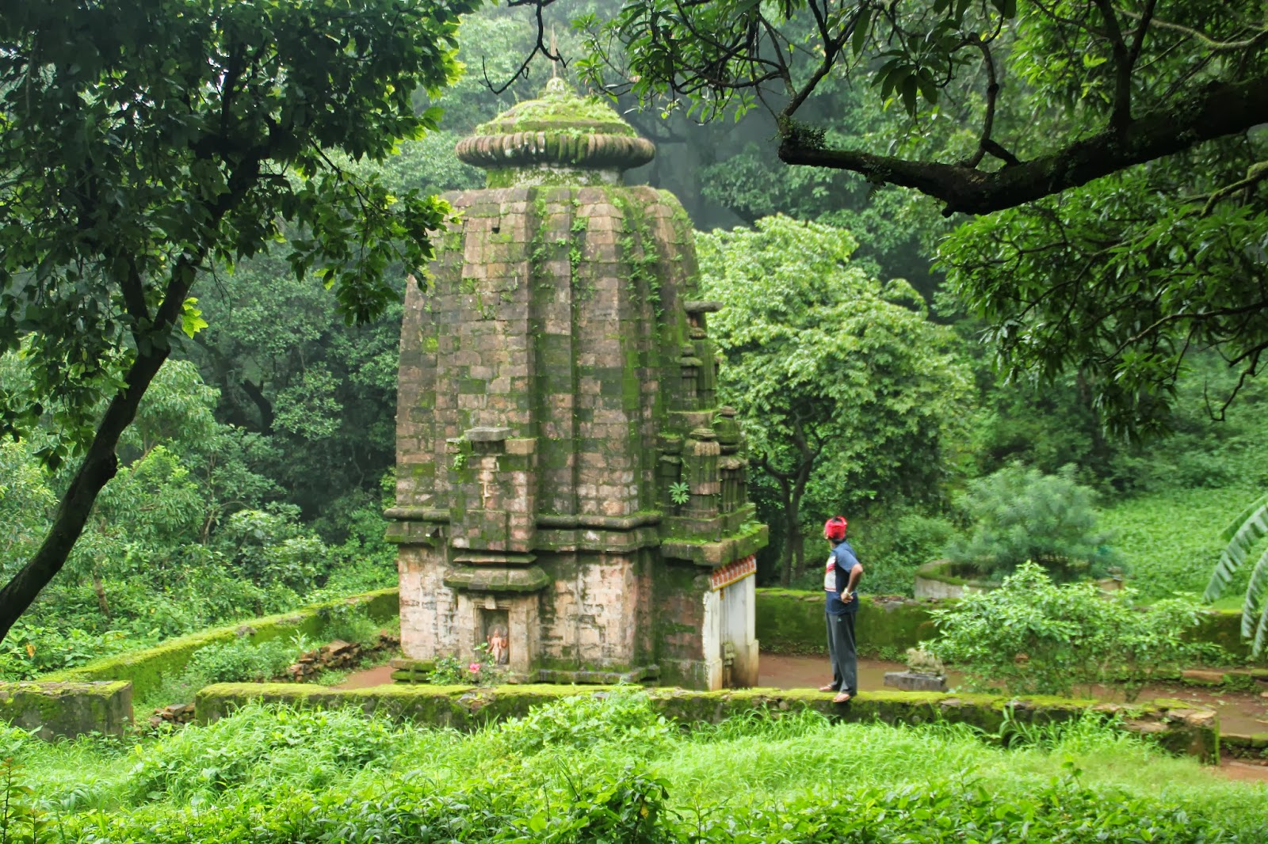
Mahendra Giri is the mountain peak and it is also a part of the Eastern Ghats. It is located at 4,976 feet above sea level. From the main town of Paralakhemundi, the peak of Mahendra Giri is located at a distance of 56 km. Mahendra Giri as a part of the Eastern Ghats is backed up by several mythological beliefs. This place is filled with many legendary stories that are taken from the Puranas.
How to reach Gajapati
By Air
Nearest Airport is Biju Patnaik International Airport - 300 Kms.
By Rail
Nearest Railway Stations is Palasa in Andhra Pradesh- 40 Kms.
By Road
From Bhubaneswar, it is 300 Kms on the NH-6.
Best Time to Visit Gajapati
Winter is the best time to visit Gajapati. Visit between November to February to enjoy the weather and your trip to Gajapati.
Weather of Gajapati
The climatic condition in the Gajapati District varies between 16°C to 40°C and the normal rainfall received is 1403.30 mm. The District is surrounded by Andhra Pardesh in its South, Ganjam District in its East, Rayagada in its West and Kandhamal in its North.

