About Ganjam
Planning a Trip to Gajapati? Here's our list of 14 top Tourist Places to visit in Ganjam
Ganjam is one of the prominent districts of Odisha. The name of the place is the name derived from ‘Gan-i-aam’ which means the storehouse of food grains. Ganjam is situated on the bank of Bay of Bengal.
The district came into existence on 1st April 1936. The district is named after the old township and European fort of Ganjam situated on the northern bank of river Rushikulya which was the headquarter of the District. The Ganjam area was a part of ancient Kalinga which was occupied by Ashok in 261 BC. The period of 1757 was ruled by the French Commander Bussy. In 1759, the French ruler was defeated by English and the District was annexed by them. The office of the District Collector was established in 1794. The District got separated from the Madras Presidency and formed the part of the newly created State of Odisha province with effect from 1.4.1936.
Top 14 Places to Visit in Ganjam
Gopalpur - On Sea
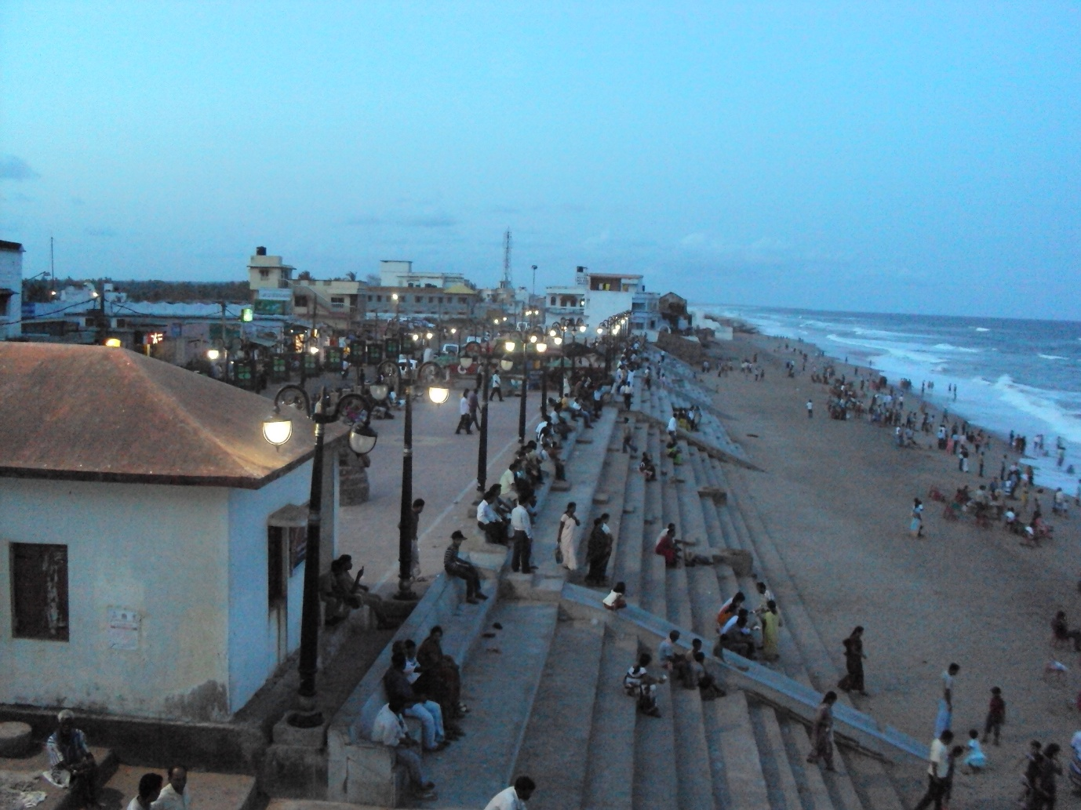
Gopalpur-on-sea is one of the most pristine and popular beaches in Odisha, India. Clusters of Palm and Coconut trees, Sand Dunes covered with casuarinas plantation divide the beach from the seawater which works as a complete set for quiet conviviality and introspection.
The sea and the golden sand makes it one of the highly sought after beaches in India. Good accommodation options in a serene and calm atmosphere turn it into a favored holiday destination.
Tara Tarini - The manifestations of Adi Shakti
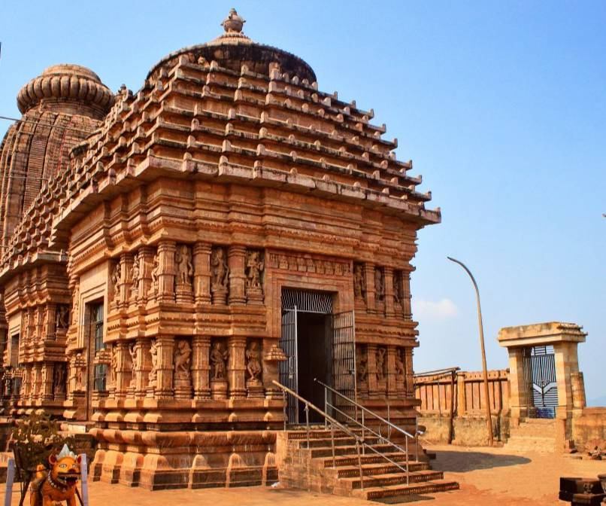
In this famous religious place, the twin sister Goddess is worshiped. Tara & Tarini adorn the sanctum situated on the top of a hillock girdled by the waddling holy river Rushikulya. Taratarani attracts thousands of devotees, picnickers and visitors throughout the year. Walking over 999 steps from the foot of the hill, to the hilltop under shadows of a green plantation is very much amusing and pleasure making.
Chilika(Rambha)– A brackish water lagoon
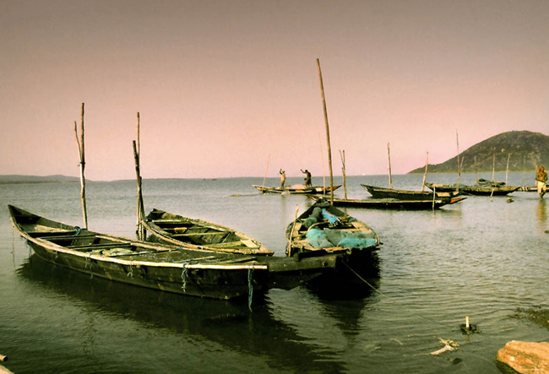
Chilika is Indias biggest inland lake. Spread over 1,100 square kilometers stretching across the length of the three districts of Puri, Khurdha and Ganjam and finally joins the Bay of Bengal through the narrow mouth, forming an enormous lagoon of brackish water. Dotted with many emerald green islands with colorful names such as Honeymoon Island and Breakfast Island, Chilika is home to a rich variety of aquatic fauna. It is also a sanctuary and winter resort for migratory birds, some coming from as far as Siberia.
Panchama – Siddhi Vinayak Temple
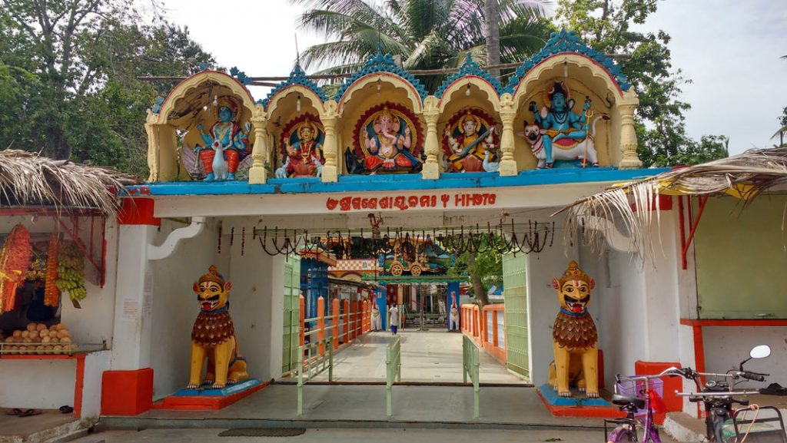
It is a small village where Lord Ganesh is worshiped in the groove of a large Pipal tree for ages. The actual age of the temple is not available on record. According to legend, the Lord Ganesh idol with its left-facing tusk(otherwise known as Sidha Vinayaka) is some way related to Sri Purushottam Dev, the then Gajapati of Puri.
Bhairabi Temple
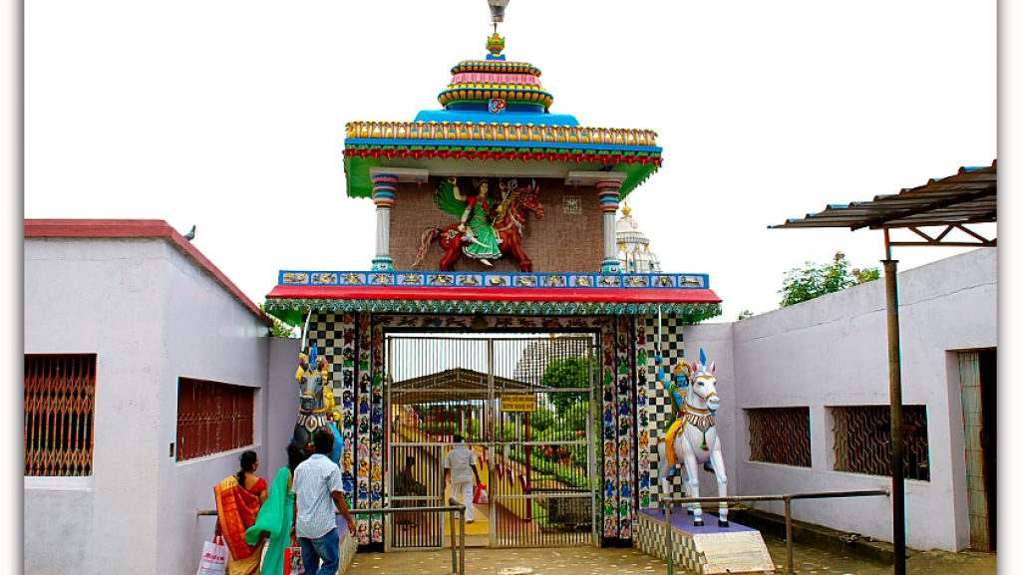
Maa Bhairabi Temple is situated in a remote village Mantridi near Berhampur city in Ganjam district. This temple pays homage to goddess Bhairabi. The deity is an icon with one leg and four hands craved in a crude fashion. The image of the idol was found beneath the land while plowing and was enshrined as such in a newly built temple in the year 1937.
Olive Ridley Turtles at Rushikulya

Uncounted Olive Ridley turtles flocked the Rushikulya river mouth for their annual mass nesting in Odisha's Ganjam district. These endangered species flock the place every year from the third week of February to the first week of March for nesting. Odisha is the largest mass nesting site for Oliver Ridleys in the world.
Narayani Devi Temple
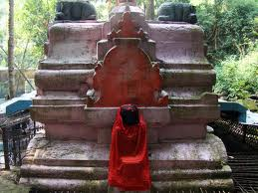
Narayani Devi temple is famous for its natural destination. It's a natural setting with a perennial spring and green mango groves attract a good number of visitors every day. The holy shrine of Goddess Narayani(Durga) with six hands is a great attraction for the devotees and picnickers.
Taptapani – A Hot Water Spring
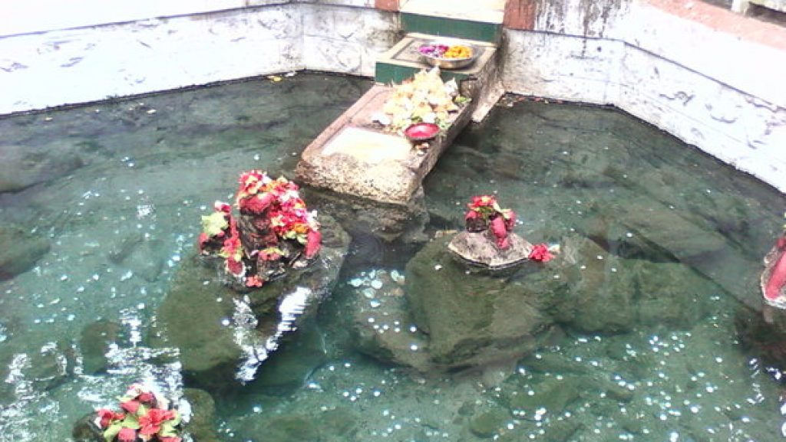
This place is famous for a perennial hot spring of Medicinal Sulfuric Water which is located on the State Highways that connects Berhampur. Being surrounded by a cluster of hills and thick forests, the serenity of nature at Taptapani is added by wonderful sights of sunrise, sunset moonlit night, tribal dance and music, chirps of birds and sight of wild animals.
Buddhakhol – Panchu Mahadeva Temple
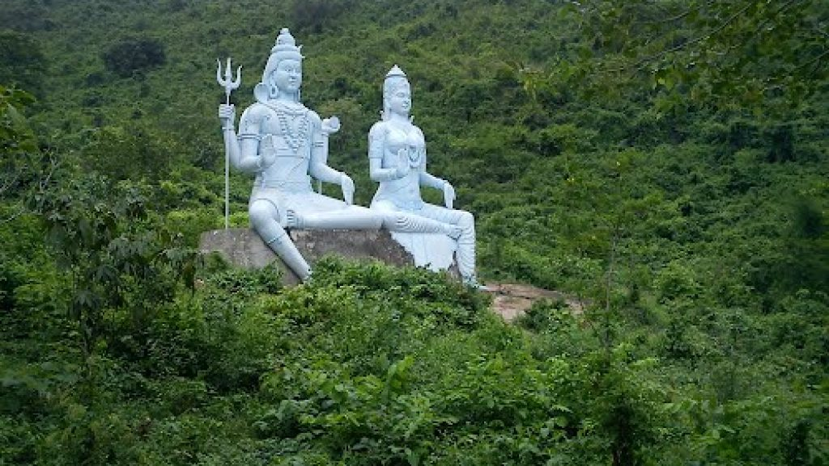
This scenic place is set amidst natural surroundings there is a cluster of five temples on the top of a hill, dedicated to Lord Siva, popularly known as Panchu Mahadeva. At the uppermost part of the hill, a perennial stream forms a waterfall. A number of Buddhist remains have been found at the place which gives the impression that it was a Buddhist settlement in ancient days. Not far from the place there are numerous caves one of which is called Siddha Gumpha where Buddhist monks were said to have performed meditation in old days.
Mahurikalua – Shakti Peetha
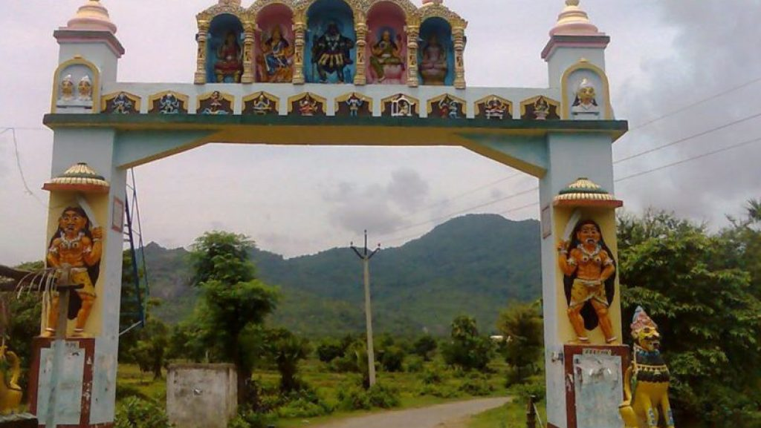
The 1st temple is on the mountain and there are stairs to climb the hill, then there is a small cave, through which the temple is accessible. It will take around 45 Mins- 1 hour to reach the Mahurikalua Temple on the mountain. The 2nd temple is down the hill which is just in front of the parking space. The Goddess is well known in the district and many people come there to pray.
Humuri Tampara - A Sweet Water Lake
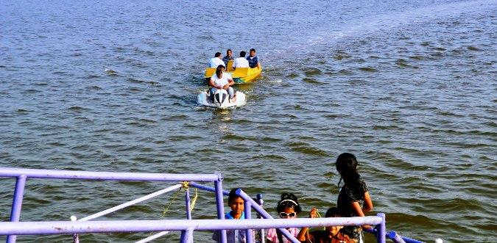
Humuri Tampara, the sweet water lake offers great avenues for water sports, One can also take a leisurely stroll through the vast stretches of cashew plantations along the shore. An exciting is trek about 2 km trough this plantation leads to a virgin beach on the Bay of Bengal.
Nirmaljhar - The Pure Stream
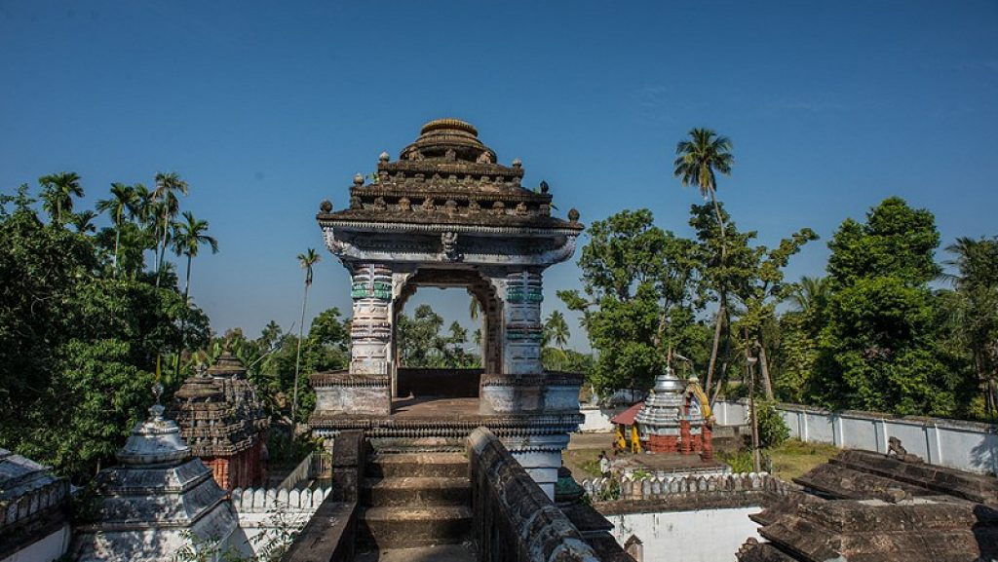
The place Nirmaljhar named after Pure Water, i.e. Sanctified by a perennial stream, let channelized to different ponds, Hallooed Shrine of Lord Vishnu. The place is embellished with Sculptures, Arbors, Idols and other carryings of the highest workmanship.
Kulada
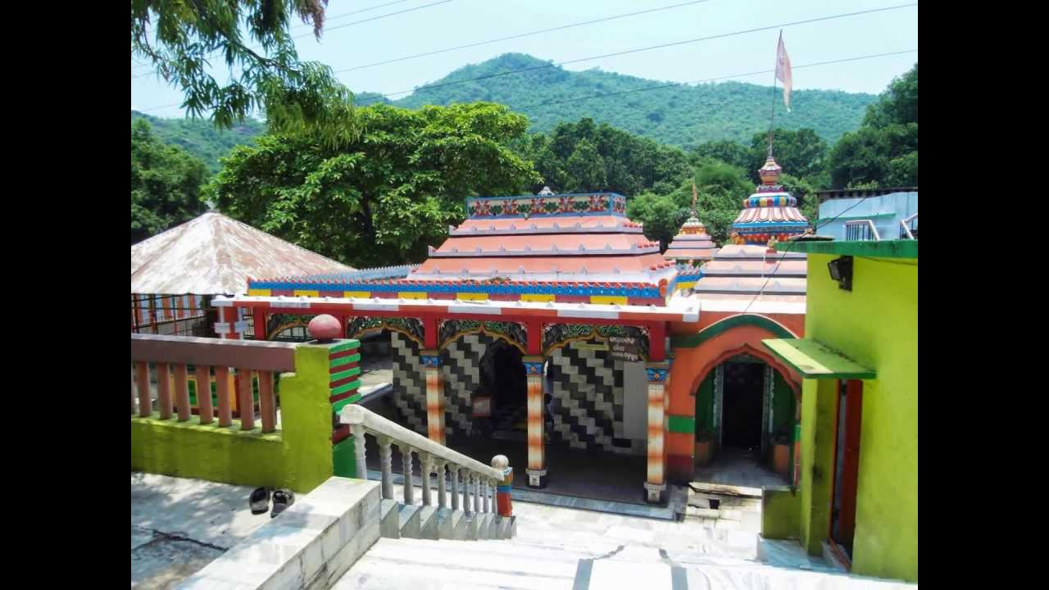
Kulada is famous for Goddess Bagh Devi which is the presiding deity, Kulada is said to be the birthplace of great Odia Poet Kabi Samrat Upendra Bhanja. It is situated to the northwest of Ganjam District with a ruined fort, river Mahanadi flowing in the east and dense forest on the west side of the ruined fort.
Aryapalli

One of the prominent Odisha beaches, Aryapalli is located at a distance of 6 km and 30 km from Chhatrapur and Berhampur respectively. The golden sandy beaches, deep blue sea and salubrious weather represent the beautiful place of Aryapalli.
How to reach Ganjam
By Air
Nearest Airport is Bhubaneswar Biju Pattnaik International Airport. It is 155 Km away from Ganjam.
By Rail
Nearest Railway Station is Chhatrapur. There are regular trains from other major cities of the country to Ganjam.
By Road
Ganjam does not have a bus stand. The nearest option is Berhampur. From Bhubaneswar, it is 150 kms on the NH-16.
Best Time to Visit Ganjam
The time between October to June is the best time to visit Ganjam. The weather is very pleasant during this time and also the maximum number of festivals are celebrated during these months.
Weather of Ganjam

