About Jagtsinghpur
Planning a Trip to Jagtsinghpur? Here's our list of 6 top Tourist Places to visit in Jagtsinghpur
Jagatsinghpur is a town and a municipality in Jagatsinghpur district in the Indian state of Odisha. It is also the headquarters of the Jagatsinghpur district. It got the recognition as a new district on 1st April 1993.
The place was converted from Hariharpur to Jagatsinghpur after the name of Jagat Singh since 1786. Consequent to the bifurcation of old Cuttack District into four new districts, the Jagatsinghpur District was created on 1st April 1993. The new district was inaugurated by the then Chief Minister Biju Pattnaik in an auspicious ceremony.
Top 6 Places to Visit in Jagatsinghpur
Siali Sea Beach
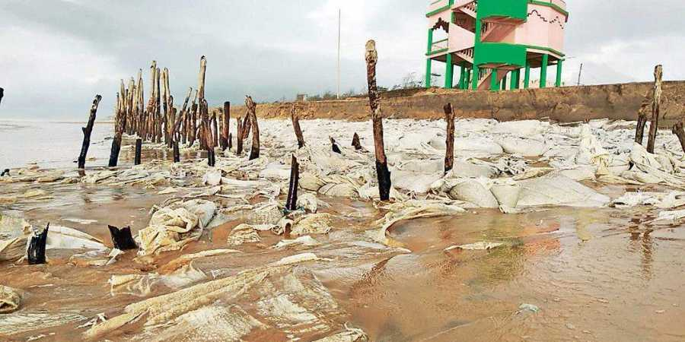
The beach is about 20 km from Balikuda block is the most attracting beach of Jagatsinghpur district. It is a very good spot for the picnic and can be visited during any season of a year.
Sandhakuda
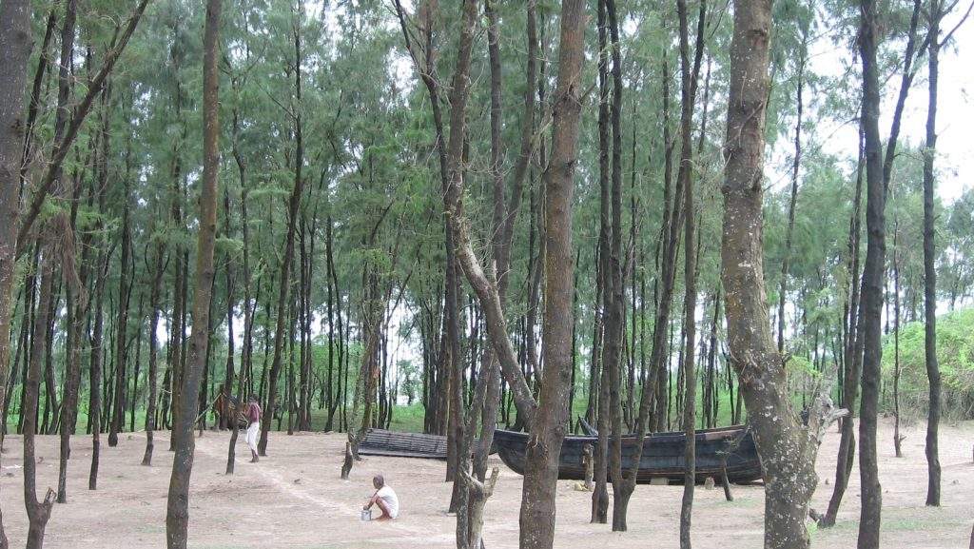
It is an attractive tourist spot comprising vast green shades of casuarinas vegetation, shimmering golden beaches, natural creeks and island. A perfect place to soak oneself in the organic value of nature. The tourists can avail of better accommodation facilities are at Paradeep.
Chandrapur
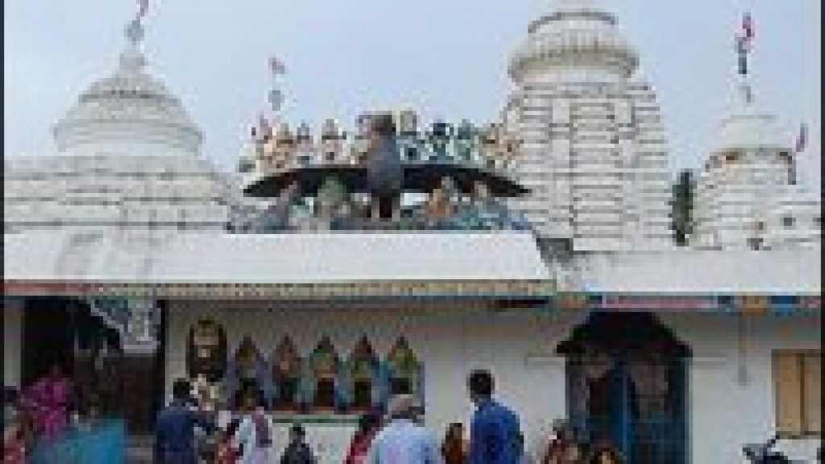
At the end of the Village Mahilo in a typical rural atmosphere, the famous temple complex of Lord Raghunath Jew and Lord Chandrasekhar stands around 30 years back. One can find a rare combination of Sri Ram known as Raghunath Jew and Lord Siva known as Chandrasekhar in a single compound.
Gada Kujanga Temple
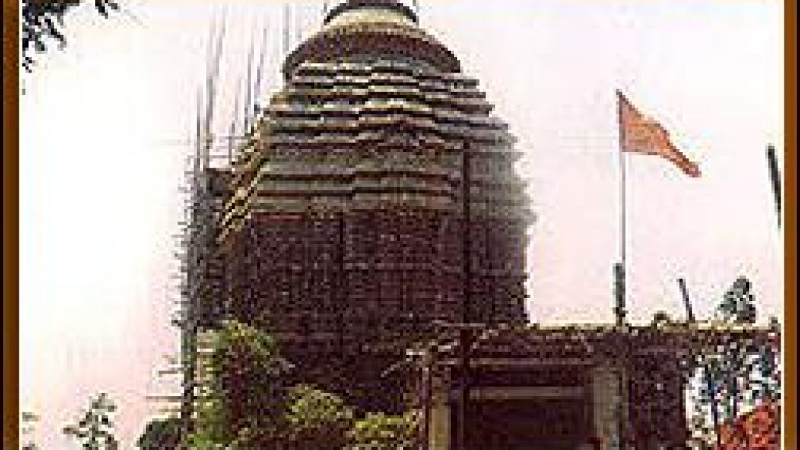
Gada Kujanga is mainly famous for its presiding deity Kunja Behari. Garh Kujanga is also known as Subhadra Kshetra. The Raghunath Jew Matha located near the temple of Kunja Behari is an added attraction of this place.
Paradeep Port
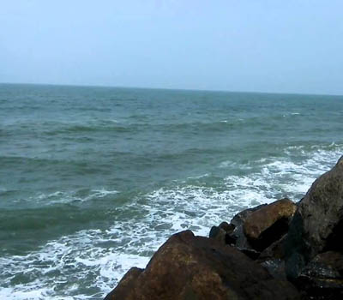
It is a major seaport of India for trade activities. The enchanting beauty of the sea, a wonderful sea beach & marine drive, beautiful creeks, estuaries and evergreen forests of estuarian islands of the river Mahanadi, make the place a major tourist attraction.
Maa Sarala
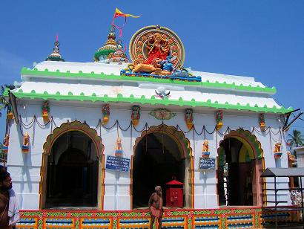
Jhankad is the sanctum sanctorum of Goddess Sarala, regarded as one of the most spiritually elevated expressions of Shaktism from time immemorial. Believed as a synthesis of the divine figure of Durga and Saraswati, the culture of Sarala is an amalgamation of three principal Hindu cults namely Vedic, Tantrik and Vaishnavite. It is one of the eight most famous Shakta shrines of Odisha. The main idol carved out of stone is of eight-armed keeping her right foot on the lion in Mahinsha Mardini posture.
How to reach Jagatsinghpur
By Air
Nearest Airport is Bhubaneswar Airport- 70 Kms.
By Rail
Nearest Railway Stations is Chhapada and Paradip. Taxi, Bus services are available from Paradip to Jagatsinghpur.
By Road
The road journey is the most convenient to Jagatsinghpur. It is very well connected to all major cities of Odisha.
Best Time to Visit Jagatsinghpur
The time between October to February is the best time to visit Jagatsinghpur. The weather is very pleasant during this time and also the maximum number of festivals are celebrated during these months.
Weather of Jagatsinghpur
Jagatsinghpur's maximum summer temperature is 40°C; the minimum winter temperature is 17°C. The mean daily temperature varies from 33°C to 38°C.

