Jajpur is a historic place of pilgrimage in the state of Odisha. This place has a number of archaeological ruins as well as monuments of the olden times, when it was the capital of Kalinga Kingdom.
About Jajpur
Planning a Trip to Jajpur? Here's our list of 7 top Tourist Places to visit in Jajpur
The Jajpur district is located at a distance of about 30 Kms(Chattia- Beginning of Jajpur District) from Cuttack. History says Jajpur was the capital of the Kalinga Kingdom and had achieved the pinnacle of glory in archaeological excellence. Jajpur is honored for its Natural Resources, Mines and Industries.
Jajpur is situated on the bank of river Baitarani it has the sacred shrine of Goddess Biraja(Durga), Sveta Baraha(incarnation of Lord Vishnu as the white boar), Sapta Matruka and a host of other shrines. It is famous for Saktipitha of Goddess Biraja. Ashokajhar, Chandikhol, Chhatia, Gokarnika, Kuransa, Mahavinayak, Patharajpur, Ratnagiri, Udaygiri, Satyapira, Singhapur, Vyas Sarobar and Baruneswar Pitha are some of the visiting places of this district.
Top 7 Places to Visit in Jajpur
Dasaswamedh Ghat
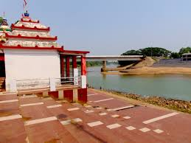
Located on the banks of river Baitarani, the ghat is very holy spot that has built during Jajati Kesari. The water here is regarded as sacred and they say that taking a dip here during any auspicious date in the Hindu calender brings about a lot of positivity in life. Baruni Snana is an important festival of the ghat when Hindus from all over the country come here to take a bath in the holy water.
Jagannath Temple
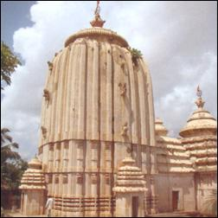
This temple's architectural style speaks about the era it might have been constructed in. This is one of the most famous temples of Jajpur. It is believed that the last Avatara of Vishnu would come to this temple, take the sword and destroy the evil in the society.
Gokarneswar Temple
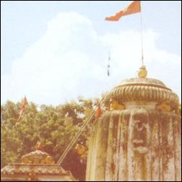
This temple is located on the banks of Brahmani river. It has link with the great epic of Mahabharat. They believe that the famous five Pandav brothers had come to the banks to pay homage to their ancestors.
Chhatia Bata
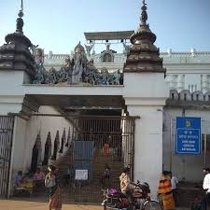
Chhatia is where the Jagannath temple is situated. This temple attracts the highest number of people. It is believed to the second Shreekeshtra of Odisha. Chhatia Bata is another famous temple of the region.
Ratnagiri
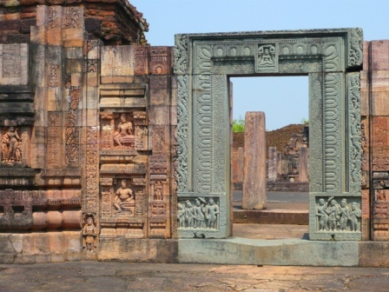
It is a famous Buddhist religious spot of Jajpur. The architectural style of the temple seems to hint towards the fact that it was built during the rule of Gupta Dynasty. The temple ages back to the 6th century AD and seems to have been built for the Mahayana sect of Buddhism.
Mahavinayak Temple
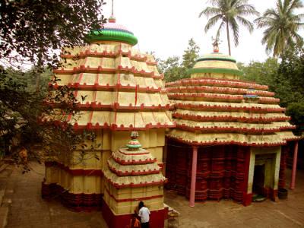
It is a major center of pilgrimage and one of the oldest Ganesha temples in Odisha. The speciality of Mahavinayak temple is that the Pancha Devata[Five Gods] ‘Shiva’, ‘Vishnu’, ‘Durga’, ‘Sun’ and ‘Ganapati’ are worshiped as a single deity in a single sanctum Sanctorum. In no other Hindu temples such tradition of worship is present.
Biraja Temple
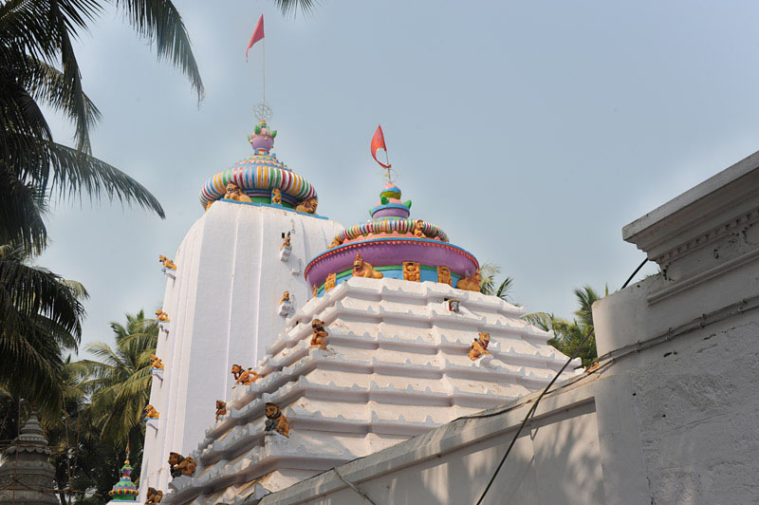
It is one of 51 shakti pentagrams and it is where Sati's navel fell. The temple was built in 13th century. Jajpur town has grown around temples. The main temple is that of Devi Biraja(Biraja Mandir). Mounted on a lion she carries a spear with one arm and holds the tail of Mahishasur with the other. Festivals are held at Durga Puja & Kali Puja.
How to reach Bhubaneswar
By Air
Bhubaneswar is the nearest Airport to reach Jajpur. The Airport has regular Domestic and International flights to many major cities like Delhi, Kolkata, Bangalore, Chennai, Hyderabad and Mumbai.
By Rail
Jajpur is well connected to other major cities of the country via regular trains.
By Road
Instead of Jajpur you can a get a bus to Chandikhol on regular basis.

