About Jharsuguda
Planning a Trip to Jharsuguda? Here's our list of 7 top Tourist Places to visit in Jharsuguda
The town of Jharsuguda remains one of Odisha's most prosperous places. Jharsuguda is the district headquarters of the Jharsuguda district of Odisha, India. It is an upcoming industrial hub, basically in the metal and cement sectors. Jharsuguda is well connected to all major cities of India through rail network. It is popularly known as the powerhouse of Orissa due to a large number of thermal power plants located nearby.
Top 7 Places to Visit in Jharsuguda
Chandi Mandir
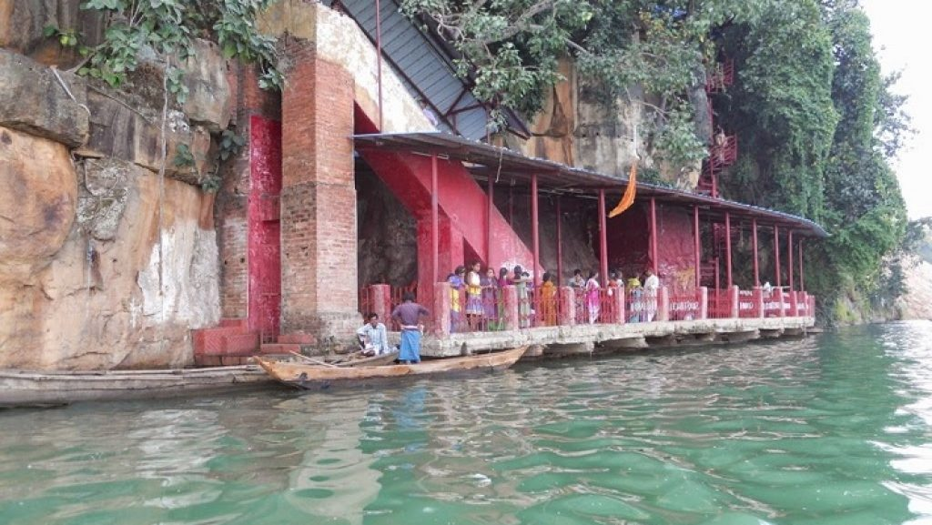
The temple is located about 30 km from Jharsuguda Railway Station at Brajarajnagar. Goddess Chandi is worshiped here and the Chandipitha is located inside a natural rock cave on the banks of river IB. One can get down to the temple by the iron stairs. And from the temple, one can have a beautiful view of the natural surroundings of the banks of the river Ib. It is a very nice picnic spot.
Pahadi Mandir
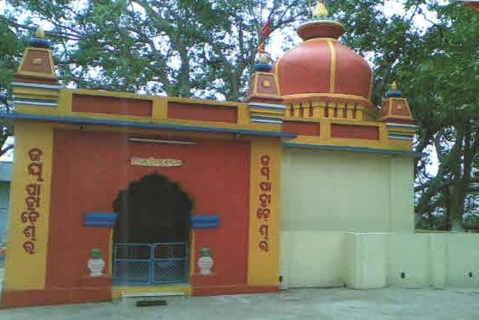
This temple is located at a distance of 3km from Jharsuguda Railway Station & 3.5 km from the bus stand on a small hilltop. Lord Shiva is worshiped at the temple. A beautiful view of Jharsuguda town can be seen from the hilltop.
Jhadeswar Temple
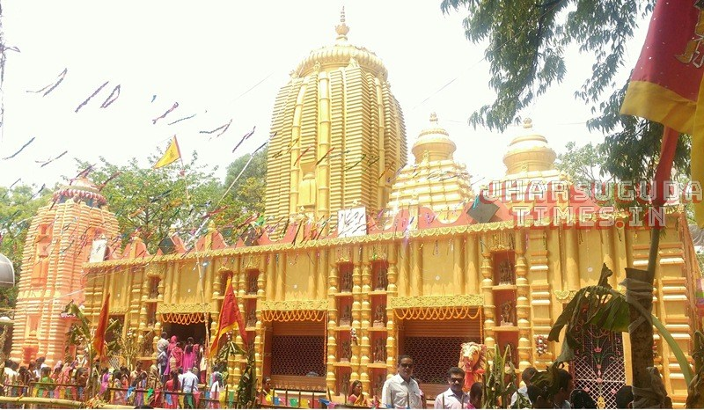
This famous temple is located in a forest near Jharsuguda town. Lord Shiva is worshiped in this temple and it is believed that the Shivalingam worshiped here is self appearing. The place is also a beautiful picnic spot due to its natural beauty and the beautiful garden located near the temple. A large number of people gather here during the Shivratri festival.
Koilighugar Waterfall
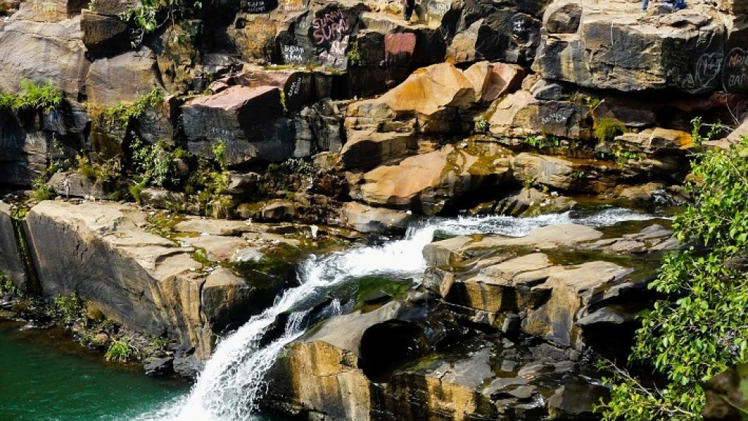
The Koilighughar waterfall is at a distance of 55 km from Jharsuguda town. There is a forest here and the waterfalls from a height of 200 ft, giving the place a beautiful natural scenery. There is a Shivalingam known as ‘Maheswarnath’ inside the fall, submerged in the water, not visible easily, sometimes seen under sunlight reflection.
Vikramkhol Rock Painting
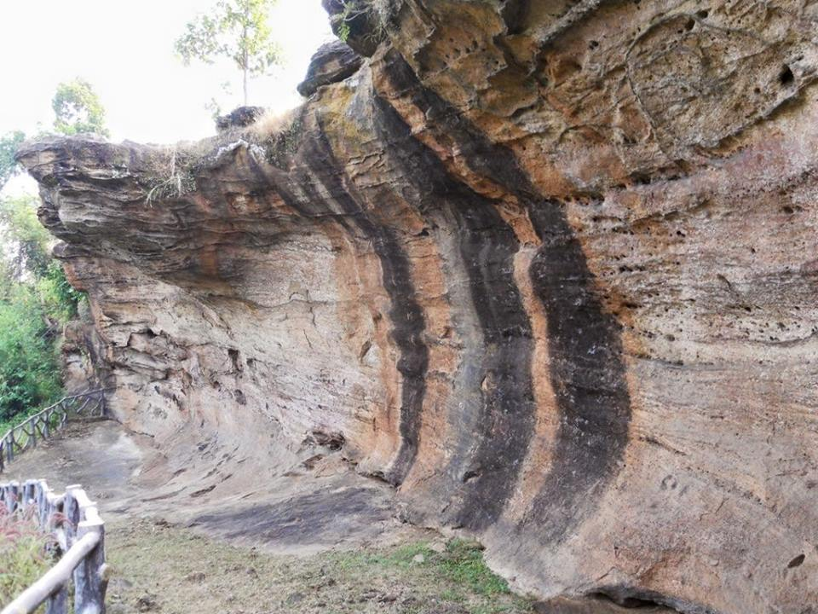
Vikramkhol cave is located near the village ‘Banjari’, 25 km away from Jharsuguda. There is a dense forest and ancient people were living in this place. The holes in the cave can be seen, where the ancient people used to keep grains and other foods. Some scripts and paintings are seen on the walls of the cave.
Ulapgarh Hill Forts
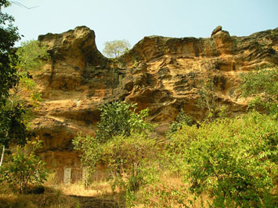
The ruins of the Ulapgarg Hill Fort are seen near the village ‘Ulap’, located at about 20 km from Jharsuguda. The fort was constructed over the large plain surface of a 100 feet high hill known as ‘Maheswar Pahad’. It is said that the kings of the ‘Naja’ dynasty used this fort as a residential place.
Ramchandi Temple
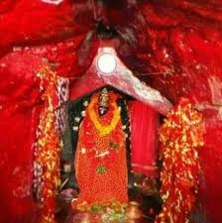
Ramchandi Temple is a famous Shakti Peetha of Odisha. The temple is located in a cave, about 10 km away from the Jharsuguda town. People from all over Odisha and other places come to worship Maa Ramchandi here.
How to reach Jharsuguda
By Air
Nearest Airport is Veer Surendra Sai Airport Jharsuguda. On a daily basis, there are approximately 17 flights that operate at Birsa Munda Airport.
By Rail
Nearest Railway Stations is Jharsuguda Junction. On average about 100+ trains pass through Jharsuguda on a daily basis.
By Road
From Bhubaneswar, it is 338 km on NH By road Jharsuguda is surrounded by Sundargarh, Sambalpur, Raigarh which are 17.21 km, 26.14 km, 40.02 km away respectively.
Best Time to Visit Jharsuguda
The winter season is cool and comfortable here. So winter is the best time to visit Jharsuguda. From October to March you can enjoy here.
Weather of Jharsuguda
Jharsuguda lies at 235m above sea level The climate is tropical in Jharsuguda. In winter, there is much less rainfall than in summer. This location is classified as Aw by Köppen and Geiger. The temperature here averages 26.5°C. The average annual rainfall is 1480 mm.

