About Kalahandi
Planning a Trip to Kalahandi? Here's our list of 6 top Tourist Places to visit in Kalahandi
Kalahandi is situated in the south-west region of Odisha, on the confluence of rivers Tel and Uttei. Located along the tributaries of Mahanadi, the region is spread across a land area of 7,920 sq km. The region is divided into plain and hilly terrains.
The district of Kalahandi is surrounded by Balangir and Nuapada districts in the north and Nabarangpur, Koraput and Rayagada districts in the south. It is believed that the district was a part of the Mahakantara territory. Known as Karunda Mandal, the region had treasures of precious stones, which include Red Stone, Blue Stone and Alexandra.
The district also witnessed the rule of the Gangas for a long period. The tradition of Durbar of Kalahandi provides evidence of the rule of Nagas over Kalahandi from Vikram sambat 1062 or 1005 A.D. Kalahandi merged with Odisha and emerged as a district on 1st January 1948.
The historic testimonies of the destination include ruins of forts and bridges that date back to the 12th century. The ruins of Amathguda Fort is one of the chief attractions of Kalahandi owing to architectural and historical significance.
Top 6 Places to Visit in Kalahandi
Dokarichanchara
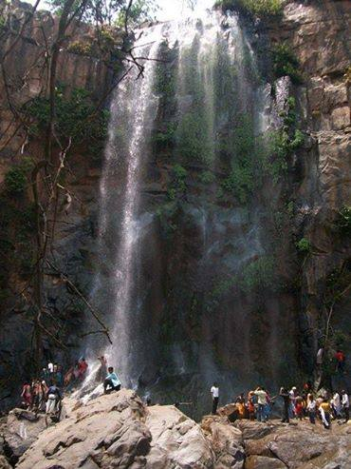
Kalahandi is one of the famous historical and ancient places of India or Odisha; where Dokarichanchara is a picnic or tourist place located in the village Kokasara, on the border of Kalahandi and Nabarangpur district. It is a completely different and unique place than that of other attractive tourist centers in Kalahandi.
Bhawanipatna
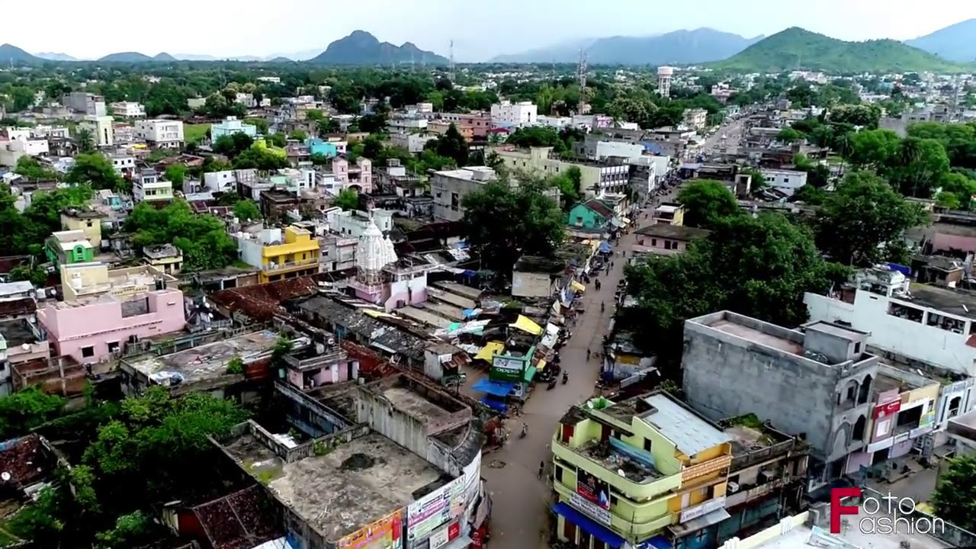
Named after Bhawanishankar, Kalahandi district's most respected deity, Bhawanipatna is a place enamored with temples dedicated to several gods and goddesses of Hindu mythology. The place is home to several temples that are dedicated to various Hindu gods and goddesses. One of the most popular tourist attractions in Bahawanipatna is the temple dedicated to Goddess Manikeshwari. The place also has thick forest which houses exotic wildlife such as Chitals, Gaurs and Sambar Deer. This place is also the base for visiting the other attractions of Kalahandi and Nawapara districts.
Manikeswari Temple
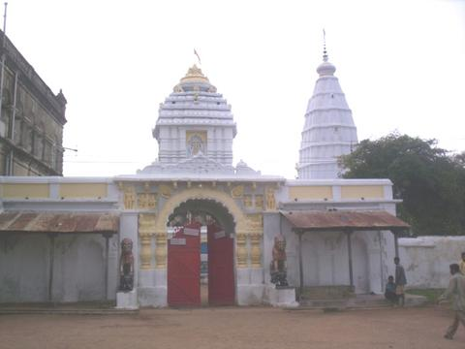
Manikeswari is one of the popular Hindu deity in Odisha. There are many Manikeswari temples present in the Western and Southern parts of Odisha.
Manikeswari temple in Bhawanipatna is well recognized in Odisha. Manikeswari is also the primary deity associated with the royal family of Paralakhemundi in Gajapati. Chhatar Jatra is one of the most popular festivals of Manikeswari at Bhawanipatna. Khandasadhaka is a festival associated with Manikeswari in Paralakhemundi.
Belkhandi Temple
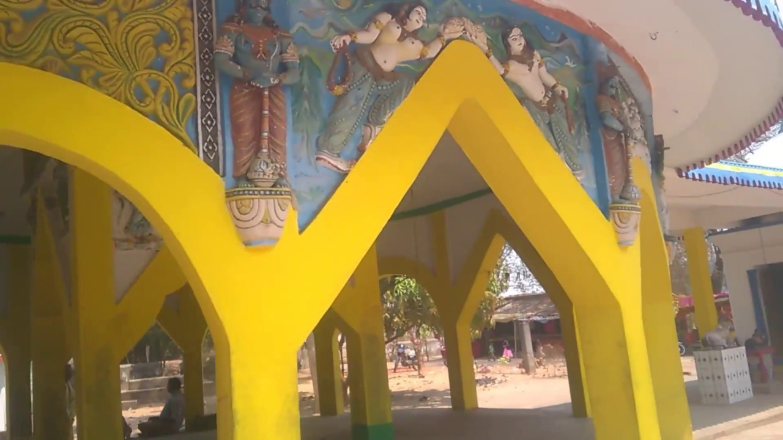
Situated on the confluence of the river Tel and Uttei, two tributaries of the river Mahanadi, Belkhandi has gained prominence as a center of religious activities and archaeological importance with a picturesque site. Besides the temples now standing therein, ruins of 12th Century monuments have been excavated from there in the recent past.
Phurlijharan
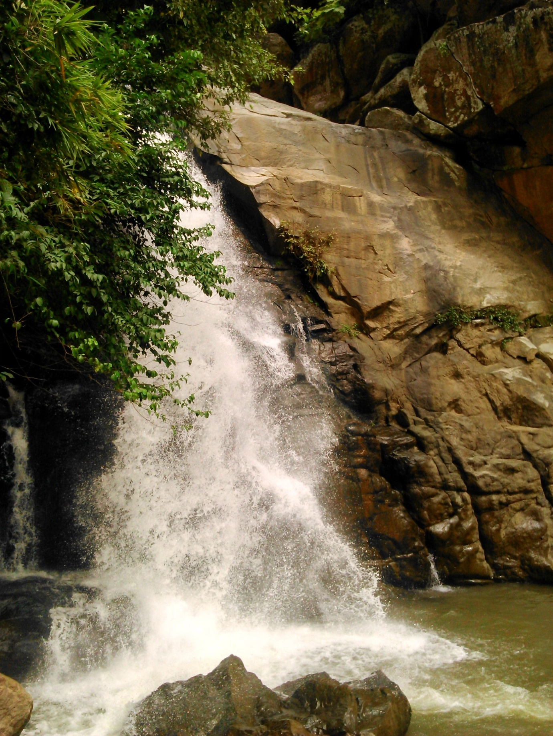
Fifteen Kilometers from Bhawanipatna, Phurlijharan is a perennial waterfall about 30 Ft in height and has a special charm of its own. The multi-colored rainbow created by the sun rays falling on the scattered water particles of the fall is an amusing sight to be seen. The evergreen forests around the fall provide ample opportunities to group picnickers.
Ampani Hills
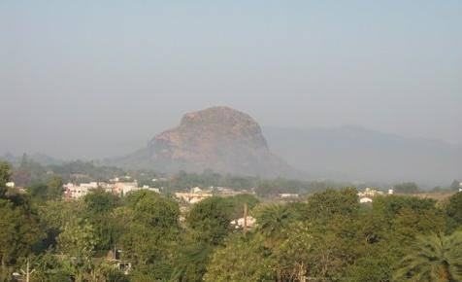
77 KMs from Bhawanipatna the picturesque Ampani hills present a panoramic view of nature. A frolicking valley called “Haladigundi” in this hill range exhibits some peculiar features due to the reflected rays on the sun.
In the morning and evening, the objects of vision appear yellow. The whole area abounds in Spotted Deer, Sambar and Black Panthers who can be seen at the Behera reservoir. 5 KMs away are the pre-historic cave paintings at Gudahandi.
How to reach Kalahandi
By Air
Nearest Airport to Kalahandi is at Bhubaneswar and Raipur which is about 418 km and 261 away respectively.
By Rail
Bhawanipatna is the nearest Railway Station and is well connected to all major cities in India. You can directly reach here.
By Road
Kalahandi is connected by regular bus services from many important cities in the state including Koraput, Bhubaneswar and Berhampur.
Best Time to Visit Kalahandi
The best time to visit Kalahandi is during the winter months of November to March as the weather is pleasant.
Weather of Kalahandi
The climate of the Kalahandi District is of an extreme type. It is dry except during monsoon. The maximum temperature of the District is 45°C+, whereas the minimum temperature recorded is 4°C.

