About Kandhamal
Planning a Trip to Kandhamal? Here's our list of 6 top Tourist Places to visit in Kandhamal
Kandhamal District is located in Odisha state, India. The headquarters for this district are located at Phulbani. It's the Kandhamal district that was announced on first Jan 1994. Before, it was known as Boudh-Kandhamal district or Phulbani district. Kandhamal district is located in the heart of Odisha stretching between 19'34 & 20'36 north latitude and 83'34 & 84'34 east longitude with an area of 7649 sq.km.
Kandhamal District owes its significant importance from the past history, which dates back far back to the 3rd century BC. At that time the District was considered as an unconquered Atavika country. From the history of the District, it reveals that Kandhamal District was under the Maurya region.
The mountainous Atavika country in the later years came to be identified as Kandhamal. From the records, it is found that the District is named after the vigorous Khonds, who use to dwell the land.
Top 6 Places to Visit in Kandhamal
Daringbadi
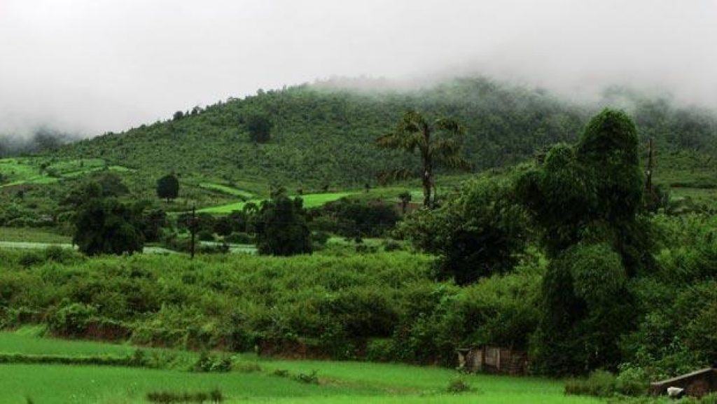
The beautiful hill station Daringbadi is situated in the highland area of Dense Forest of Daringabadi, Kandhamal Dist. of Odisha. It is situated at an average height of 3000 ft or 915m above sea level. It is the only place in Odisha, where one can experience snowfall during winter. The temperature level of Daringbadi has often recorded below the Frozen level and sometimes in minus. Because of its natural beauty and snowfall, it is popularly known as Kashmir of Odisha. As Kashmir is divine for India, similarly Daringbadi is for Odisha.
Jagannath Temple
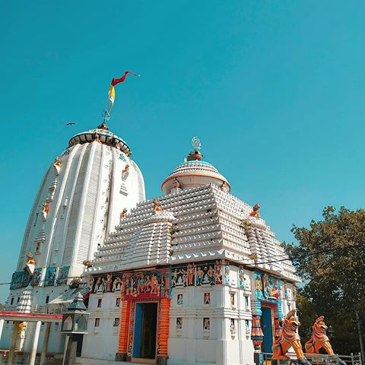
The temple is situated in the headquarter town of Kandhamal District. Here regular bus services are available from different places of the state and to different Tourist Places of the District.
Putudi
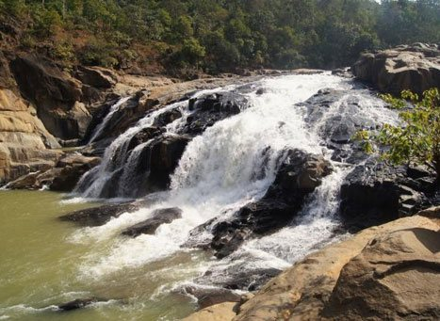
From the town of Phulbani, the Putudi waterfall is located at a distance of just 15 km. This waterfall is quite popular across Odisha. The water from the Putudi waterfall merges into the River Bada Saluki. It is also surrounded by a dense forest that promotes a great place for a picnic.
Barala Devi Temple
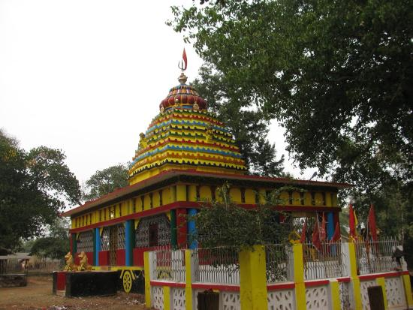
The beautiful place is famous for the Goddess Barala Devi who is believed to be the savior of the world. The people of this area visit the Goddess frequently on many occasions particularly on Dashahara. Pillasalunki Dam site which is an ideal and charming place for picnic and sightseeing is only 3 km from this spot.
Belghar
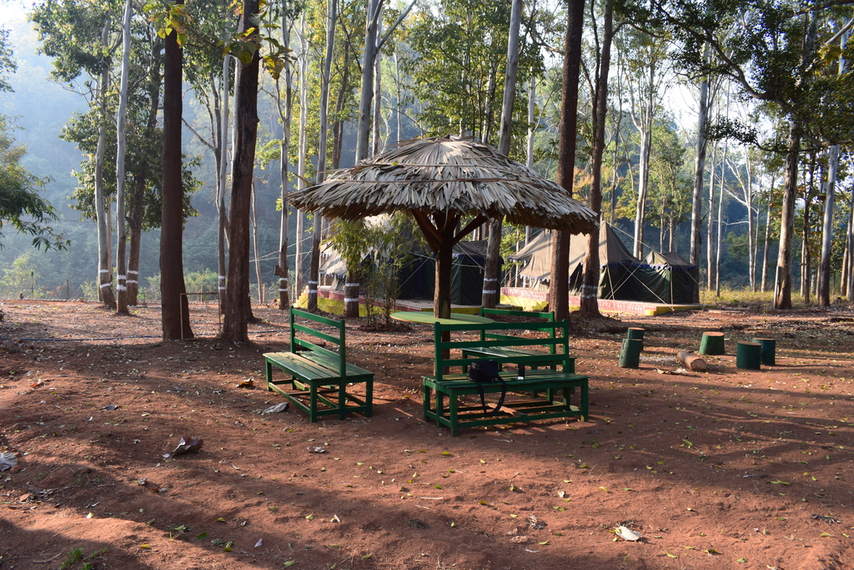
Gifted with ample scenic beauty, Belghar presents a panoramic view of lush and rolling hills. It is inhabited by the Kutia Kondha tribe, who follow the age-old tradition of food gathering and hut dwelling. They are very friendly and hospitable. More to be seen and encountered is wildlife especially elephants.
Chakapada
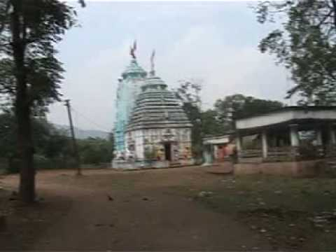
Chakapada is the abode of the Lord Birupakshya and located right at the bank of River Burtunga. This often generates the most panoramic view of the place. This is also an important Saivaism place. At the Birupakshya, Lord Shiva is worshiped. The same Hindu lord is also worshiped at Anandeswar as well as Jageswara. There are three unique temples located in these three places.
How to reach Kandhamal
By Air
Biju Pattnaik International Airport Bhubaneswar, 211 km away from the District Headquarter.
By Rail
Berhampur, 165 Kms away from the District Headquarter.
By Road
Phulbani Bus Stand, 1 km from District Headquarter.
Best Time to Visit Kandhamal
The best time to visit Kandhamal is from September to May. During this time visitors can escape from the hot summer and also enjoy quiet snow-filled winter here at Kandhamal.
Weather of Kandhamal
Kandhamal experiences a subtropical climate wherein the summers are hot and dry. The dry and cold climate in winter. The maximum temperature recorded in the District is 45.5°C and the minimum temperature is 2°C. The average annual rainfall recorded is 1522.95 mm.

