About Keonjhar
Planning a Trip to Keonjhar? Here's our list of 17 top Tourist Places to visit in Keonjhar
Keonjhar is a landlocked district situated in the northern part of Odisha. It is surrounded by Singhbhum district of Jharkhand in the North, Jajpur in the South, Dhenkanal and Sundargarh in the West and Mayurbhanj and Bhadrak in the East. Baitrani river originates from the Keonjhar plateau. To the West is a range of lofty hills which contains some of the highest peaks of Odisha namely Gandhamardan(3477 ft.), Machakandana(3639 ft.), Gonasika(3219 ft.) and Thakurani(3003 ft.). About half of the area of this district spreading about 4043 sq. km. is covered by forests of Northern tropical moist deciduous type and contains Sal, Asan, Piasal etc.
The whole District of Keonjhar was a princely state before its merger with Odisha. From history, it reveals that a part of the old Khijjinga territory with headquarters at Khijjinga Kota, identified with modern Khiching. It became a separate state with Jyoti Bhanja as its ruling chief sometime during the first half of the 12th century A.D.
Top 17 Places to Visit in Keonjhar
Kushaleswar Temple
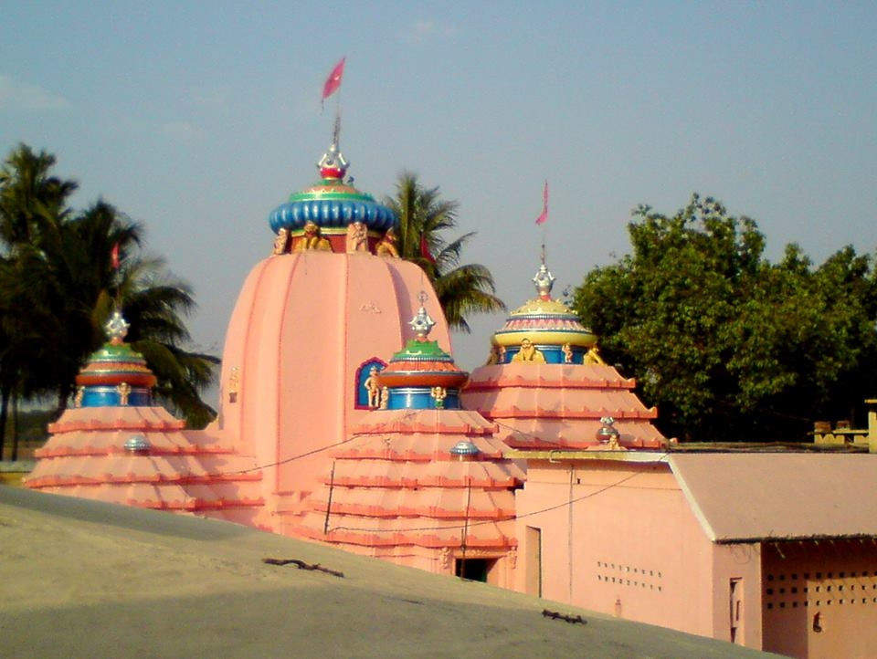
The temple, Deogaon is sanctified owing to the presence of a shrine dedicated to Lord Kusheleswar Mahadev built in 900 AD. The temple located on the bank of river Kusei is an excellent pilgrimage center of the area. Jagar Mela & Sravan Purnima is celebrated with great enthusiasm. This temple has corroborated the saga of the Koshal empire of western Odisha.
Kanjipani Ghati
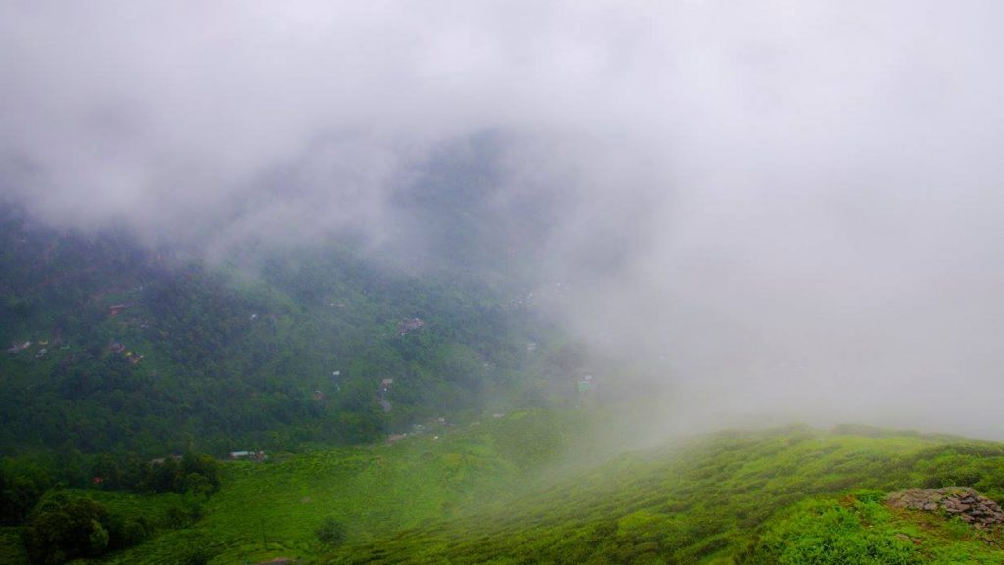
Kanjipani Ghati is a picturesque natural panoramic spot with magnificent up rolling mountain ranges. Trail of Kanjipani Ghati spread over 20 km long along NH-49 which offers a unique experience to nature lovers above 610 meter high ghat. The place is the treasure house of rich Flora & Fauna. The winter temperature goes to 0°C while clouds touch the valley during the rainy season to the delight of tourists.
Keshari Kunda
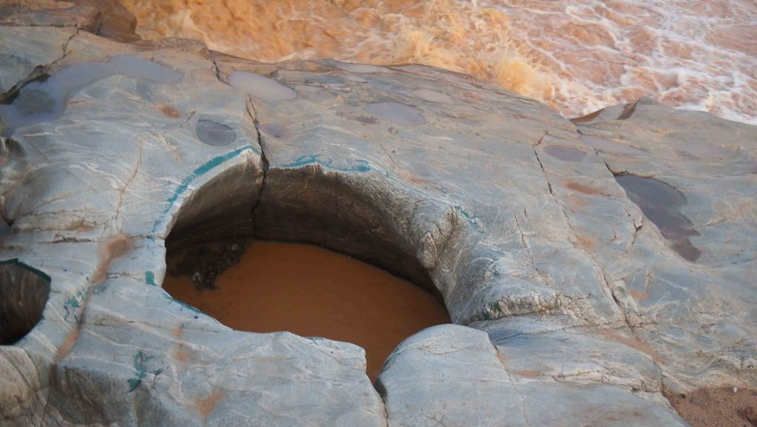
Keshari Kunda which has two holes on the bed of river Baitarani attracts people to get a holy dip and people offer their homage to Lord Siva on its bank. The landscape provides an interesting scenario for picnics and holidays.
Murga Mahadev Temple
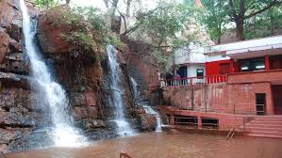
Murga Mahadev Temple stands majestically at the foot of Thakurani Hills is an important tourist spot in the district. A picturesque perennial spring of Thakurani Hills with the lush green forest has gifted a gorgeous waterfall to the nature lovers which flows nearby the temple area facilitating holy bath to the devotees.
Gonasika Temple
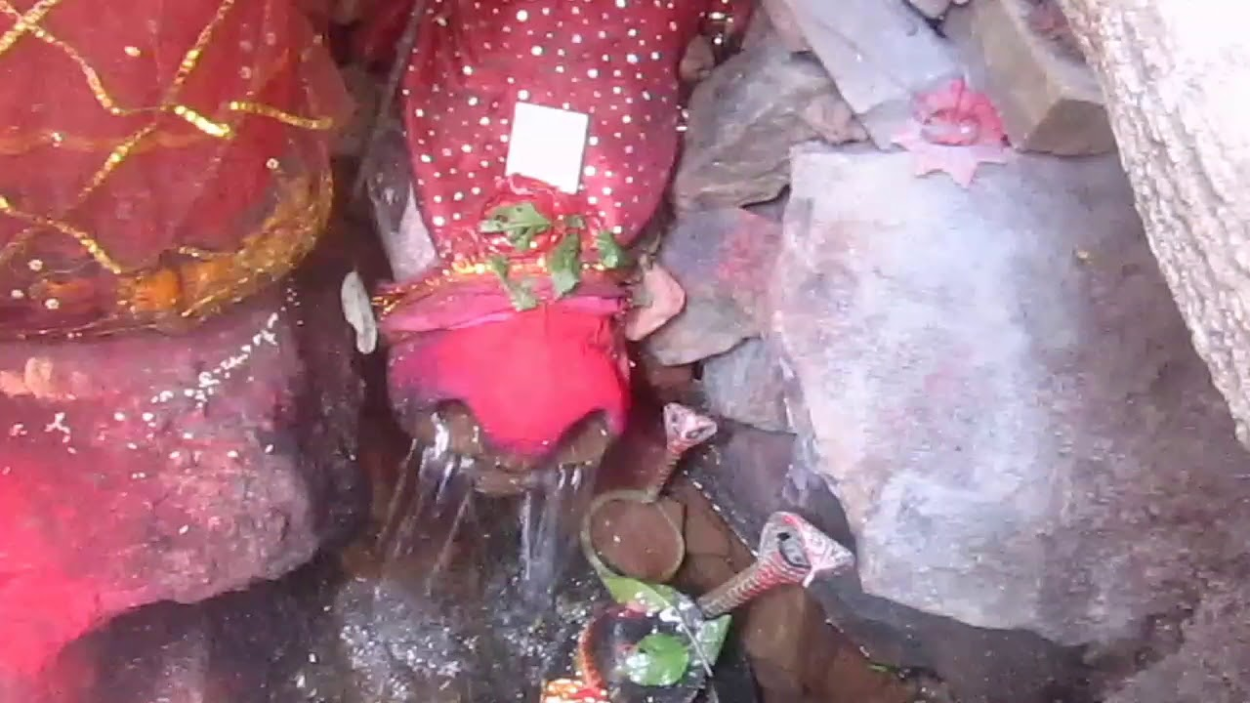
Surrounded by a series of valleys and wooded hills of varying colors, the place is famous as a center of pilgrimage for the temple of Brahmeswar Mahadev established by the side of river Baitarani. In fact, this is the place where the river starts flowing.
A little away from the point of origin, the river goes underground and hence called Gupta Ganga only to be seen jumping after a short distance over a stone projection looking like the nostril of a cow.
Hadagarh Reservoir
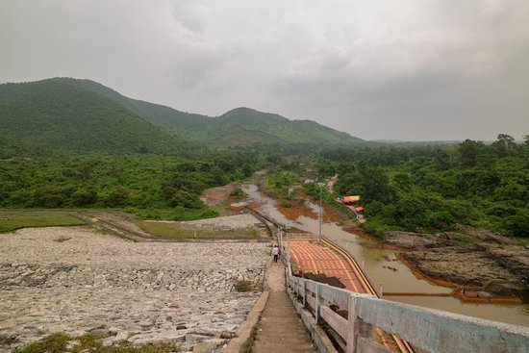
Hadagarh Reservoir has been raised on the river Salandi in Anandapur Sub-division of Keonjhar district. The dam encompasses a huge water source for the area for irrigation purposes. A splendorous natural environment with a high mountain range beautifies the reservoir which is eye-catching for natural lovers. It is an ideal place for picnickers and holidayers around the year.
Handibhanga Waterfall
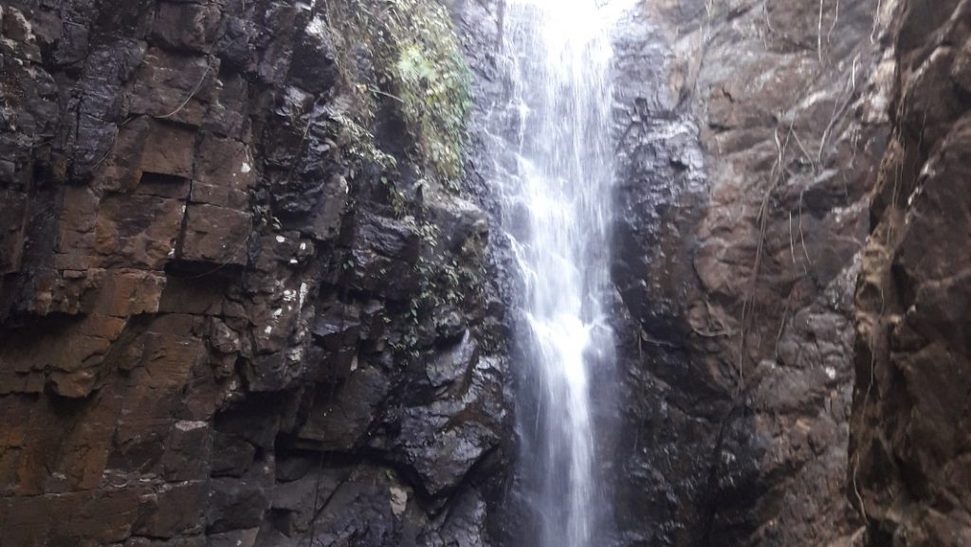
This waterfall is situated in a picturesque natural environment amidst the lush green forest with the up rolling mountain range. The nearby area is a huge reserve of rich biodiversity & ecology. Handibhanaga Waterfall with a height of 200 feet high mesmerizes the visitors for this stunning landscape.
Gundichaghai Waterfall
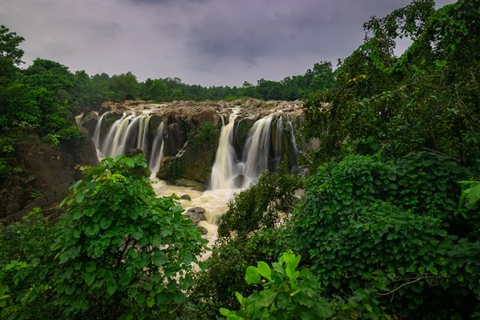
Gundichaghai waterfall is located amidst a spectacular natural environment with a lush green forest. A cascade of waterfalls on the river Musala falls at a distance of 50 feet below the river surface makes the area virtually smokey & attractive with roaring sound. The waterfall looks like a silver garland.
Sitabinji
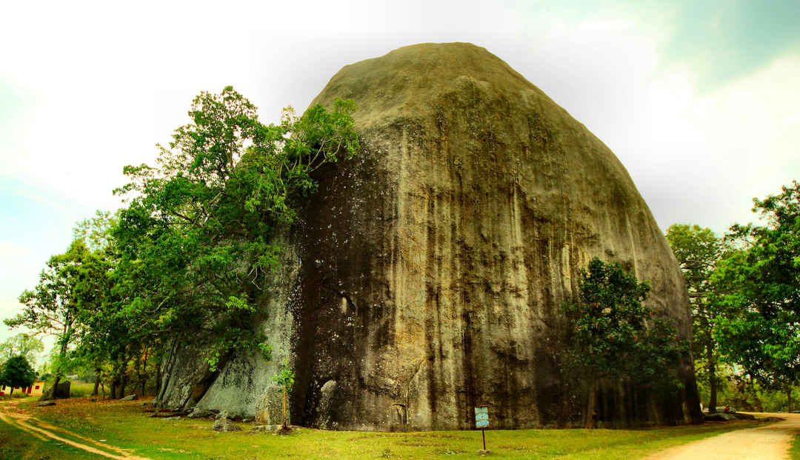
Sitabinji Fresco Painting & Rock Inscription is located on the side of the holy Sita river in a beautiful natural ambiance encircled with the sprawling mountain range. A magnificent stone looks like a temple stands in the country yard with a height of approx. 150 feet high which is considered as a major attraction of the spot. Maa Sita Thakurani is the presiding goddess of the pitha along with her two sons Laba & Kusha worshipped under a mammoth stone-like temple structures from time immemorial. The famous ancient fresco painting on a rock shelter called Ravan Chahaya is looking like a half-opened umbrella which depicts the legendary battle of Lord Rama & Ravana. A series of rock inscriptions are also found nearby the spot is still not interpreted by modern historians. A great civilization was flourished once upon a time as bricks & other antiques are earthen at the site. The latest remainings of the vestige of the history corroborate that of the golden era of the Gupta period of India.
Bhimkund
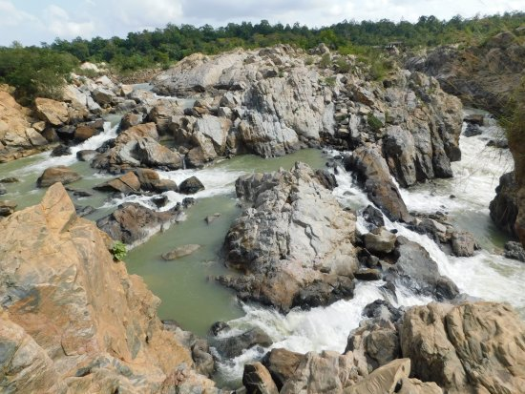
It is a beautiful natural water reservoir on the River Baitarani. It is located exactly on the boundary line between the districts Kendujhar and Mayurbhanj, at a distance of about 100 km from Keonjhar. This reservoir is two-storeyed which resulted in the formation of two waterfalls one above another.
It is being told that Bhima, the second Pandava had taken bath in this reservoir and hence it was named after him. During the Makar Festival in the month of January thousands of people gather here to take their holy dip.
Maa Tarini Pitha Ghatagaon
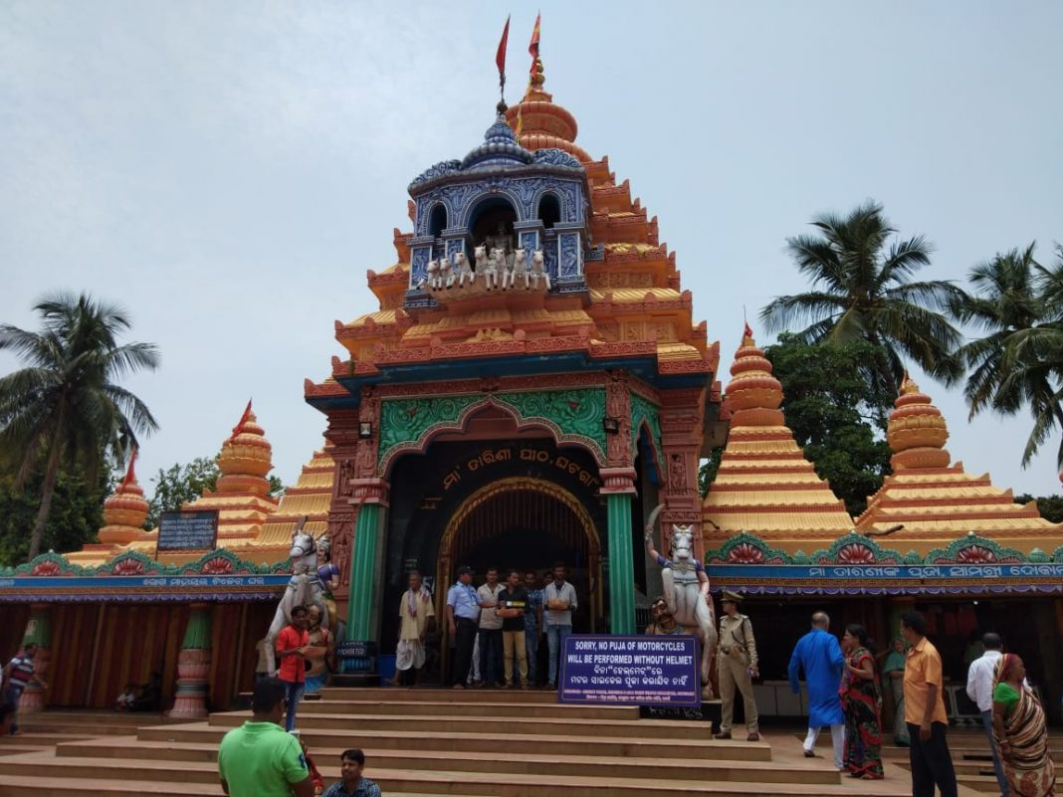
50 km. from Keonjhar town on the NH-215 towards Cuttack, the place is known through the state for the shrine of Goddess Tarini Pitha. The place is famous as a center of pilgrimage for Goddess Tarini.
Khandadhar Waterfall
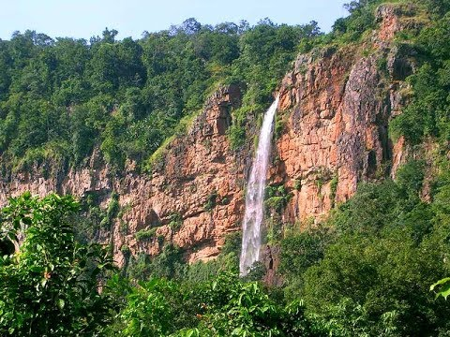
Khandadhar Fall is located in Khandadhar hill. It is a nice waterfall. the side view is also mesmerizing. The approximate distance between Keonjhar and Khandadhar Waterfall is 70 km.
Badaghagara Waterfall
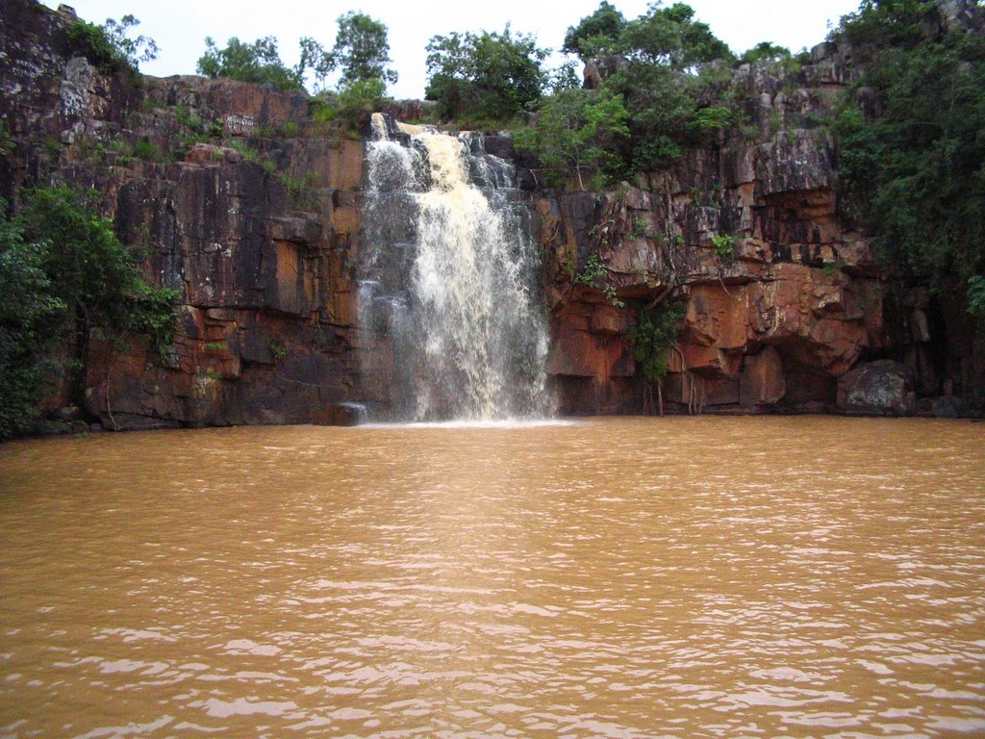
10 km. From Keonjhar town, it is yet another small(200 ft) but exciting waterfall. It is one of the most popular picnic spots in the district.
Sanaghagara Waterfall
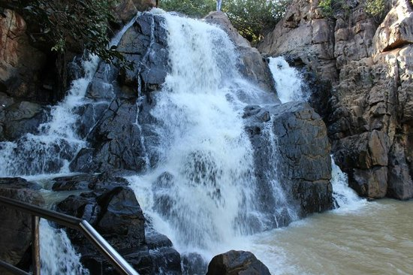
6 km. From Keonjhar town situated by the side of NH-6. It is a small(100 ft) beautiful waterfalls suitable for an outing. The spot is a very good picnic spot. Further, it keeps one's eye standstill adding the beauty of Keonjhar town.
Keonjhar Hill
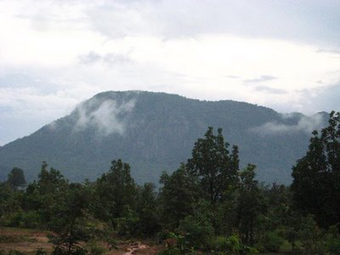
A quiet hillside town, Keonjhar district is the playground of nature, away from the hoards of tourists that throng to popular hill stations. The place thus presents an exotic mix of natural beauty along with intoxicating peace and serenity of humming river to the visitors which remain to be explored by the visitors.
Rajnagar
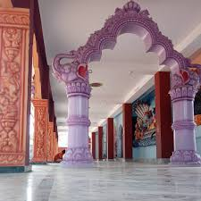
It is famous for the ruined palace of Keonjhar King. Also, Raghunath Jew Matha, Dadhibaban Jew temple and Chadhei Kudoor are other attractions of the spot. Different kinds of birds from different places gather here(Chadhei Kudoor) in winter which is most enjoyable. It 27 km. from Keonjhar.
Kichakeshwari Temple
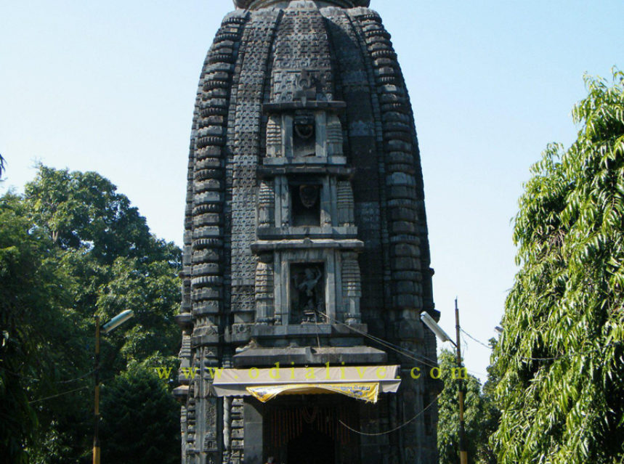
Kishakeshwari Temple is the temple of Hindu Goddess Chamunda alias Kali located in Khiching, which was the ancient capital of the Bhanja rulers, located about 205 km from Balasore and 150 km from Baripada in the Mayurbhanj district of north Odisha. The largest temple of the town is dedicated to Goddess Kichakeswari, the family goddess of the ruling chiefs of Mayurbhanj. The Goddess Kichakeshwari was not only which was not only Ishtadevata of Bhanj dynasty but also the State deity. The original temple dates back to the 7th or 8th Century, with repairs done over the centuries.
How to reach Keonjhar
By Air
The nearest airport to Keonjhar is the Bhubaneshwar Airport. The Bhubaneshwar Airport connects Keonjhar to the rest of the city.
By Rail
The nearest Railway Station is Keonjhar Garh. The railhead is the closest Railway Station that connects the city to the rest of Odisha.
By Road
By bus route, Keonjhar is linked with Calcutta, Bhubaneswar, Ranchi and Jamshedpur.
Best Time to Visit Keonjhar
The best season or months to visit places in Keonjhar are December to March. There are many tourist places in Keonjhar, which can be explored by travelers.
Weather of Keonjhar
The climate of Keonjhar District is characterized by an oppressively hot summer. Summer generally commences in the month of March. The temperature begins to rise rapidly attaining the maximum in the month of May. During the summer, maximum temperature touches around 38°C.

